

Request for Proposals (RFP)

The Division of Industrial Affairs
Modernization Project
Request for Proposals
Request No. LAB24001-DIA_MOD

- Deadline to Respond –
April 08, 2025
3:00 PM (EST)
Table of Contents
1.0 Project Purpose 5
1.01 Project Purpose 5
2.0 DOL Background 5
3.0 DOL Program Goals and Objectives 6
3.01 DOL LaborFirst Program Goal 6
3.02 DOL Strategic Enterprise Modernization (SEM) Objective 7
3.03 DIA SEM Objective 7
4.0 DIA Background 9
4.01 DIA Units Background 9
4.02 DIA’s Legacy Applications Background 10
5.0 DIA Project Goals and Objectives 15
5.01 DIA’s Goals 15
5.02 DIA’s Objectives 16
6.0 DIA Project Requirements 17
6.01 Wage & Hour Functional Requirements 18
6.02 Workers Compensation Functional Requirements 35
6.03 Construction Enforcement Functional Requirements 63
6.04 Safety & Health Functional Requirements 87
6.05 Anti-Discrimination Functional Requirements 100
6.06 Fiscal Functional Requirements 103
7.0 Proposal Response Schedule 115
7.01 Vendor Response Requirement 115
7.02 Pre-bid Meeting 116
7.03 Inquiries and Questions 116
8.0 Project Scope of Services 116
8.01 Plan and Set Up Project 116
8.02 Manage Requirements 117
8.03 System Implementation 119
8.04 Assess Infrastructure 120
8.05 Configure and Build System 120
8.06 Migrate Data 121
8.07 Implement Interfaces 122
8.08 Create / Configure Forms and Reports 123
8.09 Conduct System Testing 124
8.10 Create and Conduct Training 126
8.11 Deployment Planning and Execution 128
8.12 Maintenance and Operations (“M&O”) Plan 129
8.13 Maintain Effective Cyber Security and Business Continuity 130
8.14 End of Contract Services 131
9.0 Required Information 136
9.01 Requested Information 136
10.0 Professional Services RFP Administrative Information 137
10.01 RFP Issuance 137
10.02 RFP Submissions 138
10.03 RFP Evaluation Process 143
11.0 Contract Terms and Conditions 146
11.01 Contract Use by Other Agencies 146
11.02 Cooperative Use of Award 146
11.03 General Information 146
11.04 Collusion or Fraud 147
11.05 Lobbying and Gratuities 147
11.06 Solicitation of State Employees 148
11.07 General Contract Terms 148
11.07.01 Independent Contractors 148
11.07.02 Temporary Personnel Are Not State Employees Unless and Until They Are Hired 148
11.07.03 Work Performed in a State Building 149
11.07.04 Licenses and Permits 149
11.07.05 Notice 149
11.07.06 Indemnification 149
11.07.07 Insurance 150
11.07.08 Performance Requirements 151
11.07.09 Performance Bond 151
11.07.10 Vendor Emergency Response Point of Contact 151
11.07.11 Warranty 152
11.07.12 Costs and Payment Schedules 152
11.07.13 Liquidated Damages 152
11.07.14 Dispute Resolution 152
11.07.15 Remedies 153
11.07.16 Termination of Contract 153
11.07.17 Non-discrimination 153
11.07.18 Covenant against Contingent Fees 154
11.07.19 Vendor Activity 154
11.07.20 Vendor Responsibility 154
11.07.21 Personnel, Equipment and Services 154
11.07.22 Fair Background Check Practices 155
11.07.23 Vendor Background Check Requirements 155
11.07.24 Work Product 155
11.07.25 Contract Documents 155
11.07.26 Applicable Law 156
11.07.27 Severability 156
11.07.28 Assignment of Antitrust Claims 156
11.07.29 Scope of Agreement 156
11.07.30 Affirmation 157
11.07.31 Audit Access to Records 157
11.07.32 IRS 1075 Publication 157
11.07.33 Other General Conditions 159
11.08 RFP Miscellaneous Information 160
12.0 Glossary of Acronyms and Terms 161
13.0 APPENDIX 163
13.01 Appendix 1: OLLEA Case Management Reports 164
13.02 Appendix 2: OLLEA Management Chart Report 166
13.03 Appendix 3: SCARS Canned Reports 186
13.03 Appendix 4: DIA Project Technical Requirements 188

1.0 Project Purpose
The State of Delaware (the “State”), Department of Labor (“DOL”) is seeking proposals from qualified vendors to replace the Division of Industrial Affairs (DIA) legacy applications: SCARS and OLLEA with a centralized SaaS solution inclusive of implementation services that modernize core processes for all units within the division as described in this Request for Proposal (“RFP”), Scope of Work, and Requested Documents (outlined in the DIA Vendor Portal).

The State intends to award one (1) contract in conjunction with this RFP, as determined in the best interests of the State. DOL shall administer contract(s) resulting from this RFP. The awarded vendor contract is expected to be for an initial two (2) year contract term, with an option to extend for up to three (3) one-year terms. Based on funding and other considerations, it is paramount that full functionality be deployed and operational and available to all units within the division.

1.01 Project Purpose
DIA has been involved in an extensive planning phase to migrate from their two (2) legacy applications:
- SCARS (Scheduling Case Management Accounting and Reporting System)
- OLLEA (Office of Labor Law Enforcement Application)
to a centralized integrated enterprise case, accounting, and judicial management solution. DIA has six units: Wage & Hour, Construction Enforcement, Workers’ Compensation, Safety & Health, Anti-Discrimination, and Fiscal. The division has defined each unit’s business, functional, and technical requirements. The Readiness phase is completed, and the division is prepared for the vendor Selection phase. The purpose of this RFP is to conduct due diligence to select a SaaS solution provider who can support the division’s modernization requirements and requested information contained in this solicitation.

2.0 DOL Background
The Department of Labor (DOL) “connects people to jobs, resources, monetary benefits, workplace protections, and labor market information to promote financial independence, workplace justice, and a strong economy.” DOL has embarked in leveraging modernization efforts throughout all divisions. DOL consists of the following divisions:
- The mission of the Office of Administration is to provide accurate, timely, and professional support services to the divisions to assist them in achieving their goals and objectives for the DOL.
- The mission of the Division of Unemployment Insurance is to minimize the impact unemployment has on the individual, their family and community.
- The mission of the Division of Employment & Training is “to provide services enabling employers and job seekers to make informed employment and training choices leading to employment.”
- The mission of the Division of Industrial Affairs (DIA) is to foster, promote, and develop the welfare of the wage earners of the State of Delaware, improve their working conditions, and advance their opportunities for profitable employment.
- The mission of the Division of Vocational Rehabilitation is to provide individualized services to employers and people with disabilities, to develop career pathways that link qualified employees to jobs, resulting in greater independence and a more inclusive workplace.
- The mission of the Office of Occupational and Labor market Information is the key source of information about labor market conditions throughout Delaware. The office produces reports on the industrial and occupational structure of the State’s labor market, including supply-demand analysis and employment projections.
- The mission of the Division of Paid Leave’s (“DPL”) is to ensure that Delaware’s workers have the financial capacity to enjoy the family and medical Leave provided to them through federal law and to provide Delaware’s employers with a cost-effective means of attracting and retaining employees.

3.0 DOL Program Goals and Objectives

3.01 DOL LaborFirst Program Goal
DOL is forging forward on integrating all of its divisions: Unemployment Insurance (UI), Paid Leave (PL), Division of Industrial Affairs (DIA), Office of Occupational and Labor Market Information (OOLMI), Division of Employment and Training (DET), Division of Vocational Rehabilitation Services (DVR) in a strategic approach that offers a comprehensive suite of services tailored to support interoperability and transparency. This Strategic Enterprise Modernization (SEM) approach is known as LaborFirst. LaborFirst is a program of shared services across DOL that will facilitate efficiencies across four (4) workstreams:
- Program Management
- Workforce, Organization
- Enterprise Approach
- Process and Service Delivery
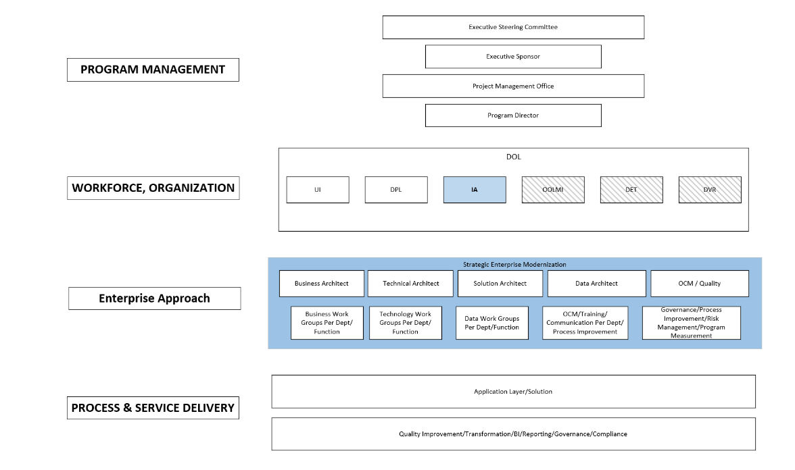
Figure 1: DOL LaborFirst Program Strategic Enterprise Modernization

This will be achieved by looking for opportunities to leverage technology across DOL and potentially utilize solutions already in use within the state as part of the future DOL topology. Submissions to this RFP must support DOL’s objective by facilitating integration with these shared services.

3.02 DOL Strategic Enterprise Modernization (SEM) Objective
Currently, DOL’s LaborFirst is in the process of modernizing the Division of Unemployment Insurance (UI) systems and implementing a new solution for Paid Family Medical Leave (PL). These 2 (two) projects are being developed with SEM shared services that other divisions within the department are required to consider when planning modernization. SEM shared services (refer to Figure 1: DOL LaborFirst Program Strategic Enterprise Modernization) include the following three (3) components:
Shared Processes
- Standardized Business Process: Common Business Functionality
- Best Practices: Improve efficiency and consistency across divisions.
- Consistent Policies: Enable the enforcement of consistent policies and standards.
- Operational Efficiency: Centralized processes enable more streamlined and efficient processes.
Shared Software
- Solution Platform: Common base application to support DOL.
- Data Analytics: Utilize single data warehouse to facilitate cross data analysis.
- Data warehouse: Data stored in one location making it easier to manage, centralize, access, and reduce discrepancies.
- Document Management: Fast easy retrieval, and centralized documentation allowing for greater collaboration. This will enhance security and compliance with document retention policies.
Shared Architecture
- Scalability: Centralized systems can be scaled to support growth and scaled to support policy changes.
- Centralized Data Governance: Simplified data governance practices to improve compliance with regulatory requirements.
- Integrations: Shared services that connect agency applications to One Stop, Okta (ID.me), Salesforce, Fiserv, FileNet (s-Docs), and Snowflake.
- Enhanced Security: Easier to implement and monitor security. Single point of control to reduce vulnerabilities.

3.03 DIA SEM Objective
DIA’s strategic enterprise modernization (SEM) objective is based on the federal government’s Modernization and Migration Management (M3) Framework. The framework is meant to lead agencies through six phases of successful shared services migrations from initial assessment to the actual migration and operations. The six phases are Assessment, Readiness, Selection, Engagement, Migration, and Operation. The M3 Framework is the roadmap for agencies “buying a service” - delivering projects on time, on budget, and on value. The M3 framework is designed to help agencies achieve successful outcomes and reduce risk during administrative system and/or service modernizations and migrations.
The M3 Framework is a six-phased approach to system and service modernizations and migrations including objectives, key activities and outcomes for each phase. Within each phase, there are associated activities grouped across four workstreams: (1) Program Management, (2) Workforce, Organization and Stakeholders, (3) Technology, (4) Process and Service Delivery.
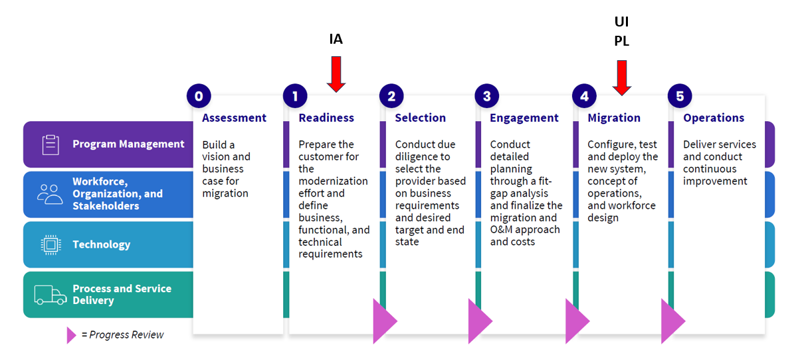
Figure 2: Modernization and Migration Management (M3) Framework

Taking into consideration the M3 Framework, UI and PL projects are currently in the Migration phase and IA is in the Readiness phase. IA has aligned their requirements with DOL’s Labor First program of SEM goals. Proposed solutions must ensure IA’s operational needs will be met as well as, achieve DOL’s vision of streamlining cross-functional processes throughout its divisions.

IA has incorporated shared technical/ functional requirements in the RFP to ensure seamless integration with UI and PL shared solution, Sales Force. Vendors must have APIs that can facilitate integration to ensure interoperability between DIA divisions, DOL UI and PL divisions, and DTI’s shared services listed below:

DIA Shared Services | Service Provided | Required/ Optional
- HubSpot | CRM | Required
- GoDE (FiServ) | Payment Processing | Required
DOL Shared Services | Service Provided | Required/ Optional
- SalesForce | UI and PL case management solution | Required
- Onbase | Document and record management | Required
DTI Shared Services | Service Provided | Required/ Optional
- ID.Me | Identity Management, Single Sign On, SAML, Access Management | Optional
- Okta | Identity Security Access | Required
- OneStop | Employer Registration | Required
- ServiceNow | IT Service Management | Required
- Aumtech/3C Logic (IVR & Call Center Service) | Customer Service Management | Required
- Mulesoft | API provider | Required
- Snowflake | Data Warehousing | Required
- Tableau | Business Intelligence/ Analytics | Optional
- Fivetran | Cloud-based automated data movement platform | Required
- FileNet (S-Docs) | Content management | Optional
- Onfido | AI-powered real identity | Required
Table 1: DIA's Modernization Shared Services

4.0 DIA Background

4.01 DIA Units Background
DIA enforces labor laws that ensure fair and equitable treatment in the workplace by administering 21 state and federal labor laws, including wage payment, minimum wage, child labor, prevailing wages for state-funded construction projects, and discrimination laws. DIA consists of six offices/units that foster, promote, and develop the welfare of the wage earners of the State of Delaware. DIA enforces improved working conditions, and advances opportunities for profitable employment.

Delaware Division of Industrial Affairs Website
https://labor.delaware.gov/divisions/industrial-affairs/

The following are DIA’s units and their specific core responsibilities:

- Wage & Hour established on February 1, 1979. The Secretary of Labor approved the administrative regulations that governs the deductions from wages for wage payment collection. This regulation created the program Wage & Hour. Wage & Hour performs employer investigations of Child Labor 19 DEL. C. Ch.5, Wage Payment and Collection 19 DEL. C. Ch. 11, and Minimum Wage 19 DEL. C. Ch.19. The unit has the right to initiate court action for labor law violations if an employer does not submit requested documents within a 10-day period.

- Workers’ Compensation administers and schedules hearings pertaining to state laws, rules and regulations regarding industrial accidents and illnesses 19 DEL. C. Ch. 21, 23, 26. DIA created within the Department of Labor the classified full-time position of workers’ compensation specialists § 2301C. The specialists assist unrepresented injured employees by providing information so that such employees can understand, assert, and protect their rights under Part II of Title 19. In addition, the specialists may assist the Department in expediting the processing of petitions. However, assistance provided under this section shall not include representing claimants in hearings or offering legal advice. Workers Compensation Labor Law Enforcement Officers verify, investigate, and compel employers to obtain insurance. Every employer within the State is required to insure their employees as required by Title 19 §2372. Investigative officers seek out employers who are violating the law and compel compliance using verification and demand letters as well as obtaining orders to compel and fines from the Industrial Accident Board.

- Construction Industry Enforcement serves to educate employers and protect workers from unfair and/or unsafe working conditions through the enforcement of laws governing Delaware’s Prevailing Wage Law Requirements 29 DEL. Ch. 69, Workplace Fraud Act (Worker Misclassification) 19 DE Admin. Code 1326, Contractor Registration Act 19 DEL. Ch. 36 and all associated labor laws enforced by the Department under Part IV of Title 19 Ch.35.

- Safety & Health provides free comprehensive on-site safety and health consultation surveys for small and medium sized businesses in the General Industry, Construction, and Agricultural sectors. All On-site Consultation services are voluntary and confidential. There are no fines, penalties, or fees associated with the service. Surveys help businesses to identify potential workplace hazards, improve safety management systems, and assist in compliance with federal Occupational Safety and Health Administration (OSHA) regulations. Consultants will not:
      - Issue citations or propose penalties for violations of OSHA standards.
      - Report possible violations to OSHA enforcement staff unless they are not abated within the agreed upon time limit.
      - Guarantee that your workplace will “pass” an OSHA inspection.

- Anti-Discrimination enforces laws against employment discrimination because of race, color, religion, sex (including pregnancy), sexual orientation, national origin, disability, age (40 or older), marital status or genetic information under 19 DEL. C. Ch. 7. The Office of Anti-Discrimination attempts to bring every charge of discrimination to resolution as quickly as possible. With limited exception, charges of discrimination are investigated on a first-filed, first-investigated basis. Every charge is unique, and the time required to investigate a claim is specific to the number of allegations and complexities of the allegations. An investigator will contact the charging party and the respondent when the investigation is started.

- Fiscal In compliance with 19 DEL.C. Ch. 23, § 2392, DIA determines the Administrative Assessment for the division on a semi-annual basis. The financial statement is extracted from Budgetary Activity Reports from the Department of Revenue and indirect cost rates determined for the division. In addition, the Fiscal unit collects, and deposits penalties paid to law enforcement units, as well as contractor’ registration payments.

4.02 DIA’s Legacy Applications Background
DIA’s two primary legacy applications: OLLEA and SCARS were custom built web browser applications for the division in 2007. The legacy applications are currently being utilized by four (4) of DIA’s six (6) units:
- Wage & Hour (OLLEA)
- Construction Enforcement (OLLEA)
- Workers’ Compensation (SCARS)
- Fiscal (OLLEA and SCARS)

OLLEA (Office of Labor Law Enforcement Application) supports DIA’s Enforcement operations for Wage & Hour and Construction Enforcement units. OLLEA provides case management and administrative business processes to create a user-friendly application that is easy to use and manage. OLLEA simplifies case processing procedures, provides easy access to information and document control and retrieval. The application provides Supervisor View landing page which includes Open Intake /Cases with Age and assigned Officer, Due Items, Scheduled Inspections by Case Type, and Referrals to other agencies. OLLEA consists of the following seven (7) modules:
- Intake Module: Add Intakes, Search Intakes
- Case Management Module: Search Cases
- Admin Program Module:
  - On-Site Inspection (Search, Add Project)
  - Prevailing Wage
    - Inspections
    - Determinations
    - Surveys
  - Wage & Hour (Inspections and Work Permits)
- Fiscal Module:
  - Bank Transactions
  - Transaction History
  - Fund Transfer
  - Accounts Receivable
  - Accounts Payable
  - Ledger
  - Account Reconciliation
  - Search Check
  - Check Request
  - Appropriation
  - General Fund Reversion
- Document Management Module:
  - Search
  - My Folder
  - Labels
  - Templates
  - Certified Payroll
- System Administration Module:
  - Access Rights (Office, Unit, Role, Role and Users, Internal Users, External Users)
  - System Tables (Lookup Tables, Violation Categories, Violation Codes, Trade Associations, Case Open Days, Intake Open Days, Prevailing Wage Inspection Compliance Codes, Workplace Fraud Inspection Compliance Codes, and Check Signatures)
  - Rules
  - User Activity
  - Employers (Employer Consolidation, UI File Import)
  - Case Tasks (Prevailing Wage, Wage & Hour, Workplace Fraud/Private, and Workplace Fraud/Public)
  - Prevailing Wage Survey (Prevailing Wage Survey Years, Consumer Price Index)
- Reports Module:
  - Case Management Report (Refer to 13.01 Appendix 1: OLLEA Case Management Reports) - View PDF or Export
Management Charts (Refer to 13.02 Appendix 2: OLLEA Management Chart Report)- View PDF
  - Work Permit Report- View PDF or Export
    - Designated Issuing Officers
    - District Information
    - Invalid Work Permit History
    - Noncompliant Minimum Wage
    - Sign-In Sheet
    - Upcoming Training Report
  - Fiscal Report (Wage Claim Checks) - View PDF or Export
  - Survey Report - View PDF or Export
    - Prevailing Wage Rate Calculation
    - Project Entry
    - Prevailing Wage Data Ledger
    - Survey Data

SCARS (Scheduling Case Management Accounting and Reporting System) support DIA’s Workers’ Compensation unit in assisting individuals in providing benefits to workers who are injured while working. The benefits include medical care, temporary disability payments, and compensation for a resulting permanent impairment. SCARS provide the following modules:
- Case Management Module:
  - Monthly Board Member Schedule (Create Monthly Schedule and View Unavailable Dates)
  - Monthly Hearing Officer Schedule (Create Monthly Schedule)
  - Scheduling (Pretrial Schedule and Hearing Schedule)
  - Print Case Labels
  - Review Online FRIs
  - Review Online Petitions
  - Copy Requests
- Accounting Module:
  - Checklist
    - Manage Checklist (Search Checklist Claimants)
    - Checklist Review M&T
    - Check List Issue
    - Claimant Payment
    - What Check
    - Reprint Bi-weekly Checks M&T
  - TSI List
    - Manage TSI Claimants
    - TSI List Review

    - Record PV# (TSI Payment Transaction)
    - What PV
  - Fund Management
    - Bank Statement
    - Ledger
    - Fund Transactions
  - 1% Assessment (Premium Statement)
  - Admin Expense
    - Profit/Loss Premium Statement
    - Admin Assessment
  - Self-Insurer Tax (Search Payroll Classification)
  - Payment Coupons - Search or Generate New Type:
    - Admin Expense
    - Assessment
    - Checklist Reimbursement
    - Fine,
    - Self-Insurer Tax
    - TSI Overpayment
  - Calculator - Calculation Types:
    - Agreement, Receipts
    - 1% Assessment
    - Admin Expense
    - Self-Insurer Tax
    - Commutation)
- Document Management Module:
  - Search Documents
  - Task List
  - Assign Documents
  - Document Templates
  - Transcript Tracking
  - Misc. Labels
- Report Module
  - Adhoc Reports - View PDF or View XLS
    - Agreement Adhoc Report
    - FRI Adhoc Report
    - Hearing Adhoc Report
    - Petition Adhoc Report
    - Receipt Adhoc Report
  - Canned Reports (Refer to 13.03 Appendix 3: SCARS Canned Reports) - View PDF or View XLS
  - Charts
    - Case Charts
    - Fiscal Charts
- SysAdmin Module:
  - Access Rights (Users and Roles)
  - FRI Tables
    - Body Parts (Edit, New, and Delete)
    - Mailing List
    - Gender (Edit, New, and Delete)
    - IAIABC Body Parts (Edit, New, and Delete)
    - IAIABC Nature of Injury (Edit, New, and Delete)
    - Deleted Online FRI Records (Edit)
    - FRI Email (Edit, New, and Delete)
  - Petition Tables
    - Petition Event Codes (Edit, New, and Delete)
    - Transcript Warnings (Edit)
    - Superior Courts (Edit, New, and Delete)
    - Petition Types (Edit, New, and Delete)
  - Pretrial & Hearing
    - Attorneys (Edit, New, and Delete)
    - Board Members (Edit, New, and Delete)
    - Hearing Locations (Edit, New, and Delete)
    - Hearing Officers (Edit, New, and Delete)
    - Holidays (Edit, New, and Delete)
    - Hearing Types (Edit, New, and Delete)
    - Pretrial Slots (Edit, New, and Delete)
    - Reschedule Reasons (Edit, New, and Delete)
    - Scheduling Officers (Edit, New, and Delete)
  - Fiscal Tables
    - Firms
    - Firms Labels Print
    - Adjusters (Edit, New, and Delete)
    - Adjuster Firms (Edit, New, and Delete)
    - Admin Expense Pct (Edit)
    - Child Support Enforcement (Edit, New, and Delete)
    - Compensation Rates (Edit, New, and Delete)
    - Payroll Classification Codes (Edit, New, and Delete)
    - Payroll Classification Rates
    - Reason Codes (Edit, New, and Delete)
    - Checklist Adjusters (Edit, New, and Delete)
    - General Fund Accounts (Edit, New, and Delete)
    - Premium Filing Periods (Edit, New, and Delete)
    - Tax Filing Periods (Edit, New, and Delete)
    - TSI Review Periods (Edit, New, and Delete)
    - SI PC Quarters (Edit, New, and Delete)
    - TSI Reimbursement Cover Letter
    - Life Expectancy (Edit, New, and Delete)
  - Manage Rules
  - Archive & Purge
  - System Tables (Check Signatures)
  - Portal Users (Security Questions)

Both applications: OLLEA and SCARS are both SQL databases that operate on SQL Server Windows 7. As of March 2023, only 3.73% of traditional PCs are running Windows 7 operating system. Mainstream support for Windows 7 ended on January 13, 2015. However, security updates were available for the operating system until January 10, 2023. In March 2019, Microsoft notified users of the upcoming end of support, and instructed users to a website urging them to purchase a Windows 10 upgrade.
A security update released in 2018 affected many applications that operate on non-SSE2 processors including all Pentium III processors with application bugs. Windows 7, which OLLEA and SCARS databases operate on, is the final version of Windows that supports processors without SSE2 and NX processors. IT Successors, Windows 8 and Windows 10, require a processor with SSE2 and NX in any supported architecture. As a result, any Microsoft security updates to applications running on Windows 7 will cause bug issues. This makes OLLEA and SCARS at its end of life. As a result, any enhancements that are undertaken will impact business operations significantly. The recommendation is to start the process of decommissioning the legacy applications and invest in a new solution that meets the needs of the entire division. Maintaining the legacy applications will not diminish the problems but only provide a temporary fix.
As a result, DIA expectations are data migration from the legacy applications to a new solution. Interested vendors must discuss their data migration strategy for the existing data residing in the legacy applications, as well as outline risk mitigation steps to ensure data integrity.

Despite the issues of the legacy applications, there are current features and functions that the administrators would like to have in the proposed solution with improved capabilities. These capabilities are defined in the units’ functional requirements, as well as part of the RFP’s Requested Documents.

5.0 DIA Project Goals and Objectives

5.01 DIA’s Goals
The Division of Industrial Affairs (DIA) is unique in comparison to all the other divisions within the Department of Labor. DIA’s goal is to:
Replace the two (2) legacy applications SCARS and OLLEA with a centralized SaaS solution inclusive of implementation services that modernize core processes for all six (6) units within the division.
The division completed the process of defining modernization functional areas of opportunities. Needed functionality are captured in the division’s software requirement specification (SRS) dashboard (Figure 3). The dashboard facilitates the prioritization of functionality to be included in modernization efforts ensuring all unit’s needs are inclusive and promotes interoperability and transparency within the division. Each unit’s administrators defined their functional needs for modernization.
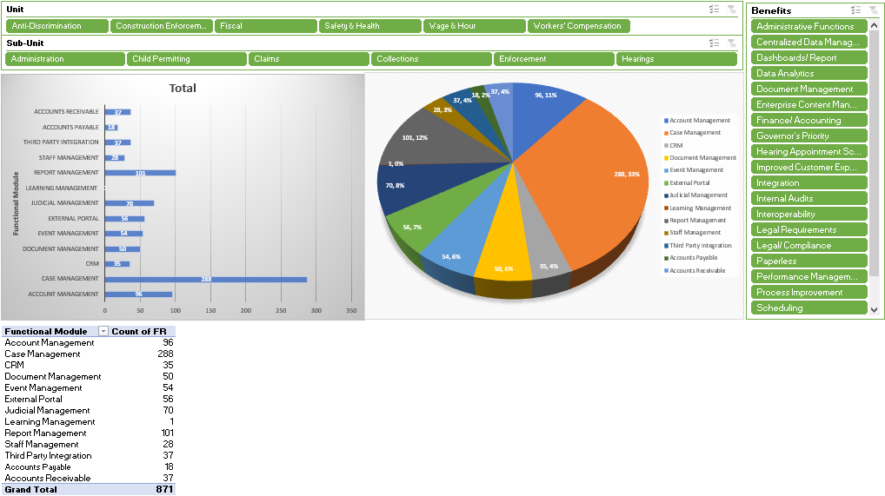
Figure 3: DIA Modernization Functional Requirements SRS Dashboard

As a result of the thirteen (13) functional modules identified by the administrators, the most needed core cross-functional modules for modernization across the division are:
- Case Management
- Report Management
- Account Management
- Judicial Management
- Document Management

5.02 DIA’s Objectives

DIA’s objective is to transform its current siloed operational processes with a central cloud-based enterprise solution that can support the units’ core functional requirements. The desired end-state is to replace the two (2) legacy applications: SCARS and OLLEA with a centralized intelligent low code no code cloud-based SaaS solution (Refer to Figure 4 DIA Saas Business Model Concept). In addition to facilitating integration with the previously mentioned shared services ( Table 1: DIA's Modernization Shared Services) leveraging modernization efforts across the division, department, and state.
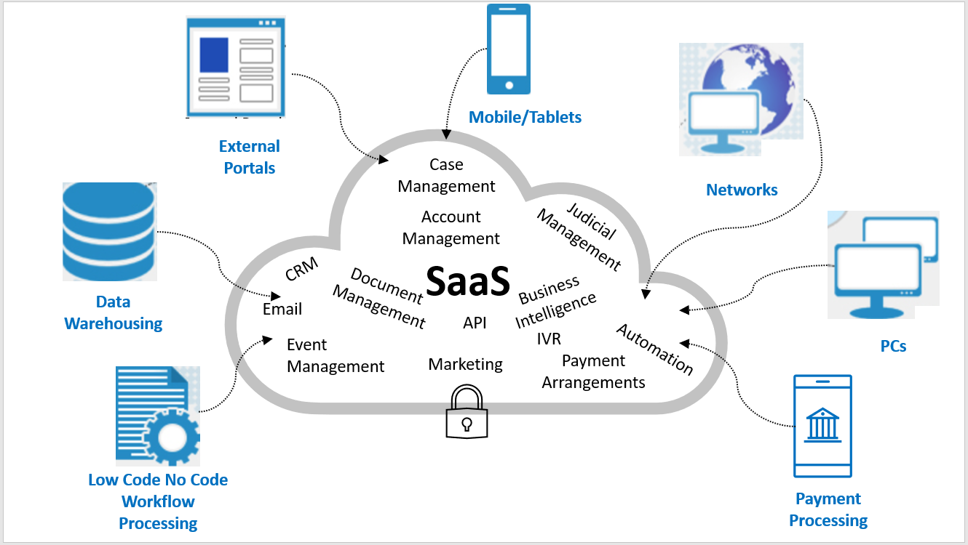
Figure 4 DIA Saas Business Model Concept
As a result, the following benefits can be realized:

- 100% Paperless Environment – satisfies DOL objective.
- Multi-Tenant Efficiency – promotes transparency and interoperability among the division’s units. Administrators share software the same computing resources, while keeping data and logic separate and secure.
- Improved Service Delivery – promotes rich user experience and self-service for external users.
- Accessibility anywhere via web – empowers LLEO to conduct onsite investigations more efficiently.
- Supports state initiatives - such as Governor’s Priority, DIDS, GoDE, and DTI Shared Services.
- Improved strategic enforcement – facilitates data sharing with outside agencies as well as, provides valuable insights through business intelligence and analytics.
- Enhanced operational visibility – through powerful data visualization tools such as dynamic user dashboards and multi-data source reporting capability.

6.0 DIA Project Requirements

The proceeding sections list each of the divisions functional requirements that elaborate on DIA’s SaaS Business Model Concept (Figure 4 ). To facilitate the prioritization of modernization efforts, each unit’s functional requirements have been segmented into six (6) subunits:

There is a total of 966 project functional requirement needs that vendors must provide their solution’ capability of supporting for DIA. Each unit’s requirements are included as questionnaires in the Bonfire requested documents (Refer to section 9.01 Requested Information of the RFP for submission instructions). Vendor responses will facilitate the due diligence of the division selecting a SaaS solution that best meets the program/ project objectives.

6.01 Wage & Hour Functional Requirements

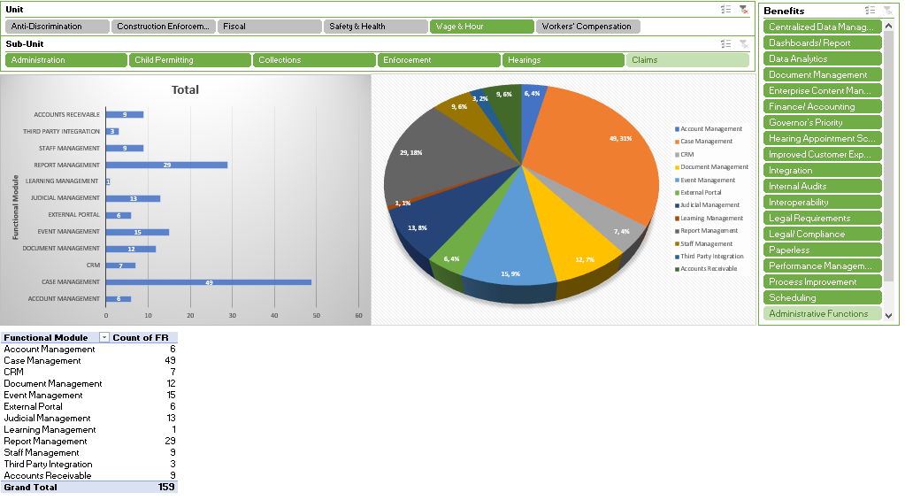

Sub-unit: Administration

 | Requirements
Case Management
1.1.1 | The system must be able to provide Case closure Age by Officer/Office
1.1.2 | The system must be able to provide Case listing by Officer/total
1.1.3 | The system must be able to provide Case open age by Officer/Office
1.1.4 | The system must be able to provide Collections by officer /total
1.1.5 | The system must allow supervisors full access to all user transactions in the core solution and all other users access to their own transactions.
1.1.6 | The system must be able to capture and report on appeals from determinations of the Secretary filed for a case record.
CRM
1.2.1 | The system must be able to integrate Emails Rec’d into case records
1.2.2 | The system must be able to integrate Incoming Calls into case records
1.2.3 | The system must be able to integrate Faxes Rec’d into case records
1.2.4 | The system must be able to provide various engagement channels, such as social media, email campaigns, online forums, and physical events to reach a wider audience.
1.2.5 | The system must be able to streamline multiple channels of engagement into a single platform.
1.2.6 | The system must be able to track click-through rates (CTR) on unit websites for tracking external users search patterns
1.2.7 | The system must provide IVR interfaces with case management system to track call volume, talk time, referrals, resolutions, etc.
Document Management
1.3.1 | The system must allow metadata search capabilities
1.3.2 | The system must allow for version control and simultaneous document editing.
1.3.3 | The system must provide storage for electronics documents, including videos, text, audio clips, and scanned documents
1.3.4 | The system must provide structured digital storage that allows for easy search and retrieval.
1.3.5 | The system must provide secure centralized solution that can grant granular document or folder access to users as necessary
1.3.6 | The system must enable users to fulfill auditors' requests promptly and accurately with powerful search capabilities, audit trails, and comprehensive reports on system activity.
1.3.7 | The system must facilitate FOIA requests with a self-service, automated portal to increase constituent satisfaction.
Event Management
1.4.1 | The system must be able to generate a report for Outreach
1.4.2 | The system must be able to calculate Community Participation Rate (= (Number of Community Participants/ Total Community Population) x 100)
1.4.3 | The system must be able to provide customer satisfaction scores through survey-based ratings after outreach events.
1.4.4 | The system must be able to provide demographic data analytics to assist with strategic community outreach.
1.4.5 | The system must be able to track number of partnerships established with local organizations
1.4.6 | The system must be able to track resource allocation used to conduct outreach events
1.4.7 | The system must be able to track Retention rate of outreach events (the percentage of members who join the community and return within a given period)
1.4.8 | The system must be able to capture the total number of attendees for outreach events.
1.4.9 | The system must be able to provide a total of outreach events based on case type.
1.4.10 | The system must be able to capture the total number of attendees for outreach events.
1.4.11 | The system must be able to provide a total of outreach events based on case type.
1.4.12 | The system must be able to calculate total number of awareness surveys by location and county.
1.4.13 | The system must be able to provide an Event Management module to enter distribution of educational material.
1.4.14 | The system must provide an external portal to capture stakeholder feedback.
External Portal
1.5.1 | The system must provide for an external portal that facilitates FOIA requests to be received and submissions sent from proposed solution to portal Inbox accompanied with automated notifications informing requesters.
1.5.2 | The system shall provide e-signature capability for all e-forms that require a signature and the ability to allow the document to be sent to multiple parties as needed i.e. DocuSign
1.5.3 | The system shall provide external users access to all units forms as an auto-filled form accessible via an external portal.
1.5.4 | The system must allow users to register though a secure portal to access account information.
1.5.5 | The system must provide an external portal FOR EMPLOYERS to upload DOCUMENTS and automatically associate with an existing casefile
Report Management
1.6.1 | The system must be able to generate Ad-hoc and canned reports with filtering capabilities accessing all case management fields.
1.6.2 | The system must be able to produce case aging reports.
1.6.3 | The system must enable filter/ data slicing functionality that supports reporting on all data fields entered into the case management solution.
1.6.4 | The system must contain all reports in the legacy application inclusive of improvement modifications as required by the respective unit.
1.6.5 | The system must allow reports on all Case Types.
1.6.6 | The system must allow admin user(s) to report on new case types to accommodate legislative mandates to business rules
Staff Management
1.7.1 | The system must provide Staff Management for employee performance management and evaluation
1.7.2 | The system must provide Staff Management for employee performance management and evaluation
1.7.3 | The system must provide Staff Management for employee performance management and evaluation
1.7.4 | The system must provide Staff Management for employee performance management and evaluation
1.7.5 | The system must be able to GENERATE a report for Individual On-Site Inspection Goals
1.7.6 | The system must provide Staff Management for employee performance management and evaluation
1.7.7 | The system must provide Staff Management for employee performance management and evaluation
1.7.8 | The system must provide Staff Management for employee performance management and evaluation
1.7.9 | The system must provide Staff Management for employee performance management and evaluation

Sub-unit: Child Permitting

 | Requirements
Case Management
2.1.1 | The system must be able to automatically route completed Work Permits to Issuing Officer to be Authorized
2.1.2 | The system must be able to provide Work Permits (E)Mailed
2.1.3 | The system must be able to track Theatrical Exemptions
2.1.4 | The system must be able to provide Resolved cases
2.1.5 | The system must be able to prohibit employment in hazardous occupations by providing a list of NAIC codes and job descriptions for minors to select via an external portal.
2.1.6 | The system must be able to automatically notify officers and supervisors when a limited theatrical permit has reached its limited term.
2.1.7 | The system must be able to automatically notify officers and supervisors when a minor has reached 18 years of age and allow users to archive the permit.
External Portal
2.2.1 | The system must be able to provide automated workflow processes for work permits via an external portal.
Report Management
2.3.1 | The system must be able to report on Work Permits Denied
2.3.2 | The system must be able to provide a report/calendar of scheduled Issuing Officer Training
2.3.3 | The system must be able to report on Work Permits Received
2.3.4 | The system must be able to provide a report on Invalid Work Permits
2.3.5 | The system must be able to provide a report on Theatrical Exemption Permits
Learning Management
2.4.1 | The system must be able to track Issuing Officers Trained (for WH officers)

Sub-unit: Enforcement

 | Requirements
Case Management
3.1.1 | The system must provide administrators with a complete list of all intakes and associated notes by Officer.
3.1.2 | The system must be able to provide Number of Inspections
3.1.3 | The system must be able to capture and track Child Labor Violation
3.1.4 | The system must be able to provide Resolved cases
3.1.5 | The system must be able to filter Cases by officer
3.1.6 | The system must be able to provide Onsite Inspections
3.1.7 | The system must be able to automatically track INTAKES for wage claims and inspections.
3.1.8 | The system must automatically track OPEN cases and automatically notify cases over 30 Days for Wage Claim, 90 Days for Inspection
3.1.9 | The system must provide integration with other DIA units and other DOL divisions to investigate employer and/ or employee OPEN cases
3.1.10 | The system must provide interoperability between other units and agencies to send referrals observed during an investigation to other units/ agencies.
3.1.11 | The system must be able to provide Cases by Business Name
3.1.12 | The system must be able to provide Payment plans for assessed penalties
3.1.13 | The system must allow for all data to be searched and filtered
3.1.14 | The system must allow for the capture of demographic information for employees and employers within the state of Delaware.
3.1.15 | The system must be able to process Theatrical Exemption Permits
3.1.16 | The system must allow officers to generate reports for number of possible violations from other division units and other state agency data.
3.1.17 | The system must allow for investigators to schedule their inspections.
3.1.18 | The system must provide a case management system that facilitates claimant and DOL vs. searches and returns all relevant records pertaining to that claimant such as wages paid.
3.1.19 | The system must allow letter templates to be attached to case records
3.1.20 | The system must be able to change an Intake into a Case prior to receiving employer checks
3.1.21 | The system must be able to provide Payment plans for assessed penalties
3.1.22 | The system must be able to associate NAIC codes with businesses
3.1.23 | The system must be able to provide Fines assessed
3.1.24 | The system must allow investigators to create an Intake with the following Request Type: Create Intake, Close Intake, Halt Intake, and Delete Intake
3.1.25 | The system should allow for deficiencies to Cases such as Total Owed, Total Collected, and Gross Wage Owed.
3.1.26 | The system must be able to automatically track payment agreements, payment schedules, and send notification on due dates.
3.1.27 | The system must be able to associate NAIC codes with businesses
3.1.28 | The system must be able to capture Contact information with history trail
3.1.29 | The system must allow enforcement officers to use tablets to enter investigative findings into proposed solution while performing onsite visits.
3.1.30 | The system must allow enforcement officers to obtain electronic signatures while performing onsite visits.
3.1.31 | The system must be able to send notifications when responses to citations and notification of penalties are going to expire
3.1.32 | The system must provide IVR interfaces with case management system to track call volume, talk time, referrals, resolutions, etc.
3.1.33 | The system must be able to allow Field Unit Officers to schedule and track hearing STATUS.
3.1.34 | The system must be able to change an Intake into a Case prior to receiving contractor payments
3.1.35 | The system must allow investigators to create an Intake with the following Request Type: Create Intake, Close Intake, Halt Intake, and Delete Intake
3.1.36 | The system must allow for investigators to schedule their inspections.
Document Management
3.2.1 | The system must be able to track age of citations and notification of penalty based on legal response time
3.2.2 | The system must allow letter templates to be updated, deleted, and added
3.2.3 | The system must be able to track age of letter templates SENT OUT based on legal response time
3.2.4 | The system must be able to send EMPLOYER notifications when responses to Preliminary and Final Determinations are going to expire
3.2.5 | The system must be able to track age of citations and notification of penalty based on legal response time.
Event Management
3.3.1 | The system must provide the ability for a unit to create outreach campaigns/ engagements, schedule events, and generate analytical reports by county.
Report Management
3.4.1 | The system must allow for reporting of total number of inspections performed within respective unit by officer, county, and employer/contractor.
3.4.2 | The system must validate Employer data by UI source data FEIN integration to ensure accurate and consistent data for reporting on compliance rate post inspection.
3.4.3 | The system must validate Employer data by UI source data FEIN integration to ensure accurate and consistent data for reporting on case status OPENED.
3.4.4 | The system must validate Employer data by UI source data FEIN integration to ensure accurate and consistent data for reporting on case status CLOSED.
3.4.5 | The system must validate Employer data by UI source data FEIN integration to ensure accurate and consistent data for reporting on case status HALTED.
3.4.6 | The system must validate Employer data by UI source data FEIN integration to ensure accurate and consistent data for reporting on reoffender rate under the Compliance rate.
3.4.7 | The system must be able to generate a report for Case Type
3.4.8 | The system must be able to generate a report for Wage Theft
3.4.9 | The system must be able to generate a report for Administrative Closure
3.4.10 | The system must be able to generate a report for Case Listing
3.4.11 | The system must be able to provide Supervisor a report for total number of CLOSED cases with Case Age for specified unit by officer and county.
3.4.12 | The system must be able to generate a report for Average Days to Closure
3.4.13 | The system must have the ability to generate demographic reports and various analytics related to claimants age, gender, ethnicity, educational background, state geographic location with zip code, employment status, NAIC code, length of employment, occupation, and language.
3.4.14 | The system must allow for reporting of total number of inspections performed within respective unit by officer, county, and employer/contractor.
3.4.15 | The system must allow officers to generate reports for number of possible violations from other division units and other state agency data.
3.4.16 | The system must provide report capability for all CASE TYPES by Assigned Officer, county, employer, CASE NUMBER, Case Count, Case Description.
3.4.17 | The system must be able to GENERATE a report filtered by Date Range with Case Type (# of Cases), Officer, Case #, Description, Penalty Assessed, and Penalty Collected. (Include Totals for Assessed and Collected).
Account Management
3.5.1 | The system must be able to maintain and generate a report for Fines assessed
3.5.2 | The system must be able to maintain Payment plans for assessed penalties
3.5.3 | The system must be able to generate a report for Collections by Investigator
3.5.4 | The system must allow administrators/ investigators to enter and generate reports for total wages from claims.
Third Party Integration
3.6.1 | The system must be able to INTEGRATE with ONESTOP to facilitate investigative work.
3.6.2 | The system must INTEGRATE with UI Employer source data.
3.6.3 | The system must facilitate interoperability to investigate compliance with all applicable labor laws, including laws governing income tax withholding, unemployment insurance, wage laws, and workers' compensation

Sub-unit: Collections

 | Requirements
Report Management
4.1.1 | The system must be able to generate reports for Collections by Employer
Account Management
4.2.1 | The system must be able to send notification to contractors before settlement payments are due. Number of days that notification is sent is set by user.
4.2.2 | The system must be able to send notification to contractors before settlement payments are due. Number of days that notification is sent is set by user.
Accounts Receivable
4.3.1 | The system must be able to capture and generate reports for Collected civil penalties
4.3.2 | The system must be able to capture and generate reports Collected wages
4.3.3 | The system must allow investigators/ administrators to enter and generate reports for settlement amounts and settlement payments received by the specific unit.
4.3.4 | The system must allow investigators/ administrators to capture and generate reports for settlement payments received.
4.3.5 | The system must be able to calculate number of days before settlement payments are due.
4.3.6 | The system must allow investigators/ administrators to enter collected civil penalties received by the specific unit.
4.3.7 | The system must provide the ability to generate collections report based on type and status (Open, Closed, Halt) by unit and investigator for each county.
4.3.8 | The system must be able to generate reports for # of Employers who agreed to pay amount due in full
4.3.9 | The system must be able to generate reports for Collections by Employer

Sub-unit: Hearings

 | Requirements
Judicial Management
5.1.1 | The system must allow enforcement officers to report on cases entered in the case management module referred to attorney general
5.1.2 | The system must be able to generate a report for # of hearings scheduled
5.1.3 | The system must have Judicial case management module included in core solution to facilitate litigation status tracking throughout case lifecycle while maintaining original case number.
5.1.4 | The system must have Judicial case management module included in core solution to facilitate litigation status tracking throughout case lifecycle while maintaining original case number.
5.1.5 | The system must have Judicial case management module included in core solution to facilitate litigation status tracking throughout case lifecycle while maintaining original case number.
5.1.6 | The system must be able to schedule and track hearing STATUS.
5.1.7 | The system must be able to track issued subpoenas calculating the response time before automatically sending notice to prepare a case summary.
5.1.8 | The system must be able to send EMPLOYER notifications when responses to Preliminary and Final Determinations are going to expire
5.1.9 | The system must be able to provide an external portal for requesting hearing and / or appeal with the Secretary.
5.1.10 | The system must be able to edit hearing scheduled including info such as Hearing Date, Start Time, End Time, Hearing Room, Location, Hearing Type, Hearing Comments, etc.
5.1.11 | The system must provide a list of OPEN cases
5.1.12 | The system must provide a list of CLOSED cases
5.1.13 | The system must provide a list of PENDING cases

6.02 Workers Compensation Functional Requirements

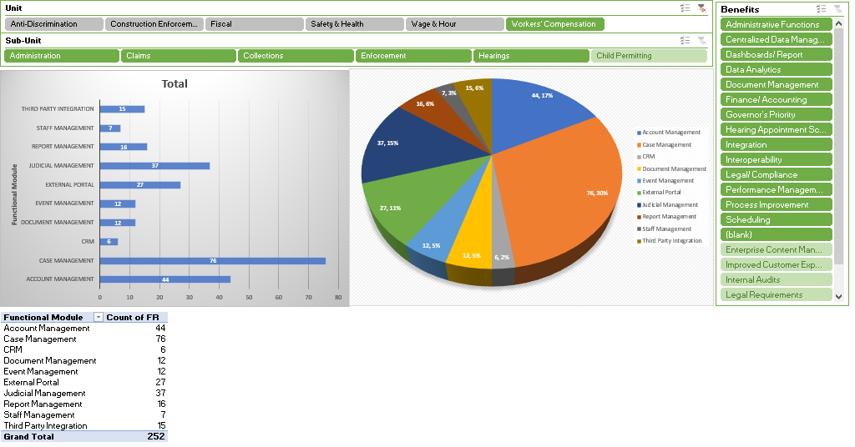

Sub-unit: Administration

 | Requirements
Account Management
1.1.1 | The system must be able to perform check processing within the core solution.
1.1.2 | The system must be able to apply payments to the appropriate fund account.
1.1.3 | The system must provide fund ledger that keeps track of payments made to uninsured claimants.
1.1.4 | The system must automate and calculate average wages for Temporary Partial (TP) payments made to claimants in a core case management solution.
1.1.5 | The system must be able to generate invoices for copy requests.
1.1.6 | The system must be able to calculate assessed taxes based on statement of premium.
1.1.7 | The system must be able to automatically send invoices based on a designated date range.
1.1.8 | The system must allow for OWC to assess special assessments.
1.1.9 | The system must provide a ledger for every carrier and self-insured & claimant
1.1.10 | The system must allow for fund account selection to receive payments.
1.1.11 | The system must generate individual or bulk digital payment coupons by insurance carrier or self-inured that are editable if needed.
1.1.12 | The system must provide a list/ report of RECEIPTs sum total amount of compensation paid by carrier and self-insured employers.
1.1.13 | The system must be able to produce report based on fiscal year or calendar year; 1st, 2nd, 3rd, 4th quarter; past 3mth, 6mth, 1 year, or anytime date range; and summarized by Agreement Type. Report must display amount per line item, case number, agreement date, and grand total.
1.1.14 | The system must provide a list/ report of cases containing RECEIPTs by insurance carrier and self-insured employers. Information included: Begin and End Date, Total Amount, Date of Receipt, Contact Email Comments.
1.1.15 | The system must allow for the capture of demographic information for opened and closed claimant cases, as well as insurance carriers and self-insured employers within Delaware state.
1.1.16 | The system must be able to calculate disability payments based on average wages and amounts to be paid as per statute 2302 & 2324
1.1.17 | The system must automatically calculate the Admin. expense integrating with PHRST & FFS.
Case Management
1.2.1 | The system must be able to integrate DCRB data for Worker's Compensation rates for the residual market data to be imported into core case management solution without manual entry.
1.2.2 | The system must be able to integrate DCRB Lost Costs & Residual Market Rate Excel spreadsheet or CSV formatted by assigned risk manual rate & assigned risk minimum premium into core case management solution without manual entry.
1.2.3 | The system must be able to send automatic reminders of late payments with a specified date range. i.e. 7 days, 15 days 30 days
1.2.4 | The system must be able to send automatic reminders of late filings. i.e. 7 days, 15 days 30 days
1.2.5 | The system after 30 days needs the ability to send a standard non-compliance message.
1.2.6 | The system needs to be able to have an override function for late filings and non-compliance
1.2.7 | The system must be able to provide the capability for carriers to update their contact/profile information automatically with an audit trail
1.2.8 | The system must be able to allow for the entry of New Providers and send automatically to OneStop (all new qualified Workers’ Comp. Carriers)
1.2.9 | The system must maintain a list of employers and/or insurance carriers who are contracted with OWC for Utilization Review.
1.2.10 | The system must be able to automatically forward UR request decisions electronically to the claimant, the claimant’s attorney of record, the health care provider in question, and the employer or its insurance carrier.
1.2.11 | The system must capture and generate reports for awards mailed.
1.2.12 | The system must be able to automatically list and generate a report of total number of employees covered by new policies.
1.2.13 | The system must be able to automatically flag employers or insurance carriers whose CERTIFICATION of COMPLIANCE with Workers’ Compensation Utilization Management Standards or Health Utilization Management Standards of Utilization Review Accreditation Council (“URAC”) has expired.
1.2.14 | The system must be able to automatically notify employers or insurance carriers whose CERTIFICATION of COMPLIANCE with URAC has expired.
1.2.15 | The system must provide a list/ report of petitions filed including File Date, Case Number, Claimant, Status, and Transaction ID.
1.2.16 | The system must be able to send mass email by type to Self-insured or Carriers.
1.2.17 | The system must be able to Print case file labels.
1.2.18 | The system must be able to provide a staging module for review and approval of online petitions SUBMITTED with required fields being populated correctly.
1.2.19 | The system must provide a list of online copy requests within the core solution.
1.2.20 | The system must provide an external facing portal for claimants, insurance carriers, medical providers, and employers to upload requested documentation.
1.2.21 | The system must be able to automatically provide total number of petitions, copy requests, pretrial memos, awards filing, scans, task list and agreement & receipts by admin specialist.
1.2.22 | The system must be able in the core solution to display CASE HEADER info including Case Number w/ status, Case Caption, Insurance Carrier, # of Agreements and Receipts, Open/Total Petitions, Attorneys, claimant selects Pro Se or not (checkbox), Claimant Address, Date of Injury, Casefile Open (enforcement) and Fiscal Status.
1.2.23 | The system must allow for the creation to file New FRIs, flagging duplicates, provide history of all modifications
1.2.24 | The system must allow for all data to be searched and filtered
1.2.25 | The system must allow the creation of new FRIs if the case is not a duplicate by providing an Override button
1.2.26 | The system must be able to send automated notification sent to claimants, insurance carriers, self-insured employers, and attorneys for requested documentation.
1.2.27 | The system must be able to receive claims submitted via an external portal to a repository awaiting approval within the proposed solution.
1.2.28 | The system must be able to assign access rights & roles for internal employees, view, & edits
1.2.29 | The system must be able to download IAIABC body parts
1.2.30 | The system must be able to download IAIABC nature of injury
1.2.31 | The system must enable adjusters/adjuster firms to be adjusted, added, or deleted
1.2.32 | The system must have a help button
1.2.33 | The system must be able to Add email permission button to profile page to email documents to claimant &/or attorney on file
1.2.34 | The system must be able to during manual receipt processing, activate or deactivate 3-day rule, so it calculates correctly.
1.2.35 | The system must have consistent pay periods (checklist, receipts, calculator) for through & including the end date listed.
1.2.36 | The system must allow an internal note update section not visible to external portal users
1.2.37 | The system must have the ability to use a print function on document section
1.2.38 | The system must be able to Drag/drop emails/pdfs, etc. into document/note section
1.2.39 | The system must be able to send Automatic email for electronic filing missing required information
1.2.40 | The system must have the Ability to assign a case file number for DCD without an FRI submitted
1.2.41 | This system must have the ability to modify an attorney without having to link to any document
1.2.42 | The system must have the field (Add) “DATE FILED” on Notice of Hearing and Re-Schedule Notice
1.2.43 | The system must have the Ability to have more than one contact email
1.2.44 | The system should have no limit on number of characters per line
1.2.45 | The system must have Automatic saves during entry
CRM
1.3.1 | The system must be able to provide total number of phone calls handled/ received within the proposed solution.
1.3.2 | The system must be able to provide call tracking metrics.
1.3.3 | The system must be able to provide various engagement channels, such as social media, email campaigns, online forums, and physical events to reach a wider audience.
1.3.4 | The system must be able to streamline multiple channels of engagement into a single platform.
1.3.5 | The system must be able to track click-through rates (CTR) on unit websites for tracking external users search patterns
1.3.6 | The system must provide IVR interfaces with case management system to track call volume, talk time, referrals, resolutions, etc.
Document Management
1.4.1 | The system must be able to generate a report listing letters ASSOCIATED WITH casefiles.
1.4.2 | The system must be able to generate a report listing Miscellaneous Correspondence for cases.
1.4.3 | The system must be able to capture and report on case files with Certified Mail.
1.4.4 | The system must PROVIDE the ability to create, revise, and send letter templates to claimants, attorneys, and insurance carriers individually or bulk email from within the solution such as Certification of Determination.
1.4.5 | The system must allow metadata search capabilities
1.4.6 | The system must allow for version control and simultaneous document editing.
1.4.7 | The system must provide storage for electronics documents, including videos, text, audio clips, and scanned documents
1.4.8 | The system must provide structured digital storage that allows for easy search and retrieval.
1.4.9 | The system must provide secure centralized solution that can grant granular document or folder access to users as necessary
1.4.10 | The system must enable users to fulfill auditors' requests promptly and accurately with powerful search capabilities, audit trails, and comprehensive reports on system activity.
1.4.11 | The system must facilitate FOIA requests with a self-service, automated portal to increase constituent satisfaction.
Event Management
1.5.1 | The system must be able to calculate Community Participation Rate (= (Number of Community Participants/ Total Community Population) x 100)
1.5.2 | The system must be able to capture the total number of attendees for outreach events.
1.5.3 | The system must be able to provide a total of outreach events based on case type.
1.5.4 | The system must be able to provide customer satisfaction scores through survey-based ratings after outreach events.
1.5.5 | The system must be able to provide demographic data analytics to assist with strategic community outreach.
1.5.6 | The system must be able to track number of partnerships established with local organizations
1.5.7 | The system must be able to track resource allocation used to conduct outreach events
1.5.8 | The system must be able to track Retention rate of outreach events (the percentage of members who join the community and return within a given period)
1.5.9 | The system must provide the ability for a unit to create outreach campaigns/ engagements, schedule events, and generate analytical reports by county.
1.5.10 | The system must be able to calculate total number of awareness surveys by location and county.
1.5.11 | The system must be able to provide an Event Management module to enter distribution of educational material.
1.5.12 | The system must provide an external portal to capture stakeholder feedback.
External Portal
1.6.1 | The system must be able to track medical provider certification submitted via AN EXTERNAL portal.
1.6.2 | The system must be able to provide an external portal for employer or insurance carrier submission of UR requests that are received in the core solution for review.
1.6.3 | The system must be able to provide an external portal for decisions of the utilization review company to be accessible by OWC for submission to employers and insurance carrier.
1.6.4 | The system must facilitate UR decisions to be sent to the claimant, the claimant’s attorney of record, the health care provider portal with SMS notification.
1.6.5 | The system shall provide an external portal that automates all OWC forms to be submitted electronically and entered information accessible in the case management solution for the specific OWC file number/ carrier file number after being reviewed and approved.
1.6.6 | The system shall provide an external portal that automates all OWC filings to be submitted electronically and entered information accessible in the case management solution to be reviewed for approval/ denial within a staging module and assigned a file number once approved.
1.6.7 | The system must be able to provide external users with status update of their submitted forms/filings within an external portal.
1.6.8 | The system must be able to provide external clients reports through a portal ID for existing casefiles with a case number.
1.6.9 | The system must provide an external portal that allows carriers to update their profile, attorney information, and upload documents while maintaining history in the proposed solution.
1.6.10 | The system must have the ability to provide an external portal for insurance carriers and self-insured employers to calculate taxes owed using an automated workflow process which includes mandated percentages that can be updated as needed.
1.6.11 | The system must provide for an external portal that facilitates FOIA requests to be received and submissions sent from proposed solution to portal Inbox accompanied with automated notifications informing requesters.
1.6.12 | The system shall provide e-signature capability for all e-forms that require a signature and the ability to allow the document to be sent to multiple parties as needed i.e. DocuSign
1.6.13 | The system must provide an external portal to claimants and attorneys to upload video and automatically associate with an existing casefile
1.6.14 | The system must allow users to register though a secure portal to access account information.
1.6.15 | The system must have the Ability to have more than one portal user id for filings
Judicial Management
1.7.1 | The system must have the capability to schedule Pretrial Conferences and hearings for petitions and motions and generate reports. Include "out to" dates for scheduling hearings in accordance with the statute (90 days, 120 days 150 days): Block Holidays. IAB days off: Add "date Filed" to Notice of Hearing and Re-Schedule Notices
Report Management
1.8.1 | The system must allow reports on all Case Types.
1.8.2 | The system must allow admin user(s) to report on new case types to accommodate legislative mandates to business rules
1.8.3 | The system must enable filter/ data slicing functionality that supports reporting on all data fields entered into the case management solution.
1.8.4 | The system must be able to generate Ad-hoc and canned reports with filtering capabilities accessing all case management fields.
1.8.5 | The system must contain all reports in the legacy application inclusive of improvement modifications as required by the respective unit.
Staff Management
1.9.1 | The system must be able to capture and report on enforcement officer performance.
1.9.2 | The system must be able to track specialist productivity.
1.9.3 | The system must be able to track Hearing Officer productivity.
1.9.4 | The system must provide Staff Management for employee performance management and evaluation for Admin Staff
1.9.5 | The system must provide Staff Management for employee performance management and evaluation for LLEOs
1.9.6 | The system must provide Staff Management for employee performance management and evaluation for Admin Vacancy
1.9.7 | The system must provide Staff Management for employee performance management and evaluation for LLEO Vacancy
Third Party Integration
1.10.1 | The system must allow integration with banking systems to facilitate direct deposit for fund check to claimants based on payment frequency.
1.10.2 | The system must integrate with Child Support Services to notify OWC of child support deductions to be subtracted from claimant benefits.
1.10.3 | The system must be able to capture COMPLETED Recert Course by employer and/ or insurance carrier every 2 years and certify compliance with OWC Health Utilization Management Standards of Utilization Review Accreditation Council (“URAC”). sufficient to achieve URAC accreditation or submit evidence of accreditation by URAC.
1.10.4 | The system must automatically populate DCRB rates for all payroll classifications.
1.10.5 | The system must be able to Download life expectancy form Us.gov
1.10.6 | The system must calculate Min/max rates entry…could possibly manually configure (compensation rates), Information is provided from OLLME

Sub-unit: Claims

 | Requirements
Account Management
2.1.1 | The system must be able to maintain and display TP benefits paid for a pay period
2.1.2 | The system must be able to automatically schedule TP benefit issued per awards from the TTD.
2.1.3 | The system must provide the amount paid to injured workers for an entered pay period.
2.1.4 | The system must be able to provide a total number of claimants receiving benefits.
2.1.5 | The system must provide an entire checklist award procedure from start to finish.
2.1.6 | The system must be able to list/ report on processed awards BY PETITION TYPE
2.1.7 | The system must provide a report on notice of awards that have been (e)mailed.
2.1.8 | The system must be able to provide an automated ACCOUNT management process with workflow of mandated procedures for determination of eligibility built-in to the solution achieving 100% paperless environment.
2.1.9 | The system must have future capability to load Fund benefits (checks) on a bank card/EBT card (similar)
Case Management
2.2.1 | The system must provide the ability to capture required fund balance info to issue payments.
2.2.2 | The system must be able to provide an external portal for document submission of First Reports of Injury. The larger employers/carriers able to electronically submit bulk FRIs through a file exchange.
2.2.3 | The system must be able to generate report for cases under Review.
2.2.4 | The system must provide a list/ report of approved online FRIs by user or system generated.
2.2.5 | The system must provide users with a list/ report of FRIs by nature of injury.
External Portal
2.3.1 | The system must provide external beneficiary users with a ledger of payments paid by pay period and display next payment date with amount information.
2.3.2 | The system must provide an external portal for claimant ach
2.3.3 | The system must be able to AUTOMATICALLY route Awards by email or to recipients' external portal.
2.3.4 | The system must be able provide an auto filled form with workflow capabilities for cases with Pretrial Memorandum.
Judicial Management
2.4.1 | The system must be able to allow Subpoenas to be sent electronically

Sub-unit: Collections

 | Requirements
Account Management
3.1.1 |  | The system must be able to report on Outstanding reimbursements including negotiated settlements.
3.1.2 |  | The system must provide the ability to have two factor authentication for fund reimbursement from carrier via ACH.
3.1.3 |  | The system must be able to perform carryover allowing balance forward payments and generate invoice with balance.
3.1.4 |  | The system must allow investigators/ administrators to capture and generate reports for settlement payments received.
3.1.5 |  | The system must be able to calculate number of days before settlement payments are due.
3.1.6 |  | The system must be able to send notification to contractors before settlement payments are due. Number of days that notification is sent is set by user.
3.1.7 |  | The system must provide sales ledger with reporting capabilities of all financial transactions received into designated fund accounts.
3.1.8 |  | The system should allow for deficiencies to Cases such as Total Owed, Total Collected, etc.
3.1.9 |  | The system must interface with FSF to auto-populate the core system with the Beginning Balance for the WC fund.
3.1.10 |  | The system must interface with FSF to auto-populate the PROPOSED SOLUTION with the Ending Balance for the WC fund.
3.1.11 |  | The system must be able to generate FY and calendar year report on reimbursements to the fund.
3.1.12 |  | The system must be able capture and report reimbursements to the fund at any given point of time.
3.1.13 |  | The system must be able capture and report on outstanding reimbursements including negotiated settlements.
3.1.14 |  | The system must be able to have the ability to handle overpayments and capture payment arrangements.
3.1.15 |  | The system must be able to perform bank statement reconciliation
External Portal
3.2.1 | The system must allow an external portal that provides insurance carriers with required fields to file their DPL.
3.2.2 | The system must allow an external portal that provides insurance carriers with required fields to file their fiscal statements. i.e statement of premiums
3.2.3 | The system must be able to receive ACH and credit card payments from an external portal where it is notated in the appropriate carrier record.
3.2.4 | The system must provide an external portal that allows self-insured to enter minimum tax and total tax that can calculate 4% premium tax owed into the core case management solution. For three periods
3.2.5 | The system must provide an external portal that allows a firm to add a new payroll classification rate as needed.
3.2.6 | The system must be able to provide users with the ability to setup payment arrangements, pay via credit card, and view balance online through a secure external portal.
Report Management
3.3.1 | The system must provide the ability to generate collections report based on type and status (Open, Closed, Halt) by unit and investigator for each county.

Sub-unit: Enforcement

 | Requirements
Account Management
4.1.1 | The system must be able to send notification to EMPLOYERS before settlement payments are due. Number of days that notification is sent is set by user.
4.1.2 | The system must be able to display fines assessed by investigator with total amount due for each case.
4.1.3 | The system must provide payment plan management capabilities for case files with assessed penalties.
Case Management
4.2.1 | The system must be able to display total number of cases for specified unit.
4.2.2 | The system must be able to display total number of RESOLVED cases for specified unit.
4.2.3 | The system must be able to display Officer View of assigned Open Intakes/Cases, Intakes Post Supervisor Review, Due Items Cases for specified unit.
4.2.4 | The system must be able to display cases by Business Name and filtered by status for specified unit.
4.2.5 | The system must allow Investigators to access case management application on tablets
4.2.6 | The system must be able to create a Case File with a CASE NUMBER when Field Unit opens an investigation. Must be able to schedule any case for a hearing in front of IAB board with the above case number.
4.2.7 | The system must be able to display total number of PENDING cases for specified unit.
4.2.8 | The system must provide integration with other DIA units and other DOL divisions to investigate employer and/ or employee OPEN cases
4.2.9 | The system must provide interoperability between other units and agencies to send referrals observed during an investigation to other units/ agencies.
4.2.10 | The system must allow for investigators to schedule their inspections.
4.2.11 | The system must allow investigators to create an Intake with the following Request Type: Create Intake, Close Intake, and Delete Intake
4.2.12 | The system must allow letter templates to be attached to case records
4.2.13 | The system must be able to change an Intake into a Case prior to receiving employer checks
4.2.14 | The system must be able to display TASK HISTORY for all Intakes and Cases
4.2.15 | The system must be able to allow Field Unit Officers to schedule and track hearing STATUS.
4.2.16 | The system must capture any notes for intakes entered into the solution.
4.2.17 | The system must be able to capture Contact information with history trail
4.2.18 | The system must be able to associate NAIC codes with businesses
4.2.19 | The system must allow for the capture of demographic information for enforcement
4.2.20 | The system must allow enforcement officers to use tablets to enter investigative findings into proposed solution while performing onsite visits.
4.2.21 | The system must allow enforcement officers to obtain electronic signatures while performing onsite visits.
4.2.22 | The system must be able to send notifications TO EMPLOYERS when responses to citations and notification of penalties are going to expire
4.2.23 | The system must be able to track age of citations and notification of penalty based on legal response time
4.2.24 | The system must be able to send notifications when responses to citations and notification of penalties are going to expire.
4.2.25 | The system must provide IVR interfaces with case management system to track call volume, talk time, referrals, resolutions, etc.
4.2.26 | The system must be able to change an Intake into a Case prior to receiving contractor payments
Document Management
4.3.1 | The system must be able to track age of citations and notification of penalty based on legal response time.
Report Management
4.4.1 | The system must allow investigators to select relevant Violation Category from a drop down and generate reports on violations specific to their unit.
4.4.2 | The system must allow for reporting of total number of inspections performed within respective unit by officer, county, and employer/contractor.
4.4.3 | The system must allow officers to generate reports for number of possible violations from other division units and other state agency data.
4.4.4 | The system must provide report capability for all CASE TYPES by Assigned Officer, county, employer, CASE NUMBER, Case Count, Case Description.
4.4.5 | The system must be able to GENERATE a report filtered by Date Range with Case Type (# of Cases), Officer, Case #, Description, Penalty Assessed, and Penalty Collected. (Include Totals for Assessed and Collected).
4.4.6 | The system must be able to provide Supervisor a report for total number of CLOSED cases with Case Age for specified unit by officer and county.
4.4.7 | The system must calculate the number of days that a case has been in OPEN status (<=30, 31-60, 61-90, >90)
4.4.8 | The system must be able to GENERATE a report for Individual On-Site Inspection Goals
4.4.9 | The system must have the ability to generate demographic reports and various analytics related to claimants age, gender, ethnicity, educational background, state geographic location with zip code, employment status, NAIC code, length of employment, occupation, and language.
4.4.10 | The system must be able to produce case aging reports.
Third Party Integration
4.5.1 | The system must INTEGRATE with UI Employer source data.
4.5.2 | The system must be able to INTEGRATE with DCRB employer data source file into proposed case management solution.
4.5.3 | The system must be able to INTEGRATE with Revenue data source file for investigative work.
4.5.4 | The system must be able to INTEGRATE with ONESTOP for investigative work.
4.5.5 | The system must validate Employer data by UI source data FEIN integration to ensure accurate and consistent data for reporting on compliance rate post inspection.
4.5.6 | The system must validate Employer data by UI source data FEIN integration to ensure accurate and consistent data for reporting on case status OPENED.
4.5.7 | The system must validate Employer data by UI source data FEIN integration to ensure accurate and consistent data for reporting on case status CLOSED.
4.5.8 | The system must validate Employer data by UI source data FEIN integration to ensure accurate and consistent data for reporting on case status HALTED.
4.5.9 | The system must validate Employer data by UI source data FEIN integration to ensure accurate and consistent data for reporting on reoffender rate under the Compliance rate.

Sub-unit: Hearings

 | Requirements
External Portal
5.1.1 | The system must be able to upload Deposition Notices, REPORTS, TRANSCRIPTS, ORDERS, and other documents into casefile
5.1.2 | The system must be able to provide any party challenging a URD the ability to file through an external portal.
Judicial Management
5.2.1 | The system must be able to generate reports for cases with Superior Court Appeals.
5.2.2 | The system must be able to generate a report listing Letters of Appearance with current attorney status and maintaining attorney history.
5.2.3 | The system must be able to capture and report on Schedule Industrial Accident Board Calendar. (how many hearings, board member activities, etc.)
5.2.4 | The system must be able to generate a monthly calendar with Board members days off.
5.2.5 | The system must be able to display audit trails for amended petitions.
5.2.6 | The system must be able to publish monthly hearing schedules. Board members and Hearing Officers redacted.
5.2.7 | The system must allow users to access monthly hearing calendars scheduled for board officers/ members and allow entries to be automatically updated, added, and deleted.
5.2.8 | The system must provide a list of OPEN cases
5.2.9 | The system must provide a list of CLOSED cases
5.2.10 | The system must provide a list of PENDING cases
5.2.11 | The system must be able to list/ report on IAB decisions.
5.2.12 | The system must be able to calculate total number of Hearings by Type AND by Board Member OR Hearing Officer: Commutation(15min), Disfigurement (5min), Evid (30min), Legal (15min), Mediation Conf (15 min), Merit (180), Read in Dismissal (15), Read in Term (15 min), Re-argument (15min), Remand (180 min), Stip & Order (15min), Teleconference (15 min) (With the ability for SA to adjust and revise durations and hearing types).
5.2.13 | The system must be able to calculate total number of Continuances including description and relevant fields.
5.2.14 | The system must be able to report on completed case load by Hearing Officer.
5.2.15 | The system must be able to calculate the number of days from hearing to decision by Hearing Officer. The date of award is issued is the date of the decision but if appealed the decision remains open.
5.2.16 | The system must display a list of cases with ONLY hearing officers.
5.2.17 | The system must be able to display PENDING decisions by Hearing Officer.
5.2.18 | The system must be able to display case SUMMARY OF APPEALS.
5.2.19 | The system must be able to report on average list days for cases AWAITING to be scheduled for hearings.
5.2.20 | The system must be able to list total number of pending pretrials.
5.2.21 | The system must be able to capture and report on outcomes of petitions. How many are denied, withdrawn, continued, approved, etc.
5.2.22 | The system must be able to display Pretrial and Hearing Schedule Summary by day, week & month
5.2.23 | The system must be able to edit hearing scheduled including info such as Hearing Date, Start Time, End Time, Hearing Room, Location, Hearing Type, Board Member(s), Hearing Officer, and Hearing Comments.
5.2.24 | The system must be able to Download hearings recordings directly to case management profile page and each case file
5.2.25 | The system must calculate total number of awards by type regardless of Hearing Officer/Board
5.2.26 | The system must be able to flag a case file 5 days prior to hearing date for missing required documentation or report generation.
5.2.27 | The system must flag hearing if on the pretrial memo the need for a translation or sign language person
5.2.28 | The system must have the Ability to choose and display more than one petition that are scheduled for hearing-on-Hearing Notice
5.2.29 | The system must have the option to “cancel” hearing without withdrawing petition.
5.2.30 | The system must be able to send Hearing and Pretrial Cancellation letters to include petition being cancelled.
5.2.31 | The system must be able to: When withdrawing a petition that hasn’t been scheduled for a hearing, the Notice of Cancellation should read the petition has been canceled, not the Pretrial Conference has been canceled.
5.2.32 | The system must have the ability to track Notice of Pretrial and Hearings sent via email
5.2.33 | The system must automatically list Key witnesses follow when hearing is rescheduled/continued. Currently this information must be re-keyed when a hearing is rescheduled.
5.2.34 | The system must have a Report showing all outstanding legal hearing/motions. Sort by alphabet and county
5.2.35 | The system must be able to sort out appealed cases in the disposition stats (days from petition to award) Appealed awards are not to be included in disposition stats. They are completed once award or resolved.
Account Management
5.3.1 | The system must have a calculator to include commutation method

6.03 Construction Enforcement Functional Requirements

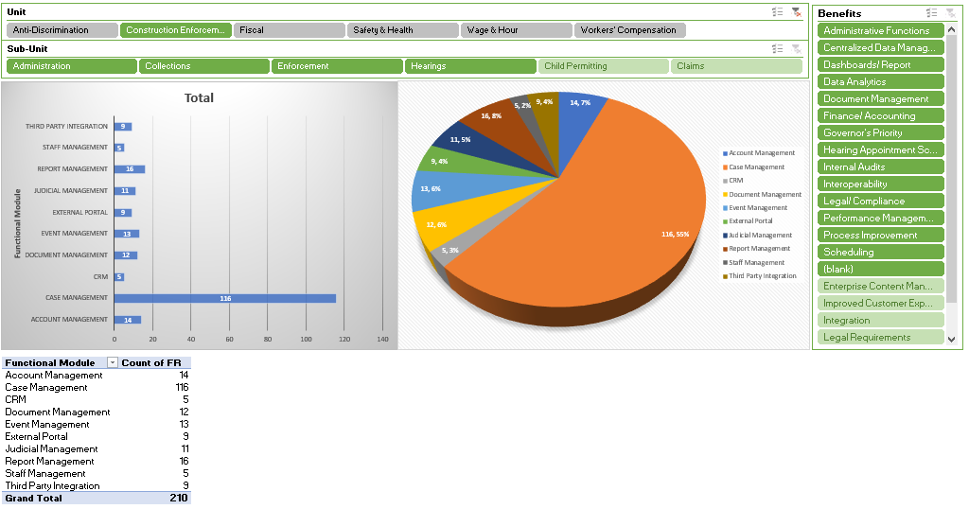

Sub-unit: Administration

 | Requirements
Case Management
1.1.1 | The system must be able to provide Case closure Age by Officer/Type of case (Prevailing Wage, Workplace Fraud Public/Private, Contractor Registration)/Total Case Age
1.1.2 | The system must be able to provide Case listing by Officer/type of case (Prevailing Wage, Workplace Fraud Public/Private, Contractor Registration)/total case listing
1.1.3 | The system must be able to provide Case open age by Officer/type of case (Prevailing Wage, Workplace Fraud Public/Private, Contractor Registration)/Office type of case/Total
1.1.4 | The system must be able to provide Collections by officer/type of case (Prevailing Wage, Workplace Fraud Public/Private, Contractor Registration /total
1.1.5 | The system must be able to provide Construction Category Determination by Officer/type of construction (Heavy, Highway, Building, Multiple or if no rates required)/total by date range
1.1.6 | The system must be able to provide Construction Classification Determination by Officer/by 28 worker classifications type in Booklet/total by date range
1.1.7 | The system must be able to provide Contractor Registration/Prevailing Wage/Workplace Fraud Public/Private/ # of cases halted/by Officer/Office Total
1.1.8 | The system must be able to provide Contractor Registration/Prevailing Wage/Workplace Fraud /Private/# of CLOSED cases/by Officer/Office Total
1.1.9 | The system must be able to provide Contractor Registration/Prevailing Wage/Workplace Fraud /Private/ # of hearings scheduled/by Officer/Office Total
1.1.10 | The system must be able to provide Contractor Registration/Prevailing Wage/Workplace Fraud /Private/ # of OPEN cases/by Officer/Office Total
1.1.11 | The system must be able to provide Contractor Registration/Prevailing Wage/Workplace Fraud /Private/ # of PENDING cases/by Officer/Office Total
1.1.12 | The system must be able to provide Contractor Registration applications Incomplete/ by date range
1.1.13 | The system must be able to provide Contractor Registration applications rejected / by date range
1.1.14 | The system must be able to provide Contractor Registration applications with Resolution needed / by date range
1.1.15 | The system must be able to provide Contractor Registration certificates expired by type/ (Public Work, Private Work, or Both)/date range
1.1.16 | The system must be able to provide Contractor Registration new and renewed certificates Issued (Public Work, Private Work, or Both)/by date range
1.1.17 | The system must be able to provide Contractor Registration Certificates Revoked (Public Work, Private Work, or Both)
1.1.18 | The system must be able to provide Contractor Registration Certificates Suspended (Public Work, Private Work, or Both)
1.1.19 | The system must be able to provide Contractor Registration Active number of certificates (Public Work, Private Work, or Both)
1.1.20 | The system must be able to provide Contractor Registration Number of contractors registered (Public Work, Private Work, or Both)
1.1.21 | The system must be able to provide Contractor Registration renewal Applications Submitted to DDOL (Public Work, Private Work, or Both)
1.1.22 | The system must be able to provide Contractor Registration new Applications Submitted to DDOL (Public Work, Private Work, or Both)
1.1.23 | The system must be able to provide Inspections by Officer/by type (Prevailing Wage, Workplace Fraud Public/Private, Contractor Registration)/by county(New Castle, Kent , Sussex)/total/date range
1.1.24 | The system must be able to provide Number of contractors not registered with a current Delaware Business License on One Stop.
1.1.25 | The system must be able to provide Number of contractors registered (Public Work, Private Work, or Both) by date range
1.1.26 | The system must be able to provide Prevailing Wage Survey Due items process
1.1.27 | The system must be able to provide Prevailing Wage Survey Enter Consumer Price Index
1.1.28 | The system must be able to provide Prevailing Wage Survey Project Entry for survey data both manually by internal users and electronically by external users
1.1.29 | The system must be able to provide Prevailing Wage Survey Rate Calculation to issue Preliminary and Final Determinations of wage rates and reports
1.1.30 | The system must be able to provide Prevailing Wage Survey Review Electronic data
1.1.31 | The system must be able to provide Prevailing Wage Survey Setup survey dates
1.1.32 | The system must be able to provide Prevailing Wage Survey Data and data reports
1.1.33 | The system must be able to provide Prevailing Wage Survey Data Ledger and data report
1.1.34 | The system must be able to provide Prevailing wage Survey project entry data and report
1.1.35 | The system must be able to provide Prevailing Wage Survey Setup
1.1.36 | The system must be able to provide View Prevailing Wage Survey rates from previous year and determine formula for calculation
1.1.37 | The system must be able to provide Workplace fraud (Public/Private), (Prevailing Wage, Contractor Registration) number of possible violations
1.1.38 | The system must provide administrators with a complete list of all intakes/by intake type/ and associated notes by Officer
1.1.39 | The system must allow supervisors full access to all user transactions in the core solution and all other users access to their own transactions.
1.1.40 | The system must be able to display all expired contractor registrations (Public Work, Private Work, or Both) based on a user defined date range.
1.1.41 | The system must be able to automatically send email notification to contractors when their registration is about to expire, and notifications of documents needed
1.1.42 | The system must be able to provide a dashboard of all contractors who were sent an automated notification for expired registration and notifications of documents needed
1.1.43 | The system must be able to maintain history of expired certification numbers for each contractor record.
1.1.44 | The system must be able to capture and report on Private, Public and Both public and Private contractors with certificates
1.1.45 | The system must be able to capture and report on issued registration
1.1.46 | The system must be able to compute contractor or CBA member submitted prevailing wage surveys rates results for each classification by county trade.
1.1.47 | The system must be able to capture and report on Grievances filed for a case record.
1.1.48 | The system must be able to capture and report on appeals from determinations of the Secretary filed for a case record.
1.1.49 | The system must be able to automatically update contractor records with status of their ACH payments from FSF
1.1.50 | The system must be able to report ACH payments that have been retracted.
1.1.51 | The system must be able to extract information from certified payroll reports submitted by employers to view potential violations
1.1.52 | The system must be able to notify contractors when their registration is about to expire (90-, 60- and 30-day notification)
1.1.53 | The system must be able to provide a list of employer violations/case No/date/case type/disposition/wages assessed/wages collected/type of penalty assessed/type of penalty collected/filter by date range
1.1.54 | The system must be able to provide fiscal year collection comparison for wages and penalties collected by Workplace Fraud Public/Private, Prevailing Wage, Contractor Registration/Total/filter by date range
1.1.55 | The system must be able to provide a list of inspections by County/Officer/type of inspection: Workplace Fraud Public/Private/Prevailing Wage/Contractor Registration/Total by Officer/total by office/filter by date range
1.1.56 | The system must be able to track case closure age by Officer/Case type: by Workplace Fraud Public/Private, Prevailing Wage, Contractor Registration/Total/filter by date range
1.1.57 | The system must be able to track case open age by Officer/Case type: by Workplace Fraud Public/Private, Prevailing Wage, Contractor Registration/Total/filter by date range
1.1.58 | The system must be able to track case age individual goals by Officer/Case type: by Workplace Fraud Public/Private, Prevailing Wage, Contractor Registration/Total/filter by date range
1.1.59 | The system must allow for office Maintenance for Role Access rights/Role & User rights/Employee User profile;(Internal and External User)
1.1.60 | The system must be able to have Document management to Search by Document type/value/template type/certified payroll /by date range
1.1.61 | The system must allow to search certified payrolls by (employer, employee, project, county, job classification, apprentice ratio, hours worked, fringe benefits)
CRM
1.2.1 | The system must be able to provide various engagement channels, such as social media, email campaigns, online forums, and physical events to reach a wider audience.
1.2.2 | The system must be able to streamline multiple channels of engagement into a single platform.
1.2.3 | The system must be able to track click-through rates (CTR) on unit websites for tracking external users search patterns
1.2.4 | The system must be able to streamline multiple channels of engagement into a single platform.
1.2.5 | The system must provide IVR interfaces with case management system to track call volume, talk time, referrals, resolutions, etc.
Document Management
1.3.1 | The system must allow metadata search capabilities
1.3.2 | The system must allow for version control and simultaneous document editing.
1.3.3 | The system must provide storage for electronics documents, including videos, text, audio clips, and scanned documents
1.3.4 | The system must provide structured digital storage that allows for easy search and retrieval.
1.3.5 | The system must provide secure centralized solution that can grant granular document or folder access to users as necessary
1.3.6 | The system must enable users to fulfill auditors' requests promptly and accurately with powerful search capabilities, audit trails, and comprehensive reports on system activity.
1.3.7 | The system must facilitate FOIA requests with a self-service, automated portal to increase constituent satisfaction.
Event Management
1.4.1 | The system must be able to calculate Community Participation Rate (= (Number of Community Participants/ Total Community Population) x 100)
1.4.2 | The system must be able to capture the total number of attendees for outreach events.
1.4.3 | The system must be able to provide a total of outreach events based on case type.
1.4.4 | The system must be able to provide customer satisfaction scores through survey-based ratings after outreach events.
1.4.5 | The system must be able to provide demographic data analytics to assist with strategic community outreach.
1.4.6 | The system must be able to track number of partnerships established with local organizations
1.4.7 | The system must be able to track resource allocation used to conduct outreach events
1.4.8 | The system must be able to track Retention rate of outreach events (the percentage of members who join the community and return within a given period)
1.4.9 | The system must provide the ability for a unit to create outreach campaigns/ engagements, schedule events, and generate analytical reports by county.
1.4.10 | The system must provide the ability for a unit to create outreach campaigns/ engagements, schedule events, and generate analytical reports by county.
1.4.11 | The system must be able to calculate total number of awareness surveys by location and county.
1.4.12 | The system must be able to provide an Event Management module to enter distribution of educational material.
1.4.13 | The system must provide an external portal to capture stakeholder feedback.
External Portal
1.5.1 | The system must provide a prevailing wage hub to facilitate employers/ contractors to comply with Prevailing Wage laws and protect workers on public sites
1.5.2 | The system must be able to provide an external portal for contractor registration submissions, as well as make payments via credit card.
1.5.3 | The system must be able to provide an external portal where submitters can complete the Certified Payroll Wage Rate Submittal Form through an auto-filled form that enters the submitted information into the respective field in the proposed solution.
1.5.4 | The system must be able to provide contractors with an external portal to submit Prevailing Wage Claims and digitally sign before submission.
1.5.5 | The system must provide for an external portal that facilitates FOIA requests to be received and submissions sent from proposed solution to portal Inbox accompanied with automated notifications informing requesters.
1.5.6 | The system shall provide e-signature capability for all e-forms that require a signature and the ability to allow the document to be sent to multiple parties as needed i.e. DocuSign.
1.5.7 | The system shall provide external users access to all units forms as an auto-filled form accessible via an external portal.
1.5.8 | The system must allow users to register though a secure portal to access account information.
1.5.9 | The system must provide an external portal FOR CONTRACTORS to upload DOCUMENTS and automatically associate with an existing casefile
Report Management
1.6.1 | The system must be able to generate Ad-hoc and canned reports with filtering capabilities accessing all case management fields.
1.6.2 | The system must be able to produce case aging reports.
1.6.3 | The system must contain all reports in the legacy application inclusive of improvement modifications as required by the respective unit.
1.6.4 | The system must allow reports on all Case Types/Prevailing Wage, Workplace Fraud Public/Private, Contractor Registration)
1.6.5 | The system must allow admin user(s) to report on new case types to accommodate legislative mandates to business rules
Staff Management
1.7.1 | The system must provide Staff Management for employee performance management and evaluation for Admin Staff
1.7.2 | The system must provide Staff Management for employee performance management and evaluation for LLEOs
1.7.3 | The system must provide Staff Management for employee performance management and evaluation for Admin Vacancy
1.7.4 | The system must provide Staff Management for employee performance management and evaluation for LLEO Vacancy
1.7.5 | The system must be able to GENERATE a report for Individual On-Site Inspection Goals/by Officer/by county (NCC, Kent or Sussex/type of inspection (Prevailing Wage, Workplace Fraud Public/Private/Contractor Registration
Account Management
1.8.1 | The system must allow to viewing of fiscal transaction history by Account (General Fund, Enforcement Account/Wage Claim Account, and transaction (account receivable/accounts payable/fund transfer/account reconciliation/ledger

Sub-unit: Collections

 | Requirements
Account Management
2.1.1 | The system must be able to send notification to contractors before settlement payments are due. Number of days that notification is sent is set by end-user.
2.1.2 | The system must allow investigators/ administrators to generate reports for Prevailing Wage collected wages/penalties.
2.1.3 | The system must provide the ability to capture and generate reports for Workplace fraud collected wages/penalties
2.1.4 | The system must provide the ability to capture and generate reports for Contractor Registration collected wages/penalties
2.1.5 | The system must allow investigators/ administrators to capture and generate reports for Prevailing Wage collected civil penalties received by the specific unit.
2.1.6 | The system must allow investigators/ administrators to capture and generate reports for Contractor Registration collected civil penalties received by the specific unit.
2.1.7 | The system must provide the ability to capture and generate a report for Workplace fraud (Public/Private) collected civil penalties
2.1.8 | The system must allow investigators/ administrators to capture and generate reports for settlement payments received/ by case type/(Prevailing Wage, Workplace Fraud Public/Private, Contractor Registration)
2.1.9 | The system must be able to calculate number of days before settlement payments are due. (Prevailing Wage, Workplace Fraud Public/Private, Contractor Registration)
2.1.10 | The system must be able to capture and generate reports for Contractor Registration Penalties collected for unregistered contractors or contractors with sub-contractors sent to General Fund
2.1.11 | The system must be able to capture and generate reports for (Contractor Registration, Workplace Fraud Public/Private, Prevailing Wage) Penalties collected sent to General Fund
2.1.12 | The system must be able to capture and generate reports for Contractor Registration fees collected for contractors by New or Renewal sent to the Enforcement Account
2.1.13 | The system must be able to automatically track payment agreements, payment schedules, and send notification on due dates/by case type/ (Contractor Registration, Workplace Fraud Public/Private, Prevailing Wage)
2.1.14 | The system must be able to send notification to contractors before settlement payments are due. Number of days that notification is sent is set by user by case type/(Contractor Registration, Workplace Fraud Public/Private, Prevailing Wage)
Report Management
2.2.1 | The system must be able to generate reports for Contractor Registration # of Employers who agreed to pay amount due in full
2.2.2 | The system must be able to generate reports for Contractor Registration # of Employers who agreed to pay amount due with a payment agreement/defined payment schedule
2.2.3 | The system must be able to generate reports for Collections by Contractor (Contractor Registration, Workplace Fraud Public/Private, Prevailing Wage)
Third Party Integration
2.3.1 | The system must be able to generate reports for Contractor Registration Referred to Unemployment Insurance Outstanding balance >$5,000.00 with an outstanding judgement

Sub-unit: Enforcement

 | Requirements
Case Management
3.1.1 | The system must allow for the capture of demographic information
3.1.2 | The system must allow for all data to be searched and filtered
3.1.3 | The system must validate Employer data by UI source data FEIN integration to ensure accurate and consistent data for reporting on Prevailing Wage case status OPENED.
3.1.4 | The system must validate Employer data by UI source data FEIN integration to ensure accurate and consistent data for reporting on Prevailing Wage case status CLOSED.
3.1.5 | The system must validate Employer data by UI source data FEIN integration to ensure accurate and consistent data for reporting on Prevailing Wage case status HALTED.
3.1.6 | The system must be able to CALCULATE the average age of Prevailing Wage/ Workplace Fraud Public/Private and Contractor Registration CLOSED cases.
3.1.7 | The system must be able to CALCULATE the average age of Prevailing Wage / Workplace Fraud Public/Private and Contractor Registration OPEN cases.
3.1.8 | The system must validate Employer data by UI source data FEIN integration to ensure accurate and consistent data for reporting on Prevailing Wage/ Workplace Fraud Public/Private and Contractor Registration case status PENDING.
3.1.9 | The system must allow for reporting of total number of Prevailing Wage INSPECTIONS performed within respective unit by officer, county, and employer/contractor.
3.1.10 | The system must be able to assess number of Prevailing Wage/ Workplace Fraud Public/Private and Contractor Registration violations.
3.1.11 | The system must allow for reporting of total number of Prevailing Wage / Workplace Fraud Public/Private and Contractor Registration /VISITS performed within respective unit by officer, county, and employer/contractor.
3.1.12 | The system must validate Employer data by UI source data FEIN integration to ensure accurate and consistent data for reporting on Workplace fraud case status OPENED.
3.1.13 | The system must validate Employer data by UI source data FEIN integration to ensure accurate and consistent data for reporting on Workplace fraud case status CLOSED.
3.1.14 | The system must validate Employer data by UI source data FEIN integration to ensure accurate and consistent data for reporting on case status HALTED.
3.1.15 | The system must validate Employer data by UI source data FEIN integration to ensure accurate and consistent data for reporting on Workplace fraud case status PENDING.
3.1.16 | The system must allow for reporting Workplace fraud Public/Private/Prevailing Wage, Contractor Registration/number of Inspections/ by county
3.1.17 | The system must allow for investigators to schedule their inspections/by project/by county/by date
3.1.18 | The system must allow investigators to create an Intake with the following Request Type: Create Intake, Close Intake, Halt Intake, and Delete Intake
3.1.19 | The system must allow letter templates to be attached to case records
3.1.20 | The system must be able to change an Intake into a Case prior to receiving contractor payments
3.1.21 | The system must be able to display TASK HISTORY and a AUDIT TRAIL for all Intakes and Cases
3.1.22 | The system must be able to allow Field Unit Officers to schedule and track hearing STATUS.
3.1.23 | The system must capture and track any notes for intakes/ cases entered into the solution.
3.1.24 | The system must provide IVR interfaces with case management system to track call volume, talk time, referrals, resolutions, etc.
3.1.25 | The system should allow for deficiencies notated onto Cases such as Total Owed, Total Collected, and Gross Wage Owed.
3.1.26 | The system must automatically track Case Resolution Time Workplace Fraud Public/Private/Prevailing Wage, Contractor Registration/
3.1.27 | The system must be able to interface with Employment and Training Rapids solution to pull apprentices % level of pay information for Certified Payroll TO VERIFY if they are being paid properly.
3.1.28 | The system must be able to send CONTRACTOR notifications when responses to letter templates are going to expire due to Office
3.1.29 | The system must be able to associate NAIC codes with businesses
3.1.30 | The system must be able to capture Contact information with history trail
3.1.31 | The system must be able to capture and report on # of OPEN cases: Workplace fraud Public/Private/Prevailing Wage, Contractor Registration
3.1.32 | The system must be able to capture and report on # of CLOSED cases: Workplace fraud Public/Private/Prevailing Wage, Contractor Registration
3.1.33 | The system must be able to capture and report on # of HALTED cases: Workplace fraud Public/Private/Prevailing Wage, Contractor Registration/
3.1.34 | The system must be able to capture and report on # of PENDING cases: Workplace fraud Public/Private/Prevailing Wage, Contractor Registration/
3.1.35 | The system must be able to match contractors from Employment and Training Rapids application with contractors in the proposed solution and notate which ones participate in the Apprenticeship Investment Program.
3.1.36 | The system must be able to schedule and track hearing STATUS. Workplace fraud Public/Private/Prevailing Wage, Contractor Registration
3.1.37 | The system must allow enforcement officers to use tablets to enter investigative findings into proposed solution while performing onsite visits.
3.1.38 | The system must allow enforcement officers to obtain electronic signatures while performing onsite visits.
3.1.39 | The system must provide the ability to capture public work projects and track prevailing wage violations, certified payroll, and contractor registration status.
3.1.40 | The system must be able to flag submitted certified payroll that does not meet the current prevailing wage rates for the county that the work is being performed.
3.1.41 | The system must be able to send notifications when responses to citations and notification of penalties are due to Office
3.1.42 | The system must be able to search cases by Case No./Officer/Case type: by Workplace Fraud Public/Private, Prevailing Wage, Contractor Registration/Intake type: Onsite inspection/status/ Employer/county/filter by date range
3.1.43 | The system must be able to search intakes by Intake No./Officer/Intake type: Prevailing Wage, Workplace Fraud, Contractor Registration inspection, Category/Classification Determination/complaint/status/ Employer/county/filter by date range
3.1.44 | The system must be able to Search projects by Project Name/Contract Number/County/Status/Employer/filter by date range
3.1.45 | The system must allow to enter Intakes by Intake Type (Prevailing Wage/Workplace Fraud Private/Public, Contractor Registration Inspection/Inspection date/Employer Information
3.1.46 | The system must allow input of employer checks received for wages owed/penalties owed and entered by check #/Check date/Date check received/gross check amount/net check amount/date paid/Claimant paid/Date sent to fiscal/case type (Prevailing Wage, Workplace Fraud, Contractor Registration/ account sent to (general Fund/Wage claim/enforcement Account/void check/release signed.
3.1.47 | The system must allow input of deficiency information to be entered by violation code/ claimant/deficiency type;(Prevailing wage, Workplace Fraud public/private, contractor registration)/weekending/hours/rate paid/rate applicable/fringe amount/fringe detail/total owed to claimant
3.1.48 | The system must allow input of civil/administrative penalties assessed and/or adjusted/settlement amount/judgement amount/by violation category
3.1.49 | The system must allow input of Violation codes/ violation code detail/disposition codes/comments/claimants detail information/employer detail information
3.1.50 | The system must allow to attach documents/case notes/email threads
3.1.51 | The system must allow to view, edit case type/case status history/Officer case load
3.1.52 | The system must have Officers view of all open intake/case number/caption of case name/case age/scope
3.1.53 | The system must have Supervisor view of all open intake/case number/caption of case name/case age/scope
Document Management
3.2.1 | The system must allow letter templates to be updated, deleted, and added
3.2.2 | The system must be able to track age of letter templates SENT OUT based on legal response time
3.2.3 | The system must be able to send CONTRACTOR notifications when responses to Preliminary and Final Determinations are going to expire
3.2.4 | The system must be able to track age of citations and notification of penalty based on legal response time: Workplace fraud Public/Private/Prevailing Wage, Contractor Registration/
3.2.5 | The system must be able to track age of citations and notification of penalty based on legal response time: Workplace fraud Public/Private/Prevailing Wage, Contractor Registration/
Report Management
3.3.1 | The system must calculate the number of days Workplace fraud Public/private and Contractor Registration average age of closed cases
3.3.2 | The system must enable filter/ data slicing functionality that supports reporting on all data fields entered into the case management solution.
3.3.3 | The system must calculate the number of days that a case has been in OPEN status (<=30, 31-60, 61-90, 90-120,120-150,150-180, 180-210,210-24, >240)
3.3.4 | The system must have the ability to generate demographic reports and various analytics related to claimants age, gender, ethnicity, educational background, state geographic location with zip code, employment status, NAIC code, length of employment, occupation, and language.
3.3.5 | The system must allow for reporting of total number of inspections performed within respective unit by officer, county, and employer/contractor.
3.3.6 | The system must allow officers to generate reports for number of possible violations from other division units and other state agency data.
3.3.7 | The system must provide report capability for all CASE TYPES by Assigned Officer, county, employer, CASE NUMBER, Case Count, Case Description: Workplace fraud Public/Private/Prevailing Wage, Contractor Registration/
3.3.8 | The system must be able to GENERATE a report filtered by Date Range with Case Type ( # of Cases), Officer, Case #, Description, Penalty Assessed, and Penalty Collected. (Include Totals for Assessed and Collected).
Third Party Integration
3.4.1 | The system must enable Contractor Registration Referred to the Office of Safety and Health
3.4.2 | The system must REPORT Contractor Registration # of Employers referred to Unemployment with no State Unemployment Account Number for additional investigation
3.4.3 | The system must be able to INTEGRATE with ONESTOP to facilitate investigative work.
3.4.4 | The system must be able to integrate with the Department of Revenue to share information concerning any suspected failure to properly classify an individual as an employee.
3.4.5 | The system must be able to integrate with the Office of the Attorney General to share information concerning any suspected failure to properly classify an individual as an employee.
3.4.6 | The system must be able to integrate with the Office of Workers' Compensation to share information concerning any suspected failure to properly classify an individual as an employee.
3.4.7 | The system must be able to integrate with the Department of Insurance to share information concerning any suspected failure to properly classify an individual as an employee.
3.4.8 | The system must INTEGRATE with UI Employer source data.

Sub-unit: Hearings

 | Requirements
Judicial Management
4.1.1 | The system must provide a report on number of Prevailing Wage hearings scheduled and update case records with hearing status entered into a judicial management module.
4.1.2 | The system must allow cases entered in the case management module referred to attorney general
4.1.3 | The system must provide hearing scheduling and internal metrics for tracking purposes.
4.1.4 | The system must be able to track issued subpoenas calculating the response time before automatically sending notice to prepare a case summary.
4.1.5 | The system must be able to allow Field Unit Officers to schedule and track hearing STATUS.
4.1.6 | The system must be able to edit hearing scheduled including info such as Hearing Date, Start Time, End Time, Hearing Room, Location, Hearing Type, Hearing Comments, etc.
4.1.7 | The system must be able to provide an external portal for requesting hearing and / or appeal with the Secretary.
4.1.8 | The system must be able to send EMPLOYER notifications when responses to Preliminary and Final Determinations are going to expire
4.1.9 | The system must provide a list of OPEN cases/by case type/Officer/total/date range
4.1.10 | The system must provide a list of CLOSED cases/by case type/Officer/total/date range
4.1.11 | The system must provide a list of HALTED cases/by case type/Officer/total/date range
4.1.12 | The system must provide a list of PENDING cases/by case type/Officer/total/date range

6.04 Safety & Health Functional Requirements

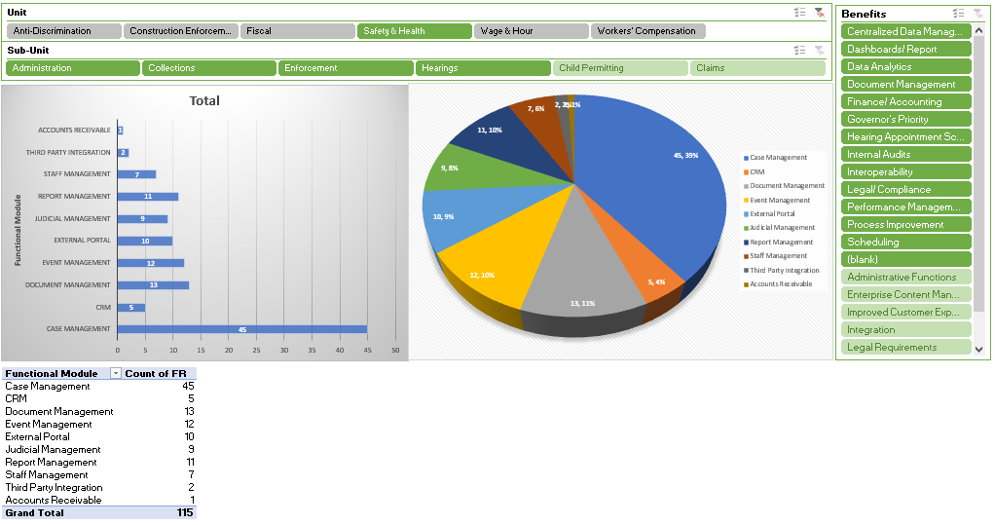

Sub-unit: Administration

 | Requirements
Case Management
1.1.1 | The system must be able to capture Employee Participation in Opening Conference
1.1.2 | The system must be able to capture Employee Participation in Walkthrough
1.1.3 | The system must be able to capture Employee Participation in Closing Conference
1.1.4 | The system must be able to capture Contact information with history trail
1.1.5 | The system must be able to capture if a business is private or public ownership
1.1.6 | The system must allow for all data to be searched and filtered
1.1.7 | The system must allow supervisors full access to all user transactions in the core solution and all other users access to their own transactions.
1.1.8 | The system must provide administrators with a complete list of all intakes and associated notes by Officer.
1.1.9 | The system must be able to capture and report on appeals from determinations of the Secretary filed for a case record.
1.1.10 | The system must be able to restrict access to confidential information in case files by user or user group (i.e., only Safety & Health can view certain things)
1.1.11 | The system must be able to associate identifiers with activities (i.e., visits) that are generated via an outside system.
1.1.12 | The system must be able to capture and incorporate ratings of customer satisfaction surveys for consultation visits
CRM
1.2.1 | The system must INTEGRATE with social media platforms to facilitate outreach planning.
1.2.2 | The system must be able to provide various engagement channels, such as social media, email campaigns, online forums, and physical events to reach a wider audience.
1.2.3 | The system must be able to streamline multiple channels of engagement into a single platform.
1.2.4 | The system must be able to track click-through rates (CTR) on unit websites for tracking external users search patterns
1.2.5 | The system must provide IVR interfaces with case management system to track call volume, talk time, referrals, resolutions, etc.
Document Management
1.3.1 | The system must allow metadata search capabilities
1.3.2 | The system must allow for version control and simultaneous document editing.
1.3.3 | The system must provide storage for electronics documents, including videos, text, audio clips, and scanned documents
1.3.4 | The system must provide structured digital storage that allows for easy search and retrieval.
1.3.5 | The system must provide secure centralized solution that can grant granular document or folder access to users as necessary
1.3.6 | The system must enable users to fulfill auditors' requests promptly and accurately with powerful search capabilities, audit trails, and comprehensive reports on system activity.
1.3.7 | The system must facilitate FOIA requests with a self-service, automated portal to increase constituent satisfaction.
Event Management
1.4.1 | The system must be able to calculate Community Participation Rate (= (Number of Community Participants/ Total Community Population) x 100)
1.4.2 | The system must be able to capture the total number of attendees for outreach events.
1.4.3 | The system must be able to provide a total of outreach events based on case type.
1.4.4 | The system must be able to provide customer satisfaction scores through survey-based ratings after outreach events.
1.4.5 | The system must be able to provide demographic data analytics to assist with strategic community outreach.
1.4.6 | The system must be able to track number of partnerships established with local organizations
1.4.7 | The system must be able to track resource allocation used to conduct outreach events
1.4.8 | The system must be able to track Retention rate of outreach events (the percentage of members who join the community and return within a given period)
1.4.9 | The system must provide the ability for a unit to create outreach campaigns/ engagements, schedule events, and generate analytical reports by county.
1.4.10 | The system must provide an external portal to capture stakeholder feedback.
1.4.11 | The system must be able to calculate total number of awareness surveys by location and county.
1.4.12 | The system must be able to provide an Event Management module to enter distribution of educational material.
External Portal
1.5.1 | The system must be able to provide an external portal for scheduling an informal consultation.
1.5.2 | The system must provide for an external portal that facilitates FOIA requests to be received and submissions sent from proposed solution to portal Inbox accompanied with automated notifications informing requesters.
1.5.3 | The system shall provide e-signature capability for all e-forms that require a signature and the ability to allow the document to be sent to multiple parties as needed i.e. DocuSign
1.5.4 | The system shall provide external users access to all units forms as an auto-filled form accessible via an external portal.
1.5.5 | The system must allow users to register though a secure portal to access account information.
1.5.6 | The system must provide an external portal FOR EMPLOYERS to upload DOCUMENTS and automatically associate with an existing casefile
1.5.7 | The system must be able to disseminate between activity types for employers and provide different options to different employers.
1.5.8 | The system must ensure security of documents submitted to be at least as secure as that of an email.
Judicial Management
1.6.1 | The system must be able to report on average list days for cases AWAITING to be scheduled for hearings.
Report Management
1.7.1 | The system must be able to generate Ad-hoc and canned reports with filtering capabilities accessing all case management fields.
1.7.2 | The system must be able to produce case aging reports.
1.7.3 | The system must allow reports on all Case Types.
1.7.4 | The system must allow admin user(s) to report on new case types to accommodate legislative mandates to business rules
Staff Management
1.8.1 | The system must provide Staff Management for employee performance management and evaluation for Admin Staff
1.8.2 | The system must provide Staff Management for employee performance management and evaluation for LLEOs
1.8.3 | The system must provide Staff Management for employee performance management and evaluation for consultants
1.8.4 | The system must provide Staff Management for employee performance management and evaluation for Admin Vacancy
1.8.5 | The system must provide Staff Management for employee performance management and evaluation for LLEO Vacancy
1.8.6 | The system must provide Staff Management for employee performance management and evaluation for consultant Vacancy
1.8.7 | The system must be able to GENERATE a report for Individual On-Site Inspection Goals

Sub-unit: Collections

 | Requirements
Report Management
2.1.1 | The system must allow investigators/ administrators to capture and generate reports for settlement payments received.
2.1.2 | The system must be able to generate reports for Collections by Employer

Sub-unit: Enforcement

 | Requirements
Case Management
3.1.1 | The system must be able to capture Planned Inspections
3.1.2 | The system must be able to capture scheduled consultation in the proposed solution.
3.1.3 | The system must be able to capture Inspections as a result of a complaint
3.1.4 | The system must be able to provide a dropdown and auto populate OSHA Standard Regulations for General Industry, Construction, Agriculture, Maritime, and Recordkeeping when a case is created.
3.1.5 | The system must be able to capture Inspections as a result of a injury and illness
3.1.6 | The system must be able to associate the number of employees on-site for an establishment.
3.1.7 | The system must be able to associate the number of employees company wide.
3.1.8 | The system must be able to associate NAIC codes with businesses
3.1.9 | The system must be able to capture Posting Requirements
3.1.10 | The system must be able to track age of citations and notification of penalty based on legal response time
3.1.11 | The system must be able to capture Failure to Abate
3.1.12 | The system must be able to capture Number of Inspections
3.1.13 | The system must be able to capture Willful
3.1.14 | The system must be able to capture Number of possible violations
3.1.15 | The system must be able to capture Repeated
3.1.16 | The system must be able to capture Investigations of fatalities with interoperability with OWC
3.1.17 | The system must be able to capture # of referrals
3.1.18 | The system must be able to capture Type of Hazards Identified
3.1.19 | The system must be able to capture Collected civil penalties
3.1.20 | The system must be able to capture Imminent Danger
3.1.21 | The system must be able to capture Serious
3.1.22 | The system must be able to capture Other-Than-Serious
3.1.23 | The system must be able to capture Regularity
3.1.24 | The system must be able to capture # of OPEN cases
3.1.25 | The system must be able to capture # of CLOSED cases
3.1.26 | The system must be able to capture # of PENDING cases
3.1.27 | The system must allow enforcement officers to use tablets to enter investigative findings into proposed solution.
3.1.28 | The system must allow enforcement officers to obtain electronic signatures while performing onsite visits.
3.1.29 | The system must be able to change an Intake into a Case prior to receiving contractor payments
3.1.30 | The system must allow investigators to create an Intake with the following Request Type: Create Intake, Close Intake, Halt Intake, and Delete Intake
3.1.31 | The system must allow for investigators to schedule their inspections.
3.1.32 | The system must allow for the capture of demographic information for employees and employers within the state of Delaware.
3.1.33 | The system must provide IVR interfaces with case management system to track call volume, talk time, referrals, resolutions, etc.
Document Management
3.2.1 | The system must be able to track age of citations and notification of penalty based on legal response time
3.2.2 | The system must allow letter templates to be updated, deleted, and added
3.2.3 | The system must be able to track age of letter templates SENT OUT based on legal response time
3.2.4 | The system must be able to send EMPLOYER notifications when responses to Preliminary and Final Determinations are going to expire
3.2.5 | The system must be able to send EMPLOYER notifications when responses to Preliminary and Final Determinations are going to expire
3.2.6 | The system must be able to track age of citations and notification of penalty based on legal response time.
External Portal
3.3.1 | The system must be able to send notifications when responses to citations and notification of penalties are going to expire
3.3.2 | The system must validate Employer data by UI source data FEIN integration to ensure accurate and consistent data for reporting.
Judicial Management
3.4.1 | The system must be able to schedule and track hearing STATUS.
Report Management
3.5.1 | The system must have the ability to generate demographic reports and various analytics related to claimants age, gender, ethnicity, educational background, state geographic location with zip code, employment status, NAIC code, length of employment, occupation, and language.
3.5.2 | The system must allow for reporting of total number of inspections performed within respective unit by officer, county, and employer/contractor.
3.5.3 | The system must allow officers to generate reports for number of possible violations from other division units and other state agency data.
3.5.4 | The system must provide report capability for all CASE TYPES by Assigned Officer, county, employer, CASE NUMBER, Case Count, Case Description.
3.5.5 | The system must be able to GENERATE a report filtered by Date Range with Case Type (# of Cases), Officer, Case #, Description, Penalty Assessed, and Penalty Collected. (Include Totals for Assessed and Collected).
Third Party Integration
3.6.1 | The system must INTEGRATE with UI Employer source data.
3.6.2 | The system must facilitate interoperability to investigate compliance with all applicable labor laws, including laws governing income tax withholding, unemployment insurance, wage laws, and workers' compensation
Accounts Receivable
3.7.1 | The system must be able to capture fines assessed from issued penalties.

Sub-unit: Hearings

 | Requirements
Judicial Management
4.1.1 | The system must be able to capture # of hearings scheduled
4.1.2 | The system must be able to edit hearing scheduled including info such as Hearing Date, Start Time, End Time, Hearing Room, Location, Hearing Type, Hearing Comments, etc.
4.1.3 | The system must be able to send EMPLOYER notifications when responses to Preliminary and Final Determinations are going to expire
4.1.4 | The system must be able to provide an external portal for requesting hearing and / or appeal with the Secretary.
4.1.5 | The system must provide a list of OPEN cases
4.1.6 | The system must provide a list of CLOSED cases
4.1.7 | The system must provide a list of PENDING cases

6.05 Anti-Discrimination Functional Requirements

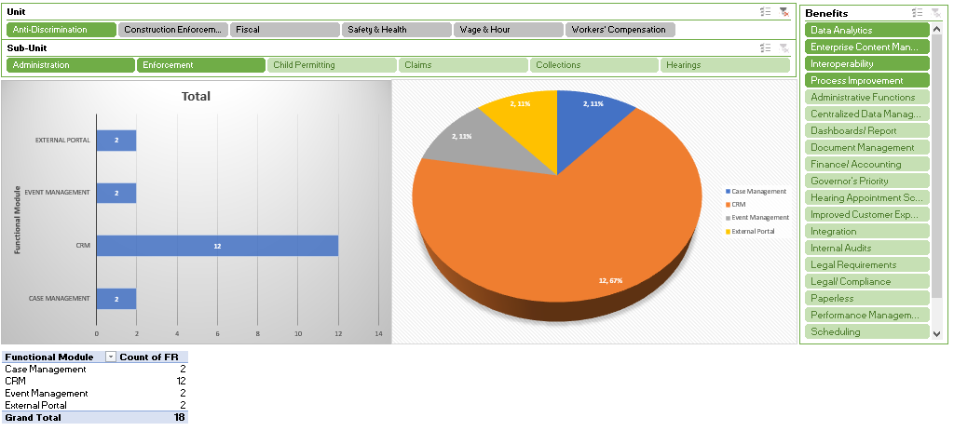

Sub-unit: Enforcement

 | Requirements
Case Management
1.1.1 | The system must allow for investigation of businesses with all IA related cases
1.1.2 | The system must provide IVR interfaces with case management system to track call volume, talk time, referrals, resolutions, etc.

Sub-unit: Administration

 | Requirements
CRM
2.1.1 | The system must be able to provide various engagement channels, such as social media, email campaigns, online forums, and physical events to reach a wider audience.
2.1.2 | The system must be able to streamline multiple channels of engagement into a single platform.
2.1.3 | The system must be able to provide # Referrals (Incoming)
2.1.4 | The system must be able to provide Calls that are referred to other units/ agencies
2.1.5 | The system must be able to provide Volume of calls received
2.1.6 | The system must be able to provide Volume of outbound calls
2.1.7 | The system must be able to TRACK Intake packets sent out (email, walk-ins)
2.1.8 | The system must be able to provide Volume of emails recd. by type
2.1.9 | The system must be able to allow uploaded documents to be dragged and dropped into ARC.
2.1.10 | The system must allow for USPS tracking number to be scanned into CRM and provide a link for tracking.
2.1.11 | The system must allow OAD Notices to be sent to a external user portal and send automated SMS notification.
2.1.12 | The system must provide an interface to The Division of Corporations to facilitate search for registered agent name.
Event Management
2.2.1 | The system must be able to track resource allocation used to conduct outreach events
2.2.2 | The system must be able to track number of partnerships established with local organizations
External Portal
2.3.1 | The system must be able to receive fillable e-forms through an external portal and received in a CRM.
2.3.2 | The system must be able to provide external users that login via a portal with status of filed charges

6.06 Fiscal Functional Requirements

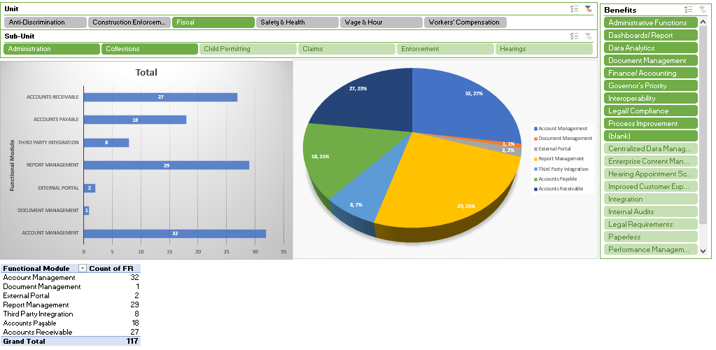

Sub-unit: Administration

 | Requirements
Account Management
1.1.1 | The system must be able to provide Checklist summary for bi-weekly checks issued
1.1.2 | The system must be able to provide TSI/SISB Claimant List
1.1.3 | The system must provide financial management and accounting information across IA units
1.1.4 | The system must provide budgetary results at the summary and detail level
1.1.5 | The system must provide the capability to maintain and monitor expenditures against funding sources to ensure balances do not go into a negative condition as required by Delaware Code
1.1.6 | The system must maintain transactional receipts of State monies in a manner established by OMB.
1.1.7 | The system must provide record retention established by the Delaware Public Archives (DPA) ensuring that records are readily available, adequately protected, legally acceptable, auditable, and evidential.
1.1.8 | The system must provide automated risk alerts when budget for each fund reaches user determined minimum amount.
1.1.9 | The system must provide internal controls that assist with providing results through effective stewardship of public resources, promoting accuracy and reliability of accounting data, and encourages compliance with State policies and procedures.
1.1.10 | The system must provide activities management to assess the quality overtime and promptly resolve the findings of audits and other reviews.
1.1.11 | The system must provide automated business rules for obtaining electronic signatures for authorizing transactions.
1.1.12 | The system must provide a review and authorization workflow process prior to and during processing of transactions due for payment for goods/services.
1.1.13 | The system must provide capabilities to receive refunds from employees or vendors that credits the appropriation from which the monies were expended.
1.1.14 | The system must provide the capability of associating documents such as invoices, purchase orders, etc. to specific transactions that reflect activity for a particular appropriation and automatically upload into FSF.
Accounts Payable
1.2.1 | The system must be able to provide Report to generate on-demand checks
1.2.2 | The system must be able to provide Generate Positive Pay file to upload to M & T
Report Management
1.3.1 | The system must be able to REPORT Contractor Paper Applications Checks
1.3.2 | The system must be able to provide Contractor registration renewal discount report
1.3.3 | The system must provide a consolidated report of total receipts by unit
1.3.4 | The system must provide a report on all account receivables to be submitted to the Department of Finance (DOF) in compliance with the GAAP report package.
1.3.5 | The system must provide the capability to generate projection reports for authorizers to ensure anticipated expenditures will not exceed appropriated balances.
Third Party Integration
1.4.1 | The system must be able to provide an interface with FSF source data into the proposed solution with needed financial data such as detail of receipts, details of appropriations and balances in all IA fund accounts.
1.4.2 | The system must be able to interface with FSF and Velocity source systems to proposed solution to facilitate e-signing and submitting of the FSF Reconciliation Certification Form (Form DOA001)
1.4.3 | The system must be able to facilitate ACH payments for claimant benefit payments
1.4.4 | The system must interface with M&T Bank and import bank statement data into proposed solution to provide automated real-time reconciliation updates of financial data.

Subunit: Collections

 |  | Requirements
Account Management
2.1.1 | The system must be able to provide View history of past Admin Assessment period
2.1.2 | The system must be able to provide Record Direct Paid Loss
2.1.3 | The system must be able to provide collections for Workers Comp Fines and Penalties
2.1.4 | The system must be able to provide Cash collection summary of payments received/applied to account
2.1.5 | The system must be able to provide FUND Balance (beginning/end)
2.1.6 | The system must be able to verify check status on checks that were issued
2.1.7 | The system must be able to Reconcile bank statement to FUND
2.1.8 | The system must be able to Reconcile bank statement to Wage Claim
2.1.9 | The system must be able to provide Admin Assessment Paid/Owed Summary
2.1.10 | The system must be able to provide Direct Paid Losses
2.1.11 | The system must be able to provide Self Insurer Tax Paid/Owed Summary
2.1.12 | The system must be able to provide Special Fund Assessment Paid/Owed Summary
2.1.13 | The system must be able to provide GF collections for Workers Comp Self Insured
2.1.14 | The system must be able to provide GF collections for Wage and Hour and Construction for fines and penalties
2.1.15 | The system must be able to provide Copy Fee Billings/Collections (F-KPI-36 and F-KPI-16)
2.1.16 | The system must be able to provide Ability to identify and report Contractor Registry Fee payments
2.1.17 | The system must be able to provide Ability to identify and report Contractor Registry fine/penalty payments
2.1.18 | The system must be able to provide Wage Claim payments deposited after a year expiration date to transfer from WC to Enforcement Account
Accounts Payable
2.2.1 |  | The system must be able to provide Report to generate wage claim checks
2.2.2 |  | The system must be able to provide Ledger/transaction for Claimants/Case files
2.2.3 |  | The system must be able to provide Ledger/transaction for FUND
2.2.4 |  | The system must be able to provide Ledger/transaction for TSI/SISB (true second injury/ supplemental insurance supplemental benefits)
2.2.5 |  | The system must be able to provide Ledger/transaction for Claimants/Case files (F-KPI-01)
2.2.6 |  | The system must be able to provide Ledger/transaction for FUND F-KPI-03)
2.2.7 |  | The system must be able to provide Ledger/transaction for TSI/SISB (F-KPI-04)
2.2.8 |  | The system must be able to provide Report for Issue FUND payments via ACH
2.2.9 |  | The system must be able to provide Report for Issue FUND payments via paper check
2.2.10 |  | The system must be able to provide Report for Issue Wage Claim payments via ACH
2.2.11 |  | The system must be able to provide Report for Issue Wage Claim payments via paper check
2.2.12 |  | The system must be able to initiate payment coupons for Admin 1%, Assessment, Reimburse fines and penalties for SI fund
2.2.13 |  | The system must be able to separate general fund penalties and fines for individual offices
2.2.14 |  | The system must track payments made to vendors or individuals involved in identified cases to ensure financial accountability and compliance with anti-trafficking protocols.
2.2.15 |  | The system must track payments made to vendors or individuals involved in identified cases to ensure financial accountability and compliance with anti-trafficking protocols.
2.2.16 |  | The system must support processing payments to claimants for wages owed, ensuring accurate tracking and compliance with wage and hour regulations.
Accounts Receivable
2.3.1 |  | The system must be able to provide Ability to receive ACH payments received in FSF/directly apply to account from Carriers for Admin Expense.
2.3.2 |  | The system must be able to provide Ability to notify employers/claimants that a payment was reversed /replacement payment needed
2.3.3 |  | The system must be able to provide Ability to receive ACH payments/directly apply to account from Carriers for Special Fund and received in FSF
2.3.4 |  | The system must be able to provide Ability to receive ACH payments/directly apply to account from Carriers for Self-Ins and received in FSF
2.3.5 |  | The system must be able to provide ability to report special assessments
2.3.6 |  | The system must be able to provide Ability to view/ report on notifications sent to employers for Reversals
2.3.7 |  | The system must be able to report PAYEMENTS received from Collected Fines
2.3.8 |  | The system must be able to report PAYEMENTS received from Collected penalties
2.3.9 |  | The system must be able to report PAYEMENTS received from Collected Wages
2.3.10 |  | The system must be able to provide Copy fee collections (F-KPI-16)
2.3.11 |  | The system must be able to provide Enter cashed check info from outside bank
2.3.12 |  | The system must be able to provide filed direct paid losses
2.3.13 |  | The system must be able to provide filed payroll classification
2.3.14 |  | The system must be able to provide filed statement of premium
2.3.15 |  | The system must be able to provide Issue payment coupons for billing
2.3.16 |  | The system must be able to provide Ledger/transaction for Carriers/Employers (F-KPI-02)
2.3.17 |  | The system must be able to provide Ledger/transaction for Human Labor Trafficking
2.3.18 |  | The system must be able to provide Ledger/transaction for Self-Ins (F-KPI-05)
2.3.19 |  | The system must be able to provide Ledger/transaction for Wage Theft (F-KPI-06)
2.3.20 |  | The system must be able to capture payment of Admin Expense based on DPL
2.3.21 |  | The system must be able to capture payment of assessment based on statement of premium
2.3.22 |  | The system must be able to provide payment of Self-insured to general fund
2.3.23 |  | The system must be able to provide Petty Cash Ledger (F-KPI-11)
2.3.24 |  | The system must be able to provide Report for ACH Velocity payments
2.3.25 |  | The system must be able to provide report for invoices automatically sent
2.3.26 |  | The system must be able to provide Report for retracted ACH payments issued from within
2.3.27 |  | The system must be able to provide Report on Electronically send billing for SI/SB cases
Document Management
2.4.1 |  | The system must be able to Report Carrier profile- document section
External Portal
2.5.1 |  | The system must be able to provide a single external portal to receive all payments for the Division of Industrial Affairs
2.5.2 |  | The system must be able to provide external users with status of ACH payments especially retracted payments.
Report Management
2.6.1 |  | The system must be able to Report on Carrier ledger
2.6.2 |  | The system must be able to Report on capture fund required info to issue payments
2.6.3 |  | The system must be able to Report on entire checklist award procedure from start to finish
2.6.4 |  | The system must be able to Report capability of child support deductions
2.6.5 |  | The system must be able to Report on mass email by type: Self-insured or Carrier
2.6.6 |  | The system must be able to Report for Record of SI/SB payment vouchers
2.6.7 |  | The system must be able to provide ACH report for collections of payments
2.6.8 |  | The system must be able to provide the ability to report on projection of fees for Year 1, Year 2, Year 3 at a discounted rate
2.6.9 |  | The system must be able to provide Report on file payroll classification
2.6.10 |  | The system must be able to provide Report on file direct paid losses
2.6.11 |  | The system must be able to provide Report on file statement of premium
2.6.12 |  | The system must be able to provide Report on FUND claimants who receive ACH payments bi-weekly
2.6.13 |  | The system must be able to provide Report on carryover allowing balance forward payments
2.6.14 |  | The system must be able to provide Report on direct deposit for fund checks to claimant
2.6.15 |  | The system must be able to provide Report on two factor authentication for fund reimbursement from carrier
2.6.16 |  | The system must be able to provide Report account receivable payments-select method
2.6.17 |  | The system must be able to provide Report on external portal for claimant ach
2.6.18 |  | The system must be able to provide Report on automatic reminders of late payments sent
2.6.19 |  | The system must be able to provide Report on automatic reminders of late filings
2.6.20 |  | The system must be able to provide Audit trail report for external carrier updated info
2.6.21 |  | The system must be able to provide Report for digital payment coupons generated
2.6.22 |  | The system must be able to provide Report for ledger for fines collected for uninsured that go into workers’ comp. fund
2.6.23 |  | The system must be able to provide Report on payments to uninsured claimant from fund ledger
2.6.24 |  | The system must be able to provide Report for Admin Assessment
Third Party Integration
2.7.1 |  | The system must be able to integrate with FSF to capture amounts for the Administrative Admin Expense into appropriate fields into proposed solution. In addition, it must perform needed calculations to automatically generate the admin expense report.
2.7.2 |  | The system must be able to integrate with JP Morgan and reflect ACH transactions into the proposed solution.
2.7.3 |  | The system must be able to integrate with Fiserv/Snap Pay API
2.7.4 |  | The system must be able to process all payments via the state's enterprise hosted payment page payements.delaware.gov using Gov DE payment engine

7.0 Proposal Response Schedule
This RFP is issued pursuant to 29 Del. C. §§ 6981 and 6982.
The proposed schedule of events subject to the RFP is outlined below:
Public Notice Date: Wed 1/8/25
Deadline for Questions Date: Thu 1/30/25 3:00pm (EST)
Response to Questions Posted by: Date: Tue 3/18/25
Deadline for Receipt of Proposals Date: Tue 4/8/25 3:00pm (EST)
Estimated Notification of Award Date: Mon 6/30/25
All vendor proposals and requested documentation must be submitted via the DIA Vendor Submission Portal: https://bids.delaware.gov.

7.01 Vendor Response Requirement
The Division of Industrial Affairs (DIA) has partnered with Bonfire Interactive to improve the online bidding process and streamline vendor management. DIA will now join Government Support Services (GSS), the Department of Health and Social Services (DHSS), the Department of Transportation (DelDOT), and the Department of Technology and Information (DTI) in accepting online bid submissions through the Bonfire Interactive portal. In preparation for this RFP there are a few things to keep in mind:

- DIA’s Bonfire Portal can be accessed at https://dia.bonfirehub.com.
- A Bonfire registration affords vendors an additional opportunity to receive email notice(s) when solicitations are available.
- Solicitation documents will be visible in Bonfire just as the documents will remain visible in GSS’ MyMarketplace.
- Vendors will need to register for the Bonfire portal to submit a bid.
- “In-person” bid/proposal submissions will not be accepted.
- Bid advertisements at the Bonfire Portal will indicate a bid submission due date and time as well as a bid opening date and time. These dates/times must be met in order for the submission to be considered responsive.

There is NO COST to register with and/or utilize Bonfire. (Bonfire may offer enhanced registration options but vendors are not obligated to pay or select the enhanced registration options.)

Bonfire resources:

- Bonfire Portal to view DIA opportunities https://dia.bonfirehub.com
- Vendor Registration
- Password Creation Error
- Creating and Uploading a Submission
- Vendor Registration and Submission (Video)

*PLEASE NOTE: Paperwork submissions WILL NOT be required for this solicitation. For more information, please reference 5.2 Vendor Submission.

7.02 Pre-bid Meeting
A mandatory pre-bid meeting has not been established for this RFP.

7.03 Inquiries and Questions
We welcome your interest in working with us, and we will be pleased to answer any questions you may have in formulating your response to this Request for Proposal.

All questions regarding the interpretation of this solicitation, drawings, or specifications, or any other aspect of this RFP must be received in the DIA Vendor Submission Portal https://dia.bonfirehub.com. All questions must make specific reference to the section(s) and page numbers from this RFP where applicable.

8.0 Project Scope of Services

8.01 Plan and Set Up Project
The Awarded Vendor will be responsible for the project planning, setup activities, and work products necessary to establish the project.
Activities include:
- Plan and conduct a project kick-off meeting.
- Conduct a kick-off meeting to introduce Awarded Vendor and DIA staff and provide a common understanding of the project scope and approach with DIA stakeholders.
- Create the agenda and presentation materials. Awarded Vendor will provide draft materials to the DIA Project Manager for approval a minimum of five (5) business days before the meeting. The DIA Project Manager will approve the agenda and presentation materials before the meeting.
- Create meeting minutes to document the meeting. The DIA Project Manager will approve the meeting minutes, and the Awarded Vendor will distribute meeting minutes to all stakeholders.
- The Awarded Vendor will submit a detailed Project Management Plan reflecting all project management processes and controls for the Project. This Project Management Plan describes all aspects of the project and how it will be managed.
- Create a detailed Work Breakdown Structure (“WBS”) and Project Integrated Master Schedule (“IMS”) in collaboration with DIA Project Manager, ensuring that the IMS includes all tasks, deliverables, milestones, dependencies, and identifies a critical path, as well as DIA and Awarded Vendor resources to complete the project.
- Create project organization chart and identify all roles, responsibilities, knowledge, skills, abilities. Also, detail the percent of time and duration for each DIA staff person.
- Create Risks, Assumptions, Issues and Dependencies (RAID) and Lessons Learned processes for collecting lessons learned throughout the project.
- Establish meeting and status report schedules to monitor project progress.

 | Deliverable
1 | Budget Plan
2 | Governance Plan
3 | Organizational Chart
4 | Project Schedule
5 | Communications Plan
6 | Decision Logs
7 | Status Reports
8 | Resource Management Plan
9 | Change Management Plan
10 | Risk Assessment Model
11 | Risk and Issue Management Plan
12 | Monthly Financial Reporting
13 | Product Roadmap: product vision, requirements, strategy, product plan, markers, metrics
14 | Backlog

Acceptance Criteria:
- Project kick-off session is completed, ensuring involvement of all DIA project staff and Awarded Vendor staff. All elements of the Project Management Plan will be reviewed and discussed. An agenda for meetings will be submitted to the DIA Project Manager no less than one (1) business day before the kick-off meeting.
- Project Management Plan is approved, including individual plans for managing issues, risks, change, communication, and quality. The final draft shall be submitted to the DIA Project Team at the kick-off meeting and sent to the DIA Project Manager no more than ten (10) business days after the kick-off meeting.
- Approved draft of the detailed WBS with the project Organizational Chart and Resource Management Plan will be distributed and discussed. The final draft shall be submitted to the DIA Project Team at the kick-off meeting and sent to the DIA Project Manager no more than ten business days after the kick-off meeting.
- Status reporting and meeting schedules are established with processes and templates for capturing and tracking project risk, issues, actions required, decisions, and lessons learned.
- Awarded Vendor will provide a roadmap for their product that covers the contract duration to include their yearly release plan. Problem fixes, enhancements, and other upgrades shall be grouped into scheduled, regular releases of the solution. These releases will undergo unit, system, quality assurance, and user acceptance testing consistent with the methodology described in Section 8.09 Conduct System Testing.

8.02 Manage Requirements
The Awarded Vendor will be responsible for implementing a requirements management process that specifies, documents, and maintains all requirements necessary to configure, customize, and operate the solution as listed in the DIA Vendor Submission Portal Requested Documents section.
The requirements may require further elaboration and decomposition by the Awarded Vendor after entry into the contract. Through the requirements refinement processes, the Awarded Vendor and DIA Project Management Team will establish the final system requirements baseline. Effort to support thorough requirements refinement must be included in the base cost and built into the proposed IMS. DIA Director has final approval over all requirements, and under no circumstances will the Awarded Vendor’s base code set, framework, Commercial Off the Shelf (COTS) product(s), or any technical base proposed by the Awarded Vendor be used to determine finalized requirements unless the DIA leadership approves.
Activities Include:
- Develop a Requirements Management Plan to provide a detailed definition of processes, approaches, and artifacts to finalize requirements and functional needs, define requirements traceability and verification, document requirements, and support changes to requirements as identified by DIA.
- Install and verify base system 4 weeks prior to initiating requirement validation workshops. Provide necessary access to users along with preliminary documentation of the system.
- Host and facilitate requirements validation workshops, using the base system as a guide, to confirm, clarify, and elaborate all requirements and process flows with documented results, encompassing reports, notices, user roles, correspondence, and data elements.
- Create requirements baseline and maintain in a requirements management tool providing access to DIA Project Manager; include traceability from requirements to design, code, and testing. Verify acceptable performance of interfaces / data exchanges, notices, reports, and correspondence.
- Ensure that requirements documentation is distributed to appropriate interested parties identified by DIA Project Manager for validation, schedule walkthroughs, and obtain approval from DIA leadership.
- Set up the Acceptance process for requirements along with DIA Project Manager as requirements evolve during various stages of the contract (including provisional acceptance through iterative development processes).
- Create a requirements traceability matrix and ensure requirements can be traced through RFP, requirements validation, design, technical specifications, code, test, and documentation phases to verify that the system performs as intended.
- Conduct a final walkthrough of requirements documentation for DIA approval.

 | Deliverable | Acceptance Criteria
1 | Requirements Matrix | The Requirements Traceability Matrix must:  - Map requirements from RFP to requirements validation, system detailed design, technical specifications, code, test plans, test cases, and implementation/code artifacts.  - Support valuation at each project phase that all requirements are defined and validated and that all design, test, and code artifacts support.  - Be organized by release, iteration, or phase.  - Be documented and stored in the DIA shared project repository.  - Confirm, clarify, and document all requirements.  - Be formally reviewed and approved by the DIA Project Manager.
2 | Requirements to Business Process Mapping | Conduct workshops with staff members to confirm, clarify, and document all business process requirements. Provide a detailed definition of processes to support effective requirement decisions (solution demonstrations, design/workflow artifacts, etc.). Document and provide electronic copies to the DIA Project Management Team.
3 | Install Base System | Vendor will be required to install their base system into a Test environment prior to starting requirements meetings.

8.03 System Implementation
The Awarded Vendor will be responsible for the definition and documentation of functional and technical design specifications providing a holistic and detailed view of the DIA system based upon the requirements provided by the DIA. Solution designs must include system behaviors, workflows, data, functionality, business rules, and integration architectures. All system components must be documented, including (but not limited to) software, hardware, operating environment, and infrastructure. Solution designs must be traceable to functional and technical requirements.

Activities Include:
- Create a holistic DIA system design document to map all baseline requirements to the proposed solution. The design must specify if each requirement is (a) standard system capability, (b) a configurable option (with a description of the mechanism like configuration table, IoC, etc. and skill level required for configuration changes), or (c) requires custom development. The Awarded Vendor must substantiate core system support of DIA requirements mapped to core system capabilities. Substantiation must be provided through supporting base product specifications or functioning prototypes.
- Include the Use Cases or similar documentation that addresses requirements, including all functional dependencies, user roles, and data elements.
- Detail the provisions of the initial software purchase or subscription, including the user licensing and support along with infrastructure hosting costs if applicable.
- Describe the cost of annual maintenance and what is covered by this plan along with description of the staff roles, skills and lessons learned from prior experience working on similar projects for other states, if applicable.
- Document the vendor's replacement plan for the proposed solution, including any planned replacements, upgrades, or discontinuation of service with prior notification.
- Attest to any current, past, or pending legal challenges or government investigations in which the vendor or proposed solution is involved.

 | Deliverable | Acceptance Criteria
1 | Integrations Design | Document with clear specificity how the solution will provide functionality listed in the requirements; include high-level, logical, and technical level architecture documentation, including system layering, services, infrastructure, and security; include mapping of requirements; specify all software and hardware to include versions, specifications, and interoperability with other software and hardware products required to support the solution.
2 | System Design Documents
3 | Use Case or similar requirements documentation
4 | Software Purchase and Licensing Plan
5 | Annual Maintenance Plan with cost, frequency of patch releases/major releases and plans for replacements, upgrades, or discontinuation of service

DIA is evaluating the adoption of an integrated business model with the primary aim of enhancing data sharing capabilities and standardizing operational procedures. This initiative necessitates a solution encompassing both technology and methodology to facilitate its implementation effectively. Specifically, DIA is actively pursuing a CRM solution that not only aligns with this integrated approach but also fully supports its objectives.

8.04 Assess Infrastructure
The Awarded Vendor will conduct an infrastructure assessment and confirm the hosting location is reliable, secure, and scalable to meet or exceed the expected demands associated with the Awarded Vendor’s solution This assessment must be approved by state representatives prior to signing of the contract. The Awarded Vendor will provide all tools necessary to validate the assessment.
Activities include:
- Conduct infrastructure assessment to ensure Awarded Vendor’s Solution can handle traffic from the following users: employers, employees, healthcare providers, third-party agencies, onsite and remote staff users.

- Prepare an Infrastructure report that documents current performance, identifies any current or expected future issues, and contains actionable recommendations to optimize infrastructure for Awarded Vendor’s solution.

 | Deliverable | Acceptance Criteria
1 | Infrastructure Report | The Report must:  - Support the System Design created in Task 8.03 System Implementation above.  - Include network device hardware and software inventory.  - Include network topology including servers, VPNs, F5, storage etc.  - Report on performance (utilization, errors, downtime, etc.) of network devices and ports.  - Identify any issues and planned remediation

8.05 Configure and Build System
The Awarded Vendor will complete configuration, customization, and development activities for requirements resulting from task 8.02 Manage Requirements above. During the configuration and build phase of the Project, the Awarded Vendor must demonstrate that the requirements are satisfied for testing activities described in task 8.09 Conduct System Testing below.
Activities include:
- Create a Software Development Plan detailing the software configuration and development methodology and processes.
- Develop a Configuration Management Plan associated with the development process and ensure all critical development documents, including but not limited to requirements, design, and code, are maintained under an appropriate level of control.
- Ensure processes and tools are in place to: identify code versions and to rebuild system configurations from source code, manage system changes including change requests, review prioritization and scheduling, ensure that mechanisms are in place to prevent unauthorized changes from being made to the system, and prevent authorized changes from being made to the wrong version.
- Complete all activities necessary to implement the standard system capabilities, configurations, and custom-developed software necessary to create a solution that meets DIA’s requirements.
- Early in the project, demonstrate prototype(s) with staff and stakeholder representatives for feedback on potential changes to incorporate during the development phase.
- Execute unit and functional testing activities and document results as outlined in the Test Plan to demonstrate that entry and exit criteria are satisfied. Validate requirements and test cases through maintaining requirements traceability.

 | Deliverable | Acceptance Criteria
1 | Configuration Management Plan | Ensure that a documented requirements configuration management process is implemented and that no changes are made to baselined requirements (not limited to requirements, design, and code) without performing a risk analysis, re-estimating impacts to cost and schedule, and obtaining stakeholder validation. Processes and tools must be in place to identify code versions and rebuild system configurations from source code. Processes must be in place to manage system changes, including formal logging of requests and scheduling. Mechanisms are in place to prevent unauthorized changes to the system and ensure authorized changes are made to the correct version only. The plan, processes, and templates are documented and stored in DIA’s shared project repository.

8.06 Migrate Data
The Awarded Vendor will complete all activities necessary to migrate all required data and sustain data integrity throughout all project phases.
Activities include:
- Collaborate with Delaware Subject Matter Experts (SMEs) to gather inputs for and create a Data Migration Strategy and Plan.
- If the Bidder proposes a phased implementation, the data migration strategy must include DIA’s existing databases, address data integrity, and describe how data will be shared or bridged between the new and existing databases while both systems are operational.
- Mapping of legacy to target/new data store, migrate data based on the mappings and all relevant transformations, conduct data migration and testing activities, track and correct defects.
- Provide validation and verification scenarios for DIA’s approval, including record count verification.
- Propose a data migration schedule that provides converted data during functional testing activities in coordination with DIA stakeholders.
- Bidders must provide the estimated level of effort DIA is expected to contribute to data migration.
- DIA team will be responsible for defining data retention schedules and completing appropriate/necessary manual data clean-up in the legacy system prior to migration.

 | Deliverable | Acceptance Criteria
1 | Data Conversion / Migration Plan | The Strategy and Plan must include: Initial assumptions for migration, business rules and logic involved in migration, dependencies on other systems and data points, validation requirements, error handling, test conditions, risks/issues log, detailed cutover plan (ETL) rules, data dictionary, default data values, methods for data cleansing and removing duplicates, test conversion and migration process, regular reports of progress and issues, testing and reporting, how and when converted data will be run through all key processes, analyzed for errors and inconsistencies, and tracked until resolved, Awarded Vendor and DIA’s roles & responsibilities, IMS tasks, and data migration tools. At a minimum, Awarded Vendor must demonstrate that they have successfully:  - Conducted all data migration and testing activities.  - Tracked and corrected all defects.  - Verified the migrations.
2 | Data Dictionary | The metadata in the data dictionary includes the following:  - Names of all tables in the database and their owners.  - Names of all indexes and the columns to which the tables in those indexes are related.  - Constraints defined on tables, including primary keys, foreign-key relationships to other tables, and not-null constraints.  - Additional physical information about the tables, including their storage location, storage method, etc.

8.07 Implement Interfaces
The Awarded Vendor will complete all activities necessary to implement all interfaces and/or data extract and exchange processes required for the new system. (For this section, the term “interface” will include data extracts and exchange processes.)
Activities include:
- Develop a detailed phased Integrations Management Plan: The plan must include a strategy and implementation plan. The interfaces and extracts will be identified DIA project team. Awarded vendor must develop a detailed implementation strategy and plan which allows DIA to sustain continuous business and system operations post production.
- All interfaces must be fully implemented before User Acceptance Testing commences.
- Ensure all system interfaces are described, by medium and by function, including inputs/outputs, data format, communications protocols, error handling, and frequency.
- Collaborate with DIA SMEs to gather inputs for and create the Integrations Management Plan and coordinate with interested parties internal and external to DIA.
- Implement the interfaces, conduct testing activities, track, and correct defects, verify, and validate interfaces.
- Assist with documentation needed for implementing Interfaces with federal and other state agencies.

 | Deliverable | Acceptance Criteria
1 | Integrations Management Plan | The Integrations Management Plan will include:  - Strategy and implementation steps with interface activities starting as early as possible in the project.  - The interface architecture and technical specifications.  - Description of the approach for coordinating with DIA stakeholders to ensure they can meet project deadlines.  - Awarded Vendor and DIA’s roles and responsibilities.  - Implementation and testing processes (in detail and aligned with the IMS).
2 | Integrations Testing Plan | At a minimum, Awarded Vendor must demonstrate they have successfully:  - Conducted all implementation and testing processes in detail.  - Validated system interface processes using migrated data defined and planned in data migration.  - Tracked and corrected all defects.  - Verified and validated interfaces.  - Coordinated with DIA stakeholders.

8.08 Create / Configure Forms and Reports
The Awarded Vendor will perform activities necessary to provide a comprehensive reporting capability to support all legislative and internal forms and reporting needs. The scope is based on what DIA has identified in Business Functional and Technical Requirements and the identification of new reports that would assist in the management and performance measurement of DIA’s program and related systems.
Activities include:
- Confirm and document requirements for future state forms, reports, and queries.
- Design and document the reporting environment so that it is responsive (generating reports and queries quickly and efficiently) and will not negatively impact the production environment.
- Implement standard forms, reports, and queries.
- Perform discovery with leadership, business, and technical staff to identify potential new forms, reports, and/or dashboards.
- Inventory of all required forms, reports, and ad hoc queries: with planned and scheduled reports and queries that users may run themselves.
- Confirm and document requirements for forms, reports and ad hoc queries; document all required forms, reports and queries required in approved inventory; specify environment for forms, reports, and queries.

 | Deliverable | Acceptance Criteria
1 | Inventory of all Required Forms, Reports and Ad Hoc Queries | At a minimum, the Inventory must:  - Plan and schedule all forms and reports to align with phased implementation schedule.  - Include queries which end users may run themselves.
2 | Confirm and Document Requirements for Forms, Reports and Ad Hoc Queries | At a minimum, the Requirements must  - Include all required forms, reports and queries identified in the approved inventory.  - Specify the environments for forms, reports, and queries.  - Specify content / output for reports and queries.
3 | Implement Replacement Forms, Reports and Queries | At a minimum, Awarded Vendor must demonstrate that they successfully:  - Conducted all forms, reports and query implementation and testing activities.  - Tracked and corrected all defects.  - Verified and validated data and results.

8.09 Conduct System Testing
During this phase, the Awarded Vendor will execute test activities defined in the DIA-approved Test Plan for each testing phase (Unit, System, Integration, User Acceptance, Security, Accessibility, Load, Stress, and Performance Testing). At the completion of each testing phase, the Awarded Vendor will update the test plan, requirements traceability matrix and demonstrate satisfaction of test phase exit criteria. During all testing activities, the Awarded Vendor will collaborate with DIA Project Manager to resolve identified defects according to the Test Plan and defect resolution processes contained in the Test Plan. Bidder responses must describe testing methods, artifacts, quality metrics, and support of DIA’s User Acceptance Testing (UAT) execution. Bidders must provide the estimated level of effort DIA is expected to contribute to vendor-conducted testing.

The Awarded Vendor will implement an automated testing solution for executing functional tests (with at least 80% code coverage) and automated regression tests (at least 80% automated regression testing with an emphasis on most frequently processed transactions), Accessibility tests (information accessibility, ADA, ease of navigation), and performance tests on all solution components. The Awarded Vendor will document instructions and conduct knowledge transfer sessions with DIA staff that will use the system to perform testing.

In addition to the execution of vendor testing activities, the Awarded Vendor must support DIA’s UAT planning and execution. UAT will be performed by DIA users in the test environment using test data to confirm that the application meets the agreed-upon requirements. The Awarded Vendor will develop the UAT plan that includes the methods for documenting and communicating test results and responses to Awarded Vendor teams, DIA, and other interested parties. The Awarded Vendor will work with DIA to define specifications and capabilities of UAT environments and support DIA’s development of test cases, test scripts, test data setup, test cycles, and necessary UI configuration, as needed. DIA will perform acceptance testing with the support of the Awarded Vendor team. UAT activities will not be completed until DIA confirms in writing that all approved requirements are satisfied.

Activities include:
- The Awarded Vendor will define and develop a Test Plan. The test plan must detail the overall test strategy, approach, methods, entrance and exit criteria, and roles and responsibilities for each testing phase of the system. The following forms of testing will be conducted to ensure the solution performs and functions as required: Unit testing, Functional Testing, System Integration Testing, User Acceptance Testing, Regression Testing, Security Testing, Load Testing, Stress Testing, Performance Testing, Code Quality Testing, and Security Scans
- The Test Plan must include relevant test cases and test scripts required to address all functional, non-functional, and technical requirements. It must also address all aspects of the system, including Solution configuration and development, data conversion and migration (including use of quality migrated data in the testing processes as early as possible), interfaces and data exchanges, reporting, correspondence, and accessibility.
- The Test Plan must be approved by DIA team prior to commencement of test execution.
- Implement the Test Plan, ensuring test cases are developed and stored in the vendor testing tool, scripts are complete with step-by-step procedures, required pre-existing events or triggers, and expected results.
- The Test Plan must include a plan to manage multiple simultaneous test environments to accommodate various concurrent testing activities.
- Test Plan results must meet agreed-upon quality metrics, including code quality, pass/fail rates, and re-open rates.
- Update the Requirements Traceability Matrix to reflect test case scripts executed to verify requirement implementation.
- Ensure test results are verified and documented, document test results and formal logging of errors/defects, resolve system defects timely as defined in the Test Plan and demonstrate approved exit criteria are satisfied to proceed through gates and conclusion of each test activity.

 | Deliverable | Acceptance Criteria
1 | Quality and Test Management Plan,  Performance Test Plan,  Requirements to Test Case Mapping | The Quality and Test Management Plan must:  - Be documented and stored in the DIA’s shared project repository.  - Align with the implementation strategy and project milestones accepted by DIA.  - Include the development of test cases.  - Describe the approach for unit test, system test, integration test, user acceptance test, security test, load test, and stress test.  - Include metrics and reporting for test results and defect tracking, conduct root cause analysis.  - Include an early access sandbox/staging plan that allows users to familiarize themselves with the solution and provide feedback.  - Describe end-to-end tests to assess total, holistic system functionality and performance, including network transmissions.  - Describe, in detail, how testing activities integrate with requirements management functions and support tracking requirements validation and verify that tests validate all DIA requirements.  - Include both Awarded Vendor and DIA resources.  - Include schedules and durations for each test type in project IMS.  - Entry and exit criteria for each phase of testing subject to DIA approval.
2 | Third Party Test Plans | - Collaboration with interested third parties to include in performance test plans.  - Vulnerability and penetration test plans and reporting.

8.10 Create and Conduct Training
The Awarded Vendor will perform activities necessary for knowledge transfer so that DIA is self-sufficient in operating and maintaining the solution. Training must cover anyone affected by the system, including but not limited to DIA and IT Staff, new hires, external users, and DIA’s customers and partners.

Activities include:
- Implement a Training environment that hosts the version of the solution that will be implemented in production for DIA.
- Develop and implement a repeatable process for synchronizing the training environment with sanitized (de-identified) production data; data must be able to be aged and must support all training needs and scenarios.
- Create training plans for each IT and DIA group.
- Create training materials that include any DIA specific modifications and configurations.
- Design and document training courses, user manuals, guides, desk aids, end user webinars and video training.
- Conduct training and demonstrations; evaluate and monitor all training effectiveness, and conduct additional training as needed.
- Create and execute a knowledge transfer plan to allow DIA and technical staff to operate, maintain, configure, and modify the solution with little or no involvement from the Awarded Vendor. Technical knowledge transfer must include superuser, security, administration, configuration, and troubleshooting.
- DIA retains the right to edit and/or customize the training materials, guides, desk aids, webinars, and videos for any use it deems necessary.

 | Deliverable | Acceptance Criteria
1 | Training Plan | The Awarded Vendor must define, document, and provide training and knowledge transfer plans, which shall include communication, and system, training. Knowledge transfer plans must be provided in addition to providing training documents for all types of users (trainers, administrators, technical staff, and end-users). In-person training must be completed for all DIA staff.  At a minimum, the plans must:  - Include approach; schedule with all tasks, deliverables, dependencies, and resource requirements; identify risks, issues, and mitigation strategies.  - Include a system configuration training plan.  - Include a technical support training plan.  - Describe the training materials, resource plan, and timeline in support of the rollout of the solution to DIA staff.  - Include a train-the-trainer approach that leverages the existing DIA Training staff for the solution’s implementation.  - Identify any Awarded Vendor staffing resources that would be needed to supplement the DIA Training staff.
2 | Training Courses and Documents,  Glossary of Terms | At a minimum, the Training Courses and Documentation Materials must:  - Include documentation and knowledge transfer necessary for instructors, users, and DIA staff to be self-sufficient.  - Include instructor guides.  - Include participant materials (student manual and exercise workbook).  - Be compliant with federal and State accessibility requirements, as defined in requirements (BUSINESS AND TECHNICAL REQUIREMENTS) and utilize print and digital formats.  - Include DIA specific modifications and configurations made in the solution.  - Include training necessary for DIA instructors, DIA and IT staff, new hires, and external users to be self-sufficient.  - Include hands-on exercises conducted in the training environment.  - The Awarded Vendor must demonstrate that they successfully conducted all train-the-trainer sessions, system configuration training, and technical support training.

8.11 Deployment Planning and Execution
The Awarded Vendor will perform activities necessary to fully implement the solution, including system configurations, customizations, data conversion and migration, interfaces, reports, testing, and training.

Activities include:
- Verify that necessary system functions are available and/or that alternative solutions are developed to help avoid major disruption of services to DIA customers and to prevent delays in reviewing, processing, and paying claims when due.
- Ensure alternative solutions do not impact resolution time for critical defects.
- Create and execute readiness checklist (including communications plan, issue reporting, support, rollback plan) for each deployment.
- Develop, for DIA approval, a detailed deployment playbook, go-live action plan, including primary and secondary task owners, tasks dependencies and sequences, estimated task durations, roll-back approach(es).
- Conduct mock go-Live exercises 120 days prior, 60 days prior, and 30 days prior to actual Go-Live.
- Report on UAT results: all Severity 1 (more than 50% of users unable to access system functionality) and Severity 2 defects (more than 25% of users unable to access system functionality) must be resolved prior to Go-live and receive Go/No-Go executive decision.
- Provide end-user support throughout deployment and post deployment.
- Create and implement the Help Ticket management process using ticket management tool like ServiceNow or equivalent.

 | Deliverable | Acceptance Criteria
1 | Implementation Plan | At a minimum, the Implementation Plan must be documented and stored in DIA’s shared project repository and contain the following:  - Include rationale, benefits, risks, and costs for each approach.  - Include a recommended implementation approach.  - Include a strategy and schedule for keeping data in sync throughout the project and preserving data integrity for all reports and queries.  - Describe how the recommended implementation strategy minimizes organizational risk, including the rationale that supports the recommendation.
2 | Go Live Checklist | At a minimum, Awarded Vendor must demonstrate that for each deployment, they’ve successfully: completed all items on the readiness checklist, published UAT results, and received a Go/No-Go executive decision.

8.12 Maintenance and Operations (“M&O”) Plan
The Awarded Vendor will include an M&O Plan for post-Go-live support throughout the term of the contract, during the implementation period, and post-Go-live.
Activities include:
- Consider the current workload, throughput targets, and demand for DIA System Services; review Key Performance Indicators and recommend additional Program area SLAs, and determine the total capacity required to meet recommended SLAs.
- Specify all roles, including but not limited to maintenance and support for applications, builds, data, environments, infrastructure, and administration of third-party tools; staffed by DIA or Awarded Vendor.
- Detail responsibilities, duties, skills, performance standards, and the number of staff needed in each role to establish and manage a support team to meet M&O demand and SLAs.
- Develop a checklist of knowledge transfer topics and a list of systems checks for any system upgrades.
- Specify the scope of M&O support.
- The Awarded Vendor will submit a Monthly Operations Status Report due no later than the fifth (5th) calendar day after the end of the month to include a summary of uptime and unplanned outage activities, all metrics related to SLAs, accomplishments, planned downtime, and future activities, and issues.

8.13 Maintain Effective Cyber Security and Business Continuity
The Awarded Vendor will provide cybersecurity artifacts to demonstrate compliance with the controls necessary to maintain the confidentiality, integrity, accessibility, and operations of the DIA System as outlined in the Business and Technical Requirements.

 | Deliverable | Acceptance Criteria
1 | FedRAMP ATO | Awarded Vendor must provide certification from a Federal Agency Sponsor that their cloud hosting Solution has FedRAMP ATO for systems with a Moderate risk level.
2 | Security Assessment Plan | Awarded Vendor must provide a plan to assess the information security controls implemented to determine whether they are operating as intended and the extent to which they are producing the desired results  This plan must include the:  - Security monitoring methods  - Control measurement methodology  - Data analysis/benchmarking and  - Continuous improvement cycle
3 | Incident Response Plan | Awarded Vendor must provide a plan that defines the steps that will be taken to detect, respond to, and recover from information security incidents including, but not limited to:  - Cybercrime  - Data loss  - Privacy violations and  - Malware intrusions
4 | System Security Plan | Awarded Vendor must provide a system security plan that outlines the preventative, detective, and corrective controls using a NIST 800-53 format in compliance with IRS Publication 1075.
5 | Business Continuity Plan | Awarded Vendor must provide a plan that defines Business Continuity Plan to provide ongoing business operations in the event of continued and sustained levels of unexpected downtime and how to meet RTO and RPO.
6 | Risk Assessment and/or SOC Compliance Reviews | Awarded vendor must provide an executive summary of the most current organization risk assessment and/or SOC Type 2 reports any subsequent such engagements during the life of the contract. This summary should identify any high-level findings, management response to those findings, and a plan of action and milestones.

8.14 End of Contract Services
Both DIA and Awarded Vendor agree that upon any termination of this contract, a seamless and transparent transfer is in the best interest of the State. DIA and Awarded Vendor therefore agree to develop and implement a comprehensive transition plan (the “Transition Plan”) designed to achieve an efficient transfer of responsibility to another entity, in a timely manner, and to cooperate fully throughout the post-termination period until such transition is complete. DIA requires that Awarded Vendor work in conjunction with DIA Project Manager and any subsequent contractor to ensure a smooth transition at the end of any contract resulting from this solicitation.
At the end of this contract Awarded Vendor must do the following:
- Fully cooperate with any subsequent vendor.
- Provide a written plan that details disposition of DIA Data and hand-off of services.
- Agree to transfer the data in its custody to DIA or any subsequent vendor, via secured means.
- Comply with audit verification that all data has been transferred that is necessary for record retention, access logging and investigation, confirming that no data is retained once the transfer is complete, received, and usability has been confirmed.
- Certify that DIA Data has been removed and sanitized from Awarded Vendor’s hosted solution.
- Awarded Vendor must identify any DIA proprietary documentation and return it to DIA. Any electronic copies of DIA proprietary information stored on Awarded Vendor equipment shall be transferred back to DIA before being deleted. The format and the medium of transfer will be at the discretion of DIA.
- Awarded Vendor must perform a risk assessment and identify the reasonably foreseeable significant risk factors relating to the migration of the services to DIA and any replacement vendor and shall initiate planning activities to mitigate such risks.
- Pay all additional costs incurred by DIA that are the result of Awarded Vendor’s failure to provide the requested records, documents, data, or materials within the time frames agreed upon in the Transition Plan.

Awarded Vendor and DIA shall develop a transition plan for the orderly, effective transition of data and operations should services under the contract terminate for any reason. The Transition Plan will specify the tasks to be performed by the parties, the schedule for the performance of such tasks, and the respective responsibilities of the parties associated with the tasks. The Transition Plan will be completed at a date agreed upon by DIA and Awarded Vendor, but not later than six (6) months from the date the contract is executed.
The written Transition Plan shall include, at a minimum, the procedures and schedule under which the following occur:
- Awarded Vendor’s and the DIA’s transition managers will meet to review the status of Transition Plan activities and to resolve any issues.
- All DIA Data and information, documents, mail, instruments, and other relevant information are transferred to DIA, via secured means.
- A transfer of knowledge plan to be agreed upon with DIA to transfer knowledge to the replacement vendor, as necessary.
- Financial reconciliation of all funds.
- Any interim measures deemed necessary to ensure compliance with federal and state law and regulations are taken.
- Final approval of the Transition Plan resides with DIA. Awarded Vendor and DIA will revisit the plan annually each year of the contract. The termination of services under this contract, occurring for any reason, will be governed by and follow the approved Transition Plan.
- Awarded Vendor shall cooperate with DIA to assist with the orderly transfer of the services, functions, and operation provided by Awarded Vendor hereunder to another service provider.
- Awarded Vendor personnel critical to the transfer efforts will be identified by the parties.
- Awarded Vendor will ensure the cooperation of its key employees during the transfer process.
- Awarded Vendor will provide full disclosure to DIA of all services required to perform services previously performed by Awarded Vendor within thirty (30) calendar days of any DIA request for same.
- Awarded Vendor will exercise reasonable efforts to affect a transfer of license or assignment of agreement(s) for any Software or third-party services utilized by Awarded Vendor to provide services to DIA.
- Awarded Vendor will place a copy of the software in the possession of a mutually acceptable third-party who will only transfer the software to the DIA for the reasons outlined in a source code escrow agreement which shall at a minimum include bankruptcy, material default, ceasing of vendor maintenance or support, or permanent closure of the vendor company.
- Awarded Vendor will ensure that DIA obtains appropriate access to third-party services, hardware, software, personnel, and facilities required to perform an orderly transition.
- Awarded Vendor’s performance of the exit services shall meet or exceed the same degree of reliability, accuracy, quality, completeness, timeliness, responsiveness, productivity, and resource efficiency that it provided throughout the contract.
In the event any contract resulting from this RFP expires or is terminated for any reason other than those reasons specified in the source code escrow before the end of the contract period, Awarded Vendor shall extend the services hereunder for a period up to three hundred sixty five (365) calendar days (time period is at sole discretion of DIA), or until such time as services of a new contract is in effect and implemented, as determined by and at the sole discretion of DIA. Following this termination assistance period, Awarded Vendor will answer questions from DIA on an “as needed” basis. Awarded Vendor will work with DIA and any other organization(s) designated by DIA to facilitate an orderly transition of services at the end of the contract term or other termination of the contract.

- Awarded Vendor must provide all agency data in any format form that can be converted to any subsequent system of DIA’s choice.
- Awarded Vendor must cooperate to this end with the Vendor of DIA’s choice, in a timely and efficient manner.
- Awarded Vendor must provide certification of the complete and permanent deletion and sanitation of DIA data and backups from all vendor storage.

 | Deliverable | Acceptance Criteria
1 | Transition Plan | At a minimum, the Plan must include the procedures and schedule under which:  - A seamless and transparent transition of data and operations will occur to a subsequent contractor.  - The Awarded Vendor’s and the DIA’s transition managers will meet to review the status of Transition Plan activities and to resolve any issues.  - Outside vendors will be notified of procedures to be followed during the transition.  - All DIA Data and information, documents, mail, instruments, and other relevant information are transferred to DIA, via secured means.  - Financial reconciliation of all funds.  - Any interim measures deemed necessary to ensure compliance with federal and state law and regulations are taken.  - The Awarded Vendor and DIA will revisit the plan during January of each year of the contract.
2 | Completed Transition Plan | At a minimum, Awarded Vendor must demonstrate that they’ve successfully:  - Fully cooperated with any subsequent vendor.  - Provided a written plan that details disposition of DIA Data and hand-off of services.  - Transferred the data in its custody to any subsequent vendor, via secured means.  - Complied with audit verification that all data has been transferred that is necessary for record retention, access logging and investigation, confirming that no data is retained once the transfer is complete, received, and usability has been confirmed.  - Certified DIA Data has been removed and sanitized from Awarded Vendor’s hosted Solution.  - Returned any DIA proprietary documentation to the DIA IT Contract Manager.  - Confirmed that any electronic copies of DIA proprietary information stored on Awarded Vendor equipment was transferred back to DIA before being deleted.
3 | Outstanding defects | - 100% of Priority 1 defects are closed (Severity Critical and priority 1).  - 90% of priority 2 defects are closed (Severity high and priority 2) with a logical workaround being available for the rest of the 10% of the defects. Also, a plan is available for closing the rest of the 10% of the defects.  - Production deployment and sanity checklist is ready.  - Production support team has been formed and ready for closing tickets.  - 70% of priority 3 defects are closed and a plan is in place for closing rest of the 30% of low defects.

9.0 Required Information
The following information shall be provided in each proposal in the order listed below. Failure to respond to any request for information within this proposal may result in rejection of the proposal at the sole discretion of the State.
- Minimum Requirements
  - Provide Delaware license(s) and/or certification(s) necessary to perform services as identified in the scope of work.
  - Prior to the execution of an award document, the successful Vendor shall either furnish DIA with proof of State of Delaware Business Licensure or initiate the process of application where required.
  - Vendor shall provide responses to the RFP scope of work and clearly identify capabilities as presented in the General Evaluation Requirements below.
  - Complete all appropriate attachments and forms as identified within the RFP.
  - Proof of insurance and amount of insurance shall be furnished to the Agency prior to the start of the contract period and shall be no less than as identified in the bid solicitation, Section11.07.07 Insurance.
- General Evaluation Requirements
  - Experience and Reputation
  - Expertise in Labor Law Enforcement programs and prior implementation experience of projects of similar scope and size (similar experience implementing private insurance plans, especially income-replacement plans, shall also be considered)
  - Capacity to meet requirements (size, financial condition, etc.)
  - Location (geographical)
  - Demonstrated ability
  - Familiarity with public works and its requirements
  - Other criteria necessary for a quality cost-effective project
  - Business functional and IT requirements provided as part of this RFP. All FUNCTIONAL AND TECHNICAL REQUIREMENTS need to be followed.

9.01 Requested Information
The list of Requested Documents needed for all vendor submissions to be deemed complete can be found in the DIA Vendor Submission Portal: https://dia.bonfirehub.com/. They are as follows:
  - NO PROPOSAL REPLY FORM
  - NON-COLLUSION STATEMENT
  - EXCEPTION FORM
  - CONFIDENTIALITY AND PROPRIETARY INFORMATION
  - BUSINESS REFERENCES
  - SUBCONTRACTOR INFORMATION FORM
  - PERFORMANCE BOND
  - PROPOSED PROJECT COST
  - VENDOR COST SCHEDULE
  - TECHNICAL REQUIREMENTS
  - WAGE & HOUR REQUIREMENTS
  - WORKERS’ COMPENSATION REQUIREMENTS
  - CONSTRUCTION ENFORCEMENT REQUIREMENTS
  - SAFETY & HEALTH REQUIREMENTS
  - ANTI-DISCRIMINATION REQUIREMENTS
  - FISCAL REQUIREMENTS

10.0 Professional Services RFP Administrative Information

10.01 RFP Issuance
- Public Notice: Public notice has been provided in accordance with 29 Del. C. § 6981.
- Obtaining Copies of the RFP: This RFP is available in DIA’s Vendor Submission website at https://dia.bonfirehub.com. Paper copies of this RFP will not be available.
- Assistance to Vendors with a Disability: Vendors with a disability may receive accommodation regarding the means of communicating this RFP or participating in the procurement process. For more information, contact the Designated Contact no later than ten days prior to the deadline for receipt of proposals.
- RFP Designated Contact: All requests, questions, or other communications about this RFP shall be made in writing to the State of Delaware. Address all communications to the DIA Vendor Submission Portal: https://dia.bonfirehub.com; communications made to other State of Delaware personnel or attempting to ask questions by phone or in person will not be allowed or recognized as valid and may disqualify the vendor. Vendors should rely only on written responses issued by the DIA portal.
- Consultants and Legal Counsel: The State of Delaware may retain consultants or legal counsel to assist in the review and evaluation of this RFP and the vendors’ responses. Bidders shall not contact the State’s consultant or legal counsel on any matter related to the RFP.
- Contact with State Employees: Direct contact with State of Delaware employees other than the State of Delaware Designated Contact regarding this RFP is expressly prohibited without prior consent. Vendors directly contacting State of Delaware employees risk elimination of their proposal from further consideration. Exceptions exist only for organizations currently doing business in the State who require contact in the normal course of doing that business.
- Organizations Ineligible to Bid: Any individual, business, organization, corporation, consortium, partnership, joint venture, or any other entity including subcontractors currently debarred or suspended is ineligible to bid. Any entity ineligible to conduct business in the State of Delaware for any reason is ineligible to respond to the RFP.
- Exclusions: The Evaluation Team reserves the right to refuse to consider any proposal from a vendor who:
  - Has been convicted for commission of a criminal offense as an incident to obtaining or attempting to obtain a public or private contract or subcontract, or in the performance of the contract or subcontract.
  - Has been convicted under State or Federal statutes of embezzlement, theft, forgery, bribery, falsification, or destruction of records, receiving stolen property, or other offense indicating a lack of business integrity or business honesty that currently and seriously affects responsibility as a state contractor.
  - Has been convicted or has had a civil judgment entered for a violation under State or Federal antitrust statutes.
  - Has violated contract provisions such as:
    - Known failure without good cause to perform in accordance with the specifications or within the time limit provided in the contract; or
    - Failure to perform or unsatisfactory performance in accordance with terms of one or more contracts.
  - Has violated ethical standards set out in law or regulation; or
  - Any other cause listed in regulations of the State of Delaware determined to be serious and compelling as to affect responsibility as a state contractor, including suspension or debarment by another governmental entity for a cause listed in the regulations.

10.02 RFP Submissions
- Acknowledgement of Understanding of Terms: By submitting a bid, each vendor shall be deemed to acknowledge that it has carefully read all sections of this RFP, including all forms, schedules and exhibits hereto, and has fully informed itself as to all existing conditions and limitations.
Proposals: To be considered, all proposals must be submitted through the DIA Bonfire portal and a response to the items outlined in the Requested Documents section. The State reserves the right to reject any non-responsive or non-conforming proposals. Each proposal must be submitted electronically through the DIA portal. Please enter proposal pricing cost by responding to Proposed Cost Criteria found in the portal. Proposals and all requested are to be uploaded and received no later than 3:00 PM (Local Time) on April 08, 2025 via the DIA Vendor Submission portal: https://dia.bonfirehub.com.
Any proposal received after the deadline for receipt of proposals date and hour shall not be considered and shall be returned unopened. The proposing vendor bears the risk of delays.
Upon receipt of vendor proposals, each vendor shall be presumed to be thoroughly familiar with all specifications and requirements of this RFP. The failure or omission to examine any form, instrument or document shall in no way relieve vendors from any obligation in respect to this RFP.
- Proposal Modifications: Any changes, amendments or modifications to a proposal must be made in writing, submitted in the same manner as the original response and conspicuously labeled as a change, amendment, or modification to a previously submitted proposal. Changes, amendments, or modifications to proposals shall not be accepted or considered after the hour and date specified as the deadline for receipt of proposals.
- Proposal Costs and Expenses: The State of Delaware will not pay any costs incurred by any Vendor associated with any aspect of responding to this solicitation, including proposal preparation, printing or delivery, attendance at vendor’s conference, system demonstrations or negotiation process.
- Proposal Expiration Date: Prices quoted in the proposal shall remain fixed and binding on the bidder at least through June 30, 2028. The State of Delaware reserves the right to ask for an extension of time if needed.
- Late Proposals: Proposals received after the specified date and time will not be accepted or considered. Evaluation of the proposals is expected to begin shortly after the proposal due date. To document compliance with the deadline, the proposal will be date and time stamped upon receipt.
There will be no public opening of proposals, but a public log will be kept of the names of all vendor organizations that submitted proposals.
- Non-Conforming Proposals: Non-conforming proposals will not be considered. Non-conforming proposals are defined as those that do not meet the requirements of this RFP. The determination of whether an RFP requirement is substantive, or a mere formality shall reside solely within the State of Delaware.
- Concise Proposals: The State of Delaware discourages overly lengthy and costly proposals. It is the desire that proposals be prepared in a straightforward and concise manner. Unnecessarily elaborate brochures or other promotional materials beyond those sufficient to present a complete and effective proposal are not desired. The State of Delaware’s interest is in the quality and responsiveness of the proposal.
- Realistic Proposals: It is the expectation of the State of Delaware that vendors can fully satisfy the obligations of the proposal in the manner and timeframe defined within the proposal. Proposals must be realistic and must represent the best estimate of time, materials and other costs including the impact of inflation and any economic or other factors that are reasonably predictable.
The State of Delaware shall bear no responsibility or increase obligation for a vendor’s failure to accurately estimate the costs or resources required to meet the obligations defined in the proposal.
- Confidentiality of Documents: The State of Delaware and its constituent agencies are required to comply with the State of Delaware Freedom of Information Act, 29 Del. C. § 10001, et seq. (“FOIA”). FOIA requires that the State of Delaware’s records are public records (unless otherwise declared by FOIA or other law to be exempt from disclosure) and are subject to inspection and copying by any person upon a written request. All proposals are subject to FOIA’s public disclosure obligations.
The State of Delaware wishes to create a business-friendly environment and procurement process. As such, the State respects the vendor community’s desire to protect its intellectual property, trade secrets, and confidential business information (collectively referred to herein as “confidential business information”). Proposals must contain sufficient information to be evaluated. If a vendor feels that they cannot submit their proposal without including confidential business information, they must adhere to the following procedure, or their proposal may be deemed unresponsive, may not be recommended for selection, and any applicable protection for the vendor’s confidential business information may be lost.
In order to allow the State to assess its ability to protect a vendor’s confidential business information, vendors will be permitted to designate appropriate portions of their proposal as confidential business information.
Vendor(s) are required to submit portions of a proposal considered to be confidential business information in a separate document titled “Confidential Business Information”. The document should be from the vendor’s legal counsel describing the documents attached, representing in good faith that the information in the document is not “public record” as defined by 29 Del. C. § 10002, and briefly stating the reasons that each document meets the said definitions.
A vendor’s allegation as to its confidential business information shall not be binding on the State. The State shall independently determine the validity of any vendor designation as set forth in this section. Any vendor submitting a proposal or using the procedures discussed herein expressly accepts the State’s absolute right and duty to independently assess the legal and factual validity of any information designated as confidential business information. Accordingly, vendor(s) assume the risk that confidential business information included in a proposal may enter the public domain.
- Multi-Vendor Solutions (Joint Ventures): Multi-vendor Solutions (joint ventures) will be allowed only if one of the venture partners is designated as the “prime vendor”. The “prime vendor” must be the joint venture’s contact point for the State of Delaware and be responsible for the joint venture’s performance under the contract, including all project management, legal and financial responsibility for the implementation of all vendor systems. If a joint venture is proposed, a copy of the joint venture agreement clearly describing the responsibilities of the partners must be submitted with the proposal. Services specified in the proposal shall not be subcontracted without prior written approval by the State of Delaware, and approval of a request to subcontract shall not in any way relieve any vendor of responsibility for the professional and technical accuracy and adequacy of the work. Further, the prime vendor shall be and remain liable for all damages to the State of Delaware caused by negligent performance or non-performance of work by its subcontractor or its sub-subcontractor.
Multi-vendor proposals must be a consolidated response with all cost included in the cost summary. Where necessary, RFP response pages are to be duplicated for each vendor.
  - Prime Vendor: The State of Delaware expects to negotiate and contract with only one “prime vendor”. The State of Delaware will not accept any proposals that reflect an equal teaming arrangement or from vendors who are co-bidding on this RFP. The prime vendor will be responsible for the management of all subcontractors.
Any contract that may result from this RFP shall specify that the prime vendor is solely responsible for fulfillment of any contract with the State as a result of this procurement. The State will make contract payments only to the awarded prime vendor. Payments to any-subcontractors are the sole responsibility of the prime vendor (awarded vendor).
Nothing in this section shall prohibit the State of Delaware from the full exercise of its options under Section IV.B.18 regarding multiple source contracting.
  - Sub-contracting: The vendor selected shall be solely responsible for contractual performance and management of all subcontract relationships. This RFP and the resulting contract allow subcontracting assignments; however, vendors assume all responsibility for work quality, delivery, installation, maintenance, and any supporting services required by a subcontractor.
Use of subcontractors must be clearly explained in the proposal, and major subcontractors must be identified by name. The prime vendor shall be wholly responsible for the entire contract performance whether or not subcontractors are used. Any sub-contractors must be approved by State of Delaware.
  - Multiple Proposals: A prime vendor may not participate in more than one proposal in any form. Sub-contracting vendors may participate in multiple joint venture proposals.
- Sub-Contracting: The vendor selected shall be solely responsible for contractual performance and management of all subcontract relationships. This RFP and the resulting contract allows subcontracting assignments; however, vendors assume all responsibility for work quality, delivery, installation, maintenance, and any supporting services required by a subcontractor.
Use of subcontractors must be clearly explained in the proposal, and subcontractors must be identified by name. Any sub-contractors must be approved by State of Delaware.
- Discrepancies and Omissions: Vendor is fully responsible for the completeness and accuracy of their proposal, and for examining this RFP and all addenda. Failure to do so will be at the sole risk of vendor. Should vendor find discrepancies, omissions, unclear or ambiguous intent or meaning, or should any questions arise concerning this RFP, vendor shall notify DIA by submitting a message through the Bonfire portal: https://dia.bonfirehub.com, of such findings at least ten (10) days after the proposal opening. This will allow issuance of any necessary addenda. It will also help prevent the opening of a defective proposal and exposure of vendor’s proposal upon which award could not be made. All unresolved issues should be addressed in the proposal.
Protests based on any omission or error, or on the content of the solicitation, will be disallowed if these faults have not been brought to the attention of DIA, at least ten (10) calendar days after the posting of the RFP.
- RFP Question and Answer Process: DIA WILL NOT allow written requests for clarification of the RFP to be submitted in writing. All questions shall be submitted through the DIA Vendor Submission Portal: https://dia.bonfirehub.com. All questions should be submitted no later than January 30, 2025. All responses will be posted on the portal. Questions should be submitted in the following format. Deviations from this format will not be accepted.
  - Section number
  - Paragraph number
  - Page number
  - Text of passage being questioned
- State’s Right to Reject Proposals: The State reserves the right to accept or reject any or all proposals or any part of any proposal, to waive defects, technicalities or any specifications (whether they be in the State’s specifications or vendor’s response), to sit and act as sole judge of the merit and qualifications of each product offered, or to solicit new proposals on the same project or on a modified project which may include portions of the originally proposed project as the State may deem necessary in the best interest of the State.
- State’s Right to Cancel Solicitation: The State reserves the right to cancel this solicitation at any time during the procurement process, for any reason or for no reason. The State makes no commitments expressed or implied, that this process will result in a business transaction with any vendor.
This RFP does not constitute an offer by the State. Vendor’s participation in this process may result in the State of Delaware selecting your organization to engage in further discussions and negotiations toward execution of a contract. The commencement of such negotiations does not, however, signify a commitment by the State to execute a contract nor to continue negotiations. The State may terminate negotiations at any time and for any reason, or for no reason.
- State’s Right to Award Multiple Source Contracting: Pursuant to 29 Del. C. § 6986, the State may award a contract for a particular professional service to two or more vendors if the agency head makes a determination that such an award is in the best interest of the State.
- Potential Contract Overlap: Vendors shall be advised that the State, at its sole discretion, shall retain the right to solicit for goods and/or services as required by its agencies and as it serves the best interest of the State. As needs are identified, there may exist instances where contract deliverables, and/or goods or services to be solicited and subsequently awarded, overlap previous awards. The State reserves the right to reject any or all bids in whole or in part, to make partial awards, to award to multiple vendors during the same period, to award by types, on a zone-by-zone basis or on an item-by-item or lump sum basis item by item, or lump sum total, whichever may be most advantageous to the State.
- Supplemental Solicitation: The State reserves the right to advertise a supplemental solicitation during the term of the Agreement if deemed in the best interest of the State.
- Notification of Withdrawal of Proposal: Vendor may modify or withdraw its proposal by written request, provided that both proposal and request is received by the State of Delaware prior to the proposal due date. Proposals may be re-submitted in accordance with the proposal due date in order to be considered further.
Proposals become the property of the State of Delaware at the proposal submission deadline. All proposals received are considered firm offers at that time.
- Revisions to the RFP: If it becomes necessary to revise any part of the RFP, an addendum will be posted on DIA’s Vendor Submission Portal: https://dia.bonfire.hub.com. The State of Delaware is not bound by any statement related to this RFP made by any State of Delaware employee, contractor, or its agents.
- Exceptions to the RFP: Any exceptions to the RFP, or the State of Delaware’s terms and conditions, must be uploaded into the DIA Vendor Submission Portal. Acceptance of exceptions is within the sole discretion of the evaluation committee.
- Business References: Provide at least three (3) business references consisting of current or previous customers of similar scope and value using the BUSINESS REFERENCES form in the RFP Requested Information found on DIA’s Vendor Submission portal: https://dia.bonfirehub.com.
- Include business name, mailing address, contact name and phone number, number of years doing business with, and type of work performed. Personal references cannot be considered.
- Award of Contract: The final award of a contract is subject to approval by the State of Delaware. The State of Delaware has the sole right to select the successful vendor(s) for award, to reject any proposal as unsatisfactory or non-responsive, to award a contract to other than the lowest priced proposal, to award multiple contracts, or not to award a contract, as a result of this RFP.
Notice in writing to a vendor of the acceptance of its proposal by the State of Delaware and the subsequent full execution of a written contract will constitute a contract, and no vendor will acquire any legal or equitable rights or privileges until the occurrence of both such events.
- RFP Award Notifications: After reviews of the evaluation committee report and its recommendation, and once the contract terms and conditions have been finalized, the State of Delaware will award the contract.
- The contract shall be awarded to the vendor whose proposal is most advantageous, taking into consideration the evaluation factors set forth in the RFP.
- It should be explicitly noted that the State of Delaware is not obligated to award the contract to the vendor who submits the lowest bid or the vendor who receives the highest total point score, rather the contract will be awarded to the vendor whose proposal is the most advantageous to the State of Delaware. The award is subject to the appropriate State of Delaware approvals.
- After a final selection is made, the winning vendor will be invited to negotiate a contract with the State of Delaware; remaining vendors will be notified in writing of their selection status.
- Cooperatives: Vendors, who have been awarded similar contracts through a competitive bidding process with a cooperative, are welcome to submit the cooperative pricing for this solicitation. State of Delaware terms will take precedence.

10.03 RFP Evaluation Process
An evaluation team composed of representatives of the State of Delaware will evaluate proposals on a variety of quantitative criteria. Neither the lowest price nor highest scoring proposal will necessarily be selected.
The State of Delaware reserves full discretion to determine the competence and responsibility, professionally and/or financially, of vendors. Vendors are to provide in a timely manner all information that the State of Delaware may deem necessary to make a decision.
- Proposal Evaluation Team: The Proposal Evaluation Team shall be comprised of representatives of the State of Delaware. The Proposal Evaluation Team shall determine which vendors meet the minimum requirements pursuant to selection criteria of the RFP and procedures established in 29 Del. C. §§ 6981 and 6982. Professional services for this solicitation are considered under 29 Del. C. § 6982(b). The Proposal Evaluation Team may negotiate with one or more vendors during the same period and may, at its discretion, terminate negotiations with any or all vendors. The Proposal Evaluation Team shall make a recommendation regarding the award to the DIA Director, who shall have final authority, subject to the provisions of this RFP and 29 Del. C. § 6982(b), to award a contract to the successful vendor in the best interests of the State.
- Proposal Selection Criteria: The Proposal Evaluation Team shall assign up to the maximum number of points for each Evaluation Item to each of the proposing vendor’s proposals. All assignments of points shall be at the sole discretion of the Proposal Evaluation Team.
The proposals shall contain the essential information on which the award decision shall be made. The information required to be submitted in response to this RFP has been determined by the State of Delaware to be essential for use by the Proposal Evaluation Team in the bid evaluation and award process. Therefore, all instructions contained in this RFP shall be met in order to qualify as a responsive and responsible contractor and participate in the Proposal Evaluation Team’s consideration for award. Proposals which do not meet or comply with the instructions of this RFP may be considered non-conforming and deemed non-responsive and subject to disqualification at the sole discretion of the Proposal Evaluation Team.
The Proposal Evaluation Team reserves the right to:
- Select for contract or for negotiations a proposal other than that with lowest costs.
- Reject any and all proposals or portions of proposals received in response to this RFP or to make no award or issue a new RFP.
- Waive or modify any information, irregularity, or inconsistency in proposals received.
- Request modification to proposals from any or all vendors during the contract review and negotiation.
- Negotiate any aspect of the proposal with any vendor and negotiate with more than one vendor at the same time.
- Select more than one vendor pursuant to 29 Del. C. § 6986.
Criteria Weight: All proposals shall be evaluated using the same criteria and scoring process. The following criteria shall be used by the Evaluation Team to evaluate proposals:

Criteria | Weight
Vendor Response to Technical Requirements. | 15
Vendor Response to DIA Units’ Functional Business Requirements. | 30
Expertise (in creating and running similar projects) | 10
Maintenance Support and Training | 20
Pricing | 25
Total | 100%

Vendors are encouraged to review the evaluation criteria and to provide a response that addresses each of the scored items. Evaluators will not be able to make assumptions about a vendor’s capabilities so the responding vendor should be detailed in their proposal responses.
- Proposal Clarification: The Evaluation Team may contact any vendor in order to clarify uncertainties or eliminate confusion concerning the contents of a proposal. Proposals may not be modified as a result of any such clarification request.
- References: The Evaluation Team may contact any customer of the vendor, whether or not included in the vendor’s reference list, and use such information in the evaluation process. Additionally, the State of Delaware may choose to visit existing installations of comparable systems, which may or may not include vendor personnel. If the vendor is involved in such site visits, the State of Delaware will pay travel costs only for State of Delaware personnel for these visits.
- Oral Presentations: After initial scoring and a determination that vendor(s) are qualified to perform the required services, selected vendors may be invited to make oral presentations to the Evaluation Team.
The selected vendors will have their presentations scored or ranked based on their ability to successfully meet the needs of the contract requirements, successfully demonstrate their product and/or service through a proof of concept and respond to questions about the Solution capabilities.
The vendor representative(s) attending the oral presentation shall be technically qualified to demonstrate their product through a proof of concept and respond to questions related to the proposed system and its components.
The Evaluation Team will determine the scope and format of any such proof of concepts, demonstrations, and interviews and may record them. Additionally, if The Evaluation Team selects more than one Finalist, the scope and format of these proof of concepts, demonstrations, and interviews may vary from one vendor to the next, depending on the issues or concerns the State may have with each Vendor’s Proposal.
The Evaluation Team normally will not rank proof of concepts, demonstrations, and interviews. Rather, if the Evaluation Team conducts the proof of concepts, demonstrations, and interviews as part of the technical evaluation, the Evaluation Team may use the information it gathers during this process in evaluating the technical merits of the Proposals. If the Evaluation Team holds the proof of concepts, demonstrations, and interviews for one or more Finalist(s) after the evaluation phase, the Evaluation Team may decide to revise its existing Proposal evaluations based on the results of this process.
Vendors must confirm in writing any substantive oral clarifications of their Proposals made during discussions. Any such written clarifications then become part of the Vendor’s Proposal and are binding if the Contract is awarded. The Procurement Officer will notify Vendors of the time and place of a proof of concept.
The Evaluation Team, at its discretion, may travel to view qualified Vendors’ proposed Solutions (or a close approximation) in operation, or may view or investigate qualified Vendors’ proposed Solutions in operation remotely using appropriate technology. This will become part of the evaluation process.
All of the vendor's costs associated with participation in oral discussions and system demonstrations conducted for the State of Delaware are the vendor’s responsibility.

11.0 Contract Terms and Conditions

11.01 Contract Use by Other Agencies
This contract will be issued to cover the requirements for all State Agencies and will be accessible to all other entities as identified by 29 Del. C. § 6910.
Pursuant to 29 Del. C. § 6904(e), if no state contract exists for a certain good or service, covered agencies may procure that certain good or service under another agency's contract so long as the arrangement is agreeable to all parties. Agencies, other than covered agencies, may also procure such goods or services under another agency's contract when the arrangement is agreeable to all parties.

11.02 Cooperative Use of Award
As a publicly competed contract awarded in compliance with 29 DE Code Chapter 69, any contract resulting from this RFP is available for use by other states and/or governmental entities through a participating addendum. Interested parties should contact the State Contract Procurement Officer identified in the contract for instruction. Final approval for permitting participation in this contract resides with the Director of Government Support Services and in no way places any obligation upon the awarded vendor(s).

11.03 General Information
The term of the contract between the successful bidder and the State shall be between 2025 and 2028 with up to five optional extensions for a period of one (1) year for each extension.
As a service subscription license costs shall be incurred at the individual license level only as the individual license is utilized within a fully functioning Solution. Subscription costs will not be applicable during periods of implementation and Solution development prior to the State’s full acceptance of a working Solution.
The selected vendor will be required to enter into a written agreement with the State of Delaware. The State of Delaware reserves the right to incorporate standard State contractual provisions into any contract negotiated as a result of a proposal submitted in response to this RFP. Any proposed modifications to the terms and conditions of the standard contract are subject to review and approval by the State of Delaware. Vendors will be required to sign the contract for all services and may be required to sign additional agreements.
The selected vendor or vendors will be expected to enter negotiations with the State of Delaware, which will result in a formal contract between parties. Procurement will be in accordance with subsequent contracted agreement. This RFP and the selected vendor’s response to this RFP will be incorporated as part of any formal contract.
The State of Delaware’s standard contract will most likely be supplemented with the vendor’s software license, support/maintenance, source code escrow agreements, and any other applicable agreements. The terms and conditions of these agreements will be negotiated with the finalist during actual contract negotiations.
The successful vendor shall make every effort to execute a contract incorporating the terms of this RFP within thirty (30) days after award of the contract. No vendor is to begin any service prior to receipt of a State of Delaware purchase order signed by authorized representatives of the agency requesting service, properly processed through the State of Delaware Accounting Office and the Department of Finance. The purchase order shall serve as the authorization to proceed in accordance with the bid specifications and the special instructions once it is received by the successful vendor.
If the vendor to whom the award is made fails to make a sincere effort to enter into the agreement as herein provided, the award may be annulled, and an award may be made to another vendor. Such vendor shall fulfill every stipulation embraced herein as if they were the party to whom the first award was made.
The State reserves the right to extend the contract on a month-to-month basis for the time-period set forth in the End of Contract Services’ section of this RFP after the term of the full contract has been completed.
Vendors are not restricted from offering lower pricing at any time during the contract term.

11.04 Collusion or Fraud
Any evidence of agreement or collusion among vendor(s) and prospective vendor(s) acting to illegally restrain freedom from competition by agreement to offer a fixed price, or otherwise, will render the offers of such vendor(s) void.
By responding, the vendor shall be deemed to have represented and warranted that its proposal is not made in connection with any competing vendor submitting a separate response to this RFP, and is in all respects fair and without collusion or fraud; that the vendor did not participate in the RFP development process and had no knowledge of the specific contents of the RFP prior to its issuance; and that no employee or official of the State of Delaware participated directly or indirectly in the vendor’s proposal preparation.
Advance knowledge of information which gives any particular vendor advantages over any other interested vendor(s), in advance of the opening of proposals, whether in response to advertising or an employee or representative thereof, will potentially void that particular proposal.

11.05 Lobbying and Gratuities
Lobbying or providing gratuities shall be strictly prohibited. Vendors found to be lobbying, providing gratuities to, or in any way attempting to influence a State of Delaware employee or agent of the State of Delaware concerning this RFP or the award of a contract resulting from this RFP shall have their proposal immediately rejected and shall be barred from further participation in this RFP.
The selected vendor will warrant that no person or selling agency has been employed or retained to solicit or secure a contract resulting from this RFP upon agreement or understanding for a commission, or a percentage, brokerage, or contingent fee. For breach or violation of this warranty, the State of Delaware shall have the right to annul any contract resulting from this RFP without liability or at its discretion deduct from the contract price or otherwise recover the full amount of such commission, percentage, brokerage, or contingent fee.
All contact with State of Delaware employees, contractors or agents of the State of Delaware concerning this RFP shall be conducted in strict accordance with the manner, forum and conditions set forth in this RFP.

11.06 Solicitation of State Employees
Until contract award, vendors shall not, directly, or indirectly, solicit any employee of the State of Delaware to leave the State of Delaware’s employ in order to accept employment with the vendor, its affiliates, actual or prospective contractors, or any person acting in concert with vendor, without prior written approval of the State of Delaware’s contracting officer. Solicitation of State of Delaware employees by a vendor may result in rejection of the vendor’s proposal.
This paragraph does not prevent the employment by a vendor of a State of Delaware employee who has initiated contact with the vendor. However, State of Delaware employees may be legally prohibited from accepting employment with the contractor or subcontractor under certain circumstances. Vendors may not knowingly employ a person who cannot legally accept employment under state or federal law. If a vendor discovers that they have done so, they must terminate that employment immediately.

11.07 General Contract Terms

11.07.01 Independent Contractors
The parties to the contract shall be independent contractors to one another, and nothing herein shall be deemed to cause the contract to create an agency, partnership, joint venture, or employment relationship between parties. Each party shall be responsible for compliance with all applicable workers compensation, unemployment, disability insurance, social security withholding and all other similar matters. Neither party shall be liable for any debts, accounts, obligations, or other liability whatsoever of the other party or any other obligation of the other party to pay on the behalf of its employees or to withhold from any compensation paid to such employees any social benefits, workers compensation insurance premiums or any income or other similar taxes.
It may be at the State of Delaware’s discretion as to the location of work for the contractual support personnel during the project period. The State of Delaware may provide working space and sufficient supplies and material to augment the Vendor’s services.

11.07.02 Temporary Personnel Are Not State Employees Unless and Until They Are Hired
Vendor agrees that any individual or group of temporary staff person(s) provided to the State of Delaware pursuant to this solicitation shall remain the employee(s) of Vendor for all purposes including any required compliance with the Affordable Care Act by the Vendor. Vendor agrees that it shall not allege, argue, or take any position that individual temporary staff person(s) provided to the State pursuant to this solicitation must be provided any benefits, including any healthcare benefits by the State of Delaware and Vendor agrees to assume the total and complete responsibility for the provision of any healthcare benefits required by the Affordable Care Act to aforesaid individual temporary staff person(s). In the event that the Internal Revenue Service, or any other third-party governmental entity determines that the State of Delaware is a dual employer, or the sole employer of any individual temporary staff person(s) provided to the State of Delaware pursuant to this solicitation, Vendor agrees to hold harmless, indemnify, and defend the State to the maximum extent of any liability to the State arising out of such determinations.
Notwithstanding the content of the preceding paragraph, should the State of Delaware subsequently directly hire any individual temporary staff employee(s) provided pursuant to this solicitation, the aforementioned obligations to hold harmless, indemnify, and defend the State of Delaware shall cease and terminate for the period following the date of hire. Nothing herein shall be deemed to terminate the Vendor’s obligation to hold harmless, indemnify, and defend the State of Delaware for any liability that arises out of compliance with the ACA prior to the date of hire by the State of Delaware. Vendor will waive any separation fee provided an employee works for both the vendor and hiring agency, continuously, for a three (3) month period and is provided thirty (30) days written notice of intent to hire from the agency. Notice can be issued at second month if it is the State’s intention to hire.

11.07.03 Work Performed in a State Building
Awarded Vendor(s) who have any employees carrying out any work related to the awarded contract at a State facility shall have those employees comply with any health mandate or policy issued by the State related to a pandemic or other State of Emergency issued by any State authority during the term of the awarded contract, including those that apply directly to State employees. This may include, but not be limited to, any active policies requiring the wearing of a mask in State buildings and requirements for receiving vaccinations. For clarity, State buildings are those owned or leased by the State.

11.07.04 Licenses and Permits
In performance of the contract, the vendor will be required to comply with all applicable federal, state, and local laws, ordinances, codes, and regulations. The cost of permits and other relevant costs required in the performance of the contract shall be borne by the successful vendor. The vendor shall be properly licensed and authorized to transact business in the State of Delaware as provided in 30 Del. C. § 2502.
Prior to receiving an award, the successful vendor shall either furnish the State of Delaware with proof of State of Delaware Business Licensure or initiate the process of application where required. An application may be requested in writing to: Division of Revenue, Carvel State Building, P.O. Box 8750, 820 N. French Street, Wilmington, DE 19899 or by telephone to one of the following numbers: (302) 577-8200—Public Service, (302) 577-8205—Licensing Department.
Information regarding the award of the contract will be given to the Division of Revenue. Failure to comply with the State of Delaware licensing requirements may subject vendor to applicable fines and/or interest penalties.

11.07.05 Notice

Any notice to the State of Delaware required under the contract shall be sent through the DIA vendor portal: https://dia.bonfirehub.com.

11.07.06 Indemnification

11.07.06.01 General Indemnification
By submitting a proposal, the proposing vendor agrees that in the event it is awarded a contract, it will indemnify and otherwise hold harmless the State of Delaware, its agents, and employees from any and all liability, suits, actions, or claims, together with all costs, expenses for attorney’s fees, arising out of the vendor’s, its agents and employees’ performance work or services in connection with the contract.

11.07.06.02 Proprietary Rights Indemnification
Vendor shall warrant that all elements of its Solution, including all equipment, software, documentation, services, and deliverables, do not and will not infringe upon or violate any patent, copyright, trade secret or other proprietary rights of any third party. In the event of any claim, suit or action by any third party against the State of Delaware, the State of Delaware shall promptly notify the vendor in writing and vendor shall defend such claim, suit or action at vendor’s expense, and vendor shall indemnify the State of Delaware against any loss, cost, damage, expense or liability arising out of such claim, suit or action (including, without limitation, litigation costs, lost employee time, and counsel fees) whether or not such claim, suit or action is successful.
If any equipment, software, services (including methods) products or other intellectual property used or furnished by the vendor (collectively “Products”) is or in vendor’s reasonable judgment is likely to be, held to constitute an infringing product, vendor shall at its expense and option either:
- Procure the right for the State of Delaware to continue using the Product(s);
- Replace the product with a non-infringing equivalent that satisfies all the requirements of the contract; or
- Modify the Product(s) to make it or them non-infringing, provided that the modification does not materially alter the functionality or efficacy of the product or cause the Product(s) or any part of the work to fail to conform to the requirements of the Contract, or only alters the Product(s) to a degree that the State of Delaware agrees to and accepts in writing.

11.07.07 Insurance
- Vendor recognizes that it is operating as an independent contractor and that it is liable for any and all losses, penalties, damages, expenses, attorney’s fees, judgments, and/or settlements incurred by reason of injury to or death of any and all persons, or injury to any and all property, of any nature, arising out of the vendor’s negligent performance under this contract, and particularly without limiting the foregoing, caused by, resulting from, or arising out of any act of omission on the part of the vendor in their negligent performance under the contract.
- The vendor shall maintain such insurance as will protect against claims under Worker’s Compensation Act and from any other claims for damages for personal injury, including death, which may arise from operations under the contract. The vendor is an independent contractor and is not an employee of the State of Delaware.
- As a part of the contract requirements, the contractor must obtain at its own cost and expense and keep in force and effect during the term of the contract, including all extensions, the minimum coverage limits specified below with a carrier satisfactory to the State. All contractors must carry the following coverage depending on the type of service or product being delivered.
  - Worker’s Compensation and Employer’s Liability Insurance in accordance with applicable law.
  - Commercial General Liability - $1,000,000 per occurrence/$3,000,000 per aggregate.
  - Automotive Liability Insurance covering all automotive units used in the work (including all units leased from and/or provided by the State to Vendor pursuant to this Agreement as well as all units used by Vendor, regardless of the identity of the registered owner, used by Vendor for completing the Work required by this Agreement to include but not limited to transporting Delaware clients or staff), providing coverage on a primary non-contributory basis with limits of not less than:
    - $1,000,000 combined single limit each accident, for bodily injury.
    - $250,000 for property damage to others.
    - $25,000 per person per accident Uninsured/Underinsured Motorists coverage.
    - $25,000 per person, $300,000 per accident Personal Injury Protection (PIP) benefits as provided for in 21 Del. C. §2118; and
    - Comprehensive coverage for all leased vehicles, which shall cover the replacement cost of the vehicle in the event of collision, damage, or other loss.
  - The successful vendor must carry at least one of the following depending on the scope of work being performed.
    - Medical/Professional Liability - $1,000,000 per occurrence/$3,000,000 per aggregate
    - Miscellaneous Errors and Omissions - $1,000,000 per occurrence/ $3,000,000 per aggregate
    - Product Liability - $1,000,000 per occurrence/$3,000,000 aggregate
  - Cyber Liability Insurance – Cyber Liability insurance shall be required as provided in the DTI standards (Terms and Conditions Governing Cloud Services and Data Usage Policy (delaware.gov)) if data is not encrypted as required by such standards.
  - Should any of the above-described policies be cancelled before expiration date thereof, notice will be delivered in accordance with the policy provisions.
  - Before any work is done pursuant to the contract, the Certificate of Insurance and/or copies of the insurance policies, referencing the contract number stated herein, shall be filed with the State. The certificate holder is as follows:
Division of Industrial Affairs
Contract No: LAB-240001-DIA_MOD
Delaware Department of Labor
4425 N. Market Street
Wilmington, DE 19802
  - Nothing contained herein shall restrict or limit the Vendor’s right to procure insurance coverage in amounts higher than those required by the contract. To the extent that the Vendor procures insurance coverage in amounts higher than the amounts required by the contract, all said additionally procured coverages will be applicable to any loss or claim and shall replace the insurance obligations contained herein.
  - To the extent that Vendor has complied with the terms of the contract and has procured insurance coverage for all vehicles Leased and/or operated by Vendor as part of the contract, the State of Delaware’s self-insured insurance program shall not provide any coverage whether coverage is sought as primary, co-primary, excess or umbrella insurer or coverage for any loss of any nature.
  - In no event shall the State of Delaware be named as an additional insured on any policy required under the contract.
  - The Vendor shall provide a Certificate of Insurance (COI) as proof that the Vendor has the required insurance. The COI shall be provided to agency contact prior to any work being completed by the Awarded Vendor(s).
  - The State of Delaware shall not be named as an additional insured.
  - Should any of the above-described policies be cancelled before expiration date thereof, notice will be delivered in accordance with the policy provisions.

11.07.08 Performance Requirements
The selected Vendor will warrant that it possesses, or has arranged through subcontractors, all capital and other equipment, labor, materials, and licenses necessary to carry out and complete the work hereunder in compliance with any and all Federal and State laws, and County and local ordinances, regulations, and codes.

11.07.09 Performance Bond
Contractors awarded contracts are required to furnish a 100% Performance Bond, to the State of Delaware for the benefit of Delaware Division of Industrial Affairs with surety in the amount of 100% of the specific award. The State of Delaware does not allow alternatives to the performance bond requirement. Said bonds shall be conditioned upon the faithful performance of the contract. This guarantee shall be submitted using the form of a good and sufficient bond drawn upon an Insurance or Bonding Company authorized to do business in the State of Delaware. The Bond Performance Form is located in the Requested Information section of the DIA Vendor Submission portal: https://dia.bonfirehub.com.

11.07.10 Vendor Emergency Response Point of Contact
The awarded vendor(s) shall provide the name(s), telephone, or cell phone number(s) of those individuals who can be contacted twenty four (24) hours a day, seven (7) days a week where there is a critical need for commodities or services when the Governor of the State of Delaware declares a state of emergency under the Delaware Emergency Operations Plan or in the event of a local emergency or disaster where a state governmental entity requires the services of the vendor.
In the event of a serious emergency, pandemic, or disaster outside the control of the State, the State may negotiate, as may be authorized by law, emergency performance from the Vendor to address the immediate needs of the State, even if not contemplated under the original contract or procurement. Payments are subject to appropriation and other payment terms.

11.07.11 Warranty
The Vendor will provide a warranty that the deliverables provided pursuant to the contract will function as designed for a period of no less than one (1) year from the date of system acceptance. The warranty shall require the Vendor correct, at its own expense, the setup, configuration, customizations, or modifications so that it functions according to the State’s requirements.

11.07.12 Costs and Payment Schedules
All contract costs must be as detailed specifically in the Vendor’s cost proposal. No charges other than as specified in the proposal shall be allowed without written consent of the State of Delaware. The proposal costs shall include full compensation for all taxes that the selected vendor is required to pay.
The State of Delaware will require a payment schedule based on defined and measurable milestones. Payments for services will not be made in advance of work performed. The State of Delaware may require holdback of contract monies until acceptable performance is demonstrated (as much as 25%) as described in the example below.

# | Release Phase Milestones | % of Release
1 | Project and Release Planning Complete | 0%
2 | Scope Definition Complete | 5%
3 | Hardware and Environment Setup Complete | 5%
4 | Training Development Complete | 5%
5 | Configuration, Customization and Unit Testing Complete | 5%
6 | System Testing Complete | 5%
7 | Data Conversion Complete | 10%
8 | User Acceptance Testing Complete | 20%
9 | Training Delivery Complete | 5%
10 | Production Cutover Complete | 20%
11 | Stabilization and Warranty Period Complete | 20%
 | TOTALS | 100%

11.07.13 Liquidated Damages
The State of Delaware may include in the final contract liquidated damages provisions for non-performance.

11.07.14 Dispute Resolution
At the option of the parties, they shall attempt in good faith to resolve any dispute arising out of or relating to the contract promptly by negotiation between executives who have authority to settle the controversy and who are at a higher level of management than the persons with direct responsibility for administration of the contract. All offers, promises, conduct and statements, whether oral or written, made in the course of the negotiation by any of the parties, their agents, employees, experts, and attorneys are confidential, privileged, and inadmissible for any purpose, including impeachment, in arbitration or other proceeding involving the parties, provided evidence that is otherwise admissible or discoverable shall not be rendered inadmissible.
If the matter is not resolved by negotiation, as outlined above, or, alternatively, the parties elect to proceed directly to mediation, then the matter will proceed to mediation as set forth below. Any disputes, claims or controversies arising out of or relating to the contract shall be submitted to a mediator selected by the parties. If the matter is not resolved through mediation, it may be submitted for arbitration or litigation. The Agency reserves the right to proceed directly to arbitration or litigation without negotiation or mediation. Any such proceedings held pursuant to this provision shall be governed by State of Delaware law, and jurisdiction and venue shall be in the State of Delaware. Each party shall bear its own costs of mediation, arbitration, or litigation, including attorneys’ fees.

11.07.15 Remedies
Except as otherwise provided in this solicitation, all claims, counterclaims, disputes, and other matters in question between the State of Delaware and the Vendor arising out of, or relating to, this solicitation, or a breach of it may be decided by arbitration if the parties mutually agree, or in a court of competent jurisdiction within the State of Delaware.

11.07.16 Termination of Contract
The contract resulting from this RFP may be terminated as follows by DIA.
- Termination for Cause: If, for any reasons, or through any cause, the Vendor fails to fulfill in timely and proper manner its obligations under the contract, or if the Vendor violates any of the covenants, agreements, or stipulations of the contract, the State shall thereupon have the right to terminate the contract by giving written notice to the Vendor of such termination and specifying the effective date thereof, at least twenty (20) days before the effective date of such termination. In that event, all finished or unfinished documents, data, studies, surveys, drawings, maps, models, photographs, and reports or other material prepared by the Vendor under the contract shall, at the option of the State, become its property, and the Vendor shall be entitled to receive just and equitable compensation for any satisfactory work completed on such documents and other materials which is usable to the State.
On receipt of the contract cancellation notice from the State, the Vendor shall have no less than five (5) days to provide a written response and may identify a method(s) to resolve the violation(s). A vendor response shall not affect or prevent the contract cancellation unless the State provides a written acceptance of the vendor response. If the State does accept the Vendor’s method and/or action plan to correct the identified deficiencies, the State will define the time by which the Vendor must fulfill its corrective obligations. Final retraction of the State’s termination for cause will only occur after the Vendor successfully rectifies the original violation(s). At its discretion the State may reject in writing the Vendor’s proposed action plan and proceed with the original contract cancellation timeline.
- Termination for Convenience: The State may terminate the contract at any time by giving written notice of such termination and specifying the effective date thereof, at least twenty (20) days before the effective date of such termination. In that event, all finished or unfinished documents, data, studies, surveys, drawings, models, photographs, reports, supplies, and other materials shall, at the option of the State, become its property and the Vendor shall be entitled to receive compensation for any satisfactory work completed on such documents and other materials, and which is usable to the State.
- Termination for Non-Appropriations: In the event the General Assembly or the federal government fails to appropriate or allow continued use of the specific funds necessary to enter into or continue the contractual agreement, in whole or part, the agreement shall be terminated as to any obligation of the State requiring the expenditure of money for which no specific appropriation is available at the end of the last fiscal year for which no appropriation is available or upon the exhaustion of funds. This is not a termination for convenience and will not be converted to such.

11.07.17 Non-discrimination
In performing the services subject to this RFP the vendor, as set forth in Title 19 Delaware Code Chapter 7 section 711 and federal law, will agree that it will not discriminate against any employee or applicant with respect to compensation, terms, conditions or privileges of employment because of such individual's race, marital status, genetic information, color, age, religion, sex, sexual orientation, gender identity, or national origin.
As a condition to the award of financial assistance from the State of Delaware under ARPA or otherwise under the contract, the Vendor will assure that it will comply fully with the nondiscrimination and equal opportunity provisions of all state and federal laws including the following laws:
- Title VI of the Civil Rights Act of 1964, as amended, which prohibits discrimination on the bases of race, color, and national origin.
- Section 504 of the Rehabilitation Act of 1973, as amended, which prohibits discrimination against individuals with disabilities.
- The Age Discrimination Act of 1975, as amended, which prohibits discrimination on the basis of age.
- Title IX of the Education Amendments of 1972, as amended, which prohibits discrimination on the basis of sex in educational programs; and
- The requirements of any other non-discrimination statute(s) which may apply to the contract.
The successful vendor shall comply with all federal and state laws, regulations and policies pertaining to the prevention of discriminatory employment practices. Failure to perform under this provision constitutes a material breach of contract.

11.07.18 Covenant against Contingent Fees
The successful vendor will warrant that no person or selling agency has been employed or retained to solicit or secure the contract upon an agreement of understanding for a commission or percentage, brokerage or contingent fee excepting bona-fide employees, bona-fide established commercial or selling agencies maintained by the Vendor for the purpose of securing business. For breach or violation of this warranty the State of Delaware shall have the right to annul the contract without liability or at its discretion to deduct from the contract price or otherwise recover the full amount of such commission, percentage, brokerage, or contingent fee.

11.07.19 Vendor Activity
No activity is to be executed in an offshore facility, either by a subcontracted firm or a foreign office or division of the vendor. The vendor must attest to the fact that no activity will take place outside of the United States in its transmittal letter. Failure to adhere to this requirement is cause for elimination from future consideration.

11.07.20 Vendor Responsibility
The State will enter into a contract with the successful Vendor(s). The successful Vendor(s) shall be responsible for all products and services as required by this RFP whether or not the Vendor or its subcontractor provided final fulfillment of the order. Subcontractors, if any, shall be clearly identified in the Vendor’s proposal and are subject to the approval and acceptance of the State. The Subcontractor Form is provided in the Requested Information section of DIA’s Vendor Submission portal: https://dia.bonfirehub.com

11.07.21 Personnel, Equipment and Services
- The Vendor represents that it has, or will secure at its own expense, all personnel required to perform the services required under the contract.
- All of the equipment and services required under the contract shall be provided by or performed by the Vendor or under its direct supervision, and all personnel, including subcontractors, engaged in the work shall be fully qualified and shall be authorized under State and local law to perform such services.
- None of the equipment and/or services covered by the contract shall be subcontracted without the prior written approval of the State. Only those subcontractors identified on the Subcontractor Form are considered approved upon award. Changes to those subcontractor(s) listed must be approved in writing by the State.

11.07.22 Fair Background Check Practices
Pursuant to 29 Del. C. § 6909B, the State does not consider the criminal record, criminal history, credit history or credit score of an applicant for state employment during the initial application process unless otherwise required by state and/or federal law. Vendors doing business with the State are encouraged to adopt fair background check practices. Vendors can refer to 19 Del. C. § 711(g) for applicable established provisions.

11.07.23 Vendor Background Check Requirements
Vendor(s) selected for an award that access state property or come in contact with vulnerable populations, including children and youth, shall be required to complete background checks on employees serving the State’s on premises contracts. Unless otherwise directed, at a minimum, this shall include a check of the following registry:
Delaware Sex Offender Central Registry at:
https://sexoffender.dsp.delaware.gov/
Individuals that are listed in the registry shall be prevented from direct contact in the service of an awarded state contract but may provide support or off-site premises service for contract vendors. Should an individual be identified, and the Vendor(s) believes their employee’s service does not represent a conflict with this requirement, Vendor may apply for a waiver to the primary agency listed in the solicitation. The Agency’s decision to allow or deny access to any individual identified on a registry database is final and at the Agency’s sole discretion.
By Agency request, the Vendor(s) shall provide a list of all employees serving an awarded contract and certify adherence to the background check requirement. Individual(s) found in the central registry in violation of the terms stated, shall be immediately prevented from a return to state property in service of a contract award. A violation of this condition represents a violation of the contract terms and conditions, and may subject the Vendor to penalty, including contract cancellation for cause.
Individual contracts may require additional background checks and/or security clearance(s), depending on the nature of the services to be provided or locations accessed, but any other requirements shall be stated in the contract scope of work or be a matter of common law. The Vendor(s) shall be responsible for the background check requirements of any authorized Subcontractor providing service to the Agency’s contract.

11.07.24 Work Product
All materials and products developed under the executed contract by the vendor are the sole and exclusive property of the State. The vendor will seek written permission to use any product created under the contract.

11.07.25 Contract Documents
The RFP, the purchase order, the executed contract and any supplemental documents between the State of Delaware and the successful vendor shall constitute the contract between the State of Delaware and the vendor. In the event there is any discrepancy between any of these contract documents, the following order of documents governs so that the former prevails over the latter: contract, State of Delaware’s RFP, Vendor’s response to the RFP and purchase order. No other documents shall be considered. These documents will constitute the entire agreement between the State of Delaware and the vendor.

11.07.26 Applicable Law
The laws of the State of Delaware shall apply, except where Federal Law has precedence. The successful vendor consents to jurisdiction and venue in the State of Delaware.
In submitting a proposal, Vendors certify that they comply with all federal, state, and local laws applicable to its activities and obligations including:
- the laws of the State of Delaware.
- the applicable portion of the Federal Civil Rights Act of 1964.
- the Equal Employment Opportunity Act and the regulations issued there under by the federal government.
- the federal American Rescue Plan Act.
- a condition that the proposal submitted was independently arrived at, without collusion, under penalty of perjury; and
- that programs, services, and activities provided to the general public under the resulting contract conform with the Americans with Disabilities Act of 1990, and the regulations issued there under by the federal government.
If any vendor fails to comply with (1) through (6) of this paragraph, the State of Delaware reserves the right to disregard the proposal, terminate the contract, or consider the vendor in default.
The selected vendor shall keep itself fully informed of and shall observe and comply with all applicable existing Federal and State laws, and County and local ordinances, regulations and codes, and those laws, ordinances, regulations, and codes adopted during its performance of the work.

11.07.27 Severability
If any term or provision of the contract is found by a court of competent jurisdiction to be invalid, illegal or otherwise unenforceable, the same shall not affect the other terms or provisions of the contract, but such term or provision shall be deemed modified to the extent necessary in the court's opinion to render such term or provision enforceable, and the rights and obligations of the parties shall be construed and enforced accordingly, preserving to the fullest permissible extent the intent and agreements of the parties herein set forth.

11.07.28 Assignment of Antitrust Claims
As consideration for the award and execution of this contract by the State, the Vendor by the contract grants, conveys, sells, assigns, and transfers to the State of Delaware all of its right, title and interest in and to all known or unknown causes of action it presently has or may now or hereafter acquire under the antitrust laws of the United States and the State of Delaware, regarding the specific goods or services purchased or acquired for the State pursuant to the contract. Upon either the State’s or the Vendor notice of the filing of or reasonable likelihood of filing of an action under the antitrust laws of the United States or the State of Delaware, the State and Vendor shall meet and confer about coordination of representation in such action.

11.07.29 Scope of Agreement
If the scope of any provision of the contract is determined to be too broad in any respect whatsoever to permit enforcement to its full extent, then such provision shall be enforced to the maximum extent permitted by law, and the parties hereto consent and agree that such scope may be judicially modified accordingly and that the whole of such provisions of the contract shall not thereby fail, but the scope of such provisions shall be curtailed only to the extent necessary to conform to the law.

11.07.30 Affirmation
The Vendor must affirm that within the past five (5) years the firm or any officer, controlling stockholder, partner, principal, or other person substantially involved in the contracting activities of the business is not currently suspended or debarred and is not a successor, subsidiary, or affiliate of a suspended or debarred business.

11.07.31 Audit Access to Records
The Vendor shall maintain books, records, documents, and other evidence pertaining to the Contract to the extent and in such detail as shall adequately reflect performance hereunder. The Vendor agrees to preserve and make available to the State, upon request, such records for a period of five (5) years from the date services were rendered by the Vendor, or such later date as required by the federal American Rescue Plan Act. Records involving matters in litigation shall be retained for one (1) year following the termination of such litigation. The Vendor agrees to make such records available for inspection, audit, or reproduction to any official State representative in the performance of their duties under the Contract. Upon notice given to the Vendor, representatives of the State or other duly authorized State or Federal agency may inspect, monitor, and/or evaluate the cost and billing records or other material relative to the Contract. The cost of any Contract audit disallowances resulting from the examination of the Vendor's financial records will be borne by the Vendor. Reimbursement to the State for disallowances shall be drawn from the Vendor's own resources and not charged to Contract cost or cost pools indirectly charging Contract costs.

11.07.32 IRS 1075 Publication
- Performance: In performance of the contract, the Vendor agrees to comply with and assume responsibility for compliance by its employees with the following requirements:
All work will be performed under the supervision of the vendor or the vendor’s responsible employees.
The vendor and the vendor’s employees with access to or who use FTI must meet the background check requirements defined in IRS Publication 1075.
Any Federal tax returns or Federal tax return information (hereafter referred to as returns or return information) made available shall be used only for the purpose of carrying out the provisions of the contract. Information contained in such material shall be treated as confidential and shall not be divulged or made known in any manner to any person except as may be necessary in the performance of the contract. Inspection by or disclosure to anyone other than an officer or employee of the vendor is prohibited.
All returns and return information will be accounted for upon receipt and properly stored before, during, and after processing. In addition, all related output and products will be given the same level of protection as required for the source material.
No work involving returns and return information furnished under the contract will be subcontracted without prior written approval of the IRS.
The vendor will maintain a list of employees authorized access. Such list will be provided to the agency and, upon request, to the IRS reviewing office.
The agency will have the right to void the contract if the vendor fails to provide the safeguards described above.
The vendor shall comply with agency incident response policies and procedures for reporting unauthorized disclosures of agency data.
- Criminal/Civil Sanctions: Each officer or employee of any person to whom returns or return information is or may be disclosed shall be notified in writing by such person that returns or return information disclosed to such officer or employee can be used only for a purpose and to the extent authorized herein, and that further disclosure of any such returns or return information for a purpose or to an extent unauthorized herein constitutes a felony punishable upon conviction by a fine of as much as $5,000 or imprisonment for as long as five years, or both, together with the costs of prosecution. Such person shall also notify each such officer and employee that any such unauthorized future disclosure of returns or return information may also result in an award of civil damages against the officer or employee in an amount not less than $1,000 with respect to each instance of unauthorized disclosure. These penalties are prescribed by IRCs 7213 and 7431 and set forth at 26 CFR 301.6103(n)-1.
Each officer or employee of any person to whom returns or return information is or may be disclosed shall be notified in writing by such person that any return or return information made available in any format shall be used only for the purpose of carrying out the provisions of the contract. Information contained in such material shall be treated as confidential and shall not be divulged or made known in any manner to any person except as may be necessary in the performance of the contract. Inspection by or disclosure to anyone without an official need-to-know constitutes a criminal misdemeanor punishable upon conviction by a fine of as much as $1,000.00 or imprisonment for as long as 1 year, or both, together with the costs of prosecution. Such person shall also notify each such officer and employee that any such unauthorized inspection or disclosure of returns or return information may also result in an award of civil damages against the officer or employee [United States for Federal employees] in an amount equal to the sum of the greater of $1,000.00 for each act of unauthorized inspection or disclosure with respect to which such defendant is found liable or the sum of the actual damages sustained by the plaintiff as a result of such unauthorized inspection or disclosure plus in the case of a willful inspection or disclosure which is the result of gross negligence, punitive damages, plus the costs of the action. The penalties are prescribed by IRCs 7213A and 7431 and set forth at 26 CFR 301.6103(n)-1.
Additionally, it is incumbent upon the vendor to inform its officers and employees of the penalties for improper disclosure imposed by the Privacy Act of 1974, 5 U.S.C. 552a. Specifically, 5 U.S.C. 552a(i)(1), which is made applicable to contractors by 5 U.S.C. 552a(m)(1), provides that any officer or employee of a vendor, who by virtue of his/her employment or official position, has possession of or access to agency records which contain individually identifiable information, the disclosure of which is prohibited by the Privacy Act or regulations established thereunder, and who knowing that disclosure of the specific material is so prohibited, willfully discloses the material in any manner to any person or agency not entitled to receive it, shall be guilty of a misdemeanor and fined not more than $5,000.
Granting a vendor access to FTI must be preceded by certifying that each individual understands the agency’s security policy and procedures for safeguarding IRS information. Vendors must maintain their authorization to access FTI through annual recertification. The initial certification and recertification must be documented and placed in the agency's files for review. As part of the certification and at least annually afterwards, vendors must be advised of the provisions of IRCs 7431, 7213, and 7213A (see IRS Publ. 1075 Exhibit 4, Sanctions for Unauthorized Disclosure, and Exhibit 5, Civil Damages for Unauthorized Disclosure). The training provided before the initial certification and annually thereafter must also cover the incident response policy and procedure for reporting unauthorized disclosures and data breaches. (See IRS Publ. 1075, Section 10.) For both the initial certification and the annual certification, the vendor must sign, either with ink or electronic signature, a confidentiality statement certifying their understanding of the security requirements.
- Inspection: The IRS and the Agency, with 24-hour notice, shall have the right to send its inspectors into the offices and plants of the vendor to inspect facilities and operations performing any work with FTI under the contract for compliance with requirements defined in IRS Publication 1075. The IRS’ right of inspection shall include the use of manual and/or automated scanning tools to perform compliance and vulnerability assessments of information technology (IT) assets that access, store, process or transmit FTI. On the basis of such inspection, corrective actions may be required in cases where the vendor is found to be noncompliant with contract safeguards.

11.07.33 Other General Conditions
- Current Version – “Packaged” application and system software shall be the most current version generally available as of the date of the physical installation of the software.
- Current Manufacture – Equipment specified and/or furnished under this specification shall be standard products of manufacturers regularly engaged in the production of such equipment and shall be the manufacturer’s latest design. All material and equipment offered shall be new and unused.
- Volumes and Quantities – Activity volume estimates and other quantities have been reviewed for accuracy; however, they may be subject to change prior or subsequent to award of the contract.
- Prior Use – The State of Delaware reserves the right to use equipment and material furnished under this proposal prior to final acceptance. Such use shall not constitute acceptance of the work or any part thereof by the State of Delaware.
- Status Reporting – The selected vendor will be required to lead and/or participate in status meetings and submit status reports covering such items as progress of work being performed, milestones attained, resources expended, problems encountered, and corrective action taken, until final system acceptance.
- Regulations – All equipment, software and services must meet all applicable local, State and Federal regulations in effect on the date of the contract.
- Assignment – Any resulting contract shall not be assigned except by express prior written consent from the Agency.
- Changes – No alterations in any terms, conditions, delivery, price, quality, or specifications of items ordered will be effective without the written consent of the State of Delaware.
- Billing – The successful vendor is required to "Bill as Shipped" to the respective ordering agency(s). Ordering agencies shall provide contract number, ship to and bill to address, contact name and phone number.
- Payment – The State reserves the right to pay by Automated Clearing House (ACH), Purchase Card (P-Card), or check. The agencies will authorize and process for payment of each invoice within thirty (30) days after the date of receipt of a correct invoice. Vendors are invited to offer in their proposal value added discounts (i.e., speed to pay discounts for specific payment terms). Cash or separate discounts should be computed and incorporated as invoiced.
- W-9 - The State of Delaware requires completion of the Delaware Substitute Form W-9 through the Supplier Public Portal at https://esupplier.erp.delaware.gov to make payments to vendors. Successful completion of this form enables the creation of a State of Delaware vendor record.
- Purchase Orders – Agencies that are part of the First State Financial (FSF) system are required to identify the contract number LAB-24001-DIA_MOD on all Purchase Orders (P.O.) and shall complete the same when entering P.O. information in the state’s financial reporting system.
- Purchase Card – The State of Delaware intends to maximize the use of the P-Card for payment for goods and services provided under contract. Vendors shall not charge additional fees for acceptance of this payment method and shall incorporate any costs into their proposals. Additionally, there shall be no minimum or maximum limits on any P-Card transaction under the contract.
- Additional Terms and Conditions – The State of Delaware reserves the right to add terms and conditions during the contract negotiations.

11.08 RFP Miscellaneous Information
- No Press Releases or Public Disclosure: The State of Delaware reserves the right to pre-approve any news or broadcast advertising releases concerning this solicitation, the resulting contract, the work performed, or any reference to the State of Delaware with regard to any project or contract performance. Any such news or advertising releases pertaining to this solicitation or resulting contract shall require the prior express written permission of the State of Delaware.
The State will not prohibit or otherwise prevent the awarded vendor(s) from direct marketing to the State of Delaware agencies, departments, municipalities, and/or any other political subdivisions, however, the Vendor shall not use the State’s seal or imply preference for the Solution or goods provided.
- Definitions of Requirements: To prevent any confusion about identifying requirements in this RFP, the following definition is offered: The words shall, will and/or must are used to designate a mandatory requirement. Vendors must respond to all mandatory requirements presented in the RFP. Failure to respond to a mandatory requirement may cause the disqualification of your proposal.
- Production Environment Requirements: The State of Delaware prefers that all hardware, system software products, and application software products included in proposals be currently in use in a production environment by a least three other customers, have been in use for at least six months, and have been generally available from the manufacturers for a period of six months. Unreleased or beta test hardware, system software, or application software will not be acceptable.

12.0 Glossary of Acronyms and Terms

Certified Payroll: Sworn Payroll that is a weekly payroll report required by the Department of Labor (DOL) for employers on state funded public works projects. Officers use this information to search to see if there's any prevailing wage violations in the payrolls to initiate an Intake and open a case for investigation.
Child Permitting: Work Permits are required for minors 14 to 17 years old. The law restricts hours of work and prohibits employment in hazardous occupations. Work Permit Form.
Contractor Registration: 19 DEL. Ch. 36 and all associated labor laws enforced by the Department under Part IV of Title 19 Ch.35.
Consumer Price Index: (CPI) measures the monthly change in prices paid by U.S. consumers. The Bureau of Labor Statistics (BLS) calculates the CPI as a weighted average of prices for a basket of goods and services representative of aggregate U.S. consumer spending.
DIDS: Delaware Integrated Data System provides agencies with a secure environment to enable collaboration for data analytics within or across agencies.
DCRB: Delaware Compensation Rating Bureau where Workers’ Compensation Admin obtains schedules of residual market rates and loss costs for all classifications online from the following URL DCRB Rating Values
FRI: First Report of Injury
GoDE: is a partnership among the Governor’s office, OST, GIC, and DTI to develop the new digital government portal for residents and visitors. This portal will provide a single human-centered entry to reach state services managed across many different agencies.
Governor’s/ Priority: GoDE initiative to provide one stop digital services to Delawarean citizens to interact with state government agencies.
IAB: Industrial Accident Board
IAIABC: International Association of Industrial Accident Boards and Commission empowers, educates, and connects the global workers’ compensation community to reduce harm and aid recovery from work injuries and illnesses.
LLEO: Labor Law Enforcement Officer
On-site Consultation: service is offered by the Delaware Department of Labor and is delivered by the Office of Safety and Health Consultation using a well-trained professional staff. Most consultations take place on-site.
OLLEA: Office of Labor Law Enforcement Administrative System
OSHA: Office of Safety & Health Administration is a regulatory agency of the United States Department of Labor committed to safeguarding worker health and safety.
Labor First: Department of Labor strategic enterprise modernization program of shared services across divisions that will facilitate efficiencies across four (4) workstreams:
- Program Management
- Workforce, Organization and Stakeholders
- Technology
- Process and Service Delivery
PHRST: Payroll Human Resources Statewide Technology for Employee Self-Service which is a secure online website, available through my.delaware.gov, for State Employees to update and view personal information such as Home and Mailing Address, Phone Numbers, W-2 Form, Emergency Contacts, Email Address, Ethnicity and Disability.
Prevailing Wage: The Department of Labor establishes and enforces the payment of wage rates for laborers and mechanics employed on state-funded construction projects under DEL Code Title 29 § 6960.
PV: Payment vouchers maintained in SCARS.
SCARS: Scheduling Case Management Accounting & Reporting System is primarily for supporting Workers’ Compensation perform a variety of tasks and maintain administrative information related to assisting individuals obtain medical care and temporary disability payments when injured on the job.
SEM: Strategic Enterprise Modernization is the objective of the Department of Labor’s LaborFirst Program.
TSI: True Second Injury
Wage : means compensation due to an employee by reason of the employee’s employment, payable in legal tender of the United States or check or bank convertible into cash on demand at full face value, subject to such deductions, charges or allowances as may be permitted by the regulations of the Department under Chapter 9.
Workplace Fraud Act: 19 DE Admin. Code 1326 contain the regulations set forth in the procedures established by the Department of Labor for carrying out its responsibilities in the administration and enforcement of the Workplace Fraud Act.

APPENDIX

13.01 Appendix 1: OLLEA Case Management Reports

 | OLLEA Reports
1 | New Cases for Workers Comp Reference
2 | New Claims Filed
3 | Open Case Summary
4 | Collections By Investigator
5 | Average Days to Closure
6 | Administrative Closures
7 | Attorney General Referrals
8 | Case in HALT Status
9 | Case Age
10 | On-Site Inspection
11 | Compliance Visits by Unit
12 | Survey Data
13 | Compliance Inspections by Unit
14 | Collections
15 | Compliance Inspections vs. Cases Generated
16 | Cases by Unit
17 | Wage Collections by Investigator
18 | Wage Collections To Date
19 | Wage Claim Checks
20 | Governors Council Sponsor Summary
21 | Designated Issuing Officers
22 | Governors Council Apprentice Summary
23 | Governors Council Apprentice Detail
24 | Unit Compliance Activity
25 | Apprenticeship Active Programs
26 | District Information
27 | Apprenticeship Active Apprentices
28 | Upcoming Training Report
29 | Apprenticeship Journey Papers Awarded - Cumulative
30 | Prevailing Wage Determinations
31 | Individual Inspection Goals by Unit
32 | Prevailing Wage Breakdown of Cases Generated by Inspections
33 | Prevailing Wage Cases Generated by Type
34 | Average Amount Per Collection
35 | Case Type
37 | Sign-In Sheet
38 | Non-Compliant Minimum Wage
39 | Invalid Work Permit History
40 | Case Age Individual Goals
41 | Cases Age Report
42 | Fiscal Year Collections Comparison
43 | Case Average Age by Unit
44 | Case by Intake Type
45 | ALL
46 | Delaware SAC Report - Sponsor
47 | Delaware SAC Report - Apprentice
48 | Audit Items by Officer
49 | WP Non-wage Claim Case Age Individual Goals
50 | WP Non-wage Claim Case Average Age
51 | WP Non-wage Claim Cases
52 | WP Non-wage Claim Case Age Report
53 | PW Survey Data Ledger
54 | Apprenticeship Sponsor Reviews
55 | Prevailing Wage Rates Calculation
56 | Active Sponsors As Of
57 | Project Entry
58 | Child Labor Violation
59 | Compliance Visits by Unit Detail
60 | Compliance Inspections by Unit Detail
61 | Sponsor Reviews Detail
62 | Active Sponsors Comparison
63 | Case Listing
64 | Deficiency Collection by Contractor
65 | Violations by Contractor
66 | Wage Claim Checks M & T

13.02 Appendix 2: OLLEA Management Chart Report

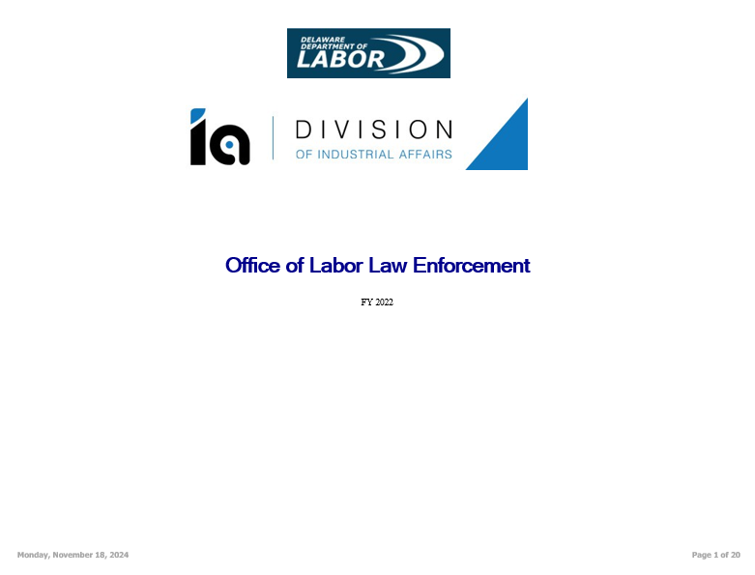

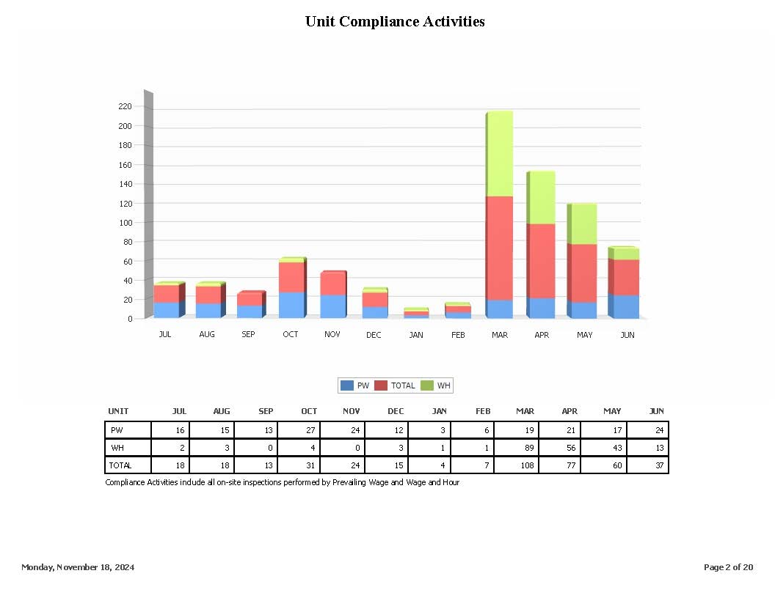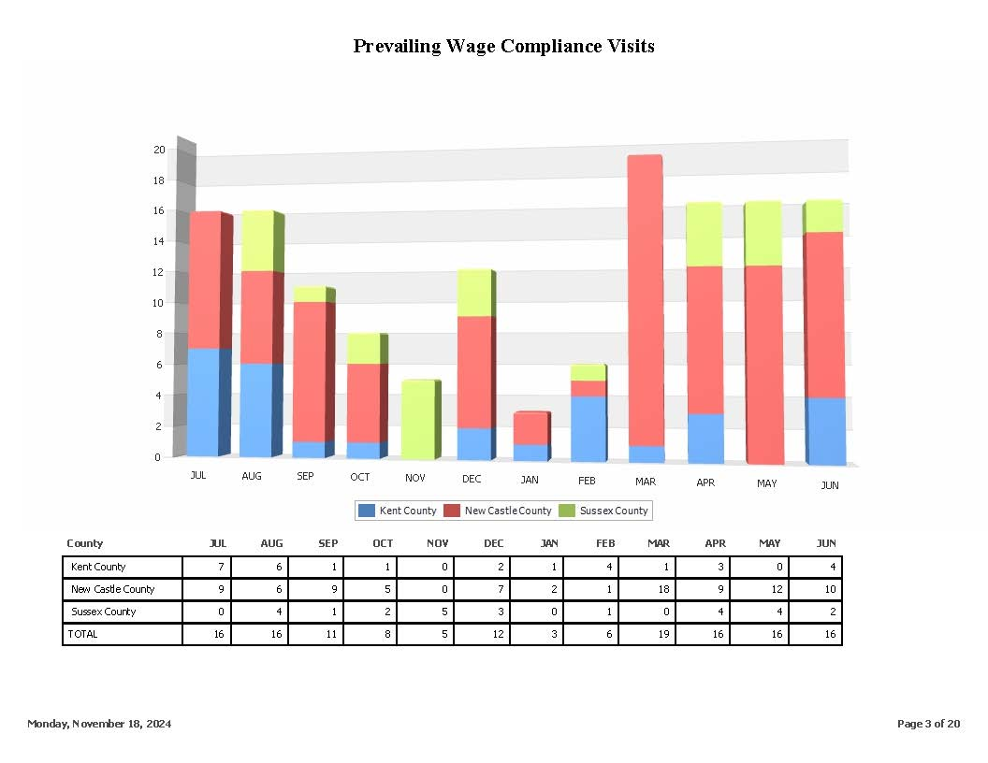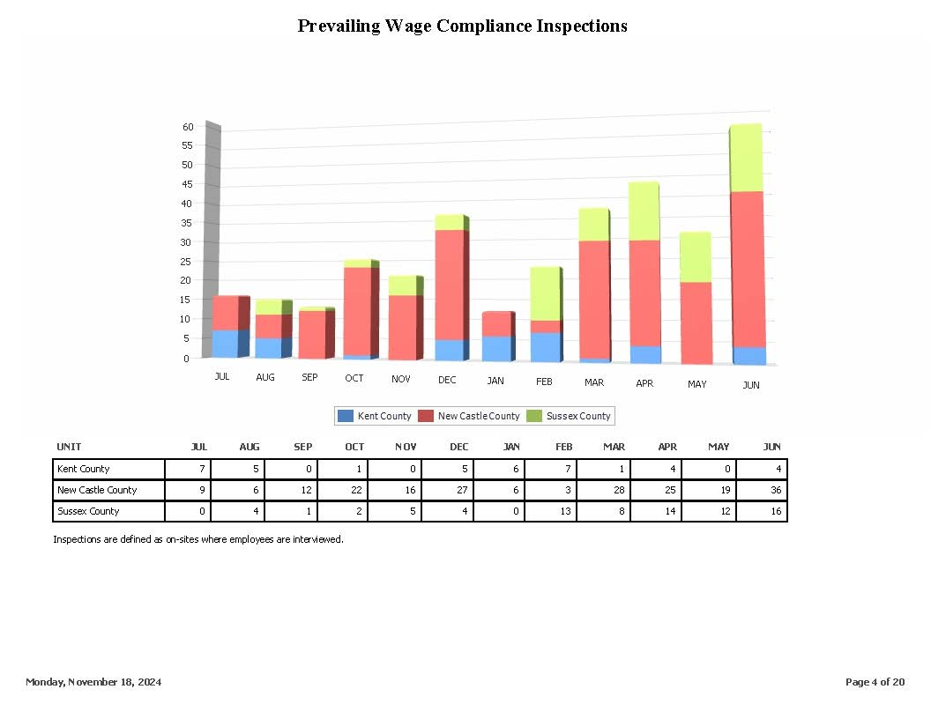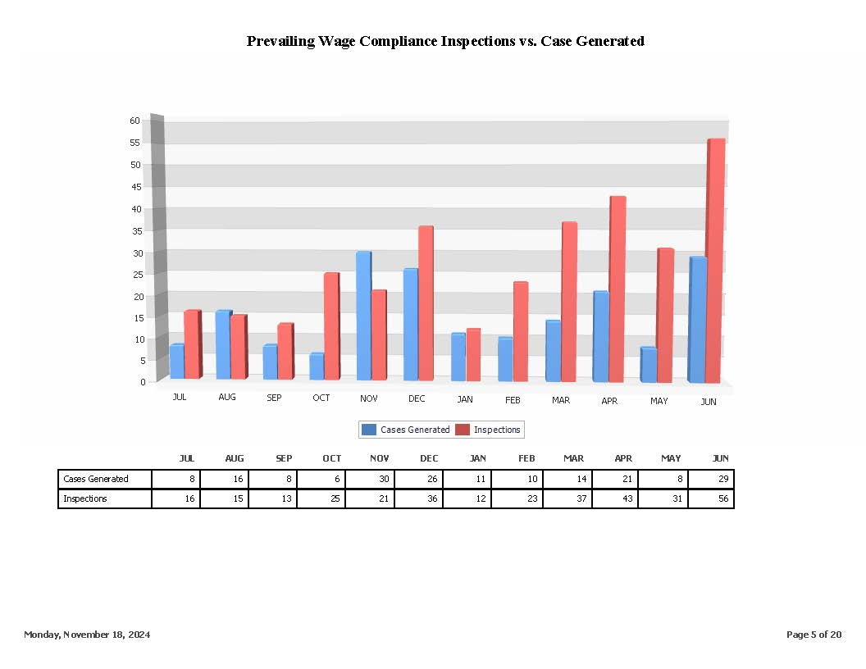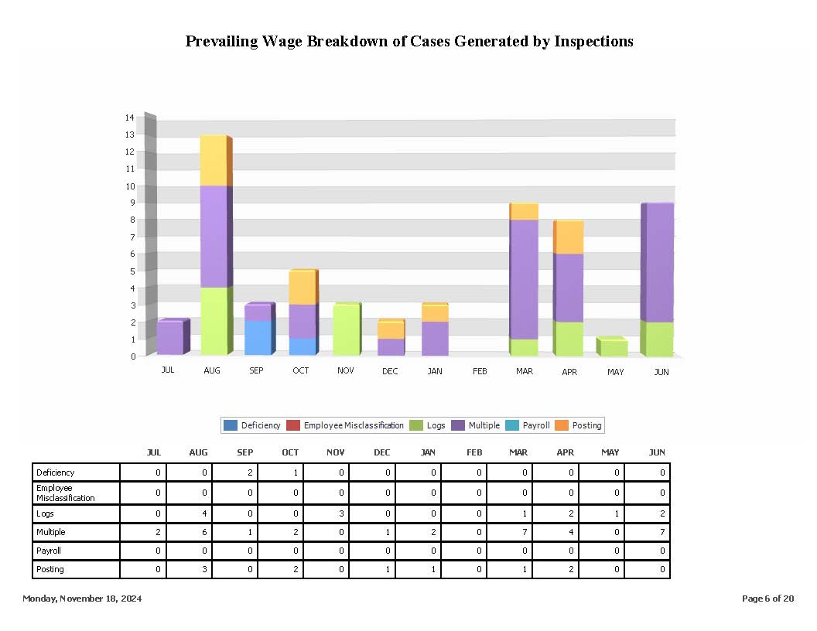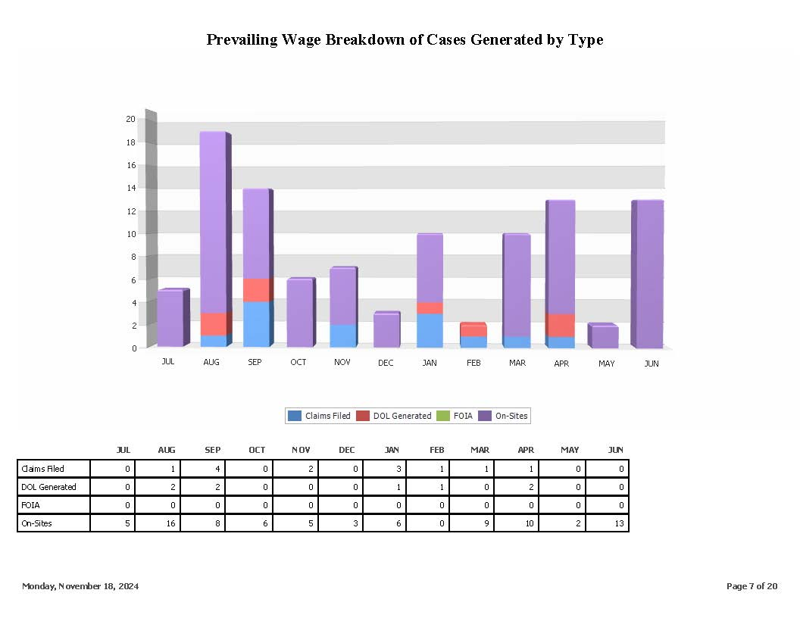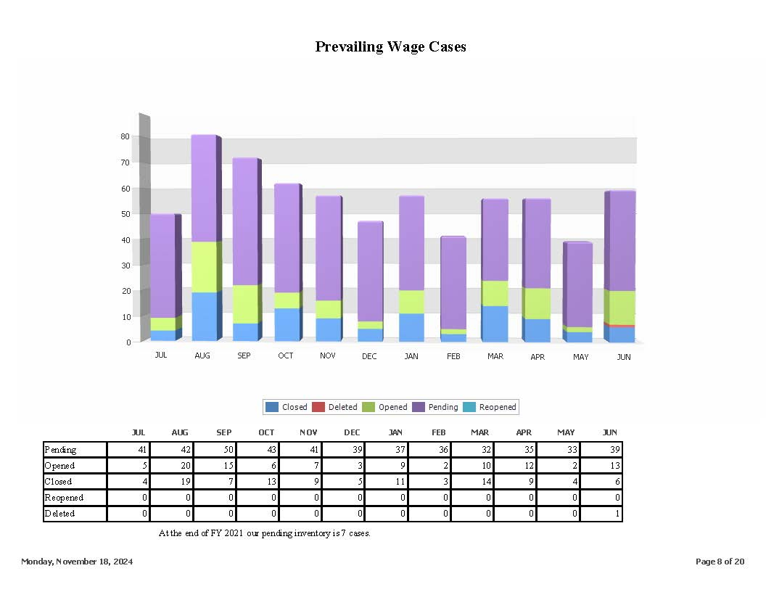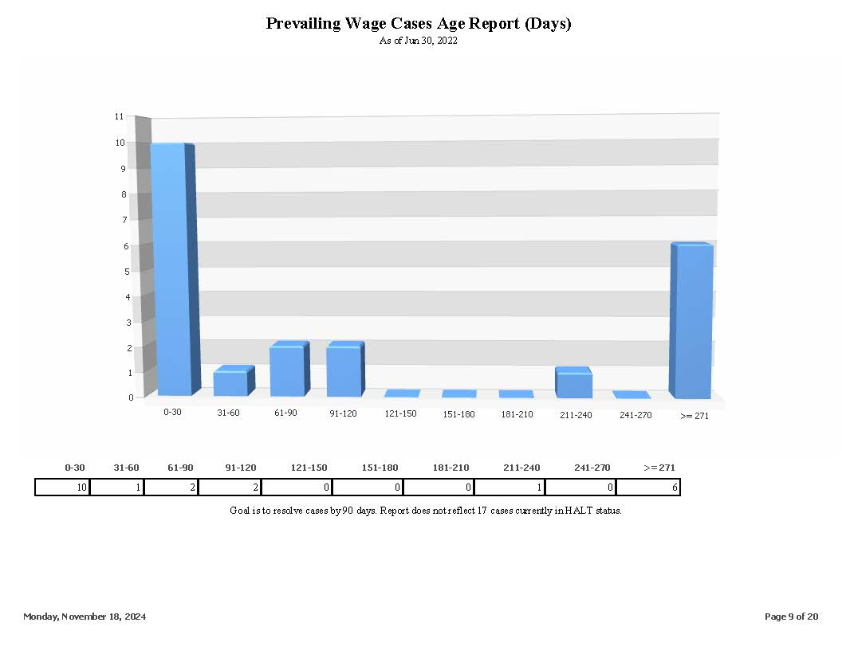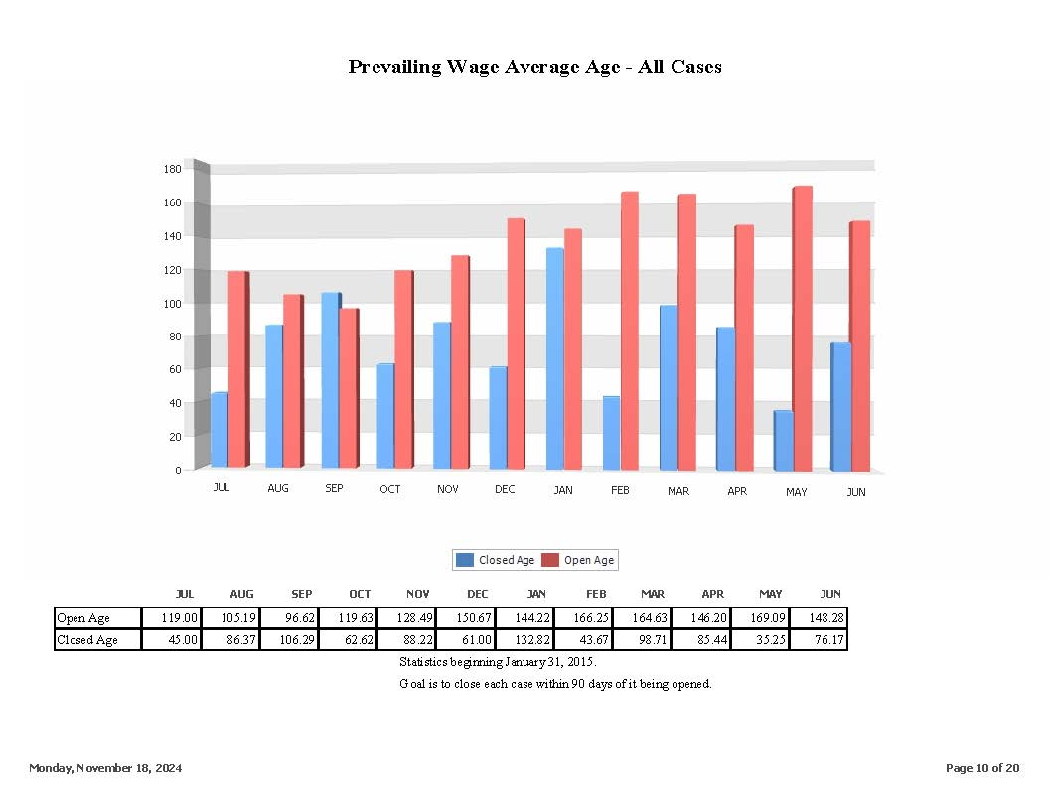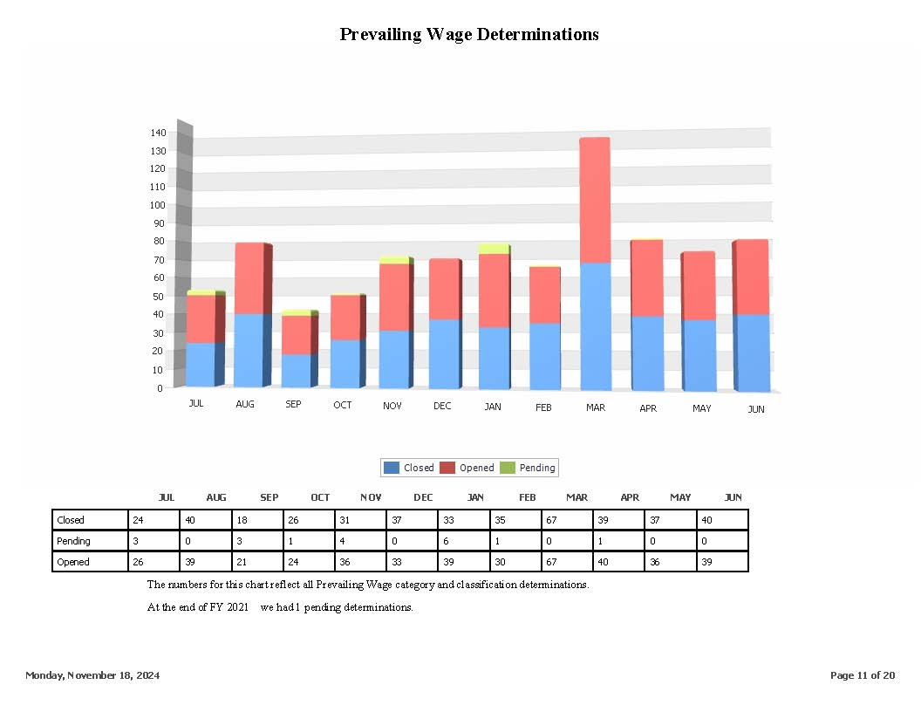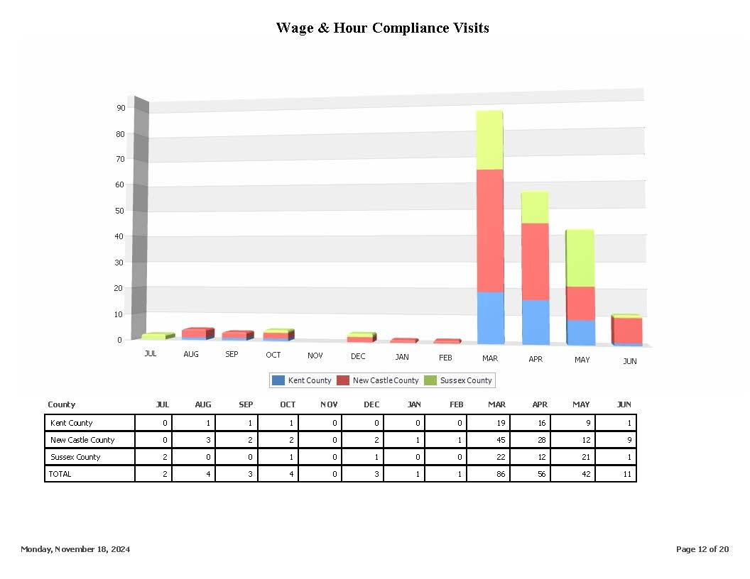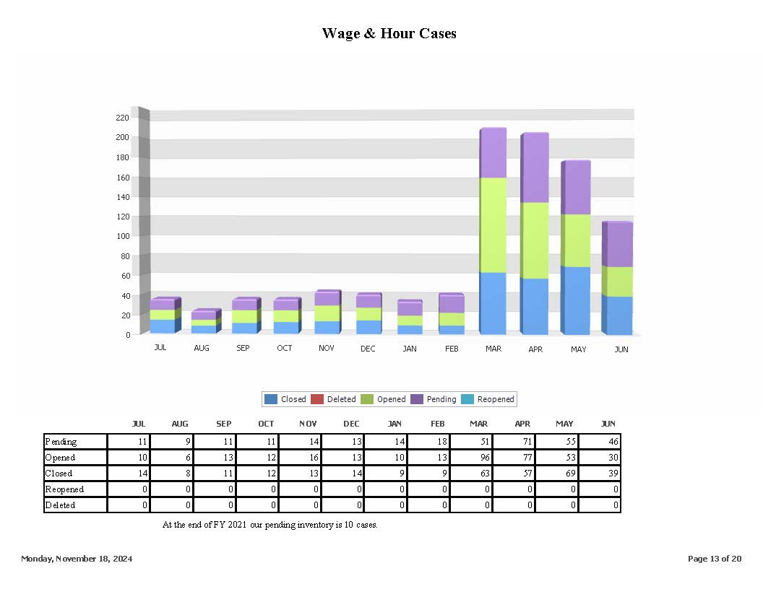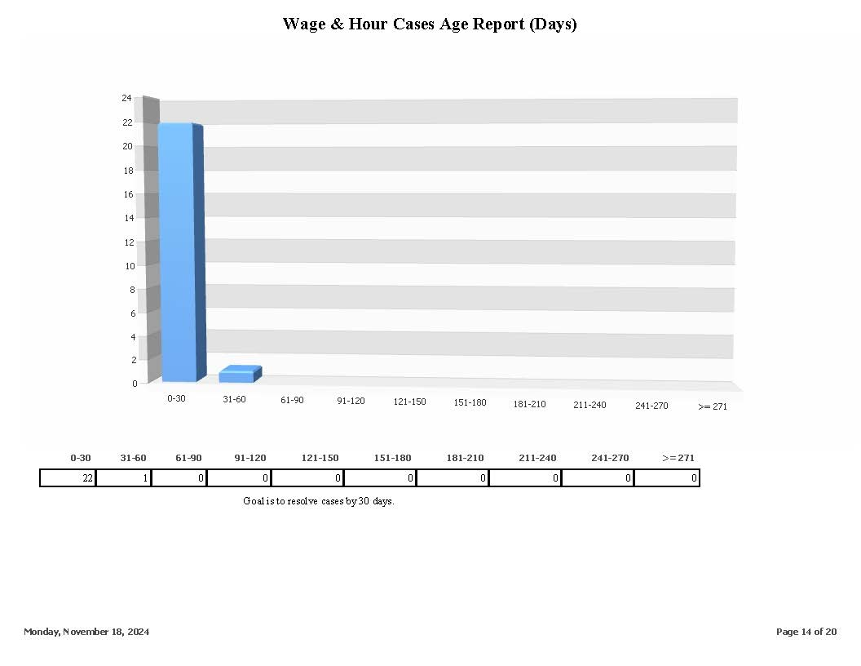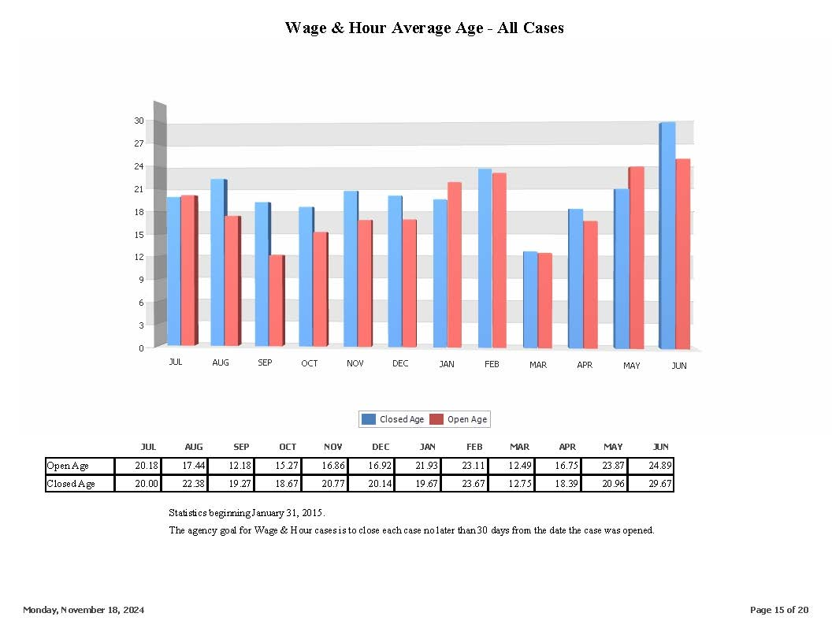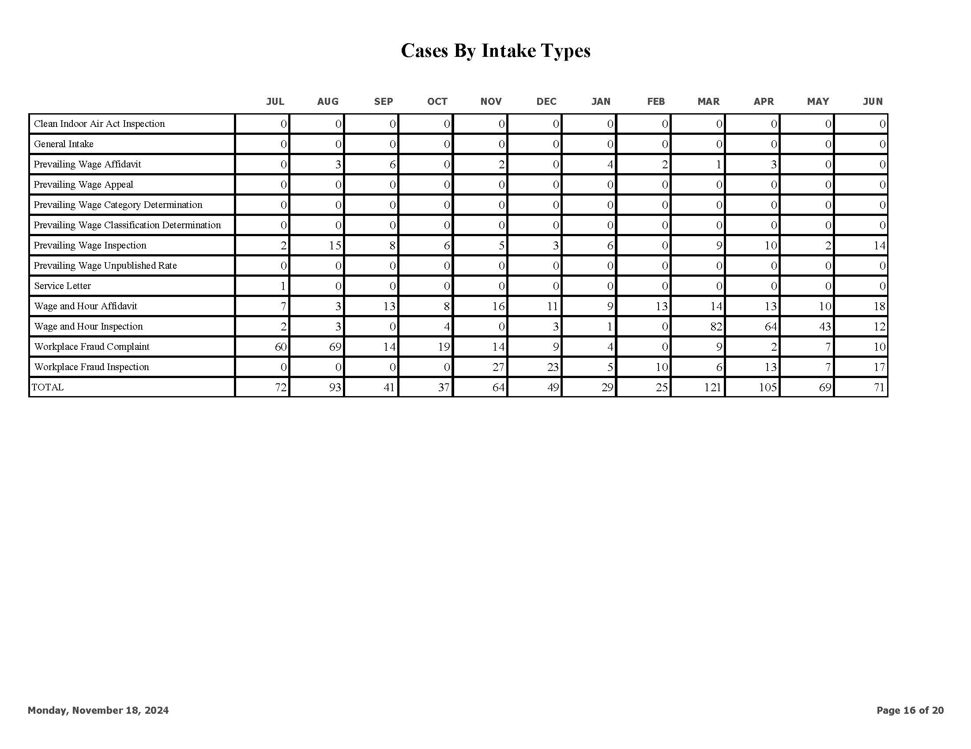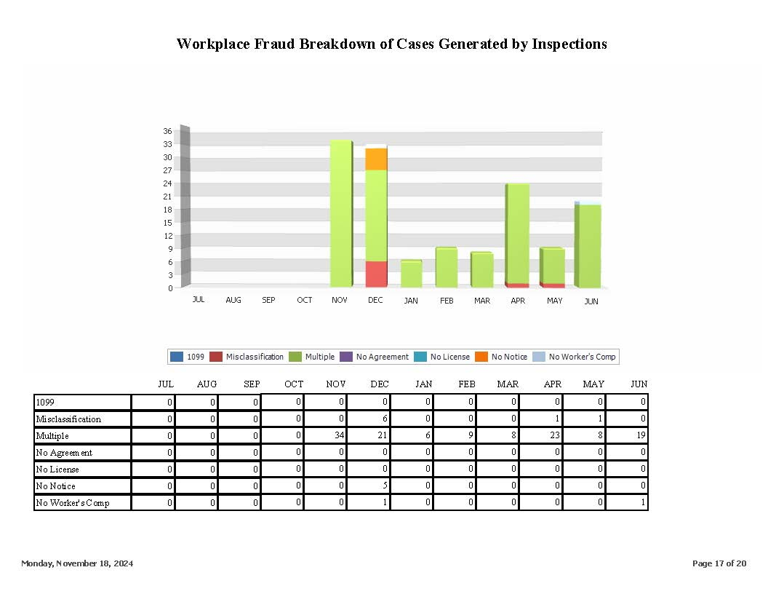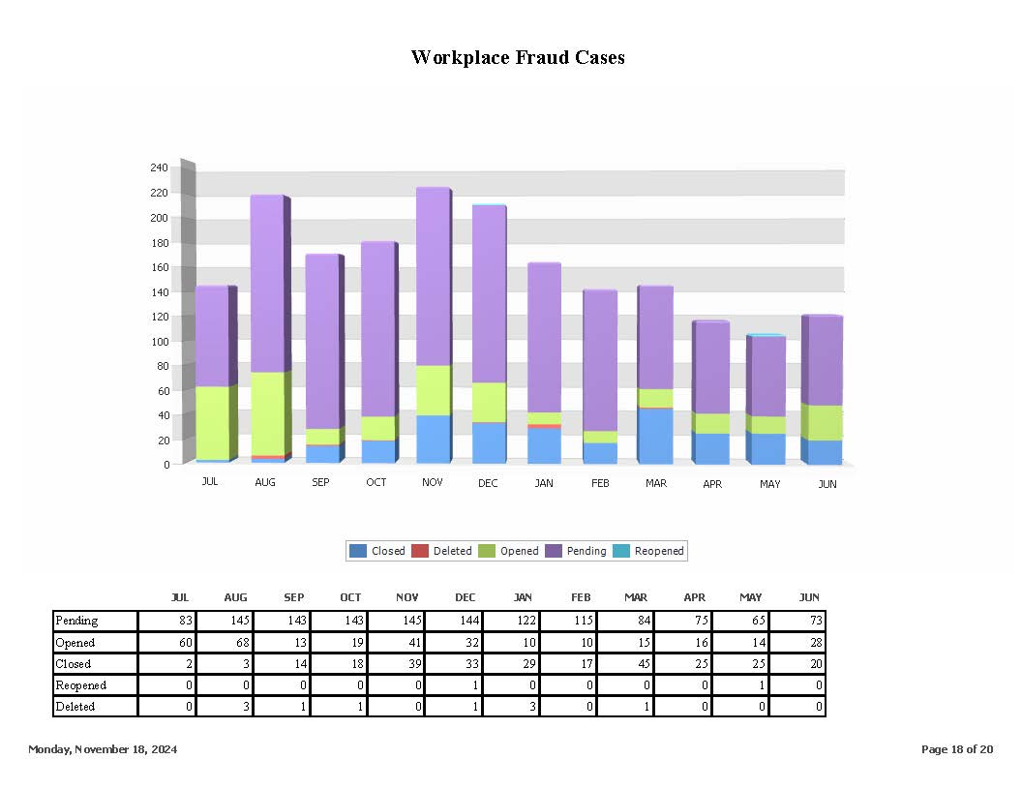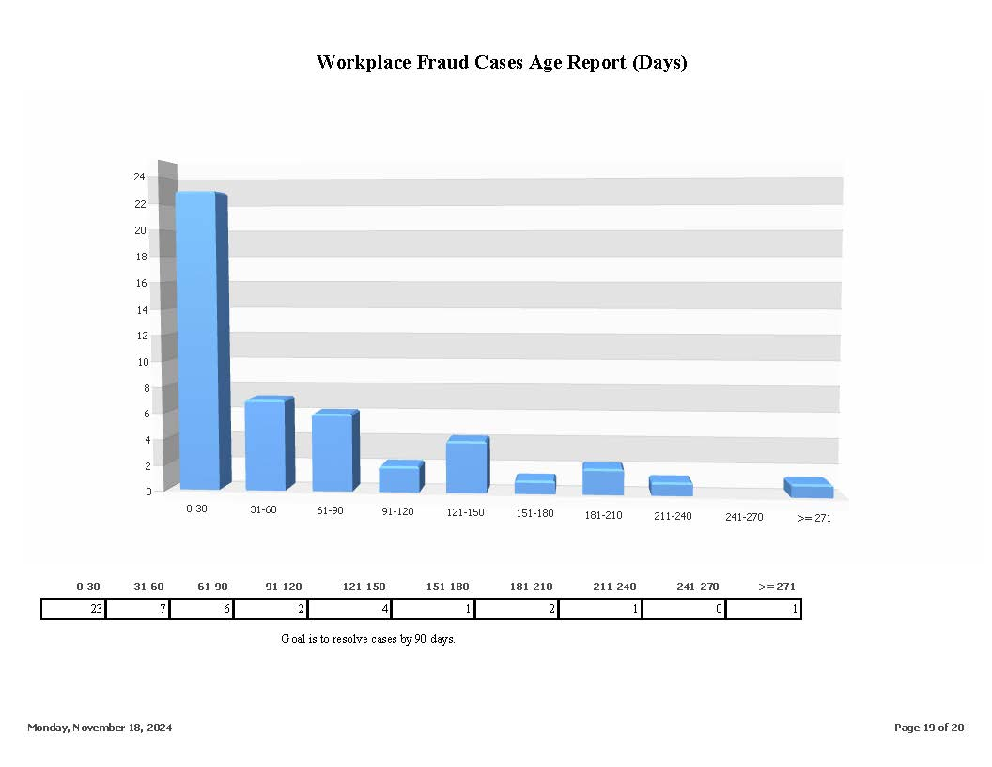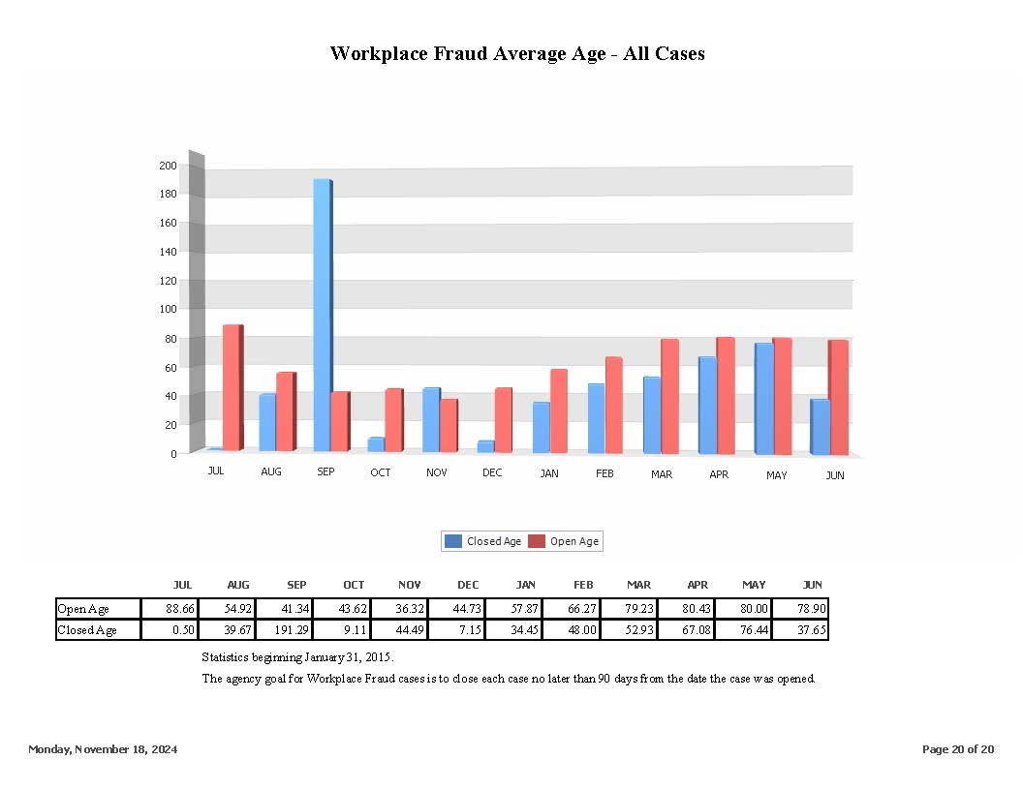

13.03 Appendix 3: SCARS Canned Reports

 | SCARS Reports
1 | Accounting Reason Codes
2 | Accounting Transaction Statistics
3 | Accounts Receivable Debit Balance
4 | Admin Assessment Paid/Owed Summary
5 | Agreement Approved Tally
6 | Annual Statement of Premium
7 | Attorney Pretrial and Hearing List
8 | Award Mailed Type
9 | Biweekly Checks
10 | Board Member Activities
11 | Board Member Hearing Schedules
12 | Carrier Without Loss Statement
13 | Carrier Without Premium Statement
14 | Case Age
15 | Case Document Task List (closed)
16 | Case Document Task List (open)
17 | Caseload of Individual Hearing Officers
18 | Case By Employer
19 | Cash Collection Summary
20 | Claimant Under Age 18
21 | Continuance
22 | Continuance – Detail
23 | Controverted Case Load
24 | Days Between Hearing & Award Mailed
25 | Days Between Petition & Award Mailed
26 | Direct paid Losses
27 | Document Statistics
28 | Filed Petitions
29 | Fund Chart
30 | Heard Petitions
31 | Hearing Statistics
32 | Insurance Carrier Listing
33 | List of Petitions
34 | Lost-Time Cases
35 | M&T Reconciliation
37 | Monthly Petition/ Hearing Report
38 | On-Hold Petitions
39 | Online FRI
40 | Online TSI Review
41 | Open Self-Insurer Cases
42 | Payroll Classification
43 | Pending Petitions
44 | Petitions Without Pretrial
45 | PNC Reconciliation
46 | Pretrial Schedule
47 | Receipt Approved Tally
48 | Self-Insurer Listing
49 | Self-Insurer Tax Paid/ Owed Summary
50 | Special Fund Assessment Paid/ Owed Summary
51 | Transcript Tracking
52 | TSI Claimant List
53 | UR Appeal Petition Dispositions
54 | UR Appeal Petition Listing
55 | UR Appeal Petition Treatments

13.03 Appendix 4: DIA Project Technical Requirements

 |  |  |  |  |  |  |  |  |  |  |  |  | Ability to Meet Requirement
Technical Requirements |  |  |  |  |  |  |  |  | Requirement Description |  |  |  |  | As Delivered |  | Configurable |  | w/ Third Party |  | w/ Customization |  | Only Partially Meets |  | Not Available |  | Specify
Shared Tech. Requirements | IT Requirements
 | 1.1 |  |  | Security and Data Handling
 |  |  |  | 1.1.1 |  |  | The Vendor must provide a description of managed hosting infrastructure (e.g. hardware, operating systems, network, communications, connectivity, backup, fail-over, disaster recovery components, etc.)
 |  |  |  | 1.1.2 |  |  | The Vendor must provide an assurance that the Cloud-based solution maintains an independent tenant for the State’s service
 |  |  |  | 1.1.3 |  |  | The Vendor must provide evidence of IPS signatures and events being maintained, which may be requested by the state for validation
X |  |  |  | 1.1.4 |  |  | The Vendor must provide assurance that credentials stored in solutions are encrypted
 |  |  |  | 1.1.5 |  |  | The Vendor must be current with all operating system patches and be no more than 2 patch levels behind for 3rd party software and the Vendor will provide monthly reports to verify the same.
X |  |  |  | 1.1.6 |  |  | The Vendor must provide a description of active services such as web services and hardening standards applied.
 |  |  |  | 1.1.7 |  |  | The solution must provide a comprehensive next generation endpoint security solution with machine learning capable anti-malware, abnormally detection, file integrity monitoring, log file monitoring, host-based intrusion detection, and file reputation scanning.
X |  |  |  | 1.1.8 |  |  | The solution must provide host-based disk encryption capabilities, including encryption at rest and in transit.
X |  |  |  | 1.1.9 |  |  | The solution must provide auditing capabilities on hosts capturing all security related activities, and the environment must maintain the event logs for up to 7 years.
 |  |  |  | 1.1.10 |  |  | The solution must provide access to application data noted as restricted only to authorized database administrators. DBA should be able to perform DML operations directly in UAT and PROD instances. Developers should be able to perform CRUD operations in DEV environment.
X |  |  |  | 1.1.11 |  |  | The solution must provide application authentication capabilities supporting federation with state or agency identity stores to ensure governance over access and the certification of access.
X |  |  |  | 1.1.12 |  |  | The solution must integrate with the State's Identify and Access Management (IAM) solution (OKTA) for new employee and employer registration.
X |  |  |  | 1.1.13 |  |  | The solution must support new user identity proofing government ID and knowledge-based validation during registration directly or through the State’s IAM solution.
X |  |  |  | 1.1.14 |  |  | The solution must support for OpenID Connect, OAuth and or SAML.
 |  |  |  | 1.1.15 |  |  | The solution must protect internet-facing web front-end servers with an enterprise web application firewall with protections to include the OWASP Top 10, Botnets, DDoS and application virtual patching.
X |  |  |  | 1.1.16 |  |  | The solution must use of the State’s brand and domain name to traverse a cloud-based web application firewall for centralized visibility to all brand threats.
X |  |  |  | 1.1.17 |  |  | The solution must ensure that application communications from users and across components of the application are encrypted in transit.
 |  |  |  | 1.1.18 |  |  | The solution must ensure application security related events like logins, changes and administrator activities are logged and reviewed for malicious or abnormal activity and an alert is sent immediately to the appropriate security contacts.
 |  |  |  | 1.1.19 |  |  | The solution must ensure static scans, application code security scans are run at least yearly and prior to any changes being loaded into production for example authentication, authorization, security testing.
 |  |  |  | 1.1.20 |  |  | The solution must ensure that applications undergo dynamic application scans at least yearly and after any changes are loaded into production. Dynamic scans are executed while an application is in operation for example, testing and evaluation of program by executing data in real-time. The objective is to find errors in a program while it is running rather than repeatedly examining the code offline.
X |  |  |  | 1.1.21 |  |  | The Vendor must be capable of notifying the System Administrator regarding which releases of third-party software are known to create problems with the current version of the vendor software within 24 hours of the update announcement. The new version should be rigorously tested in lower environments before being put in production.
X |  |  |  | 1.1.22 |  |  | The Vendor must provide a description of their approach to installation and configuration of all software, hardware, and cloud services necessary to provide a complete working environment to meet the initial performance requirements of the centralized web and mobile user interface, integration with State of Delaware's Master Data Management , and integration with Customer Agency applications. Additionally, to the extent that cloud computing is used in the solution, explain how the solution will utilize, configure, maintain, and update cloud computing resources.
 |  |  |  | 1.1.23 |  |  | The Vendor must provide a description of their approach to providing post deployment ongoing support, maintenance, and upgrades.
 |  |  |  | 1.1.24 |  |  | The Vendor must provide a description of their approach to day-to-day operations, maintenance, and administration of the centralized web and mobile user interface. The platform shall operate 24 hours per day every day of the year. Operations include customer service, facilities, hardware, networking, security, performance monitoring, and problem resolution. Maintenance includes keeping all off-the-shelf software on current releases and keeping the development environment on mainstream industry and State accepted standards. Administration includes all financial, record keeping, reporting, and management aspects of the platform.  A maintenance window period should be designated in advance by the technical staff, during which preventive maintenance that could cause disruption of service may be performed.
X |  |  |  | 1.1.25 |  |  | The Vendor must provide an example of integration scenarios that explain the process, methodology, and technology solutions associated with the integration of Customer Agency applications with the centralized web and mobile user interface for example: integration points with other applications, mobile interfaces, ONE API.
 |  |  |  | 1.1.26 |  |  | The solution must conform to State Web Presentation Guidelines: https://gic.delaware.gov/web-standards/ and the specific editions of the standards and guidelines listed in Chapter 7 of the Section 508 Standards, especially ISO/IEC 40500:2012, the World Wide Web Consortium (W3C) Web Content Accessibility Guidelines (WCAG) 2.0 (https://www.w3.org/TR/WCAG20/)
 |  |  |  | 1.1.27 |  |  | The Vendor must provide a description of the usability and compatibility of the solution across internet browsers, devices, and assistive technologies, including desktop and mobile devices supporting all major operating systems, and all major browsers including current and recent versions of Internet Explorer, Google Chrome, Microsoft Edge, Mozilla Firefox, and Safari. Include any applicable VPAT or similar assessments of accessibility of existing technologies and plans to verify usability of solutions while in development and once ready for deployment.
 |  |  |  | 1.1.28 |  |  | The Vendor must confirm to the State Offshore Staffing policy (https://webfiles.dti.delaware.gov/pdfs/pp/OffshoreITStaffingPolicy.pdf)
 |  |  |  | 1.1.29 |  |  | The Vendor must provide a description of any third-party certificates of audit certifying on a recurring basis including but not limited to any of the following:  - Internal Revenue Service Publication 1075 Compliance  - NIST 800-53  - CSA STAR – Cloud Security Alliance – Security, Trust & Assurance Registry  - Federal Risk and Authorization Management Program (FedRAMP) certification for a System hosted in a cloud environment  - PCI DSS Compliance  - Health and Human Services Health Insurance Portability and Accountability Act (HIPAA) Compliance
X |  |  |  | 1.1.30 |  |  | The Vendor must provide a description of the proposed solution’s technical and data architecture. Responses should include: how the proposed architecture flexibility adapts, integrates, and utilizes evolving policies, best practices, and operating procedures utilizes open architecture standards supports for a distributed computing environment provides secure data exchange includes request/reply, publish/subscribe, and synchronous/asynchronous functionality to facilitate information sharing.
 |  |  |  | 1.1.31 |  |  | The solution must separate the layers in the architecture using a firewall or other next generation network logical control system.
 |  |  |  | 1.1.32 |  |  | The solution must justify and document all firewall rules which must be specific to the application needs
 |  |  |  | 1.1.33 |  |  | The solution must evaluate communications between hosts within the computing environment by a network or host-based intrusion detection and prevention system.
X |  |  |  | 1.1.34 |  |  | The Vendor must develop and deliver a comprehensive information security program to protect the state citizen information while hosted within the Vendor's infrastructure and must be able to show evidence of the implementation of the program and continuous maintenance of the program.
 |  |  |  | 1.1.35 |  |  | The solution must log application security related events like logins, changes, and administrator activities and review them for malicious or abnormal activity.
X |  |  |  | 1.1.36 |  |  | The solution must ensure API integration for state data traverses through a state API gateway with OWASP top-10 and XML security protection.
 |  |  |  | 1.1.37 |  |  | The solution must ensure source network IPs, client certificates and database queries are authenticated and validated if accessed over the internet.
 |  |  |  | 1.1.38 |  |  | The solution must ensure default database credentials are reset and disabled.
 |  |  |  | 1.1.39 |  |  | The solution must ensure unique database access credentials are established for all users.
X |  |  |  | 1.1.40 |  |  | The solution must ensure services have a comprehensive security incident detection and response program with:  Log Collection, correlation and threat intelligence  24x7, 365 active security event monitoring and attack response  Compliance aligned log retention  Copies of raw logs and threat events available upon request this may include log forwarding to Security Incident and Event Management (SIEM) system.
 |  |  |  | 1.1.41 |  |  | The solution must ensure System vulnerability scans are performed and remediated at least quarterly
 |  |  |  | 1.1.42 |  |  | The solution must respond to State requests for summaries of all assessments performed against the environment.
 |  |  |  | 1.1.43 |  |  | The solutions must undergo external penetration testing at least yearly.
 |  |  |  | 1.1.44 |  |  | The solution must publish evidence to the state security team quarterly and on demand with a written request from the state security office to support compliance to these requirements.
 |  |  |  | 1.1.45 |  |  | The solution must meet digital accessibility in ADA Section 508 compliance (WCAG 2.0, AA Industry Standard).
 |  |  |  | 1.1.46 |  |  | The solution must ensure whitelisting is supported for an approved list of email addresses and IP addresses while denying all others, if accessed over the internet.
X |  |  |  | 1.1.47 |  |  | The solution must support log analysis involving collecting, evaluating and managing data reported by various components to proactively identify bugs, security threats or risks
 |  |  |  | 1.1.48 |  |  | The solution must be able to run on devices that are configured to comply with the State of Delaware's Mobile Device Encryption and Mobile Device Management policies and standard available at https://webfiles.dti.delaware.gov/pdfs/pp/MobileDeviceEncryptionStandard.pdf ; https://webfiles.dti.delaware.gov/pdfs/pp/MobileDeviceManagementPolicy.pdf ;
 |  |  |  | 1.1.49 |  |  | The Solution must provide foreign language accessibility in compliance to Title VI of the Civil Rights Act of 1964 and 2000’s Executive Order 13166, in addition to providing IA the ability to add new language requirements as needed.
 | 1.2 |  |  | Support & Maintenance
 |  |  |  | 1.2.1 |  |  | The solution must provide access to existing customer support forums and the knowledge base.
 |  |  |  | 1.2.2 |  |  | The solution must be able to be customizable/adaptable when a new law/legislation requires a change.
 |  |  |  | 1.2.3 |  |  | The solution must provide administrators with ability to configure the application with little or no customization.  Each business requirement will require the vendor to reply that it meets the requirement via configuration, customization, etc.
X |  |  |  | 1.2.4 |  |  | The Vendor must provide timely technical and software support for upgrades keeping the solution in the most recent version, ensuring the new versions are tested thoroughly in lower environments for compatibility purposes.
 |  |  |  | 1.2.5 |  |  | The Vendor must provide periodic or as-needed technical communication to address system performance and system availability issues.
 |  |  |  | 1.2.6 |  |  | The Vendor must plan for regular, periodic upgrades to the solution to ensure the system receives the most current enhancements or fixes to The solution software.
 |  |  |  | 1.2.7 |  |  | The Vendor must provide a robust business and continuity/disaster recovery plan that accounts for a rating of Moderate Risk. The Vendor must demonstrate the ability to execute the plan to ensure that Delaware data can be recovered quickly and completely in the event of a business interruption. Vendor to provide timeframes for business continuity and disaster recovery situations.
 |  |  |  | 1.2.8 |  |  | The Vendor must provide an escalation plan for issues that are unresolved in the agreed upon timeframe.
 |  |  |  | 1.2.9 |  |  | The Vendor must provide Issues reports including the following metrics: resolved issues, time taken to resolve, currently open issues, and issues escalated.
 |  |  |  | 1.2.10 |  |  | To address business or functional issues, the solution must provide technical and functional support including helpdesk services, online help features and other cost-effective support such as real-time chat.
 |  |  |  | 1.2.11 |  |  | The Vendor must provide online documentation provided for all current modules along with screenshots of new releases/functionality for upcoming releases.
 |  |  |  | 1.2.12 |  |  | The Vendor must provide an online support portal for incident submission and tracking (e.g., Jira, ServiceNow or similar tools).
 |  |  |  | 1.2.13 |  |  | The Vendor must provide telephone support coverage.
 |  |  |  | 1.2.14 |  |  | The Vendor must provide a Maintenance Agreement which shall include all product releases and upgrades available as part of the solution.
 |  |  |  | 1.2.15 |  |  | The solution must provide "built-in" capability for remote support via proxy as user.
 |  |  |  | 1.2.16 |  |  | The Vendor must notify the System Administrator regarding which releases of third-party software are known to create problems with the current version of the vendor software within 24 hours of the update announcement.
 |  |  |  | 1.2.17 |  |  | The Vendor must provide support within 24 hours of identifying the issue to assign severity level to solution issues. The vendor must commit to continuously working until the issue has been resolved.
 |  |  |  | 1.2.18 |  |  | The solution must use industry best practice and completely test and apply patches for all third-party software products before release.
 |  |  |  | 1.2.19 |  |  | The solution must be capable of generating On-demand security role report to show which users are in security roles for all users.
 |  |  |  | 1.2.20 |  |  | The Vendor must provide an ongoing system development/test environment (i.e. Pilot, Stage, and Production) for all modules.
 |  |  |  | 1.2.21 |  |  | The solution must be scalable to support current and future usage / growth.
 |  |  |  | 1.2.22 |  |  | The solution must ensure upgrades do not interfere with customizations or modifications.
 |  |  |  | 1.2.23 |  |  | The solution must ensure modularity, allowing administrators to configure the deployment of only relevant functionality as needed.
 |  |  |  | 1.2.24 |  |  | The solution must allow users to request their password via e-mail or reset.
X |  |  |  | 1.2.25 |  |  | Cloud-based solution as used in this document is defined as the capability provided to the State to use the Contractor’s applications running on a cloud infrastructure. The applications are accessible from various client devices through a thin client interface such as a Web browser (e.g., Web-based email) or a program interface. The State does not manage or control the underlying cloud infrastructure, including network, servers, operating systems, or storage, but may be permitted limited user-specific application configuration settings.  The vendor is responsible for the acquisition and operation of all hardware, software and network support related to the services being provided, and shall keep all software current. The technical and professional activities required for establishing, managing, and maintaining the environments are the responsibilities of the Contractor.
 |  |  |  | 1.2.26 |  |  | The Vendor must maintain a full disaster recovery (DR) site with all the capabilities of the Primary site; utilizing a completely independent infrastructure, stack and geographically separated by a minimum of one hundred fifty miles from the primary site. Both sites must be within the continental United States. Note: Based on DTI's Criticality Level 1.
 |  |  |  | 1.2.27 |  |  | The solution must ensure that transactional records are available online for the length of the contract.
 |  |  |  | 1.2.28 |  |  | The solution must provide online help and a support knowledge base.
 |  |  |  | 1.2.29 |  |  | The Vendor must provide procedures, build notes for updating underlying platform, builds, deployments and release notes.
 |  |  |  | 1.2.30 |  |  | The Solution must allow administrator(s) to accept/decline features for a system upgrade.
 | 1.3 |  |  | Data & Database Management
 |  |  |  | 1.3.1 |  |  | The Vendor must comply with the State of Delaware Terms & Conditions Governing State Data Usage Policy. The Delaware Data Usage Terms & Conditions Agreement shall be signed and included as an attachment to contracts related to The solution.  https://webfiles.dti.delaware.gov/pdfs/pp/Terms%20and%20Conditions%20Governing%20State%20Data%20Usage%20Policy.pdf  https://webfiles.dti.delaware.gov/pdfs/pp/Delaware%20Data%20Usage%20Terms%20and%20Conditions%20Agreement.pdf
 |  |  |  | 1.3.2 |  |  | The Vendor must describe the proposed database architecture including the database software supported by the proposed application.
 |  |  |  | 1.3.3 |  |  | If applicable, The Vendor must describe the proposed database warehouse solution, if applicable.
 |  |  |  | 1.3.4 |  |  | The Vendor must describe how the proposed solution is built upon an integrated data model, such as a relational database management system (RDBMS), with referential integrity enforced. Also, the Vendor must describe the integrated data model.
 |  |  |  | 1.3.5 |  |  | The Vendor must describe how the proposed solution maintains an automated history of all transactions, including, but not limited to: date and time of change, "before" and "after" data field contents, and operator identifier or source of the update.
 |  |  |  | 1.3.6 |  |  | The Vendor must describe how the solution is designed to ensure business rule parameters and code lookup tables can be easily updated without changing the overall application program logic.
 |  |  |  | 1.3.7 |  |  | The Vendor must describe how the proposed solution provides a comprehensive set of reviews at the point of data entry to minimize data errors and immediate feedback in order for incorrect data to be corrected before further processing.
 |  |  |  | 1.3.8 |  |  | The solution must be able to import and export data from (or to) standard file formats including but not limited to XML, Word, Excel, PDF.
 |  |  |  | 1.3.9 |  |  | The solution must provide real-time data feed capability to be consumed by external entities (RSS, Web Service, API).
 |  |  |  | 1.3.10 |  |  | The solution must maintain the integrity and accuracy of all data, including imported data.
 |  |  |  | 1.3.11 |  |  | The Vendor must describe the proposed system of auditing and related capabilities.
 |  |  |  | 1.3.12 |  |  | The solution must make archived data accessible and retrievable.
 |  |  |  | 1.3.13 |  |  | The solution must be able to view scanned and uploaded documents within the application.
 |  |  |  | 1.3.14 |  |  | The solution must be able to upload and store scanned documents and link documents to workflow.
 |  |  |  | 1.3.15 |  |  | The solution must provide seamless integration with standard e-mail systems for electronic communication, notifications, and reminders to and from internal and external users.
 |  |  |  | 1.3.16 |  |  | The solution must be able to configure State of Delaware-defined limitations on the size of file attachments.
 |  |  |  | 1.3.17 |  |  | The solution must be able to assign users multiple security levels by module.
 |  |  |  | 1.3.18 |  |  | The solution must be able to assign users multiple security roles concurrently.
 |  |  |  | 1.3.19 |  |  | The Vendor must describe their ability to convert data from the current legacy systems into the proposed solution, in addition to describing how conversion will be performed.
 |  |  |  | 1.3.20 |  |  | The Solution must be capable of exporting all Delaware proprietary information from the solution (.csv, .xlsx, .xls or other format as requested by the State) upon request.
 |  |  |  | 1.3.21 |  |  | The Solution must be able to upload and store scanned documents and link documents to workflow.
 | 1.4 |  |  | Reporting
 |  |  |  | 1.4.1 |  |  | The Vendor must describe how the proposed solution provides for the generation of standard and customizable error reports.
 |  |  |  | 1.4.2 |  |  | The solution must provide a complement of standard (canned) reports.
 |  |  |  | 1.4.3 |  |  | The solution must be able to configure elements of the standard reports.
 |  |  |  | 1.4.4 |  |  | The solution must be able to generate configurable audit reports for various business areas.
 |  |  |  | 1.4.5 |  |  | The solution must be able to generate configurable exception reports for various business areas.
 |  |  |  | 1.4.6 |  |  | The solution must be able to schedule reports (i.e. pay-period, monthly, quarterly, annually).
 |  |  |  | 1.4.7 |  |  | The solution must provide robust ad hoc reporting capability for all fields in the system and allow building customized reports without the need to purchase an additional tool, upgrade, or module.
 |  |  |  | 1.4.8 |  |  | The solution must be able to configure customized reports for one-time or repeated use, which can be saved by one user for themselves or for all other users.
 |  |  |  | 1.4.9 |  |  | The solution must be able to query for data that may not be included in the reporting capability.
 |  |  |  | 1.4.10 |  |  | The solution must provide dashboards with the ability to configure and filter/drill down on user-defined parameters and configurable for each user group such as Administrators, Employers, DOL staff, etc.
 |  |  |  | 1.4.11 |  |  | The solution must be able to create dashboards to allow users to view reporting statistics, schedule of reports, etc.
 |  |  |  | 1.4.12 |  |  | The solution must be able to produce reports in a graphical view, when appropriate, with Security limiting capability.
 |  |  |  | 1.4.13 |  |  | The solution must support configurable role-based security with regards to data delivery and reporting capabilities.
 |  |  |  | 1.4.14 |  |  | The solution must allow all reports to be exported as print files, flat files (e.g., XML, MS Word, MS Excel, CSV or PDFs) and be transmitted electronically e.g., MS Office 365.
 |  |  |  | 1.4.15 |  |  | The solution must be able to print a series of documents as a single complete document rather than individually.
 |  |  |  | 1.4.16 |  |  | The solution must be able to populate variable data from the application at run time on forms, letters, and boilerplate documents.
 |  |  |  | 1.4.17 |  |  | The solution must be able to email reports using encrypted channels to authorized users.
 |  |  |  | 1.4.18 |  |  | The solution must be able to image, download, and print letters, reports, and forms (e.g., JPEG, PDF).
 |  |  |  | 1.4.19 |  |  | The solution must be able to conduct ad hoc reporting, including current and historical data for all modules.
 |  |  |  | 1.4.20 |  |  | The solution must be able to provide users with a user-friendly report generator.
 |  |  |  | 1.4.21 |  |  | The solution must be able to store ad hoc reports and queries in private and shared folders.
 |  |  |  | 1.4.22 |  |  | The solution must provide a built-in audit trail capability for all actions, including actions related to communications to users.
 |  |  |  | 1.4.23 |  |  | The solution must be able to edit incorrect or mistyped information.
 |  |  |  | 1.4.24 |  |  | The solution must allow Administrator to configure security roles and permissions for reporting.
 |  |  |  | 1.4.25 |  |  | The solution must allow Administrator robust reporting on all fields in the system without vendor action.
 |  |  |  | 1.4.26 |  |  | The solution must be able to create reports with encrypted information (birthdate, gender, EEO, etc.) based on security role.
 |  |  |  | 1.4.27 |  |  | The solution must be able to export reports into various formats such as flat files, XML, Excel, CSV, Word and PDF's, while restricting the display of PII and/or FTI data fields based on individuals security roles.
 | 1.5 |  |  | Service Level Agreements
 |  |  |  | 1.5.1 |  |  | The solution must provide an initial response to all support requests within the timeframes based on the following four categories:  1) Emergency – 15-minute response during core hours; 60-minute response during non-core hours via an open bridge line where outage root cause must be found, analyzed and next steps should be aligned with owner names next to it. An updated progress email/notification has to be sent every 30 minutes, with a next follow up call in an agreed amount of time period between DOL and Vendor.  2) High – 30-minute response during core hours; 120 minutes during non-core hours - via help desk/phone call and email acknowledgement of the issue and ETA for the fix. If required, bridge line can be opened to analyze the issue.  3) Medium – 120-minute response during core hours; by 8:00 AM the next business day during non-core hours via email confirmation on the issue  4) Low – 120-minute response during core hours; by 8:00 AM the next business day during non-core hours via email confirmation on the issue
 |  |  |  | 1.5.2 |  |  | The vendor must circumvent or resolve support requests within the timeframes based on the following four categories:  1) Emergency – 2 hour resolution time  2) High – 4 hour resolution time  3) Medium – Prioritized based on need  4) Low – Prioritized based on need
 |  |  |  | 1.5.3 |  |  | The solution must have no single unscheduled outage lasting more than 2 hours during normal business hours that impact DOL staff.
 |  |  |  | 1.5.4 |  |  | The solution must be architected to achieve 99.5% uptime availability 24x7, except designated maintenance windows.  The Service Level calculation for System Availability is the sum of Actual Uptime for the individual Applications divided by the sum of expected, scheduled Uptime for the Applications, with the result expressed as a percentage.  • Available Uptime per week = 105 hours / week  o 6:00 AM – 10:00 PM Monday – Saturday (16 hours per day)  o 8:00 AM – 5:00 PM Sunday (9 hours)  • Available Uptime per month = 454.65 hours / month  o 52/12 = 4.33 * 105 = 454.65 available hours / month  Available Hours/Month Availability Target Available Target Hours/Month Downtime Hours/Month  454.65 .999 454.20 0.45  454.65 .995 452.38 2.27  454.65 .990 450.10 4.55  454.65 .985 447.83 6.82  454.65 .980 445.56 9.09  454.65 .975 443.28 11.37  454.65 .950 431.92 22.73
 |  |  |  | 1.5.5 |  |  | The solution must provide a recovery time and procedures in the event of a disaster recovery situation.
 | 1.6 |  |  | Cloud Hosting
 |  |  |  | 1.6.1 |  |  | The Vendor must comply with the State of Delaware Terms & Conditions Governing Cloud Services Policy. The Delaware Cloud Services Terms & Conditions Agreement shall be signed and included as an attachment to contracts related to The solution.
 |  |  |  | 1.6.2 |  |  | Terms & Conditions Governing Cloud Services Policy
 |  |  |  | 1.6.3 |  |  | Delaware Cloud Services Terms & Conditions Agreement
 |  |  |  | 1.6.4 |  |  | The Vendor must use commercially reasonable resources and efforts to maintain internet connection bandwidth and server capacity.
 |  |  |  | 1.6.5 |  |  | The Vendor must be solely responsible for all data storage required.
 |  |  |  | 1.6.6 |  |  | The Vendor must locate servers in a climate-controlled environment and house all servers and equipment in an operational environment that meets industry standards including climate control, fire and security hazard detection, electrical needs, and physical security.
 |  |  |  | 1.6.7 |  |  | The Vendor must annually submit to an SSAE 16 SOC 2 Type II report.
 |  |  |  | 1.6.8 |  |  | The Vendor must perform routine maintenance during planned maintenance periods.
 |  |  |  | 1.6.9 |  |  | The Vendor must perform non-routine maintenance at a mutually agreeable time.
 |  |  |  | 1.6.10 |  |  | The Vendor must provide advance notice as soon as possible in the event of emergency maintenance requiring immediate action that cannot wait for the next scheduled maintenance period.
 |  |  |  | 1.6.11 |  |  | The Vendor must monitor, prevent, and deter unauthorized system access. In the event of any impermissible disclosure, loss or destruction of State data, the vendor must immediately notify DIA and take all reasonable steps to mitigate any potential harm or further disclosure, loss or destruction of such data.
 |  |  |  | 1.6.12 |  |  | The Vendor support and problem resolution process must provide a means to classify problem criticality and impact and provide appropriate resolution procedures and escalation processes for each classification of problem.
 |  |  |  | 1.6.13 |  |  | The Vendor must use industry best practices to provide system intrusion detection and prevention.
 | 1.7 |  |  | Security and Compliance
 |  |  |  | 1.7.3 |  |  | The solution must contain or integrate with a configurable workflow engine that can be used to create workflows for System Administration Processes (e.g., Correspondence Compliance/Editorial process)
 |  |  |  | 1.7.4 |  |  | The solution must handle all State data pursuant to IRS Publication 1075 standards.
 |  |  |  | 1.7.5 |  |  | The Vendor must not utilize data from production for testing purposes.
 |  |  |  | 1.7.6 |  |  | The solution must support the ability to restrict access based on location (e.g., no access from outside of the State’s network).
X |  |  |  | 1.7.7 |  |  | The solution must assign rights based on the user being authenticated and authorized.
 |  |  |  | 1.7.8 |  |  | The Vendor must agree that before the solution can be placed into production, all CAT-1 and CAT-2 findings are remediated OR negotiated for acceptance of risk AND under Plan of Action & Milestones (POA&M) approved by the State.
 |  |  |  | 1.7.9 |  |  | The Vendor must agree that before the solution can be placed into production, they will complete DOL's Security Acceptance Test Plan in the highest pre-prod instance
 |  |  |  | 1.7.10 |  |  | The Vendor must prepare and provide a NIST-compliant System Security Plan before going live with the solution.
 |  |  |  | 1.7.11 |  |  | The solution must store all PII data fields in encrypted format.
 |  |  |  | 1.7.12 |  |  | The Vendor must implement a security information and event management (SIEM) solution. The SIEM system shall monitor The solution for potential security events, and if a security incident is discovered, it will be addressed according to the approved incident response plan.
 |  |  |  | 1.7.13 |  |  | The Vendor must produce a Data Classification Document that defines the data elements related to the security and privacy controls in the solution. The Data Classification Document is a key factor in determining the control requirements applicable to the project and detailed in the System Security Plan (SSP). The Data Classification Document shall track and monitor all data from input and output sources.
 |  |  |  | 1.7.14 |  |  | The Vendor must ensure all its on-site personnel utilize Delaware DOL-issued workstations and laptops exclusively.
 |  |  |  | 1.7.15 |  |  | The Vendor must ensure all its on-site personnel exchange email with off-site workers using Delaware DOL issued email accounts.
 |  |  |  | 1.7.16 |  |  | The Vendor must ensure all its off-site personnel work in development area(s) that conform(s) to NIST requirements.
 |  |  |  | 1.7.17 |  |  | The Vendor must ensure all its off-site personnel use networks, email systems, development system, testing systems, workstations, and laptops governed by the vendor’s NIST-compliant security policies.
 |  |  |  | 1.7.18 |  |  | The Vendor must ensure all its off-site personnel exchange email with the on-site team using on-site team members’ DOL email accounts.
 |  |  |  | 1.7.19 |  |  | The Vendor must restrict all its off-site personnel from sharing DOL remote access accounts with other off-site team members.
 |  |  |  | 1.7.20 |  |  | The Vendor must utilize a security testing approach that aligns with NIST 800-115, Technical Guide to Information Security Testing and Assessment.
 |  |  |  | 1.7.21 |  |  | The Vendor must provide all staffing resources required to assist DOL in their IRS Safeguard audits as well as all pre-audit activities conducted by DOL.
 |  |  |  | 1.7.22 |  |  | The Vendor must provide a list of security scans/vulnerability scans performed routinely against their product and the results of the most recent assessment.
 |  |  |  | 1.7.23 |  |  | The solution must allow only authorized users to have the ability to print any PII or FTI data fields in the reports.
X |  |  |  | 1.7.24 |  |  | The solution must not, by default, display any PII or FTI data on the user interfaces.
 |  |  |  | 1.7.25 |  |  | The solution must perform rotation of encryption keys as per state standards. (https://webfiles.dti.delaware.gov/pdfs/pp/EncryptionKeyManagementPolicy.pdf)
 |  |  |  | 1.7.26 |  |  | The solution must not use the PROD data as-is but scrub the PII data fields before releasing it in lower environments.
 |  |  |  | 1.7.27 |  |  | The solution must support audits, including but not limited to the following.  - Federal / IRS  - State / DOL
 |  |  |  | 1.7.28 |  |  | The Solution must provide a Event Bus architecture.
 |  |  |  | 1.7.29 |  |  | The Solution must have management consoles displaying performance indicators for various processes. This should be viewable to the DOL / DTI staff.
 |  |  |  | 1.7.30 |  |  | The solution must be fully compliant with IRS publication 1075.
X |  |  |  | 1.7.31 |  |  | The solution must interface with a the State standard hosted web checkout for credit card payments.
 | 1.8 |  |  | Data Ownership and Privacy
 |  |  |  | 1.8.1 |  |  | The Vendor must ensure that the State of Delaware owns the data which describes the operations of a government; electronic records which the government maintains to do its business; statistical information created or maintained by or on behalf of and an agency that records a measurement, transaction, or determination related to the mission of an agency.
 |  |  |  | 1.8.2 |  |  | The Vendor must identify the intellectual property in its proposal, If it anticipates bringing pre-existing intellectual property into the project.
 |  |  |  | 1.8.3 |  |  | The solution must comply with DIA’s requirement that all data remain in the United States and meet stringent Data Privacy and Cyber Security requirements. These include but are not limited to the following.  - A cloud-based solution shall be FedRAMP moderate or high  - If the Awarded Vendor is not FedRAMP certified, and in the cloud, the Awarded Vendor shall provide their plan for reaching that certification  - Ensuring cloud-based solutions, hardware, and data are located within the United States and all access and support of the solution is performed from the United States  - Ensuring software, data and services are isolated within the cloud environment so that other cloud customers sharing physical or virtual space cannot access other customer data or applications  - Providing a complete listing of all data centers within the cloud environment where this solution will operate  - Ensuring data in transit and at rest is encrypted using FIPS 140-3 compliant algorithms and modules  - Ensuring any storage devices used in the solution are securely sanitized and/or destroyed prior to disposal using methods acceptable by National Security Agency (NSA)/Central Security Service (CSS)  - Conducting an annual assessment of the security controls in place on all information systems used in the solution  - Incorporating multi-factor authentication for access to the cloud solution from the internet  - Ensuring, if using Network Edge Managed Services, that the National Institute of Standards and Technology (NIST)/ISO/IEC 27018:2014 certification has been achieved for the specific services being added to the portfolio  - Ensuring the protection of DIA confidential information, including PII and SPI, from unauthorized disclosure, unauthorized access, and misuse, at a minimum in accordance with the NIST Special Publication 800-122, Guide to Protecting the  - Confidentiality of PII through the implementation of controls including but not limited to role-based access controls, encryption at rest and in transit  - Providing for security vulnerability assessments and controlled penetration testing by DIA and/or its agent as agreed to for the duration of services of the Awarded Vendor  - Fully cooperating with the State Chief Information Security Officer (CISO) and security team in the detection and remediation of any security vulnerability of the hosting infrastructure and/or the application  - Providing a dedicated customer encryption key management capability
 |  |  |  | 1.8.4 |  |  | The Vendor must maintain the source code with an escrow agent and list the State as an authorized recipient of the source code for instances in which the Awarded Vendor is unable to maintain the software. These instances include, but are not limited to, business failure, contract default, disaster recovery, or a different vendor continuing services after the termination or expiration of the contract. These conditions shall be specified in the escrow agent contract, and this contract is subject to the approval of DIA.
 |  |  |  | 1.8.5 |  |  | The solution must allow outside entities to have limited access to DIA data.
 |  |  |  | 1.8.6 |  |  | The solution must track usage by each entity or user ID.
 |  |  |  | 1.8.7 |  |  | The solution must notify DIA of any attempts to view or access data not covered by data sharing agreements.
 |  |  |  | 1.8.8 |  |  | The solution must allow updates due to contract changes and amendments.
 |  |  |  | 1.8.9 |  |  | The solution must allow authorized DIA staff to revoke a user’s access.
 |  |  |  | 1.8.10 |  |  | The Vendor must not make use of the State Data for any commercial purpose, whether to the benefit of Vendor or a third party.
 |  |  |  | 1.8.11 |  |  | The solution must retain full audit trail for each SSNs searched.
 | 1.9 |  |  | Additional Requirements - Version Control
 |  |  |  | 1.9.1 |  |  | The solution must provide a Version control, also known as source control, for tracking and managing changes to software code
 | 1.9 |  |  | Additional Requirements - Scalability
 |  |  |  | 1.9.2 |  |  | The solution must provide the 'Black Friday test'. What are the highest workloads under which the system will perform as expected without impacting the day-to-day business.
 | 1.9 |  |  | Additional Requirements - Performance
 |  |  |  | 1.9.3 |  |  | The solution must provide the KPI's on how quickly the system responds to users' actions, or how long users wait for a specific operation to happen.
 | 1.9 |  |  | Additional Requirements - Deployment
 |  |  |  | 1.9.4 |  |  | The solution must provide the operability and transition attributes, the deployability requirement type is focused on making deployment a straightforward, low-risk push-button event. Deployments should be enabled based on templates.
 | 1.9 |  |  | Additional Requirements - Maintainability
X |  |  |  | 1.9.5 |  |  | The solution must provide the approaches to ensuring maintainability such as loose coupling, using standard API formats, clear interfaces
 | 1.9 |  |  | Additional Requirements - Observability
X |  |  |  | 1.9.6 |  |  | The solution must provide tactics to ensure observability including Correlation IDs generated at receipt of request, passed on to all subsystems and API calls, and included in logs for easier debugging, reporting response status and timings of API calls, internal, as well as third party services
 | 1.9 |  |  | Additional Requirements - Event Driven Messaging
 |  |  |  | 1.9.7 |  |  | The solution must provide the usage of event-driven architecture in the system
 | 1.9 |  |  | Additional Requirements - Change Management
 |  |  |  | 1.9.8 |  |  | The solution must provide change management techniques for example: every change to database is documented and versioned in DOL version tracking system.
 | 1.9 |  |  | Additional Requirements - Upgradeability
 |  |  |  | 1.9.9 |  |  | The solution must support browser upgrades (including but not limited to Chrome, Edge, Bing, and Firefox).
 | 1.9 |  |  | Additional Requirements - System Monitoring
 |  |  |  | 1.9.10 |  |  | The solution must retain a history of system monitoring information and results for at least 90 days.
 |  |  |  | 1.9.11 |  |  | The solution must allow for customize notifications and alerts to staff regarding system activity.
 |  |  |  | 1.9.12 |  |  | The solution must monitor system use and capacity and forecast necessary resource needs for the future based on analysis of available resource data.
 |  |  |  | 1.9.13 |  |  | The solution must keep track the data necessary to process, investigate, diagnose, and resolve incidents by functional area in order to monitor system performance measures that exceed configured thresholds. In other words, solution should keep history of issues in detail - what data was used to reproduce issues, resolve, debug the issues, and performance issues.
 |  |  |  | 1.9.14 |  |  | The solution must include role-based security as part of the system administration capabilities.
 |  |  |  | 1.9.15 |  |  | The solution must have management consoles displaying performance indicators for various processes.
 | 1.9 |  |  | Additional Requirements - Case Management
 |  |  |  | 1.9.16 |  |  | The solution must provide a case management system capability with all functionalities necessary to manage cases, that is intuitive, intelligent, and proactive, including but not limited to the following:  ○ Prepopulate and allow IA staff to manually add case data  ○ Collect, capture and manage case notes and identify if it is one of the following including but not limited to.  - Benefits/ Fiscal Input  - Enforcement Input  - Appeal Input  ○ Attach, retrieve, and remove files (Word, Excel, PDF, audio, images, video, and other formats) to/from a case  ○ Allow authorized IA staff to manage attached files (deleting, duplicating, re-associating data, etc.)  ○ System or IA staff can (re)assign or present cases/issues (electronic or paper) based on including but not limited to the following.  - Issue type and issue reason identification  - Staff availability (vacation, holiday, sick, etc.)  - Priority  - Pending or no action pending  ○ Manage and track case status, including but not limited to the following.  - Deadlines  - Timelines  - Due Dates  - Events and configurable conditions  - Establish/Update issue detection date "
 |  |  |  | 1.9.17 |  |  | The Solution must  ○ Perform edits and updates to multiple records at the same time based on configurable IA business rules  ○ Issue determinations and re-determinations on multiple claims  ○ Provide an audit trail for cases  ○ Track outcomes of cases  ○ Allow for quality assurance (QA) sampling  ○ Generate standard and ad hoc reports  ○ Manage, search, and display case information  ○ Notify IA staff of the next best action  ○ Notify IA staff of pending deadlines  ○ Record active task time and duration (start to finish), logs activities and link to Fiscal  ○ Allow for customizable workflows (including across departments), ad hoc tasks, customizable workflow templates based on business rules  ○ Manage tasks and deadlines including alerts  ○ Include automated task scheduling  ○ Allow authorized users to view information
 | 1.9 |  |  | Additional Requirements - Correspondence
 |  |  |  | 1.9.18 |  |  | The solution must provide integrated error and exception handling capabilities
 |  |  |  | 1.9.19 |  |  | The solution must generate dynamic error messages to IA business rules.
 |  |  |  | 1.9.20 |  |  | The solution must support configurable levels of error handling details.
 |  |  |  | 1.9.21 |  |  | The solution must support IA assigned role-based display of various error message details (e.g., Users will see an English language error message with identification number, developers will see a stack trace.)
 |  |  |  | 1.9.22 |  |  | The solution must capture and report System errors. System Environment shall allow customized notifications and alerts to staff regarding System errors.
 |  |  |  | 1.9.23 |  |  | The solution must allow authorized IA staff to assign a severity level to System errors and exceptions.
 |  |  |  | 1.9.24 |  |  | The solution must notify IA Email group(s) when an error occurs via email.
 |  |  |  | 1.9.25 |  |  | The solution must provide the ability for technical IA staff to restore the System to a previously committed unit of work and process uncommitted transactions.
 |  |  |  | 1.9.26 |  |  | The solution must track failed communications and support re-transmittal of the print, SMS text messages, as applicable, and electronic correspondence as appropriate (e.g., electronic correspondence examples include email, fax.)
 |  |  |  | 1.9.27 |  |  | The solution must track failed communications due to incorrect mailing addresses, correct the addresses, and support re-transmittal of the correspondence as appropriate based on a IA determined configurable time.
 |  |  |  | 1.9.28 |  |  | The solution must track failed System interface transmissions, both incoming and outgoing, and support re-transmittal of the information as appropriate.
 |  |  |  | 1.9.29 |  |  | The solution must provide the ability to configure notifications for failed interface transmissions, both incoming and outgoing, based on IA business rules (e.g., Real-time vs. scheduled transmissions, Notification will be sent to IA staff or automatically processed by System.)
 | 1.9 |  |  | Additional Requirements - Help
 |  |  |  | 1.9.30 |  |  | The solution must provide online user guides, on-screen or one-click help text (e.g., hover text, help button, hyperlinks to definitions/glossary).
 |  |  |  | 1.9.31 |  |  | The solution must provide online videos/vignettes (subject to IA approval) on how to complete workflows for internal and external users for topics including, but not limited to the following. Registration, Filing Claims, Logging in, Reporting
 |  |  |  | 1.9.32 |  |  | The solution must provide/support processes including but not limited to the following:  - Function specific help  - User role specific help  - Federal and State specific help  - Page and field specific help  - On-line help in all legislatively mandated languages  - Self-service interactive help (e.g., AI, chat bot, virtual assistant)  - A knowledge base
 |  |  |  | 1.9.33 |  |  | The solution must provide support a Help Desk for IA staff for problem resolution.
 |  |  |  | 1.9.34 |  |  | The solution must have a role-based centralized help repository that shall be updated and maintained by Awarded Vendor.
 |  |  |  | 1.9.35 |  |  | The solution must ensure that IA business and technical staff are involved in review and approval of help text respective to their specific areas.
 |  |  |  | 1.9.36 |  |  | The solution must provide an integrated help system that mimics the entire system’s screen flow.
 | 1.9 |  |  | Additional Requirements - Imaging
 |  |  |  | 1.9.37 |  |  | The solution must support the automated processing of forms that contain sufficient information for indexing and processing.
 |  |  |  | 1.9.38 |  |  | The solution must support individual and multiple scanned documents in a single transmission.
 |  |  |  | 1.9.39 |  |  | The solution must provide the capability to perform full-text Optical Character Recognition (OCR) or Intelligent Character Recognition (ICR) on a document, with the ability to turn functionality on or off.
 |  |  |  | 1.9.40 |  |  | The solution must provide the capability to read multiple bar code formats (e.g., 2D and 3D.)
 |  |  |  | 1.9.41 |  |  | The solution must support multiple output formats of scanned documents.
 |  |  |  | 1.9.42 |  |  | The solution must provide notification when a document is successfully uploaded to the claimant or employer’s account, including the total page count.
 |  |  |  | 1.9.43 |  |  | The solution must index documents by various and multiple attributes appropriate to the document per IA business rules.
 |  |  |  | 1.9.44 |  |  | The solution must integrate imaging functionality with other general system functionality as appropriate.
 |  |  |  | 1.9.45 |  |  | The solution must ingest documents, correspondence, and related materials and begin appropriate workflow.
 |  |  |  | 1.9.46 |  |  | The Solution must provide notifications to the assigned IA staff when a document is received on a pending work item, .
 |  |  |  | 1.9.47 |  |  | The solution must provide the ability for IA staff to annotate scanned documents. The solution must allow for deletion of annotations.
 |  |  |  | 1.9.48 |  |  | The solution must allow annotations to be tracked through system audit.
 |  |  |  | 1.9.49 |  |  | The solution must support retrieval of scanned documents by attributes appropriate for document indexing.
 |  |  |  | 1.9.50 |  |  | The solution must allow retrieval of scanned documents based on searching text within the document.
 |  |  |  | 1.9.51 |  |  | The solution must provide system-wide management dashboards and reports to provide imaging statistics as appropriate.
 |  |  |  | 1.9.52 |  |  | The solution must have multiple levels of indexing.
X |  |  |  | 1.9.53 |  |  | The Solution must provide an API for integration of Imaging with rest of the Systems
 |  |  |  | 1.9.54 |  |  | The solution must include all functionality necessary to store documents, correspondence, and related materials in a CMS.
 |  |  |  | 1.9.55 |  |  | The solution must allow for authorized IA staff to delete, reindex, and edit a document’s metadata based on IA business rules.
 | 1.9 |  |  | Additional Requirements - Federal Reporting
 |  |  |  | 1.9.56 |  |  | The solution must generate all required and IA DOL reports.
 |  |  |  | 1.9.57 |  |  | The solution must distribute appeals related DOL reports to all interested parties.
 |  |  |  | 1.9.58 |  |  | The solution must allow IA staff to correct and modify DOL reports.
 |  |  |  | 1.9.59 |  |  | The solution must upload, maintain, and format data for all reports to be uploaded to DOL SUN System.
 |  |  |  | 1.9.60 |  |  | The solution must integrate reports with dashboards for visual representation of data and other capabilities including but not limited to the following:  - Aggregates  - Drill down  - Trend analysis  - Regression  - Variance  - Sub reports  - Ranking  - Parameter-based reports
 |  |  |  | 1.9.61 |  |  | The solution must store and index reports based on IA business rules.
 |  |  |  | 1.9.62 |  |  | The solution must, where applicable, reconcile Federal reports with all validation activities. All Federally required reporting should match where appropriate (e.g., Appeals Sample Decision Universe & reported appeal decisions).
 | 1.9 |  |  | Additional Requirements - Workflow
 |  |  |  | 1.9.63 |  |  | The solution must include all functionality necessary to process work from initiation to completion.
 |  |  |  | 1.9.64 |  |  | The solution must support integrated workflow management capabilities that allow authorized IA staff to select, create and/or modify workflows, templates, and processes for business processes as appropriate.
 |  |  |  | 1.9.65 |  |  | The solution must allow authorized IA staff to distribute work items and assign/reassign/reopen, to groups, individuals and queues.
 |  |  |  | 1.9.66 |  |  | The solution must allow authorized IA staff to assign selected work items based on skill-based routing, balancing workload, and business rules.
 |  |  |  | 1.9.67 |  |  | The solution must allow IA staff to mass cancel and/or cancel work items based on configurable parameters.
 |  |  |  | 1.9.68 |  |  | The solution must provide real-time and on demand status updates and reminders (including on-screen and email alerts).
 |  |  |  | 1.9.69 |  |  | The solution must provide the ability to track time at the activity level up to and including the entire workflow.
X |  |  |  | 1.9.70 |  |  | The solution must allow IA staff to flag specific attributes including cases and issues and be notified when the status changes.
 |  |  |  | 1.9.71 |  |  | The solution must identify and prevent duplicate work items from being entered into the System according to business rules.
 |  |  |  | 1.9.72 |  |  | The solution must allow IA staff to create workflow items and route to the appropriate work group, unit, agency, etc.
X |  |  |  | 1.9.73 |  |  | The solution must provide all data to IA staff necessary to complete a work item, eliminating the need to gather information from outside sources by centralizing data on one easily accessible screen.
 |  |  |  | 1.9.74 |  |  | The solution must determine if there is a companion case(s) and adjust workflow as needed.
X |  |  |  | 1.9.75 |  |  | The solution must integrate workflow functionality with other system services.
 |  |  |  | 1.9.76 |  |  | The solution must provide visual dashboards and comprehensive standard reports on workflow as well as ad hoc reporting tools to manage IA staff and metrics.
 |  |  |  | 1.9.77 |  |  | The solution must allow IA staff to access claim and account data directly from the workflow items.
X |  |  |  | 1.9.78 |  |  | The solution must have the ability to support push-based and pull-based workflows.
 |  |  |  | 1.9.79 |  |  | The solution must have the ability for staff to set workflow reminders for follow-up.
 |  |  |  | 1.9.80 |  |  | The solution must provide authorized IA staff the ability to review and reassign workflow items, including but not limited to reassign scheduled interviews/hearings to another staff member.
 |  |  |  | 1.9.81 |  |  | The solution must provide staff access to a dashboard of daily work activities, including any other metrics determined by IA.
 |  |  |  | 1.9.82 |  |  | The solution must provide an overview of his/her scheduled interviews and hearings for the day
 |  |  |  | 1.9.83 |  |  | The solution must provide links to case records
 |  |  |  | 1.9.84 |  |  | The solution must provide any other follow ups that need to be completed
 |  |  |  | 1.9.85 |  |  | The solution must provide alerts and reminders to staff about workflows, based on IA business rules.
 |  |  |  | 1.9.86 |  |  | The solution must provide the ability for the workflows to be automatically and manually assigned to staff based on IA defined parameters including but not limited to the following.  - Skill set  - Issue type  - Language abilities  - Schedule
 |  |  |  | 1.9.87 |  |  | The solution must have the ability to automatically prevent duplicate issues from being created.
 |  |  |  | 1.9.88 |  |  | The solution must have the ability to automatically establish a work item and add it to staff workflow.
 |  |  |  | 1.9.89 |  |  | The solution must have the ability to remove a work item based on IA business rules.
 |  |  |  | 1.9.90 |  |  | The solution must be able to create and maintain various statuses of staff work items, per IA business rules, including but not limited to the following.  - Open  - Closed  - Canceled
 |  |  |  | 1.9.91 |  |  | The solution must allow authorized IA staff with proper role-based security to view and search for all work items per IA business rules.
 |  |  |  | 1.9.92 |  |  | The solution must alert management if deadlines are becoming past due based on configurable parameters set by IA.
 |  |  |  | 1.9.93 |  |  | The solution must be able to generate a real-time status of a Fact-Finding interview assigned to each IA staff member.
 |  |  |  | 1.9.94 |  |  | The solution must notify IA staff when documents are received for a workflow, configurable based on IA business rules.
 |  |  |  | 1.9.95 |  |  | The solution must automatically attach documents to the correct case, staff dashboard, issue, or workflow.
 |  |  |  | 1.9.96 |  |  | The solution must contain or integrate with a configurable workflow engine that can be used to create workflows for System Administration Processes (e.g., Correspondence Compliance/Editorial process)
 | 1.9 |  |  | Additional Requirements - Business Continuity
 |  |  |  | 1.9.97 |  |  | The solution must provide the ability for IA staff to conduct business remotely.
X |  |  |  | 1.9.98 |  |  | The solution must automatically reconnect to resources that were temporarily unavailable once the resource becomes available.
X |  |  |  | 1.9.99 |  |  | The solution must provide a business continuity test plan subject to IA approval.
X |  |  |  | 1.9.100 |  |  | The solution must design appropriate and feasible continuity mechanisms and procedures to meet the agreed upon business continuity targets, including the processes and procedures to leverage alternate infrastructure and/or environments.
 |  |  |  | 1.9.101 |  |  | The solution must resume operations within IA’s Recovery Time Objective (RTO) in case of a system failure.
X |  |  |  | 1.9.102 |  |  | The Vendor must ensure all business continuity requirements are based on agreed upon terms for non-production environments.
X |  |  |  | 1.9.103 |  |  | The Solution must provide planned and proven redundancy that includes automatic detection and failover mechanisms for each potential point of failure that could result in a service outage.
 |  |  |  | 1.9.104 |  |  | The Solution must not have a single point of failure except as approved, in writing by IA.
X |  |  |  | 1.9.105 |  |  | The Vendor must ensure System architecture and design must utilize hardware or software to distribute connectivity and load processing across multiple, redundant computing resources for performance and failover capabilities.
 |  |  |  | 1.9.106 |  |  | The Solution must not interrupt active sessions in the case of disruption (planned or unplanned) of any distributed server, service, or component . There should be a graceful shutdown.
 |  |  |  | 1.9.107 |  |  | The Solution must support restart and recovery, where the solution must recover to a working state.
 |  |  |  | 1.9.108 |  |  | The Solution must provide recovery to a consistent transactional state of data or component following service disruption.
X |  |  |  | 1.9.109 |  |  | The solution must provide a fully automated, coordinated managed file transfer provides consistent and reliable straight-through processing.
 | 1.9 |  |  | Additional Requirements - Error Handling
 |  |  |  | 1.9.110 |  |  | The Solution must addresses the occurrence of exceptions and special conditions that change the normal flow of program execution through Error Handling.
 |  |  |  | 1.9.111 |  |  | The Solution must provide integrated error and exception handling capabilities
 |  |  |  | 1.9.112 |  |  | The Solution must generate dynamic error messages to IA business rules.
 |  |  |  | 1.9.113 |  |  | The Solution must support configurable levels of error handling details.
 |  |  |  | 1.9.114 |  |  | The Solution must support IA assigned role-based display of various error message details (e.g., Users will see an English language error message with identification number, developers will see a stack trace.)
 |  |  |  | 1.9.115 |  |  | The Solution must capture and report System errors. System Environment shall allow customized notifications and alerts to staff regarding System errors.
 |  |  |  | 1.9.116 |  |  | The Solution must allow authorized IA staff to assign a severity level to System errors and exceptions.
 |  |  |  | 1.9.117 |  |  | The Solution must notify IA Email group(s) when an error occurs via email.
 |  |  |  | 1.9.118 |  |  | The Solution must provide the ability for technical IA staff to restore the System to a previously committed unit of work and process uncommitted transactions.
 |  |  |  | 1.9.119 |  |  | The Solution must track failed communications and support re-transmittal of the print, SMS text messages, as applicable, and electronic correspondence as appropriate (e.g., electronic correspondence examples include email, fax.)
 |  |  |  | 1.9.120 |  |  | The Solution must track failed communications due to incorrect mailing addresses, correct the addresses, and support re-transmittal of the correspondence as appropriate based on a IA determined configurable time.
X |  |  |  | 1.9.121 |  |  | The Solution must track failed System interface transmissions, both incoming and outgoing, and support re-transmittal of the information as appropriate.
X |  |  |  | 1.9.122 |  |  | The Solution must provide the ability to configure notifications for failed interface transmissions, both incoming and outgoing, based on IA business rules (e.g., Real-time vs. scheduled transmissions, Notification will be sent to IA staff or automatically processed by System.)
 |  |  |  | 1.9.123 |  |  | The Solution must allow authorized IA staff to generate reports when data related errors occur, in both real-time and batch processing.
 |  |  |  | 1.9.124 |  |  | The Solution must allow authorized IA staff to filter by various criteria and review the following queued-up unprocessed interface requests.  - System/interface batches  - Single transactions within system/interface batches
 |  |  |  | 1.9.125 |  |  | The Solution must allow authorized IA staff to manually edit the following queued-up unprocessed interface requests.  - System/interface batches  - Single transactions within system/interface batches
 |  |  |  | 1.9.126 |  |  | The Solution must reprocess the following queued-up unprocessed interface requests after authorized IA staff manually edits.  - System/interface batches  - Single transactions within system/interface batches
 | 1.9 |  |  | Additional Requirements - Code Table Maintenance
 |  |  |  | 1.9.127 |  |  | The Solution must include all functionality necessary to enter and update code tables and business rules.
 |  |  |  | 1.9.128 |  |  | The Solution must allow authorized IA staff to maintain code tables, examples including but not limited to the following.  - NAICS codes from Bureau of Labor Statistics (BLS)  - UI data validated by EIN  - Occupational (SOC) codes
 |  |  |  | 1.9.129 |  |  | The Solution must allow authorized IA staff to maintain code table values, examples including but not limited to the following.  - Work search thresholds  - Display messages  - Weekly OWC benefit amount  - Start and end dates of OWC benefit programs
 |  |  |  | 1.9.130 |  |  | The Solution must allow authorized IA staff to create and edit code tables, preformatted text segments, and templates.
 |  |  |  | 1.9.131 |  |  | The Solution must allow authorized IA staff to create and edit business rules.
 |  |  |  | 1.9.132 |  |  | The Solution must allow authorized IA staff to enter and designate working/non-working days, mail/no-mail days, and process/no process payment days, into the system.
 |  |  |  | 1.9.133 |  |  | The vendor must identify all technologies with the specific version and release utilized to develop and operate the application and submit the list to DOL. This is the technology stack for the application. Delaware DOL will provide the specific STIG checklists for those technologies to the vendor. The vendor shall conduct an assessment as to the technologies' adherence to each STIG.
 | 1.9 |  |  | Additional Requirements - Miscellaneous
 |  |  |  | 1.9.134 |  |  | The vendor must provide to DOL a description of the architecture used to develop the application (e.g., three-tier, web client). Delaware DOL will provide the specific Security Technical Implementation Guide (STIG) checklists for an application of that specified architecture. The vendor shall conduct an assessment as to the application's adherence to each STIG.
X |  |  |  | 1.9.135 |  |  | The Solution must implement and regression test each change in application or technology stack in the non-production instances of the DOL System before implementing the update in the DOL production instance. DOL shall conduct their final acceptance regression test before authorizing migration to Production.
 |  |  |  | 1.9.136 |  |  | The Solution must have at least one each of DEV, QA and UAT environments. Business acceptance has to be performed in UAT environments, closer to PROD environment.
 |  |  |  | 1.9.137 |  |  | The Solution must maintain audit trails of before and after values for each record change
 |  |  |  | 1.9.138 |  |  | The Solution must operate properly when antivirus software is running on all servers and workstations.
 |  |  |  | 1.9.139 |  |  | The Solution must create log files using common industry formats that can be loaded and parsed by a Security Information and Event Management System.
 |  |  |  | 1.9.140 |  |  | The Solution must provide how the batch processing takes place, how does it effect the performance of the system during batch processing.
 |  |  |  | 1.9.141 |  |  | The Solution must provide foreign language accessibility in compliance to Title VI of the Civil Rights Act of 1964 and 2000’s Executive Order 13166, in addition to providing IA the ability to add new language requirements as needed.
X |  |  |  | 1.9.142 |  |  | The Solution must provide foreign language accessibility in compliance Technical Standard—WCAG 2.1 Level AA for web accessibility to meet obligations under Title II of the ADA for web and mobile app accessibility.

