APPENDIX D- VENDOR WORK PLAN TEMPLATE
MEDICAL LEGAL PARTNERSHIP (MLP)

Name of VENDOR is a bidder for RFP HSS-26-046, Medical Legal Partnership to perform the service functions required to successfully implement and maintain a Medical Legal Partnership (MLP).

Parts of RFP HSS-26-046 Appendix B-Scope of Work and Technical Requirements are restated for vendor completion of this Work Plan Template.

A Medical Legal Partnership (MLP) takes an integrated upstream approach to addressing and preventing health-harming civil legal barriers that disproportionately affect people living in poverty. In an MLP, lawyers collaborate with healthcare providers to ensure the health of vulnerable clients and families by addressing unmet health harming needs in conjunction with health care treatment. MLP impact is demonstrated by the chart below (Excerpted by: Marple, Kate. Framing Legal Care as Health Care. Washington, DC: The National Center for Medical-Legal Partnership, January 2015):
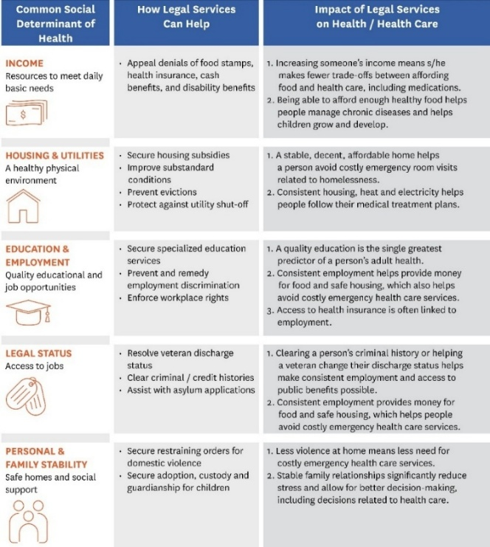

BRIEF VENDOR DESCRIPTION

Directions: In the box below, Vendor shall provide the name of their organization, the organization mission, the address where the Vendor will operate, how the location facilitates access for the client target population statewide, and a description of how hours will be scheduled for the project.

Name of Vendor
State Mission of Organization
Address where Vendor will operate
How the Location facilitates access for the client target population statewide
Describe how hours will be scheduled

Client Target Population

Name of VENDOR agrees to serve statewide, adults (age 18 and over) diagnosed with a behavioral health condition engaged with DSAMH services or a DSAMH behavioral healthcare contracted service provider.

Service Functions

The primary functions of the MLP include the following general areas:
- Direct legal representation
- Legal advice/consultation
- Training for DSAMH staff and identified DSAMH Providers
- Information and Referral
Name of VENDOR agrees to implement and maintain the I-HELP™ framework as developed by the National Center for Medical Legal Partnership. I-HELP™ categories to be addressed include Income, Housing and utilities, Education and Employment, Legal status, and Personal and family stability

Name of VENDOR shall make available to the DSAMH a MLP Attorney to strategically plan and coordinate referrals, facilitate training efforts, and respond to applicable emergencies. The Attorney will coordinate with DSAMH’s Project Lead to develop a workflow process to manage and monitor referrals and outcomes.

Name of VENDOR shall be responsible to provide legal services to DSAMH eligible clients to improve access to an overwhelming legal system. Clients will receive direct legal services in a variety of areas including housing, immigration, family issues and public benefits. This level of direct legal intervention can improve a client’s understanding of their own legal rights while positively impacting one’s health issues related to unaddressed legal concerns.
As important as ensuring legal assistance to DSAMH clients is, it is as valuable to provide training to behavioral health workers on the substantive legal issues associated with the social determinants of health. Training on the laws pertaining to housing, family issues, immigration, and public benefits enhances the behavioral health staff’s skills in identifying underlying issues and matching the client’s need with the appropriate resource. This cross-training seeks to increase the professional’s confidence level on various issues; and more importantly may give the practitioner an opportunity to gather more comprehensive information about the client’s social history. Name of VENDOR is responsible to train DSAMH direct care staff and targeted providers on the legal domains identified in the screening process. In partnership with DSAMH’s Project Lead, the training will include introduction to legal concepts, refresher seminars, and round table discussions to improve the integration of legal intervention into behavioral health care.
- Name of VENDOR shall facilitate four (4) introductory sessions (1 each quarter) for behavioral health personnel on relative topics including I-HELP™ categories previously mentioned.
- Name of VENDOR shall arrange round table discussions following an introductory session.
- Name of VENDOR shall facilitate four (4) refresher trainings, as needed, for DSAMH direct care workers and identified DSAMH Providers.
- Name of VENDOR shall develop and maintain MLP resources for client distribution including posters, hand-outs, fliers, etc. as an added resource to increase client awareness.
- Name of VENDOR shall enhance the MLP’s role in educating the legal and medical community of their initiative in addressing unmet legal needs of the targeted DSAMH client population.

Vendor Implementation Plan
Directions: In the chart below, Vendor shall identify the intended Implementation Plan in chart format with key activities (shade the appropriate contract month (1-12) for the start and completion time frame, as seen in monthly invoice line). The plan must cover start up through implementation of activities, including recruitment, hiring and orientation of key staff.

Key Activities | 1 | 2 | 3 | 4 | 5 | 6 | 7 | 8 | 9 | 10 | 11 | 12
Recruitment and Hiring
Orientation of Staff
Implementation of project
ENTER OTHER ACTIVITIES THAT SUPPORT MLP MODEL IMPLEMENTATION AND SERVICE FUNCTION COMPLETION (i.e referral process development, training, etc) can insert additional rows as needed
Monthly performance reports
Monthly provider/DSAMH meetings
Monthly invoices

Directions: Vendor can add any additional content, in the box below, that supports the implementation of the project:

Adherence to Policies and Procedures
Vendors are required to adhere to all federal, state and DSAMH policies, processes, procedures, requirements, rules, laws, and regulations, including, but not limited to, those listed under RFP# HSS-26-046, Medical Legal Partnership.
Name of VENDOR agrees to adhere to the following requirements:
- Criminal Background Check
- DSAMH011 – Trauma Informed Care
- DSAMH012 – Provision of Culturally and Linguistically Appropriate Services
- Human Subjects Review Board
- Inclusion
- Trauma Informed Care
- The Drug-Free Workplace Act of 1988.
- The Americans with Disabilities Act (PL 101-336).
- State of Delaware, Office of Management and Budget, Budget and Accounting Manual. https://budget.delaware.gov/accounting-manual/index.shtml.
VENDOR RESPONSE TO ADHERENCE TO POLICIES AND PROCEDURES
Name of VENDOR shall submit any policies in place that support the agreeance of identified policies, processes, and regulations as requested by the Division as part of its contract monitoring process.
Name of VENDOR acknowledges that the Division reserves the right to modify, replace, or add to these policies with 60 days’ written notice to Name of VENDOR. In the event of a policy modification or addition of new policy, Name of VENDOR agrees to formulate a plan, in writing, regarding its compliance strategy with the modified or new policy.

Evaluation and Performance Measures
The following content establishes sustainable systems to understand the program and its outcomes as simply as possible, integrating data collection into current systems wherever possible. DSAMH has the right to conduct any onsite evaluation and monitoring of the Vendor’s activity at any time.
The extension of the service period of the contract is based on, but not limited to, the past performance of the Vendor. The determination shall be based on, but not limited to, considerations of the following factors:
Performance Objective | Method of Assessment
Provide services as identified in the Scope of Services | Vendor monthly provider meeting participation, Review of program reports, third-party feedback
Compliance with all State and Federal statutes and regulations as applicable for the operation of services identified in the Scope of Work. | Review of program reports, third-party feedback
Adhere to requirements in Professional Service Agreement, Divisional Requirements, Scope of Services, and Contract Budget information. | Vendor monthly provider meeting participation, Review of program reports, third-party feedback, Annual submission of policies, procedures, and plans outlined in scope of work
Reconcile accounts before submitting invoices | Review of Vendor invoices and back-ups to the invoices
Submit required invoices on time | Review of Invoices
Deliver required reports | Review of Reports and Deadlines

VENDOR RESPONSE TO EVALUATION AND PERFORMANCE MEASURES
Name of VENDOR agrees to the following responsibilities as outlined for Evaluation and Performance Measures:
- Participate in all meetings (as appropriately scheduled) related to program/project management and contractual administrative functions.
- Coordinate and communicate work product efforts in conjunction with the Division’s Project Lead.
- Submit a Continuity of Operations (COOP) Plan annually as part of the Division’s contract monitoring process. COOP Plans are intended to guide the Vendor as whole in the continued provisions of essential operations and the re-establishment of critical business functions during and after a disaster occurs.
- Comply with performance objectives and all contractual requirements outlined in contract.
- Prominently display on all materials related to and developed for this project the following wording “Funding for this project has been provided by Delaware Health and Social Services’ Division of Substance Abuse and Mental Health through state general funds.”

Quality Improvement
Vendor shall implement a method for identifying, evaluating, and correcting deficiencies in the quality and quantity of services to be provided under any resulting contract arising out of this RFP. The quality assurance plan shall include the proposed indicators essential to assess the Vendor’s performance and the overall adequacy of services being provided to individuals in the target population. Specifically, within the quality assurance plan, identify expected individual and system outcomes and benefits, and how client satisfaction and stakeholder satisfaction will be assessed.
Vendors must comply with regular program and service reporting. Presently, the Vendor shall submit monthly program reports to DSAMH_housing@delaware.gov by the 10th of each month for the preceding month of service. DSAMH shall establish the content and format structure of the report.
As DSAMH reviews its various reporting mechanisms for the purpose of standardization across its behavioral health ecosystem, DSAMH reserves the right to shift the mechanism of how monthly program information is submitted which may include submission via a state contracted cloud-based survey platform. DSAMH shall provide the Vendor 60 days’ notice of any report submission changes in writing.
VENDOR RESPONSE TO QUALITY IMPROVEMENT
Name of VENDOR agrees to submit an updated quality assurance plan annually as part of the Division’s contract monitoring process.

This plan should include a description of how the fidelity of the MLP model will be sustained (i.e. methodology, reporting mechanisms used, etc.). This plan shall include performance targets and how these will be evaluated, tracked, and reported. Additionally, this plan shall include how client satisfaction and stakeholder satisfaction will be assessed.

Measurement and Key Outcome Indicators
Presently, the Vendor shall submit monthly program reports to DSAMH_housing@delaware.gov by the 10th of each month for the preceding month of service. DSAMH shall establish the content and format structure of the report. As DSAMH reviews its various reporting mechanisms for the purpose of standardization across its behavioral health ecosystem, DSAMH reserves the right to shift the mechanism of how monthly program information is submitted which may include submission via a state contracted cloud-based survey platform. DSAMH shall provide the vendor 60 days’ notice of any report submission changes in writing.

The selected Vendor will be required to establish a monthly reporting process at the time of contracting and on an ongoing basis to monitor project milestones. Additional reporting measures may be asked of the vendor ad hoc by DSAMH as needed. Below are the category measures that the Vendor shall be asked to collect:

- Referral information-Tracks aggregate number of client referrals from behavioral health partners to vendor, including basic client demographics (gender, age (Young People (18-24); Young Adults (25-35); Older Adults (36-60); Seniors 60+), race and ethnicity), dates of referrals, name of referral source, referral(s) legal issue, and referral(s) status.
- Case management statistics-This includes, legal case status (cases opened/closed and by type), number of consultations conducted, number of contacts/hours spent (includes on-going case contacts by month), and the legal outcome. Client HIPAA de-identified success stories or challenge narratives may also be requested as qualitative analysis based on direct client experience provides a complete understanding of the service’s importance.
- Training information-Aggregate metrics related to training behavioral healthcare staff on social determinants of health and legal issues, which can improve client-provider conversations and outcomes. This includes number of trainings presented, types of training presented, number of attendees, number of individuals reached through digital media/social media dissemination efforts, and changes to provider staff knowledge and practice due to vendor trainings and resources.

As part of the quality improvement plan, the monthly program report must also highlight issues raised either by the vendor as continuous improvement objectives along with recommendations to address these objectives.
DSAMH reserves the right to claw back or hold funds for program reports not submitted.

VENDOR RESPONSE TO Measurement and Key Outcome Indicators
Name of VENDOR agrees to submit the requested metrics as outlined. Name of VENDOR acknowledges that the Division reserves the right to shift the mechanism of how monthly program information is submitted provided Name of VENDOR receive 60 days’ notice of any report submission changes in writing.

