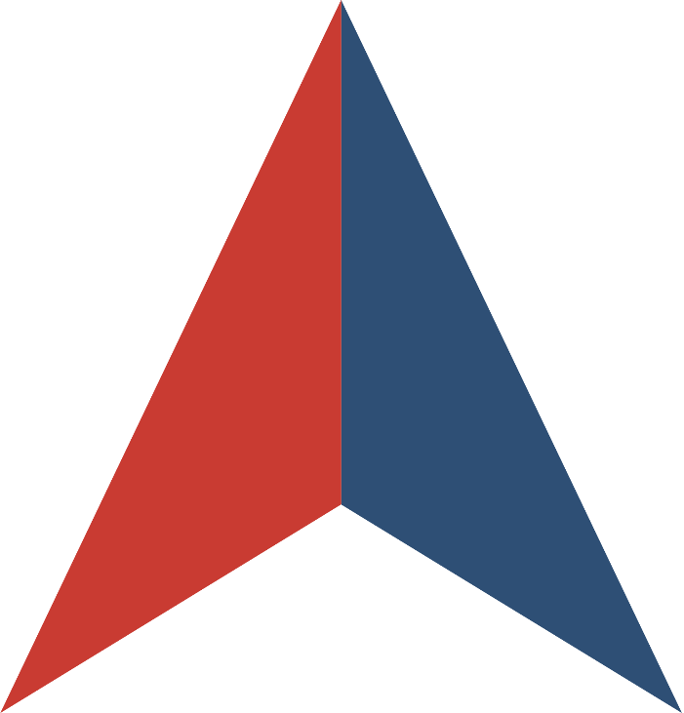

REQUEST FOR PROPOSALS
for
BODY ARMOR AND BALLISTIC RESISTANT PRODUCTS

Issued by the
STATE OF COLORADO



In collaboration with


SOLICITATION NUMBER: RFP-SPCO-AR-25-03
RFP WEBSITE: http://colorado.gov/vss
RFP OVERVIEW

- INTRODUCTION
This Request for Proposals (RFP) is being issued by the State of Colorado (“Lead State”) in collaboration with the NASPO ValuePoint cooperative purchasing program. The purpose of this RFP is to establish one or more Master Agreements for Body Armor and Ballistic Resistant Products with qualified suppliers.
Offerors should be able to provide new ballistic-resistant vests, spike- and edged-blade-resistant vests, ballistic-resistant helmets, ballistic-resistant shields, and associated products that meet the following requirements as established by the National Institute of Justice (NIJ) and ASTM:
- NIJ Standard 0101.06, Ballistic Resistance of Body Armor
- NIJ Standard 0101.07, Ballistic Resistance of Body Armor
- NIJ Standard 0115.00, Stab Resistance of Personal Body Armor
- NIJ Standard 0115.01, Stab Resistance of Personal Body Armor
- ASTM E3347/E3347M, Ballistic Resistant Shields
- ASTM E3368/E3368M, Ballistic Resistant Helmets
- Other relevant standards for Body Armor and Ballistic Resistant Products
Products for which there exists an NIJ Compliant Products List (NIJ CPL) shall be listed on the appropriate NIJ CPL. Products for which there exists an ASTM Verified Products List shall be listed on the appropriate ASTM Verified Products List.
The objective of this RFP is to obtain the best value and, in some cases, achieve more favorable pricing than is obtainable by an individual state or local government entity because of the collective volume of potential purchases by numerous state and local government entities.
About NASPO ValuePoint
NASPO ValuePoint is a division of the National Association of State Procurement Officials (NASPO), a non-profit association dedicated to advancing public procurement through leadership, excellence, and integrity. In accordance with NASPO ValuePoint’s Lead State Model™, the Lead State is issuing this RFP, evaluating responses, and establishing Master Agreements with the support and assistance of a Multistate Sourcing Team™ composed of individuals from other member states, representing a broad range of perspectives that ensure the RFP incorporates best practices recognized by public entities across the country.
Participation in NASPO ValuePoint Master Agreements is convenient and cost-effective for eligible entities—including state departments, institutions, agencies, political subdivisions, federally recognized tribes, and other eligible public and nonprofit entities in the 50 states, the District of Columbia, and U.S. territories—and suppliers, with no membership or registration required. In 2023, contractors reported a combined $20.48 billion in sales through NASPO ValuePoint Master Agreements awarded through cooperative solicitations like this RFP, including a combined $70.25 million in sales through the current Body Armor and Ballistic Resistant Products portfolio.
More information about NASPO, NASPO ValuePoint, and the NASPO ValuePoint Lead State Model can be found at www.naspo.org and www.naspovaluepoint.org and in Attachment E – Participation Information.

- GENERAL INFORMATION AND INSTRUCTIONS
  - RFP Contact. The following individual is the sole contact for this RFP:
Amy Risley
State Procurement Administrator
State of Colorado
amy.risley@state.co.us
303-866-5663
  - RFP Website. The following website is the sole official source for RFP information and updates:
http://colorado.gov/vss
Click “View Published Solicitations” and choose “Open” under the Show Me dropdown. Then search “*BODY ARMOR*” or “*2025000008*” in the Keyword Search box. After clicking on the hyperlinked solicitation number, click on the “Attachments” tab to access the RFP files.
Proposal Submission. Send an email to RFP_SPC.h158ekv4bex7k3l3@u.box.com, attaching the proposal as a zip folder. Proposals sent by other methods will not be accepted.
IMPORTANT: The Zip Folder must be titled with the RFP Number, RFP Title, and the Offeror’s name, such as below:
RFP-SPCO-AR-25-03 – Body Armor and Ballistic Resistant Products – Company Name
Please note the following:
- The subject line and body of the email are not uploaded into the online submission application; only email attachments are. Should any Offeror wish to ask a question or make a comment regarding the solicitation, Offerors should send a separate email to amy.risley@state.co.us.
- Offerors should submit one zip folder that contains all required proposal submission documents. The zip folder name should include the following title: RFP- SPCO-AR-25-03, Body Armor and Ballistic Resistant Products and also include the Offeror’s name.
- The solicitation submission application typically uploads proposals within five minutes. Offerors are advised to submit proposals no later than one hour prior to the solicitation deadline to ensure the proposal has been received.
- Please make certain that your email program will allow zip folders of the size your proposal response is being submitted to be sent from your email address.
- The application sends an email confirmation if the proposal was uploaded correctly.
- Please do not encrypt your email. The e-submission program automatically encrypts attachments and any additional encryption may result in failure to upload the proposal.
- The solicitation submission application is only for proposal submission. All inquiries, questions, comments, or concerns should be submitted to the procurement contact via email and not through the solicitation submission application.
  - RFP Documents. This RFP consists of this RFP Overview, the following attachments, and any information or materials posted by the Lead State to the RFP Website, as amended:
    - Attachment A – RFP Terms and Conditions
    - Attachment B – Scope of Work
    - Attachment C – RFP Evaluation Plan
    - Attachment D – Sample Master Agreement
    - Attachment E – Participation Information
    - Attachment F – Protest Information
    - Attachment G – Offeror Information, Acknowledgements, and Certifications
    - Attachment H – Offeror Response Worksheet
    - Attachment I – Cost Proposal
    - Attachment J – Proposed Modifications to Sample Master Agreement
    - Attachment K – Claim of Business Confidentiality
    - Attachment L – Agents and Distributors by State
  - Important Dates.
    - RFP Post Date: September 26, 2024
    - RFP Q&A Questions Deadline: October 09, 2024 @ 03:00 pm MDT
    - RFP Close Date: November 05, 2024 @ 02:00 pm MST
    - Public Opening: November 05, 2024 @ 02:30 pm MST
If Offeror wishes to attend the virtual Public Opening, Offeror shall reach out to the RFP Contact in Section II.A.
Dates and deadlines are subject to change. Offerors should continue checking the RFP Website for the most up-to-date information.
  - How to Ask Questions.
    - Read and review this RFP, including all attachments, exhibits, and amendments.
    - For questions about the content of this RFP, send your questions via email to the RFP Contact. Questions must reference the specific section of the RFP to which the question relates.
    - Distributors and/or Agents must direct all questions through the Offeror.
    - Please limit inquiries to only those questions that are essential in order to submit a viable proposal in response to this RFP. Requests for detailed or exhaustive information may be declined if said information is not deemed by the Lead State to be necessary in order to submit a viable proposal.
    - Response to supplier questions will be published as a modification on VSS. Suppliers should not rely on any other information if it is not published on VSS, either written or oral, that alter any specification or other term or condition of the RFP during the open solicitation period. Suppliers are NOT to contact any other state office or individual regarding this solicitation, as doing so may result in the supplier being disqualified.
    - The identity of potential suppliers will not be published with the answers, but the text of questions may be restated, so suppliers are cautioned about including context in questions that may reveal the source of questions.
    - For assistance with technical issues associated with the RFP Website, contact the ColoradoVSS Help Desk, available Monday through Friday from 8:00 a.m. to 5:00 p.m. MT (excluding State holidays) by email: VSSHelp@state.co.us.
  - How to Respond.
    - Read and review this RFP, including all attachments, exhibits, and amendments.
    - Prepare a proposal that:
      - Follows the requested format;
      - Includes the Solicitation Number on all materials making up the proposal;
      - Addresses each question and request for a response in this RFP, including all questions in Attachment H – Offeror Response Worksheet;
      - Clearly demonstrates your ability to meet the Scope of Work described in Section III and Attachment B; and
      - Includes all required submissions identified in Section IV.A.
    - Submit your proposal as described in Section II.B by the RFP Close Date.
- SCOPE OF WORK
A detailed description of the Deliverables being sought through this RFP is attached as Attachment B – Scope of Work.
The scope of this RFP and its resulting Master Agreement(s) is intended to benefit all state departments, institutions, agencies, political subdivisions, and other eligible public and nonprofit entities in the 50 states, the District of Columbia, and U.S. territories. Therefore, Offerors should not interpret the Scope of Work to be associated with or limited to any specific purchase, implementation, project, need, or program within the Lead State or any other state or eligible entity. Proposals should be generally applicable to all potential Participating Entities and Purchasing Entities, except where specificity is requested.
The initial term of the Master Agreement(s) resulting from this RFP is anticipated to be two (2) years, with the option to exercise renewals totaling up to an additional three (3) years following the initial term, upon mutual agreement by the Lead State and Contractor.
- OFFEROR RESPONSE
  - Required Submissions. The following must be submitted with your proposal:
    - Any response must be submitted directly through an online submission application. To use this application, please send an email to RFP_SPC.h158ekv4bex7k3l3@u.box.com, attaching the proposal response as a zip folder.
    - Completed and signed Attachment G – Offeror Information, Acknowledgements, and Certifications
    - Completed Attachment H – Offeror Response Worksheet
    - Completed Attachment I – Cost Proposal, submitted as a separate document and separate file, in electronic submission
    - Completed Attachment J – Proposed Modifications to Sample Master Agreement
    - Redlined copy of Attachment D – Sample Master Agreement, if proposing modifications
    - Completed and signed Attachment K – Claim of Business Confidentiality
    - Redacted copy of proposal clearly marked as such, if claiming confidential, proprietary, or protected information
    - Completed Attachment L – Agents and Distributors by State
  - Other Documents. The following are informational only and do not need to be submitted with your proposal:
    - This RFP Overview
    - Attachment A – RFP Terms and Conditions
    - Attachment B – Scope of Work
    - Attachment C – RFP Evaluation Plan
    - Attachment D – Sample Master Agreement
    - Attachment E – Participation Information
    - Attachment F – Protest Information

- EVALUATION AND AWARD PROCESS
  - A comprehensive, thorough, complete, and impartial evaluation of each proposal received will be conducted in accordance with §24-103-203(7), C.R.S, which states, “The award shall be made to the responsible Offeror whose proposal is determined in writing to be the most advantageous to the state, taking into consideration the price and evaluation factors set forth in the request for proposal.”
  - Proposals will be sealed until the Public Opening. After opening, proposals will be evaluated in stages as set forth in this section and further detailed in Attachment C – RFP Evaluation Plan.
    - Stage 1: Initial Responsiveness Evaluation. Proposals will be reviewed for completeness, initial responsiveness, and compliance with all mandatory requirements. Proposals omitting required documents or responses or failing to meet all Mandatory Requirements may be rejected in accordance with Attachment A – RFP Terms and Conditions.
    - Stage 2: Technical Criteria Evaluation. Proposals meeting or exceeding the Mandatory Minimum Requirements will be evaluated against the Technical Criteria set forth in Attachment C – RFP Evaluation Plan. The Lead State and Multistate Sourcing Team will then determine which proposals will proceed to Stage 3: Cost Evaluation. Methods used to make this determination may include, but are not limited to, one or more of the following:
- Identification of a natural break in total scores
- Consideration of the optimal number of Contractors required to successfully supply Deliverables to Participating Entities and Purchasing Entities
    - Stage 3: Cost Evaluation. Cost Proposals for proposals not rejected following evaluation of Technical Criteria will be evaluated based on MSRP/List Price Discount Percentages. Cost Proposals may also be subject to an independent review for reasonableness and best value by the Lead State. Costs determined not to be reasonable or best-value by the Lead State may result in all or part of Offeror’s proposal being rejected, notwithstanding the results of the Cost Proposal evaluation.
    - Scores from the technical criteria and cost evaluations will be combined, as set forth in Attachment C – RFP Evaluation Plan, to get a final score for each category type.
  - The Lead State and Multistate Sourcing Team will then determine which proposals are most advantageous to the Lead State and potential Participating Entities and Purchasing Entities. Methods used to make this determination may include, but are not limited to, one or more of the following:
- Identification of a natural break in total scores
- Consideration of the optimal number of Contractors required to successfully supply Deliverables to Participating Entities and Purchasing Entities
  - Prior to announcement of awards and execution of Master Agreements, the Lead State will present an award recommendation to NASPO ValuePoint for approval of the proposed awards.
  - Following approval of NASPO ValuePoint and the approvals required by the Lead State, a public Notice of Intent to Award will be published on Colorado VSS.
Negotiations with successful Offerors will begin after the conclusion of the Protest Period.

