E X H I B I T I

D O C U M E N T S A N D S P E C I F I C A T I O N S

F O R

SOLICITATION No. AGR2602R

CONTRACT NO. FS-2026-02-R

E N T I T L E D

REDDEN S T A T E F O R E S T
Bailey Tract

COMMERCIAL TIMBER SALE
58 Acres

Date__7/15/25

Delaware Department of Agriculture Forest Service
2320 S DuPont Hwy
Dover DE 19901
302-698-4548

Bids will be received until 1:00 p.m. August 15, 2025 and will be opened publicly and read aloud at that time. Proposals received after the date and time set for the opening will be returned un-opened.

DOCUMENTS AND SPECIFICATIONS
FOR
CONTRACT NO. FS-2026-02-R
REDDEN STATE FOREST
Bailey Tract Stand 6
Commercial Timber Sale
DATE 7/15/2025
I. BIDS

A. Bids will be received until 1:00 p.m., August 15, 2025 and will be opened publicly and read aloud at that time. Proposals received after the date and time set for the opening will be returned unopened.

B. Proposals must be delivered to the Delaware Department of Agriculture Forest Service, 2320 S DuPont Hwy, Dover DE 19901 and bear the following:
"AGR-FS-2026-02-R, Redden State Forest Commercial Timber Sale" and the bidder’s company name.

C. The Delaware Department of Agriculture reserves the right to reject any and all bids.

II. DEPOSITS

A. A bid deposit in the amount of $5,000 must accompany each bid. This deposit shall be submitted in the form of a certified check drawn on a reputable banking institution and made payable to the Delaware Department of Agriculture Forest Service.

B. The successful bidder(s) bid deposit(s) shall be retained and deposited by the Delaware Department of Agriculture as a performance guarantee that the terms and conditions of the Contract are met.

III. RETURN OF BIDDER'S DEPOSIT
Deposits from unsuccessful bidders shall be returned within seven (7) days after the signing of the Contract by the successful bidder. This shall not exceed sixty (60) days.

IV. PREPARATION OF PROPOSAL

The bidder's proposal shall be printed clearly or typed. All bid proposals are required to be submitted on Exhibit III, Proposal Form, which is provided.

V. DELIVERY OF PROPOSALS

Proposals shall be placed in sealed envelopes and shall bear on the outside the following:
"AGR-FS-2026-02-R, Redden State Forest Commercial Timber Sale" and the bidder’s company name.

VI. WITHDRAWAL OF PROPOSALS

A bidder may withdraw a proposal unopened after it has been submitted, if such a request is made prior to the time set for the opening of the proposal. Any bids that are in at the time of closing shall not be withdrawn.

VII. PUBLIC OPENING OF PROPOSALS

Proposals will be opened publicly and read aloud at the Department of Agriculture, Forest Service, 2320 S DuPont Hwy, Dover DE 19901, on the date and hour set within the RFP. Bidders or their authorized representatives are invited to be present. Proposals received after the time set for the public opening will be returned unopened or not accepted

VIII. DISQUALIFICATION OF BIDDERS

Any one or more of the following may be considered as a sufficient cause for the disqualification of a bidder and the rejection of his/her proposal or proposals:

A. More than one proposal for the same Contract from an individual or company.

B. Evidence of collusion among bidders.

C. Unsatisfactory performance record of a bidder as evidenced by past experiences on both private and public lands. Examples of unsatisfactory performance include but are not limited to; Best Management Practices (BMP) violations, permit violations, failure to secure permits prior to harvests, fraud, failure to complete prior harvests, etc.

D. Any unauthorized additions, interlineation, conditional or alternate bids, or irregularities of any kind which may tend to make the proposal incomplete, indefinite, or ambiguous as to its meaning.

IX. BASIS OF AWARD

 | EVALUATION CRITERIA
 |  | PERCENTAGE | POINTS
1. | The offeror’s ability to meet the conditions of this Timber Harvest:  - Prior Harvesting Evaluations (Public/Private)  - Ability to Perform contract requirements*  - Equipment to Perform the Task | 15  5  5 | 15  5  5
2. | Bid Amount | 75 | 75
. | TOTAL SCORE | 100% | 100

*Under 1-B of the Evaluation Criteria, the names and references of each member of the crew that will be working on State Forest grounds will be reviewed and evaluated. This information must be placed on the Exhibit III. The Proposal Form. The Department reserves the right to deny bids based on members of the crew/company that are deemed to have unsatisfactory performance on prior harvesting jobs throughout the region.

X. CONTRACT AWARD

A. Unless all bids are rejected as per Section I Paragraph C, or disqualified per Section VIII, the Contract shall be awarded within thirty (30) calendar days from date of bid opening.

B. The successful bidder will be notified in writing by the Delaware Department of Agriculture Forest Service during this period. All Contract(s) and attachments will be provided to the successful bidder at the time of notification.

XI. EXECUTION OF CONTRACT DOCUMENTS AND PAYMENT

A. The successful bidder will sign and return the Contract Documents within thirty (30) calendar days following notification of bid award. Failure to do so shall result in the cancellation of the Contract offer and bid deposit.

XII. INDEMNIFICATION

A. The Buyer, his or her agent, and employees agree to indemnify and hold harmless the State of Delaware and the Delaware Department of Agriculture, their agents and employees from any and all liability suits, actions, or claims, together with all costs, expenses or attorney’s fees arising from the negligence or other tortuous acts or omissions by the Buyer, his or her agent, and employees regardless of whether such suits, actions, claims, or liabilities are also based upon acts or failure to act attributable to the State of Delaware, Delaware Department of Agriculture, their agents or employees.

XIII. INSURANCE

A. The Buyer, his or her agent, and employees shall maintain and furnish such insurance as will protect against claims under Workmen's Compensation Acts and from any other claims for damages for personal injury, including death, which may arise from work under their operation. The Buyer, his or her agent, and employees is an independent contractor and is not an employee of the State.

B. The Buyer, his or her agent, and employees shall, at their expense, carry liability insurance with a minimum coverage of $100,000 each person, $300,000 each occurrence and property damage insurance with minimum limits of $50,000. Insurance policies are to remain in effect at all times until the completion of the Contract. A copy of the certified insurance must be forwarded to the Department with the signed Contract Document.

C. Notwithstanding the information contained in paragraphs A and B above, the Buyer, his or her agent, and employees shall indemnify and hold harmless the State of Delaware, the Delaware Department of Agriculture, their employees and agents from contingent liability to others for damages because of bodily injury, including death, which may arise from the Buyer’s, his or her agent’s, and employees' performance under this Contract, and any other liability for damages for which the Buyer, his or her agent, and employees are required to indemnify the State under any provision of the Contract. No provision of the Contract shall waive the State of Delaware's sovereign immunity defense to any claim or action arising from the Contract.

TECHNICAL SPECIFICATIONS
XIV. VOLUMES, LOCATION AND SPECIFICATIONS
- The Department offers for sale the following estimated sawtimber stumpage on approximately 58 acres located on the Bailey tract of Redden State Forest. (See Exhibit II).

Species Live Trees Only - Sawtimber Volume

Loblolly Pine 1,070,158 bd. ft.

B. Sawtimber volumes were computed from standard volume tables for southern conifers and eastern hardwoods, International 1/4" Kerf, from individual tree measurement with minimal sawlog diameters of 12” DBH.. Volumes and acres are not guaranteed.

C. All areas marked in white crossed hatch will not be touched, see stand map, this will be a direct violation of timber trespass. This will carry a penalty of three (3) times the market value of the damaged tree. Restitution will be paid to the Department of Agriculture Forest Service if any violation occurs before the performance bond is returned.

D. The Department’s prescription is for the clearcut harvesting method to be used. With the exception of the aforementioned, all live trees, within the contract boundaries, shall be the property of the buyer until contract expiration date at which time all rights to standing, downed, stacked, and processed products or trees will revert to the Department, unless an extension of time or early release is agreed upon by both parties in writing. The Buyer shall not harvest any dead trees as they will remain for wildlife habitat.

E. The sale area is located west of Piglet Path and south of Wilson Hill Rd. Please see maps for exact location.

F. See Exhibit II for generalized and specific location maps.

G. The entire perimeter of the timber sale area is marked with pink flagging which reads “TIMBER SALE BOUNDARY.”
H. All exclusion areas represented on the map within the timber sale boundaries are marked in pink flagging which reads “ DO NOT CUT”.

XV. DURATION OF CONTRACT

A. Unless in default or prior inspection and completion is granted in writing, the Contract shall terminate 365 calendar days after the date that the Contract Document Agreement is executed.
B. Any requests for extension of time beyond 365 calendar days shall be made at least two weeks in advance of the contract expiration date, in writing from the Buyer to the Delaware Department of Agriculture POC.

Exhibit II
General Location Maps for
FS-2025-01-R Commercial Timber Sale
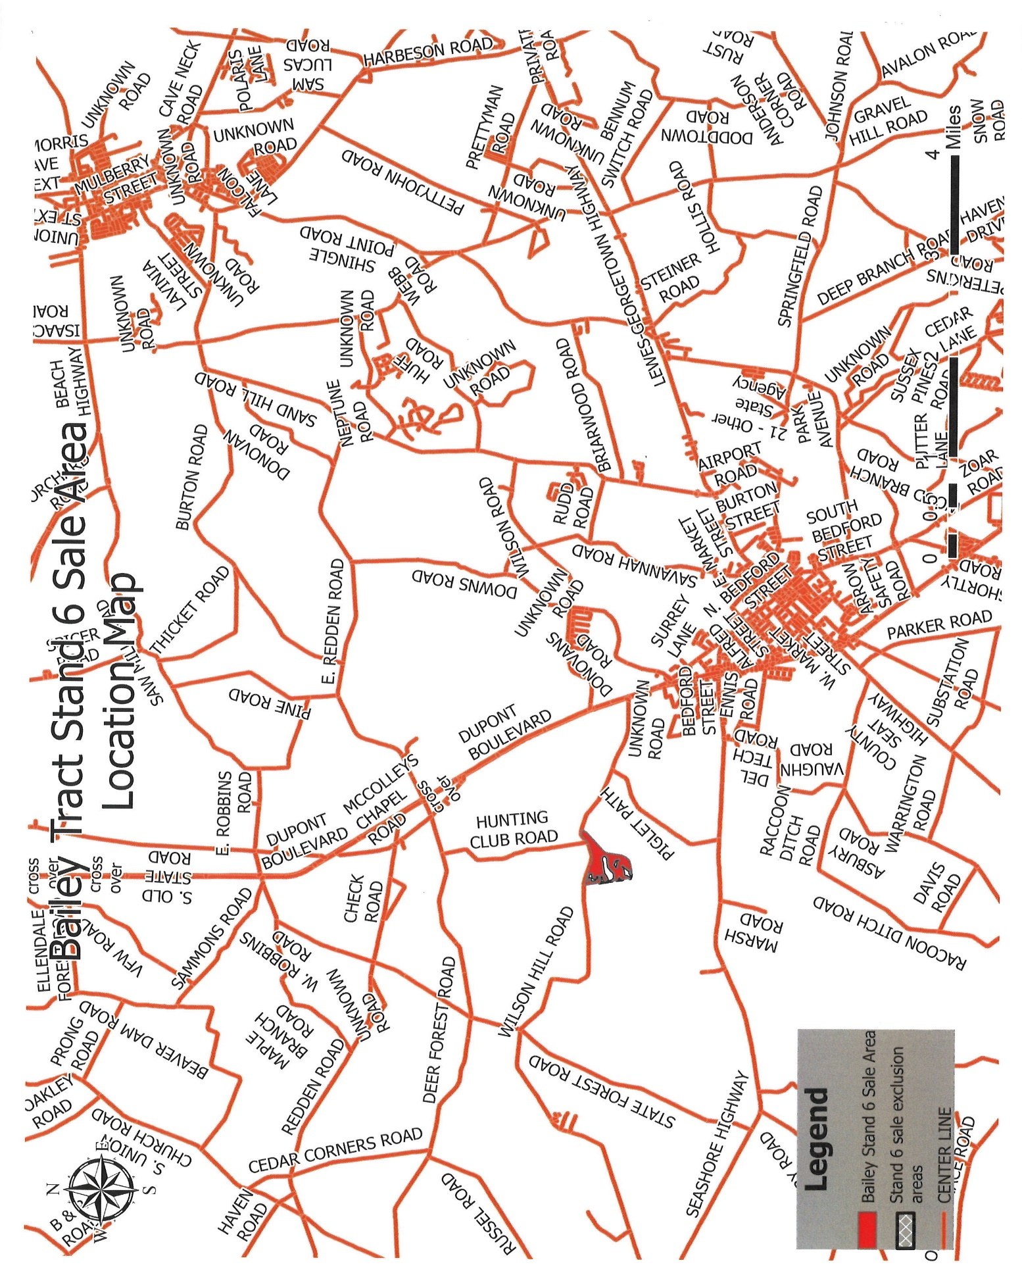

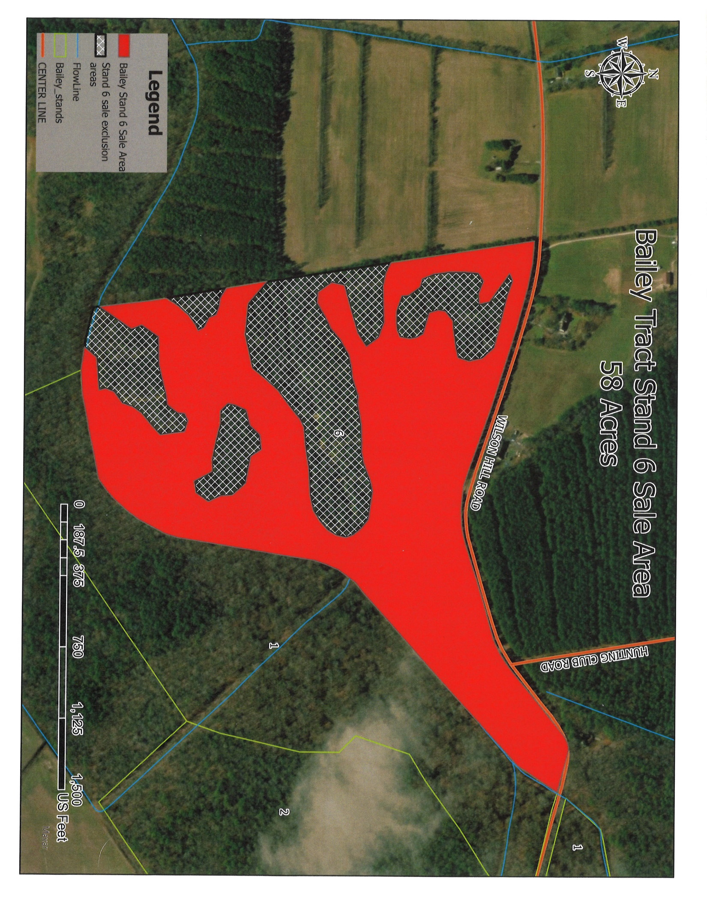

EXHIBIT III
PROPOSAL FORM
DELAWARE DEPARTMENT OF AGRICULTURE FOREST SERVICE
CONTRACT NO. FS-2026-02-R
DATE 7/15/2025
REDDEN STATE FOREST
TRACT: Bailey
The undersigned, having read the Contract Documents, hereby proposes to provide all necessary equipment and labor to perform and complete said Contract for the following quoted price:
TOTAL BID PRICE FOR ALL STUMPAGE _ FIGURES
TOTAL BID PRICE FOR ALL STUMPAGE_ __ _
WORDS
ABILITY TO MEET THE PERFORMANCE STANDARDS OUTLINED YES/NO
NAMES OF HARVESTING CREW AND REFRENCES____________________________________________________________________________________________________________________________________________________________________________________________________________________________________________________________________________________________________________________________________________________________________________________________________________________________________________________________________________________________________________________________________________________________________________________________________________
OTHER COMMENTS AND PROPOSAL INFORMATION: ________________________________________
__________________________________________________________________________________________
BID SUBMITTED BY: (Please print in ink or type)
Company Name
Address____ ___
Telephone No._ ( ) ____________________ ___________
By ______________ _
Title_ ___________________
SIGNED ___________________________
TITLE _ _________
COMPANY_________________________
Sworn to and subscribed before me this day of ,2025
__________________________
Notary Public

EXHIBIT IV
CONTRACT DOCUMENT
DELAWARE DEPARTMENT OF AGRICULTURE
CONTRACT NO. FS-2025-01-R
Bailey Tract Commercial Timber Sale
7/15/25

THIS AGREEMENT, made and executed this day of , by and between Buyer (hereinafter designated as Buyer), party of the first part, and the Delaware Department of Agriculture, a department created under the laws of the State of Delaware (hereinafter designated as Department) party of the second part.

WITNESSETH that the Buyer in consideration of the covenants and agreements herein contained and made by the Department agree to the following:

ARTICLE ONE. The Buyer shall and will provide and furnish all the necessary labor and equipment to perform and complete this Contract and all Specifications and Proposals issued by the Department, entitled Contract No.FS-2025-01-R, "Redden State Forest, Bailey Tract Commercial Timber Sale" dated _____________, as hereby incorporated by reference as Exhibit I, Exhibit II, Exhibit III, and Exhibit IV.

ARTICLE TWO. The Buyer shall and will pay to the Delaware Department of Agriculture based on the stumpage price offered. This must be paid at the time of contract execution.

ARTICLE THREE. The Department agrees to allow the Buyer right of access, ingress, egress, and regress to, on, over, and through property of the Department using such roads as the Department shall prescribe for the purpose of cutting and removing there from such timber as is included in the terms of the Timber Sale Specifications contained in Exhibits I, II, III, and IV.

The Department guarantees that it is the owner of said timber, holds a good title to the same and has the statutory right to remove said timber, and further agrees to answer any and all claims to the contrary at its expense.

The Department guarantees that all requirements and regulations of Title 3, Chapter 10, Subchapter V, the Delaware Seed Tree Law, have been met, and the Buyer has no reforestation responsibilities on this property.

The Department reserves the right to stop all logging operations due to wet weather conditions which can cause environmental degradation, safety violations, and/or violations of this Contract which shall be identified by the Department.

Landing sites will be designated by signs or approved by the State Forester or his/her designated agent.

ARTICLE FOUR. The Buyer shall perform all logging functions in a professional manner at all times, including, but not limited to the following:

1. Shall cut only those trees designated to be within the sale area. The term designated trees, as used herein, is understood to be only those live trees located within the designated area as outlined in the Timber Sale Specifications contained in Exhibits I, II, III, and IV.

2. Shall avoid damage to trees not designated for harvest within the sale area and any trees outside the sale area, during all phases of logging operations.

- Shall perform all logging functions in a professional manner at all times per the Department.

- Shall use landing sites, existing roads and forest roads as designated and permitted by the Department. These sites and roads shall be restored and seeded per the Departments standards.

- Shall refrain from allowing equipment parts, motor oil containers and filters, air filters, paper, scrap metal, wire, or any discarded material to be left on lands of the Department or adjoining lands. Realizing that logging operations tend to generate materials of this type, the Buyer will provide suitable containers on site for depositing discarded material and trash. These containers will be removed from the logging site when full and emptied off-site by the Buyer. Upon completion of logging operations, trash containers will be permanently removed from the logging site. In case of accidental oil or fuel spills on lands of Department, Buyer will immediately initiate cleanup of said oil or fuel spills and remove contaminated soil and other materials from the site.

7. Shall make stump cuts so that all stumps shall be at a height no greater than 12 inches above ground level.

8. Shall leave the streams, ditches, ponds, or other water sources free and clear of treetops, brush, or other obstructions. To repair anything that is damaged by the operation and leave trails, roads, and property boundary markers in a condition as close to the original condition as possible.

9. Shall notify the Department or the designated agent, two (2) working days in advance of the intention to start cutting or moving equipment onto the site. Notice will also be given two (2) working days prior to the completion of the Contract and before equipment is moved off sight

10. Shall exercise caution at all times by the Buyer, his or her agents, and employees, or those that may be under Contract to him, that fires are not to be started or permitted to spread.

11. Shall carry liability insurance, workman's compensation, and such motor vehicle insurance as required by the Timber Sale Specifications, Exhibit I, Delaware State Law, and furnish proof of same to the Department prior to commencement of the harvesting operation.

12. Shall hold the Department harmless and blameless from any and all claims that may arise as a result of Buyer's operation on the Department's property.

13. Shall pay three (3) times the stumpage value for each tree not in the Contract that is cut or wantonly damaged. Damaged trees and stumpage amounts will be tallied by the Department at which time the Buyer has five (5) days to pay the Department.

14. Shall comply with all state and county laws/regulations and be responsible for any violations that occur on the Departments’ property as a result of the Buyers/Buyers agents’ actions.

15. Shall provide the Department with a list of the harvesting crew member names and references which must be approved by the Department prior to the start of work. Buyer agrees that no work can be performed, or equipment moved on the Departments property, until this is approved.

ARTICLE FIVE. The Buyer further agrees: To use best management practices throughout the operation to ensure that erosion and sedimentation are not generated during or following the operation, according to the rules and regulations of Title 3, Chapter 10, Subchapter VI, Delaware’s Forestry Practices Erosion and Sediment (E&S) Control Law. An Erosion and Sediment Control Permit must be approved by the Department prior to harvesting timber on this site. The buyer agrees to follow said permit requirements. Any restoration work needed on site as a result of the Buyer's operations will be the sole responsibility of the Buyer and at the discretion of the Department. Restoration work will be performed to the satisfaction of the Department, failure to comply shall result in the loss of the bid deposit.

ARTICLE SIX. It is hereby understood by the parties that the Delaware Department of Agriculture is an agency of the State of Delaware and is sovereignly immune from liability claims.

ARTICLE SEVEN. The terms of this agreement and Contract will be completed on or before .

ARTICLE EIGHT. The Contract Documents include this Contract, the Invitation to Bid, the Specifications and Exhibits, and the Bids.

ARTICLE NINE. This Contract may be amended upon the mutual written consent of both parties.

IN WITNESS WHEREOF, the said parties have duly executed this agreement in triplicate the day and year first above written.

IN WITNESS WHEREOF, the parties below hereunto set their hands on this day of ____________,2025.
______________________________ ___________________
Buyer’s Name Title
_____________________________________
Company Name
________________________________
Witness
State of __________________________

County of ________________________
Sworn and subscribed before me this day of _______ , 2025.
_____________________
Notary Public
_____________________________________________________________________________

IN WITNESS WHEREOF, the parties below have hereunto set their hands on this day of _________ ,2025.
___________________________
William D. Clifton
Secretary Delaware Department of Agriculture
________________
Witness
State of _______________________
County of ______________________
Sworn and subscribed before me this day of ,2025.
____________________
Notary Public

