

State of Delaware

MARINA LIFT (FORKLIFT)

Request for Proposal

Contract No. NAT15001-MARINA_LIFT

August 28, 2015

- Deadline to Respond -
September 30, 2015
1:00 PM (Local Time)

CONTRACT NO. NAT15001-MARINA_LIFT

ALL VENDORS:

The enclosed packet contains a "REQUEST FOR PROPOSAL" for MARINA LIFT (FORKLIFT). The proposal consists of the following:

- Introduction
- Scope of Work
- Format For Proposal
- Proposal Evaluation Procedures
- Mandatory Pre-Bid Meeting - Waived
- Definitions and General Provisions
- Proposal Reply Section
  - Attachment 1 – No Proposal Reply Form
  - Attachment 2 – Non-Collusion Statement
  - Attachment 3 – Exceptions
  - Attachment 4 – Company Profile and Capabilities
  - Attachment 5 – Confidentiality and Proprietary Information
  - Attachment 6 – Business References
  - Attachment 7 – Subcontractor Information Form
  - Attachment 8 – Monthly Usage Report
  - Attachment 9 – Subcontracting (2nd tier spend) Report
  - Attachment 10 – Office of Supplier Diversity Certification Application
  - Attachment 11 – Waived
  - Attachment 12 – Proposal Reply Requirements and Checklist
  - Appendix A – Scope of Work details
  - Appendix B – Pricing Form(s) and Instructions (if applicable)
  - Appendix C – Current Marina Lift (Forklift) Trade In Report

In order for your proposal to be considered, the Proposal Reply Section shall be executed completely and correctly and returned in a sealed envelope clearly displaying the contract number and vendor name by September 30, 2015 at 1:00 PM (Local Time) to be considered.

Proposals must be mailed to:

Delaware Department of Natural Resources and Environmental Control
Division of Parks and Recreation
89 Kings Hwy
Dover, DE 19901
Attn: Becky Lovin

Please review and follow the information and instructions contained in the general and special provisions section of the Request for Proposal. Should you need additional information, please contact Rebecca Lovin at 302-739-9206 or rebecca.lovin@state.de.us..

- INTRODUCTION

- PURPOSE

The purpose of this Request for Proposal is to obtain sealed proposals for procuring a new Marina Lift (Forklift) with the specifications listed herein and trading in the current owned Marina Lift towards that procurement to lower the overall cost. It is the goal of this Request for Proposal to identify a vendor(s) and execute a contract for purchase or lease of a Marina Lift (Forklift).

- COMPETITIVE SEALED PROPOSAL

It has been determined by the Division of Parks and Recreation, pursuant to Delaware Code Title 29, Chapter 6924 (a) that this solicitation be offered as a request for competitive sealed proposals because the use of competitive sealed bidding is not practical and/or not in the best interest of the State. The use of competitive sealed proposals is necessary to:

- Use a contract other than a fixed-price type; or
- Conduct oral or written discussions with vendors concerning technical and price aspects of their proposals; or
- Afford vendors an opportunity to revise their proposals through best and final offers; or
- Compare the different price, quality and contractual factors of the proposals submitted; or
- Award a contract in which price is not the determining factor.

- CONTRACT REQUIREMENTS

This contract will be issued to procure a new Marina Lift (Forklift).

- AGENCY USE CONTRACT

Pursuant to 29 Del. C. §6904(e) respectively, if no state contract exists for a certain good or service, covered agencies may procure that certain good or service under another agency's contract so long as the arrangement is agreeable to all parties. Agencies, other than covered agencies, may also procure such goods or services under another agency's contract when the arrangement is agreeable to all parties.

- MULTIPLE SOURCE AWARD

The Agency reserves the right to award this contract to more than one vendor pursuant to 29 Del.C. §6926. The Division of Parks and Recreation reserves the right to reject any or all bids in whole or in part, to make multiple awards, partial awards, award by types, item by item, or lump sum total, whichever may be most advantageous to the State of Delaware.

- CONTRACT PERIOD

Each Vendor’s contract shall be valid for three (3) years from November 1, 2015 through October 31, 2018. Each contract may be renewed for two (2) one (1) year periods through negotiation between the Vendor and the Division of Parks and Recreation. Negotiation may be initiated no later than ninety (90) days prior to the termination of the current agreement.

The State reserves the right to extend this contract on a month-to-month basis for a period of up to three months after the term of the full contract has been completed.

- KEY RFP DATES/MILESTONES

The following dates and milestones apply to this RFP and subsequent contract award. Vendors are advised that these dates and milestones are not absolute and may change due to unplanned events during the bid proposal and award process.

Activity | Due Date
RFP Availability to Vendors | Friday, August 28th, 2015
Written Questions Due No Later Than (NLT) | 2:00pm Local Time, Wednesday, September 9th, 2015
Written Answers Due/Posted to Website NLT | Friday, September 18th, 2015
Proposals Due NLT | 1:00pm Local Time, Wednesday, September 30th, 2015
Public Proposal Opening | 1:00pm Local Time, Wednesday, September 30th, 2015
Proposal Evaluation/Presentations as required | As Required
Vendor Best & Final Discussions, as required | As Required
Contract Award | Will occur within 90 days of bid opening

- INQUIRIES & QUESTIONS

We welcome your interest in working with us, and we will be pleased to answer any questions you may have in formulating your response to this Request for Proposal.

All questions with regard to the interpretation of this solicitation, drawings, or specifications, or any other aspect of this RFP must be received in writing by 2:00pm Local Time, Wednesday, September 9th, 2015. All questions will be answered in writing by Friday, September 18th, 2015 and posted on http://bids.delaware.gov/ website. All questions must make specific reference to the section(s) and page numbers from this RFP where applicable. Oral explanations or instructions will not be binding.

- RFP DESIGNATED CONTACT

All requests, questions, or other communications about this RFP shall be made in writing to the State of Delaware. Address all communications to the person listed below; communications made to other State of Delaware personnel or attempting to ask questions by phone or in person will not be allowed or recognized as valid and may disqualify the vendor. Vendors should rely only on written statements issued by the RFP designated contact.

Delaware Department of Natural Resources and Environmental Control
Division of Parks and Recreation
89 Kings Hwy
Dover, DE 19901
Attn: Becky Lovin

To ensure that written requests are received and answered in a timely manner, electronic mail (e-mail) correspondence is acceptable, but other forms of delivery, such as postal and courier services can also be used.

CONTACT WITH STATE EMPLOYEE

Direct contact with State of Delaware employees other than the State of Delaware Designated Contact regarding this RFP is expressly prohibited without prior consent. Vendors directly contacting State of Delaware employees risk elimination of their proposal from further consideration. Exceptions exist only for organizations currently doing business in the State who require contact in the normal course of doing that business.

- SCOPE OF WORK

- OVERVIEW

The Vendor(s) shall provide all equipment, materials and labor to supplement the State of Delaware’s need for MARINA LIFT (FORKLIFT) as described herein. The contract will require the Vendor(s) to cooperate with the ordering agency to insure the State receives the most current state-of-the-art material and/or services.

- BACKGROUND

The Division of Parks and Recreation operates the Indian River Marina at Delaware Seashore State Park. Part of the operational responsibilities are lifting and hauling boats from dry stack, storage and wet slip areas and transporting them. This is currently being handled by two (2) Wiggins Marina Bull forklifts.

- STATEMENT OF NEEDS

The Division of Parks and Recreation currently has two (2) Wiggins Marina Bull model forklifts (22,000 & 23,000). We are interested in procuring a new Marina Lift with the specifications listed herein and trading in the current model (22,000) towards that procurement to lower the overall cost. We are requesting various pricing options as part of this Request for Proposal in order to determine the best procurement method for the Division. Procurement Options shall include:

- STATE PURCHASE OPTION
- STATE PURCHASE OPTION WITH TRADE-IN
- STATE LEASE OPTION
- STATE LEASE OPTION WITH TRADE-IN

The bidder shall submit a proposal for any and/or all categories. If bidding only on selected categories, enter NO BID on the categories for which a bid is not being submitted.

The Division of Parks and Recreation will choose the best option based on suitability for the Division. The Division will award one or more categories under this contract.

- DETAILED REQUIREMENTS

The technical requirements (Scope of Work) of this RFP are stated in Appendix A. Vendors must provide pricing for the items listed in the Excel Spreadsheet, Appendix B. Details regarding the existing Marina Forklift can be reviewed in Appendix C (Current Marina Lift (Forklift) Trade In Report).

- FORMAT FOR PROPOSAL

- INTRODUCTION

This section prescribes the mandatory format for the presentation of a proposal in response to this RFP. Each Vendor must provide every component listed in the order shown in this RFP, using the format prescribed for each component. A proposal may be rejected if it is incomplete or conditional.

- PROPOSAL RESPONSE

The Request for Proposal may contain pre-printed forms for use by the vendor in submitting its proposal. The forms required by this solicitation shall be considered mandatory, prevailing documents.

When preprinted forms are used, the forms shall contain basic information such as description of the item and the estimated quantities and shall have blank spaces for use by the vendor for entering information such as unit bid price, total bid price, as applicable.

The Vendor's proposal shall be written in ink or typewritten on the form provided, and any corrections or erasures MUST be initialed by vendor’s representative completing the bid submission.

If items are listed with a zero quantity, Vendor shall state unit price ONLY (intended for open end purchases where estimated requirements are not known). The proposal shall show a total bid price for each item bid and the total bid price of the proposal excluding zero quantity items.

Vendors’ proposal must respond to each and every requirement outlined in the RFP criteria in order to be considered responsive. Proposals must be clear and concise.

- NON-CONFORMING PROPOSALS

Non-conforming proposals will not be considered. Non-conforming proposals are defined as those that do not meet the requirements of this RFP. The determination of whether an RFP requirement is substantive or a mere formality shall reside solely within the State of Delaware.

- CONCISE PROPOSALS

The State of Delaware discourages overly lengthy and costly proposals. It is the desire that proposals be prepared in a straightforward and concise manner. Unnecessarily elaborate brochures or other promotional materials beyond those sufficient to present a complete and effective proposal are not desired. The State of Delaware’s interest is in the quality and responsiveness of the proposal.

- COVER LETTER

Each proposal will have a cover letter on the letterhead of the company or organization submitting the proposal. The cover letter must briefly summarize the Vendor's ability to provide the services specified in the RFP. The cover letter shall be signed by a representative who has the legal capacity to enter the organization into a formal contract with the Division of Parks and Recreation.

- TABLE OF CONTENTS

Each proposal must include a Table of Contents with page numbers for each of the required components of the proposal.

- DESCRIPTION OF SERVICES AND QUALIFICATIONS

Each proposal must contain a detailed description of how the Vendor will provide the goods and services outlined in this RFP. This part of the proposal may also include descriptions of any enhancements or additional services or qualifications the Vendor will provide that are not mentioned in this RFP.

- DISCOUNT

Vendors are invited to offer in their proposal value added discounts (i.e. speed to pay discounts for specific payment terms). Cash or separate discounts should be computed and incorporated into unit bid price(s).

- SAMPLES OR BROCHURES

Samples or brochures may be required by the agency for evaluation purposes. They shall be such as to permit the Agency to compare and determine if the item offered complies with the intent of the specifications.

- ACKNOWLEDGEMENT OF UNDERSTANDING OF TERMS

By submitting a bid, each Vendor shall be deemed to acknowledge that it has carefully read all sections of this RFP, including all forms, schedules and exhibits hereto, and has fully informed itself as to all existing conditions and limitations.

- BID BOND

The Bid Bond requirement has been waived.

- PERFORMANCE BOND REQUIREMENT

The Performance Bond requirement has been waived.

- NUMBER OF COPIES WITH MAILING OF PROPOSAL

To be considered, all proposals must be submitted in writing and respond to the items outlined in this RFP. The State reserves the right to reject any non-responsive or non-conforming proposals. Each proposal must be submitted with 2 paper copies and 3 electronic copies on CD, DVD media disk or USB drive. One of the copies shall be marked “Master Copy” and will contain original signatures in all locations requiring a vendor signature. The remaining copies do not require original signatures. CD or DVD media disk must also contain the completed Appendix B Excel sheets, in Excel format.

All properly sealed and marked proposals are to be sent to the State of Delaware and received no later than 1:00 PM (Local Time) on Wednesday, September 30, 2015. The Proposals may be delivered by Express Delivery (e.g., FedEx, UPS, etc.), US Mail, or by hand to:

Delaware Department of Natural Resources and Environmental Control
Division of Parks and Recreation
89 Kings Hwy
Dover, DE 19901
Attn: Becky Lovin

Any proposal submitted by US Mail shall be sent by either certified or registered mail. Any proposal received after the date and time deadline referenced above shall not be considered and shall be returned unopened. The proposing vendor bears the risk of delays in delivery. The contents of any proposal shall not be disclosed as to be made available to competing entities during the negotiation process.

Upon receipt of vendor proposals, each vendor shall be presumed to be thoroughly familiar with all specifications and requirements of this RFP. The failure or omission to examine any form, instrument or document shall in no way relieve vendors from any obligation in respect to this RFP.

The State reserves the right to award the proposed contract to multiple Vendors if the Head of the Agency determines that such an award is in the best interest of the State.

- PROPOSAL EXPIRATION DATE

Prices quoted in the proposal shall remain fixed and binding on the bidder at least through December 30, 2015. Delaware reserves the right to ask for an extension of time if needed.

- WITHDRAWAL OF PROPOSALS

A Vendor may withdraw its proposal unopened after it has been deposited, if such a request is made prior to the time set for the opening of the proposal.

- PROPOSAL MODIFICATIONS

Any changes, amendments or modifications to a submitted proposal requires that the original proposal be withdrawn, prior to the time set for the submission of the proposal, and a new proposal submitted prior to the deadline for submission of proposals.

Changes, amendments or modifications to proposals shall not be accepted or considered after the hour and date specified as the deadline for submission of proposals.

- LATE PROPOSALS

Proposals received after the specified date and time will not be accepted or considered. To guard against premature opening, sealed proposals shall be submitted, plainly marked with the proposal title, vendor name, and time and date of the proposal opening. Evaluation of the proposals is expected to begin shortly after the proposal due date. To document compliance with the deadline, the proposal will be date and time stamped upon receipt.

- ADDENDA TO THE REQUEST FOR PROPOSAL (RFP)

If it becomes necessary to revise any part of this RFP, revisions will be posted at http://bids.delaware.gov/ . By submitting an offer to the State, vendors have acknowledged receipt, understanding and commitment to comply with all materials, revisions, and addenda related to the Request for Proposal.

- INCURRED EXPENSES

The State will not be responsible for any expenses incurred by the vendor in preparing and submitting a proposal.

- ECONOMY OF PREPARATION

Proposals should be prepared simply and economically, providing a straight-forward, concise description of the Vendor’s offer to meet the requirements of the RFP.

- DISCREPANCIES AND OMISSIONS

Vendor is fully responsible for the completeness and accuracy of their proposal, and for examining this RFP and all addenda. Failure to do so will be at the sole risk of vendor. Should vendor find discrepancies, omissions, unclear or ambiguous intent or meaning, or should any questions arise concerning this RFP, vendor shall notify the State of Delaware’s Designated Contact, in writing, of such findings at least ten (10) days before the proposal opening. This will allow issuance of any necessary addenda. It will also help prevent the opening of a defective proposal and exposure of vendor’s proposal upon which award could not be made. All unresolved issues should be addressed in the proposal.

Protests based on any omission or error, or on the content of the solicitation, will be disallowed if these faults have not been brought to the attention of the Designated Contact, in writing, no later than ten (10) calendar days prior to the time set for opening of the proposals.

- EXCEPTIONS

Bidders may elect to take minor exception to the terms and conditions of this RFP by completing Attachment 3. Government Support Services shall evaluate each exception according to the intent of the terms and conditions contained herein, but Government Support Services must reject exceptions that do not conform to State bid law and/or create inequality in the treatment of bidders. Exceptions shall be considered only if they are submitted with the bid or before the date and time of the bid opening.

Exceptions must be submitted utilizing Attachment 3 to be considered. Exceptions listed elsewhere in the Vendor’s proposal will not be considered. The Division of Parks and Recreation maintains sole discretion to reject any vendor exceptions that are submitted.

- BUSINESS REFERENCES

Business references are to be provided via Attachment 6.

- DOCUMENT(S) EXECUTION

All vendors must complete and submit with its proposal the non-collusion statement that is enclosed with this Request for Proposal labeled as Attachment 2. The awarded vendor(s) will be presented with the contract form for signature and seal, if appropriate. Both of these documents shall be executed by a representative who has the legal capacity to enter the organization into a formal contract with Division of Parks and Recreation.

The State of Delaware requires completion of the Delaware Substitute Form W-9 to make payments to vendors. Successful completion of this form enables the creation of a State of Delaware vendor record. The Taxpayer ID (SSN or EIN) and Applicant (vendor) name are submitted to the Internal Revenue Service for “matching.” If the Taxpayer ID and name do not match, the vendor record cannot be approved.

It is the applicant’s responsibility to select the appropriate 1099 Withholding Type and Class. If incorporated, a business is not subject to 1099 reporting unless the business is providing legal or medical services.

Any questions about completing this form or specific comments about a form that you have submitted, please contact vendor services by phone at 302-672-5000.

- SUBCONTRACTS

Subcontracting is permitted under this RFP and contract. However, every subcontractor shall be identified in the Proposal using Attachment 7.

- CONFIDENTIALITY

Subject to applicable law or the order of a court of competent jurisdiction to the contrary, all documents submitted as part of the vendor’s proposal will be treated as confidential during the evaluation process. As such, vendor proposals will not be available for review by anyone other than the State of Delaware/Proposal Evaluation Team or its designated agents. There shall be no disclosure of any vendor’s information to a competing vendor prior to award of the contract unless such disclosure is required by law or by order of a court of competent jurisdiction.

The State of Delaware and its constituent agencies are required to comply with the State of Delaware Freedom of Information Act, 29 Del. C. § 10001, et seq. (“FOIA”). FOIA requires that the State of Delaware’s records are public records (unless otherwise declared by FOIA or other law to be exempt from disclosure) and are subject to inspection and copying by any person upon a written request. Once a proposal is received by the State of Delaware and a decision on contract award is made, the content of selected and non-selected vendor proposals will likely become subject to FOIA’s public disclosure obligations.

The State of Delaware wishes to create a business-friendly environment and procurement process. As such, the State respects the vendor community’s desire to protect its intellectual property, trade secrets, and confidential business information (collectively referred to herein as “confidential business information”). Proposals must contain sufficient information to be evaluated. If a vendor feels that they cannot submit their proposal without including confidential business information, they must adhere to the following procedure or their proposal may be deemed unresponsive, may not be recommended for selection, and any applicable protection for the vendor’s confidential business information may be lost.

In order to allow the State to assess its ability to protect a vendor’s confidential business information, vendors will be permitted to designate appropriate portions of their proposal as confidential business information.

Vendor(s) may submit portions of a proposal considered to be confidential business information in a separate, sealed envelope labeled “Confidential Business Information” and include the specific RFP number. The envelope must contain a letter from the Vendor’s legal counsel describing the documents in the envelope, representing in good faith that the information in each document is not “public record” as defined by 29 Del. C. § 10002, and briefly stating the reasons that each document meets the said definitions.

Upon receipt of a proposal accompanied by such a separate, sealed envelope, the State of Delaware will open the envelope to determine whether the procedure described above has been followed. A vendor’s allegation as to its confidential business information shall not be binding on the State. The State shall independently determine the validity of any vendor designation as set forth in this section. Any vendor submitting a proposal or using the procedures discussed herein expressly accepts the State’s absolute right and duty to independently assess the legal and factual validity of any information designated as confidential business information. Accordingly, Vendor(s) assume the risk that confidential business information included within a proposal may enter the public domain.

- ATTACHMENTS

Attachment 1 – No Proposal Reply Form
Attachment 2 – Non-Collusion Statement
Attachment 3 – Exceptions
Attachment 4 – Company Profile and Capabilities
Attachment 5 – Confidentiality and Proprietary Information
Attachment 6 – Business References
Attachment 7 – Subcontractor Information Form
Attachment 8 – Monthly Usage Report
Attachment 9 – Subcontracting (2nd Tier Spend) Report
Attachment 10 – Office of Supplier Diversity Certification Application
Attachment 11 – Waived
Attachment 12 – Proposal Reply Requirements and Checklist
Appendix A – Scope of Work details
Appendix B – Pricing Form(s) and Instructions (if applicable)
Appendix C – Current Marina Lift (Forklift) Trade In Report

- PROPOSAL EVALUATION PROCEDURES

- GENERAL ADMINISTRATION

- State’s Right to Reject Proposals

The Division of Parks and Recreation reserves the right to reject any or all proposals in whole or in part, to make multiple awards, partial awards, award by types, item by item, or lump sum total, whichever is determined to be the most advantageous to the State of Delaware. Vendors submitting proposals may be afforded an opportunity for discussion. Vendors may be requested to provide a best and final offer during the negotiation process. Negotiations may be conducted with responsible Vendors who submit proposals found to be reasonably likely to be selected for award. The contents of any proposal shall not be disclosed so as to be available to competing vendors during the negotiation process.

- State’s Right to Cancel Solicitation

The State of Delaware reserves the right to cancel this solicitation at any time during the procurement process, for any reason or for no reason. The State of Delaware makes no commitments expressed or implied, that this process will result in a business transaction with any vendor.

This RFP does not constitute an offer by the State of Delaware. Vendor’s participation in this process may result in the State of Delaware selecting your organization to engage in further discussions and negotiations toward execution of a contract. The commencement of such negotiations does not, however, signify a commitment by the State of Delaware to execute a contract nor to continue negotiations. The State of Delaware may terminate negotiations at any time and for any reason, or for no reason.

- FORMAL CONTRACT AND/OR PURCHASE ORDER

No employee of the Contractor(s) is to begin any work prior to receipt of a State of Delaware Purchase Order signed by authorized representatives of the agency requesting service, properly processed through the State of Delaware Accounting Office. A purchase order, telephone call, email, fax, or State credit card shall serve as the authorization to proceed with work in accordance with the bid specifications and the special instructions, once it is received by the Contractor(s).

- DELIVERY OF PROPOSALS

Proposals shall be delivered in sealed envelopes, and shall bear on the outside the name and address of the Vendor as well as the designation of the contract. Proposals forwarded by U.S. Mail shall be sent first class to the address stated in this RFP. Proposals forwarded by delivery service other than the U.S. Mail or hand delivered must be delivered to the applicable addresses also stated in this RFP. All bids must clearly display the bid number on the envelope.

Delaware Department of Natural Resources and Environmental Control
Division of Parks and Recreation
89 Kings Hwy
Dover, DE 19901
Attn: Becky Lovin

All proposals will be accepted at the time and place set in the RFP. Vendor bears the risk of delays in delivery. Proposals received after the time set for public opening will be returned unopened.

- PUBLIC OPENING OF PROPOSALS

The proposals shall be publicly opened at the time and place specified by the Agency. Vendors or their authorized representatives are invited to be present.

Only the vendor’s name and address will be read aloud during the bid opening process.

- DISQUALIFICATION OF VENDORS

Any one or more of the following causes may be considered as sufficient for the disqualification of a vendor and the rejection of its proposal or proposals:

  - More than one proposal for the same contract from an individual, firm, or corporation under the same or different names.

  - Evidence of collusion among vendors.

  - Unsatisfactory performance record as evidenced by past experience with the State of Delaware or on a State of Delaware central contract.

  - Any suspension or debarment of the parent company, subsidiary or individual involved with the vendor by federal, any state or any local governments within the last five (5) years.

  - If the unit prices are obviously unbalanced either in excess or below reasonable cost analysis values.

  - If there are any unauthorized additions, interlineations, conditional or alternate bids or irregularities of any kind which may tend to make the proposal incomplete, indefinite, or ambiguous as to its meaning.

  - Non-attendance of mandatory pre-bid meetings shall be cause of disqualification.

- AUTHORITY OF AGENCY

On all questions concerning the interpretation of specifications, the acceptability and quality of material furnished and/or work performed, the classification of material, the execution of the work, and the determination of payment due or to become due, the decision of the Agency shall be final and binding.

- OR EQUAL (PRODUCTS BY NAME)

Specifications of products by name are intended to be descriptive of quality or workmanship, finish and performance. Desirable characteristics are not intended to be restrictive. Substitutions of products for those named will be considered provided the vendor certifies that the function, characteristics, performance and endurance qualities of the material offered is equal or superior to that specified.

- RESPONSIVENESS AND RESPONSIBILITY OF VENDOR

The Division of Parks and Recreation shall award this contract to the most responsible and responsive vendor who best meets the terms and conditions of the proposal.
- Rejection of individual proposals. -- A proposal may be rejected for 1 or more of the following reasons:
  - The person responding to the solicitation is determined to be nonresponsive or non-responsible;
  - It is unacceptable;
  - The proposed price is unreasonable; or
  - It is otherwise not advantageous to the State.
- Vendors whose proposals are rejected as non-responsive shall be notified in writing about the rejection.

- Responsibility of vendors. -- It shall be determined whether a vendor is responsible before awarding a contract. Factors to be considered in determining if a vendor is responsible include:

- The vendor's financial, physical, personnel or other resources, including subcontracts;
- The vendor's record of performance and integrity;
- Any record regarding any suspension or debarment;
- Whether the vendor is qualified legally to contract with the State;
- Whether the vendor supplied all necessary information concerning its responsibility; and
- Any other specific criteria for a particular procurement which an agency may establish.

- If a vendor is determined to be non-responsible, the vendor shall be informed in writing.

- The State reserves the right to waive minor irregularities, or request additional information before determining the responsiveness of the Vendor. All Vendors will be afforded the same or similar opportunities, as necessary, and will be treated with equal regard before such determinations are finalized.

- PROPOSAL EVALUATION COMMITTEE

The Proposal Evaluation Committee (“Committee”) is comprised of representatives of the State of Delaware.

The Committee reserves the right to:
- Select for contract or for negotiations a proposal other than that with lowest costs.
- Reject any and all proposals or portions of proposals received in response to this RFP or to make no award or issue a new RFP.
- Waive or modify any information, irregularity, or inconsistency in proposals received.
- Request modification to proposals from any or all vendors during the contract review and negotiation.
- Negotiate any aspect of the proposal with any vendor and negotiate with more than one vendor at the same time.
- Select more than one vendor pursuant to 29 Del. C. §6926. Such selection will be based on the following criteria:
  - Ability to select an alternative supplier based on agency budget constraints.
  - Ability to select an alternative supplier

The Division of Parks and Recreation reserves the right to reject any or all bids in whole or in part, to make multiple awards, partial awards, award by types, item by item, or lump sum total, whichever may be most advantageous to the State of Delaware.

- REQUIREMENTS OF THE VENDOR

The purpose of this section is to assist the Proposal Evaluation Committee to determine the ability of the organization to provide the materials and services described in the application.

The proposal response should contain at a minimum the following information:

- Brief history of the organization, including accreditation status, if applicable.

- Applicant’s experience, if any, providing similar services. Include references on Attachment 6.

- Financial information (balance sheets and income statements) for the past three years. Include background, balance sheets and income statements for the past three years and/or Dun & Bradstreet report.

- Describe the methodology/approach used for providing marina forklift(s) to the Division of Parks and Recreation including work plan and timeline. Include well defined ACTION PLAN that will describe the bidder’s organization and method for providing and delivering marina forklift(s) and providing services as specified herein from receipt of customer inquiry for purchase to final delivery. Include billing processes. Also include removal of trade-in forklift if applicable.

- Bidder’s service/maintenance (if applicable), manufacturer’s standard warranty and extended warranty (if applicable) ACTION PLAN and offerings. ACTION PLAN’s shall include response timelines, standards, training/certifications and procedures.

- Brochures/Specification information for proposed marina forklift, optional equipment proposed, customer service and maintenance service/warranty being offered.

- Vendor Emergency Contact Data as required in this Proposal on checklist Attachment 12.

- CRITERIA AND SCORING

 | EVALUATION CRITERIA
 |  | PERCENTAGE | POINTS
1. | The history, qualifications and experience of the organization. | 5 | 20
2. | Financial stability/resources, past performance, financials/Dun & Bradstreet report (if applicable) and references. | 5 | 20
3. | Bidders well defined Action Plan describing methodology/approach for providing marina forklifts including work plan, timeline, delivery, providing services, billing process, and removal of trade-in forklift (if applicable). | 10 | 40
4. | Bidders well defined Action Plan describing service/maintenance (if applicable), manufacturer’s standard warranty and extended warranty (if applicable). | 15 | 60
5. | Quality & Functionality and the Service Capabilities of the Equipment. Product line/Equipment proposed relative to requirements provided in RFP. | 25 | 100
6. | The price proposal/pricing structure or Total Proposed Cost. | 35 | 140
7. | Extent to which the offeror agrees to the State’s terms, conditions, and specifications without taking exception. Thoroughness and completeness of the proposal relative to the requirements. | 5 | 20
 | TOTAL SCORE | 100% | 400

Procurement Evaluation Committee members will assign up to the maximum number of points listed for each of the criteria listed above. For items having quantitative answers, points will be proportionate to each proposal’s response. Items with qualitative answers will receive the average of points assigned by Proposal Evaluation Committee members.

- Best and Final Offers

Once the proposals have been evaluated and negotiations have been held with the vendor(s) determined to be likely to receive an award, the Procurement Evaluation Committee issue a request for Best and Final Offers from the vendor(s).

- References

The Committee may contact any customer of the vendor, whether or not included in the vendor’s reference list, and use such information in the evaluation process. Additionally, the State of Delaware may choose to visit existing installations of comparable systems, which may or may not include vendor personnel. If the vendor is involved in such site visits, the State of Delaware will pay travel costs only for State of Delaware personnel for these visits.

- Oral Presentations

Selected vendors may be invited to make oral presentations to the Committee. The vendor representative(s) attending the oral presentation shall be technically qualified to respond to questions related to the proposed system and its components.

All of the vendor's costs associated with participation in oral discussions and system demonstrations conducted for the State of Delaware are the vendor’s responsibility.

- MANDATORY PREBID MEETING

A mandatory pre-bid meting has not been established for this Request for Proposal.

- DEFINITIONS AND GENERAL PROVISIONS

The attached Definitions and General Provisions apply to all contracts and are part of each Request for Proposal. The requirement to furnish a bid bond and performance bond is applicable unless waived. Should the General Provisions conflict with the Special Provisions, the Special Provisions shall prevail. Vendors or their authorized representatives are required to fully acquaint themselves as to State procurement laws and regulations prior to submitting bid.

- DEFINITIONS: Whenever the following terms are used, their intent and meaning shall be interpreted as follows:

STATE: The State of Delaware

AGENCY: State Agency as noted on cover sheet.

BID INVITATION: The "invitation to bid" or “Request for Proposal” is a packet of material sent to vendors and consists of General Provisions, Special Provisions, specifications, and enclosures.

BOND: The approved form of security furnished by the Vendors and its surety as a guaranty of good faith on the part of the Vendor to execute the work in accordance with the terms of the contract.

CONTRACT: The written agreement covering the furnishing and delivery of material or work to be performed.

DESIGNATED OFFICIAL: The agent authorized to act for an Agency.

GENERAL PROVISIONS: General Provisions are instructions pertaining to contracts in general. They contain, in summary, requirements of laws of the State, policies of the Agency, and instructions to vendors.

LOCAL TIME: Eastern Standard Time/Eastern Daylight Time

OPPORTUNITY BUY: A special offer from a supplier that is usually associated with a limited time to respond.

PROPOSAL: The offer of the Vendor submitted on the approved form and setting forth the Vendor's prices for performing the work or supplying the material or equipment described in the specifications.

RFP: Request for Proposal.

SPECIAL PROVISIONS: Special Provisions are specific conditions or requirements peculiar to the contract under consideration and are supplemental to the General Provisions. Should the Special Provisions conflict with the General Provisions, the Special Provisions shall prevail.

SURETY: The corporate body which is bound with and for the contract, or which is liable, and which engages to be responsible for the Vendor's payments of all debts pertaining to and for its acceptable performance of the work for which he has contracted

VENDOR: Any individual, firm, or corporation formally submitting a proposal for the material or work contemplated, acting directly or through a duly authorized representative.

VENDOR'S DEPOSIT: The security designated in the proposal to be furnished by the Vendor as a guaranty of good faith to enter into a contract with the Agency if the work to be performed or the material or equipment to be furnished is awarded to it.

- GENERAL PROVISIONS

- INTERPRETATION OF ESTIMATES/QUANTITIES

- Unless stated otherwise, the quantities given in the RFP are to be considered to be approximate only and are given as a basis for the comparison of bids. The Agency may increase or decrease the amount of any item as may be deemed necessary or expedient, during the period of the contract. Bidders shall recognize there are no guaranteed minimum contract quantities or values associated with this solicitation.

- An increase or decrease in the quantity for any item is not sufficient ground for an increase or decrease in the unit price.

- Vendor usage reports for previous awards may be found at http://gss.omb.delaware.gov/contracting/calpha.shtml . Past usage shall not be considered a guaranteed future volume.

- SILENCE OF SPECIFICATIONS

The apparent silence of the specifications as to any detail, or the apparent omission from it of detailed description concerning any point, shall be regarded as meaning that only the best commercial practice is to prevail and only material and workmanship of the first quality are to be used. Proof of specifications compliance will be the responsibility of the vendor.

- EXAMINATION OF SPECIFICATIONS AND PROVISIONS

The Vendor shall examine carefully the proposal and the contract forms for the material contemplated. The Vendor shall investigate and satisfy itself as to the conditions to be encountered, quality and quantities of the material to be furnished, and the requirements of any Special Provisions in the RFP and the contract. The submission of a proposal shall be conclusive evidence that the Vendor has made examination of the aforementioned conditions.

- PRICES QUOTED

The prices quoted are those for which the material will be furnished F.O.B. Ordering Agency and include all charges that may be imposed during the period of the contract. All prices quoted must be in U.S. Dollars.

All vendors that maintain a core list of products under this contract shall maintain the appropriate negotiated prices on their core list. Vendors shall routinely offer to add to the core list materiel that has been identified as necessary. The Vendors are expected to routinely update any changes to the core list with the appropriate discounts listed.

Any adjustments to a core list must receive prior written approval from the State before a core list can be changed by the Vendor. Changes include but are not limited to the migration of items on and off the core list as well as any price adjustments from the original agreed upon pricing.

- PUBLIC INSPECTION OF PROPOSALS

All documents submitted as part of the vendor’s proposal will be deemed confidential during the evaluation process. Vendor proposals will not be available for review by anyone other than the State of Delaware/Proposal Evaluation Committee or its designated agents. There shall be no disclosure of any vendor’s information to a competing vendor prior to award of the contract.

The State of Delaware is a public agency as defined by state law, and as such, it is subject to the Delaware Freedom of Information Act, 29 Del. C. Ch. 100. Under the law, all the State of Delaware’s records are public records (unless otherwise declared by law to be confidential) and are subject to inspection and copying by any person. Vendor(s) are advised that once a proposal is received by the State of Delaware and a decision on contract award is made, its contents will become public record and nothing contained in the proposal will be deemed to be confidential except proprietary information.

Vendor(s) shall not include any information in their proposal that is proprietary in nature or that they would not want to be released to the public. Proposals must contain sufficient information to be evaluated and a contract written without reference to any proprietary information. If a vendor feels that they cannot submit their proposal without including proprietary information, they must adhere to the following procedure or their proposal may be deemed unresponsive and will not be recommended for selection. Vendor(s) must submit such information in a separate, sealed envelope labeled “Proprietary Information” with the RFP number. The envelope must contain a letter from the Vendor’s legal counsel describing the documents in the envelope, representing in good faith that the information in each document is not “public record” as defined by 29 Del. C. § 10002(d), and briefly stating the reasons that each document meets the said definitions.

Upon receipt of a proposal accompanied by such a separate, sealed envelope, the State of Delaware will open the envelope to determine whether the procedure described above has been followed.

- LAWS TO BE OBSERVED

The vendor is presumed to know and shall strictly comply with all Federal, State, or County laws, and City or Town ordinances and regulations in any manner affecting the conduct of the work. The Vendor shall indemnify and save harmless the State of Delaware, the Agency, and all Officers, Agency and Servants thereof against any claim or liability arising from or based upon the violation of any such laws, ordinances, regulations, orders, or decrees whether by itself , by its employees, or by its subcontractor (s).

- APPLICABLE LAW AND JURISDICTION

This bid, any resulting contract, and any and all litigation or other disputes arising therefrom, in connection with, or related hereto shall be governed by the applicable laws, regulations and rules of evidence of the State of Delaware. Bidder submits to personal jurisdiction in the State of Delaware. Any and all litigation or other disputes arising out of, in connection with, or relating to this bid, and any resulting contract, shall be brought exclusively in a court in the State of Delaware or the United States District Court of the District of Delaware as applicable.

- SEVERABILITY

If any term or provision of this Agreement is found by a court of competent jurisdiction to be invalid, illegal or otherwise unenforceable, the same shall not affect the other terms or provisions hereof or the whole of this Agreement, but such term or provision shall be deemed modified to the extent necessary in the court's opinion to render such term or provision enforceable, and the rights and obligations of the parties shall be construed and enforced accordingly, preserving to the fullest permissible extent the intent and agreements of the parties herein set forth.

- PERMITS AND LICENSES

All necessary permits, licenses, insurance policies, etc. required by local, State or Federal laws, shall be provided by the Vendor at its own expense.

- PATENTED DEVICES, MATERIAL AND PROCESSES

- The Vendor shall provide for the use of any patented design, device, material, or process to be used or furnished under this contract by suitable legal agreement with the patentee or owner, and shall file a copy of this agreement with the Agency.

- The Vendor and the surety shall hold and save harmless the State of Delaware, the Agency, the Director, their Officers or Agents from any and all claims because of the use of such patented design, device, material, or process in connection with the work agreed to be performed under this contract.

- EMERGENCY TERMINATION OF CONTRACT

- Due to restrictions which may be established by the United States Government on material, or work, a contract may be terminated by the cancellation of all or portions of the contract.

- In the event the Vendor is unable to obtain the material required to complete the items of work included in the contract because of restrictions established by the United States Government and if, in the opinion of the Agency, it is impractical to substitute other available material, or the work cannot be completed within a reasonable time, the incomplete portions of the work may be cancelled, or the contract may be terminated.

- TAX EXEMPTION

- Material covered by this proposal is exempt from all FEDERAL and STATE TAXES. Such taxes shall not be included in prices quoted.

- Any material which is to be incorporated in the work or any equipment required for the work contemplated in the proposal may be consigned to the Agency. If the shipping papers show clearly that any such material is so consigned, the shipment will be exempt from the tax on the transportation of property under provisions of Section 3475 (b) of the Internal Revenue Code, as amended by Public Law 180 (78th Congress). All transportation charges shall be paid by the Vendor. Each Vendor shall take its exemption into account in calculating its bid for its work.

- INVOICING

After the awards are made, the agencies participating in the bid may forward their purchase orders (“P.O.”) to the successful Vendor(s) in accordance with State Purchasing Procedures. The State will generate a payment voucher upon receipt of an acceptable invoice from the vendor.

- EQUALITY OF EMPLOYMENT OPPORTUNITY ON PUBLIC WORKS

During the performance of any contract for public works financed in whole or in part by appropriation of the State of Delaware, the contractor agrees as follows:

- The contractor, as set forth in Title 19 Delaware Code Chapter 7 section 711, will not discriminate against any employee or applicant for employment with respect to compensation, terms, conditions or privileges of employment because of such individual's race, marital status, genetic information, color, age, religion, sex, sexual orientation, gender identity, or national origin. The contractor will take affirmative action to ensure that applicants are employed and that employees are treated equally during employment without regard to their race, marital status, genetic information, color, age, religion, sex, sexual orientation, gender identity, or national origin. Such action shall include, but not be limited to the following: advertising, lay-off or termination, rates of pay or other forms of compensation, and selection for training including apprenticeships. The contractor agrees to post in conspicuous places, notices to be provided by the contracting agency setting forth the provisions of this non-discrimination clause.

- During the performance of this contract, the contractor agrees as follows:

- The contractor, as set forth in Title 19 Delaware Code Chapter 7 section 711, will not discriminate against any individual with respect to compensation, terms, conditions or privileges of employment because of such individual's race, marital status, genetic information, color, age, religion, sex, sexual orientation, gender identity, or national origin. The contractor will take positive steps to ensure that applicants are employed and that employees are treated during employment without regard to their race, marital status, genetic information, color, age, religion, sex, sexual orientation, gender identity, or national origin. Such action shall include, but not be limited to, the following: employment, upgrading, demotion or transfer; recruitment or recruitment advertising; layoff or termination; rates of pay or other forms of compensation; and selection for training, including apprenticeship. The contractor agrees to post in conspicuous places available to employees and applicants for employment notices to be provided by the contracting agency setting forth this nondiscrimination clause.

- The contractor will, in all solicitations or advertisements for employees placed by or on behalf of the contractor, state that all qualified applicants will receive consideration for employment without regard to race, marital status, genetic information, color, age, religion, sex, sexual orientation, gender identity, or national origin.”

- The term "contractor for public works" means construction, reconstruction, demolition, alteration, and/or repair work, maintenance work, and paid for in whole or in part out of the funds of a public body except work performed under a vocational rehabilitation program. The manufacture or furnishing of materials, articles, supplies or equipment is not a public work within the meaning of this subsection unless conducted in connection with and at the site of the public work.

- PRICES

Prices and/or rates shall remain firm for the initial three (3) year term of the contract, unless further negotiations are deemed necessary by the State.

The pricing policy that you choose to submit must address the following concerns:

- The structure must be clear, accountable and auditable.
- It must cover the full spectrum of services required.
- Costs and compensation must be consistent with the rates established or negotiated as a result of this RFP or P.O. issued based on this contract.

- COOPERATIVES

Vendors, who have been awarded similar contracts through a competitive bidding process with a cooperative, are welcome to submit the cooperative pricing for this solicitation.

- PRICE ADJUSTMENT

The Vendor is not prohibited from offering a price reduction on its services or materiel offered under the contract. The State is not prohibited from requesting a price reduction on those services or materiel during the initial term or any subsequent options that the State may agree to exercise.

If agreement is reached to extend this contract beyond the initial three (3) year period, the Division of Parks and Recreation shall have the option of offering a determined price adjustment that shall not exceed the current Philadelphia All Urban Consumers Price Index (CPI-U), U.S. City Average. If the CPI-U is used, any increase/decrease shall reflect the change during the previous published twelve (12) month period at the time of renegotiation.

- SHIPPING TERMS

FOB Destination, freight prepaid.

- ELECTRONIC CATALOG

At the discretion of the Division of Parks and Recreation, the successful vendor(s) may be required to submit their items list in an electronic format designated by the State.

By example, but not limited to, the following items may be required:

- Electronic catalogs,
- Electronic catalogs converted to a CSV format with contract specific pricing,
- Items designated by commodity/classification code: United Nations Standard Products and Services Code (UNSPSC), and/or
- A unique item ID for all items in your system and/or our award.

- INDEPENDENT CONTRACTORS

The parties to any contract from this solicitation shall be independent contractors to one another, and nothing herein shall be deemed to cause the agreement to create an agency, partnership, joint venture or employment relationship between parties. Each party shall be responsible for compliance with all applicable workers compensation, unemployment, disability insurance, social security withholding and all other similar matters. Neither party shall be liable for any debts, accounts, obligations or other liability whatsoever of the other party or any other obligation of the other party to pay on the behalf of its employees or to withhold from any compensation paid to such employees any social benefits, workers compensation insurance premiums or any income or other similar taxes.

- TEMPORARY PERSONNEL ARE NOT STATE EMPLOYEES UNLESS AND UNTIL THEY ARE DIRECTLY HIRED

Vendor agrees that any individual or group of temporary staff person(s) provided to the State of Delaware pursuant to this Solicitation shall remain the employee(s) of Vendor for all purposes including any required compliance with the Affordable Care Act by the Vendor. Vendor agrees that it shall not allege, argue, or take any position that individual temporary staff person(s) provided to the State pursuant to this Solicitation must be provided any benefits, including any healthcare benefits by the State of Delaware and Vendor agrees to assume the total and complete responsibility for the provision of any healthcare benefits required by the Affordable Care Act to aforesaid individual temporary staff person(s). In the event that the Internal Revenue Service, or any other third party governmental entity determines that the State of Delaware is a dual employer or the sole employer of any individual temporary staff person(s) provided to the State of Delaware pursuant to this Solicitation, Vendor agrees to hold harmless, indemnify, and defend the State to the maximum extent of any liability to the State arising out of such determinations.

Notwithstanding the content of the preceding paragraph, should the State of Delaware subsequently directly hire any individual temporary staff employee(s) provided pursuant to this Solicitation, the aforementioned obligations to hold harmless, indemnify, and defend the State of Delaware shall cease and terminate for the period following the date of hire. Nothing herein shall be deemed to terminate the Vendor’s obligation to hold harmless, indemnify, and defend the State of Delaware for any liability that arises out of compliance with the ACA prior to the date of hire by the State of Delaware. Vendor will waive any separation fee provided an employee works for both the vendor and hiring agency, continuously, for a three (3) month period and is provided thirty (30) days written notice of intent to hire from the agency. Notice can be issued at second month if it is the State’s intention to hire.

- ACA SAFE HARBOR

The State and its utilizing agencies are not the employer of temporary or contracted staff. However, the State is concerned that it could be determined to be a Common-law Employer as defined by the Affordable Care Act (“ACA”). Therefore, the State seeks to utilize the “Common-law Employer Safe Harbor Exception” under the ACA to transfer health benefit insurance requirements to the staffing company. The Common-law Employer Safe Harbor Exception can be attained when the State and/or its agencies are charged and pay for an “Additional Fee” with respect to the employees electing to obtain health coverage from the Vendor.

The Common-law Employer Safe Harbor Exception under the ACA requires that an Additional Fee must be charged to those employees who obtain health coverage from the Vendor, but does not state the required amount of the fee. The State requires that all Vendors shall identify the Additional Fee to obtain health coverage from the Vendor and delineate the Additional Fee from all other charges and fees. The Vendor shall identify both the Additional Fee to be charged and the basis of how the fee is applied (i.e. per employee, per invoice, etc.). The State will consider the Additional Fee and prior to award reserves the right to negotiate any fees offered by the Vendor. Further, the Additional Fee shall be separately scored in the proposal to ensure that neither prices charged nor the Additional Fee charged will have a detrimental effect when selecting vendor(s) for award.

- FUNDING OUT or NON-APPROPRIATION

In the event the General Assembly fails to appropriate the specific funds necessary to enter into or continue the contractual agreement, in whole or part, the agreement shall be terminated as to any obligation of the State requiring the expenditure of money for which no specific appropriation is available at the end of the last fiscal year for which no appropriation is available or upon the exhaustion of funds.

- MANDATORY INSURANCE REQUIREMENTS

As a part of the contract requirements, the contractor must obtain at its own cost and expense and keep in force and effect during the term of this contract, including all extensions, the minimum coverage limits specified below with a carrier satisfactory to the State. All contractors must carry the following coverage depending on the type of service or product being delivered.

- Commercial General Liability - $1,000,000 per occurrence/$3,000,000 aggregate,

and

- Product Liability - $1,000,000 per occurrence/$3,000,000 aggregate,

and

- Automotive Liability Insurance covering all automotive units used in the work with limits of not less than $100,000 each person and $300,000 each accident as to bodily injury and $25,000 as to property damage to other,

and

- The vendor shall maintain such insurance as will protect against claims under Worker’s Compensation Act and from any other claims for damages for personal injury, including death, which may arise from operations under this contract. The vendor is an independent contractor and is not an employee of the State of Delaware.

All contractors must carry (a), (b), (c) and (d) based on the type of service or product being delivered.

Before any work is done with the State, a Certificate of Insurance referencing the name and contract number stated herein, shall be filed with the State. The certificate holder is as follows:

State of Delaware
Delaware Department of Natural Resources and Environmental Control
Division of Parks and Recreation
89 Kings Hwy
Dover, DE 19901

Note: The State of Delaware shall not be named as an additional insured.

Should any of the above described policies be cancelled before the expiration date thereof, notice will be delivered in accordance with the policy provisions.

- STATE OF DELAWARE BUSINESS LICENSE

Prior to receiving an award, the successful Vendor shall either furnish the Agency with proof of State of Delaware Business Licensure or initiate the process of application where required. An application may be requested in writing to: Division of Revenue, Carvel State Building, P.O. Box 8750, 820 N. French Street, Wilmington, DE 19899 or by telephone to one of the following numbers: 302-577-8778. http://revenue.delaware.gov/services/BusServices.shtml

Information regarding the award of this contract will be given to the Division of Revenue. Failure to comply with the State of Delaware licensing requirements may subject your organization to applicable fines and/or interest penalties.

- INDEMNIFICATION

- General Indemnification: By submitting a proposal, the proposing vendor agrees that in the event it is awarded a contract, it will indemnify and otherwise hold harmless the State of Delaware, its agents and employees from any and all liability, suits, actions, or claims, together with all costs, expenses for attorney’s fees, arising out of the vendor’s its agents and employees’ performance work or services in connection with the contract, regardless of whether such suits, actions, claims or liabilities are based upon acts or failures to act attributable, in whole or part, to the State, its employees or agents.

- Proprietary Rights Indemnification: Vendor shall warrant that all elements of its solution, including all equipment, software, documentation, services and deliverables, do not and will not infringe upon or violate any patent, copyright, trade secret or other proprietary rights of any third party. In the event of any claim, suit or action by any third party against the State of Delaware, the State of Delaware shall promptly notify the vendor in writing and vendor shall defend such claim, suit or action at vendor’s expense, and vendor shall indemnify the State of Delaware against any loss, cost, damage, expense or liability arising out of such claim, suit or action (including, without limitation, litigation costs, lost employee time, and counsel fees) whether or not such claim, suit or action is successful.

If any equipment, software, services (including methods) products or other intellectual property used or furnished by the vendor (collectively “”Products”) is or in vendor’s reasonable judgment is likely to be, held to constitute an infringing product, vendor shall at its expense and option either:

- Procure the right for the State of Delaware to continue using the Product(s);

- Replace the product with a non-infringing equivalent that satisfies all the requirements of the contract; or

- Modify the Product(s) to make it or them non-infringing, provided that the modification does not materially alter the functionality or efficacy of the product or cause the Product(s) or any part of the work to fail to conform to the requirements of the Contract, or only alters the Product(s) to a degree that the State of Delaware agrees to and accepts in writing.

- NON-PERFORMANCE

In the event the Vendor does not fulfill its obligations under the terms and conditions of this contract, in addition to proceeding with termination of the contract, the ordering agency may terminate any individual orders in accordance with General Provisions, Item titled as “TERMINATION OF INDIVIDUAL PURCHASE ORDERS” below and purchase equivalent product on the open market. Regarding any such open market purchase, payment for any difference in cost or expense in excess of the contract prices for reasonably equivalent products or services herein shall be the responsibility of the Vendor and shall be submitted to the State no later than 30 days following the delivery of the State’s invoice detailing the open market purchase. Under no circumstances shall monies be due the Vendor in the event open market products can be obtained below contract cost. Any monies charged to the Vendor may be deducted from an open invoice.

- FORCE MAJEURE

Neither the vendor nor the ordering agency shall be held liable for non-performance under the terms and conditions of this contract due, but not limited to, government restriction, strike, flood, fire, or unforeseen catastrophe beyond either party's control. Each party shall notify the other in writing of any situation that may prevent performance under the terms and conditions of this contract.

- VENDOR NON-ENTITLEMENT

State of Delaware Vendors for Materiel and for Services shall not have legal entitlement to utilize any Central Contract held by the State of Delaware. The Vendors may not seek business from another Vendors’ Central Contract for the purpose of preparing a bid or proposal to the State of Delaware. Additionally, they shall not utilize other Central Contracts to fulfill the requirements of their respective contract unless they are considered a “Covered Agency” as defined by Title 29 Chapter 69 of the State Procurement Code or otherwise permitted by law.

This is not a prohibition from any Vendor choosing to work with another Vendor who holds a State Central Contract for private business.

- OPPORTUNITY BUYS

The Director for the State of Delaware, Office of Management and Budget, Government Support Section can waive use of a central contract pursuant to 29 Del. C. §6911(e). A process has been developed to permit any vendor the opportunity to submit an Opportunity Buy offer to the State for goods and/or services for consideration despite the existence of a central contract. See http://gss.omb.delaware.gov/contracting/documents/agencyboilers/opportunity_buy_flowchart.pdf. The Director will afford any vendor on an existing central contract an opportunity to match or to beat the Opportunity Buy offer made by a non-contracted vendor prior to a waiver being granted.

- I FOUND IT CHEAPER

Director for the Government Support Services can waive use of a central contract pursuant to 29 Del. C. §6911(e). A process has been developed to permit any State employee or Vendor to identify a lower price for material and or services for consideration despite the existence of a central contract. See http://gss.omb.delaware.gov/contracting/documents/agencyboilers/opportunity_buy_found_cheaper_flowchart.pdf. The Director will afford any Vendor on an existing central contact an opportunity to match or to beat the I Found It Cheaper suggestion and if not matched or beaten, approve the purchase via a waiver.

- REQUIRED REPORTING

One of the primary goals in administering this contract is to keep accurate records regarding its actual value/usage. This information is essential in order to update the contents of the contract and to establish proper bonding levels, if they are required. The integrity of future contracts revolves around our ability to convey accurate and realistic information to all interested parties.

A complete and accurate Usage Report (Attachment 8) shall be furnished in an Excel format and submitted electronically, no later than the 15th (or next business day after the 15th day) of each month, detailing the purchasing of all items on this contract. The reports shall be submitted and sent as an attachment to Parks_OBS@state.de.us. Submitted reports shall contain accurate descriptions of the products, goods or services procured, purchasing agency information, including the six-digit department and organization code, quantities procured and prices paid. Any exception to this mandatory requirement or failure to submit complete reports, or in the format required, may result in corrective action, up to and including the possible cancellation of the award. Failure to provide the report with the minimum required information may also negate any contract extension clauses. Additionally, Vendors who are determined to be in default of this mandatory report requirement may have such conduct considered against them, in assessment of responsibility, in the evaluation of future proposals.

In accordance with Executive Order 44, the State of Delaware is committed to supporting its diverse business industry and population. The successful Vendor will be required to accurately report on the participation by Diversity Suppliers which includes: minority (MBE), woman (WBE), veteran owned business (VOBE), or service disabled veteran owned business (SDVOBE) under this awarded contract. The reported data elements shall include but not be limited to; name of state contract/project, the name of the Diversity Supplier, Diversity Supplier contact information (phone, email), type of product or service provided by the Diversity Supplier and any minority, women, veteran, or service disabled veteran certifications for the subcontractor (State OSD certification, Minority Supplier Development Council, Women’s Business Enterprise Council, VetBiz.gov). The format used for Subcontracting 2nd Tier reporting is shown as Attachment 9.

Accurate 2nd Tier reports shall be submitted to the contracting Agency’s Office of Supplier Diversity at vendorusage@state.de.us on the 15th (or next business day) of the month following each quarterly period. For consistency quarters shall be considered to end the last day of March, June, September and December of each calendar year. Contract spend during the covered periods shall result in a report even if the contract has expired by the report due date.

- ORDERING PROCEDURE

Successful vendors are required to have either a local telephone number within the (302) area code, a toll free (800) number, or agree to accept collect calls. Depending on the nature and scope of the event, each State agency or other governmental entity shall be responsible for contacting the awarded vendor directly for all required resources. All consumables delivered by the Vendor and received by a State agency or other governmental entity, become the property of that State agency or entity. Orders may be accomplished by written purchase order, telephone, email, fax or computer on-line systems.

- PURCHASE ORDERS

Agencies that are part of the First State Financial (FSF) system are required to identify the contract number NAT15001-MARINA_LIFT on all Purchase Orders (P.O.) and shall complete the same when entering P.O. information in the state’s financial reporting system.

- BILLING

The Vendor is required to "Bill as Shipped" to the respective ordering agency(s). Ordering agencies shall provide contract number, ship to and bill to address, contact name and phone number. The Vendor shall not charge a late fee that exceeds more than one percent (1%) per month, not to exceed twelve percent (12%) per annum.

Agencies will make every effort to achieve available discount opportunities under this contract. Vendors shall be required to report semi-annually opportunities to enhance the discounts achieved.

- METHOD OF PAYMENT

- For each P.O. issued as part of this contract, the State will pay Vendor monthly, within thirty (30) days of receipt of the Vendor's billing, the amount which is legitimately earned by the Vendor, and supported by payroll data and an itemized accounting of reasonable reimbursable direct non-salary costs. A current progress report of the work shall accompany each billing.

Final settlement for total payment to the Vendor will be made within thirty (30) days from the date of final written State acceptance of the work and services as agreed to in the P.O.

- No premium time for overtime will be paid without prior written State authorization. Indirect overhead cost shall not be applied to the premium portion of the overtime.

- The agencies or school districts using this award will authorize and process for payment each invoice within thirty (30) days after the date of receipt of a correct invoice. The State of Delaware intends to maximize the use of the P-Card for payment for goods and services provided under contract. Vendors shall not charge additional fees for acceptance of this payment method and shall incorporate any costs into their proposals. Additionally there shall be no minimum or maximum limits on any P-Card transaction under the contract. While it is the State’s intention to utilize the P-card payment method the State reserves, at its discretion, the right to pay by ACH/ ACI or check. Should a Vendor wish to provide a financial incentive to not process payment by P-Card in their proposal, they are to prepare their proposals to clearly outline any incentives for alternative payment methods the Vendor is willing to accept.

- PRODUCT SUBSTITUTION

All items or services delivered during the life of the contract shall be of the same type and manufacture as specified or accepted as part of the proposal unless specific approval is given by the Agency to do otherwise. Awarded vendors are highly encouraged to offer any like substitute product (s), either generic or brand name, at any time during the subsequent contract term, especially if an opportunity for cost savings to the state exists. In all cases, the state may require the submission of written specifications and/or product samples for evaluation prior to any approvals being granted.

If a substitution is granted by the state, the Vendor must update its core list and maintain said list in a timely manner.

- SCHEDULE FOR PERFORMANCE OF WORK

All work described in these specifications shall be completed with reasonable promptness. As used in this Section, the State of Delaware shall be the sole judge of the term “reasonable”. If the Vendor does not begin the work in a reasonable amount of time, they will be notified that if they fail to initiate the work promptly, the contract may be terminated and the State will forthwith proceed to collect for nonperformance of work.

- VENDOR RESPONSIBILITY

The State will enter into a contract with the successful Vendor(s). The successful Vendor(s) shall be responsible for all products and services as required by this RFP whether or not the Vendor or its subcontractor provided final fulfillment of the order. Subcontractors, if any, shall be clearly identified in the Vendor’s proposal by completing Attachment 7, and are subject the approval and acceptance of the Division of Parks and Recreation.

- VENDOR- OWNED RENTAL EQUIPMENT AND SUPPLIES REMOVAL

The awarded Vendor shall remove all rental equipment and supplies from the event location (s) no later than an agreed to date once all contract obligations by the Vendor have been met.

- ENVIRONMENTAL PROCUREMENT REQUIREMENTS

Energy Star - If applicable, the Vendor must provide products that earn the ENERGY STAR rating and meet the ENERGY STAR specifications for energy efficiency in order to keep overall event costs to a minimum. The Vendor is encouraged to visit www.energystar.gov for complete product specifications and updated lists of qualifying products.

Green Products – third party certification of green products accepted from GSS w/approved green certification shall be offered wherever available in addition to or as a substitute for non-green products.

Vendors shall report all green items procured during the monthly reporting period using the Usage Report that will be provided to the awarded Vendor(s).

Environmental Procurement Policies of the State shall determine acceptable consideration and credit for environmentally preferred products and services in the performance of this award. The State Environmental Procurement Policies may be found: http://www.gss.omb.delaware.gov/contracting/documents/environmentally-preferred-purchasing-policy.pdf

- PERSONNEL, EQUIPMENT AND SERVICES

  - The Vendor represents that it has, or will secure at its own expense, all personnel required to perform the services required under this contract.

  - All of the equipment and services required hereunder shall be provided by or performed by the Vendor or under its direct supervision, and all personnel, including subcontractors, engaged in the work shall be fully qualified and shall be authorized under State and local law to perform such services.

  - None of the equipment and/or services covered by this contract shall be subcontracted without the prior written approval of the State. Only those subcontractors identified in Attachment 7 are considered approved upon award. Changes to those subcontractor(s) listed in Attachment 7 must be approved in writing by the State.

- FAIR BACKGROUND CHECK PRACTICES

Pursuant to 29 Del. C. §6909B and effective November 4, 2014 the State does not consider the criminal record, criminal history, credit history or credit score of an applicant for state employment during the initial application process unless otherwise required by state and/or federal law. Vendors doing business with the State are encouraged to adopt fair background check practices. Vendors can refer to 19 Del. C. §711(g) for applicable established provisions.

- VENDOR BACKGROUND CHECK REQUIREMENTS

Vendor(s) selected for an award that access state property or come in contact with vulnerable populations, including children and youth, shall be required to complete background checks on employees serving the State’s on premises contracts. Unless otherwise directed, at a minimum, this shall include a check of the following registry:
• Delaware Sex Offender Central Registry at:
https://sexoffender.dsp.delaware.gov/

Individuals that are listed in the registry shall be prevented from direct contact in the service of an awarded state contract, but may provide support or off-site premises service for contract vendors. Should an individual be identified and the Vendor(s) believes their employee’s service does not represent a conflict with this requirement, may apply for a waiver to the primary agency listed in the solicitation. The Agency’s decision to allow or deny access to any individual identified on a registry database is final and at the Agency’s sole discretion.

By Agency request, the Vendor(s) shall provide a list of all employees serving an awarded contract, and certify adherence to the background check requirement. Individual(s) found in the central registry in violation of the terms stated, shall be immediately prevented from a return to state property in service of a contract award. A violation of this condition represents a violation of the contract terms and conditions, and may subject the Vendor to penalty, including contract cancellation for cause.

Individual contracts may require additional background checks and/or security clearance(s), depending on the nature of the services to be provided or locations accessed, but any other requirements shall be stated in the contract scope of work or be a matter of common law. The Vendor(s) shall be responsible for the background check requirements of any authorized Subcontractor providing service to the Agency’s contract.

- MINIMUM WAGE RATES

Work performed under this solicitation may fall under the State of Delaware Minimum Wage Rates or the Delaware Prevailing Wage rates. Prior to issuing a purchase order, the ordering agencies must obtain from the Department of Labor a determination if prevailing wage applies to the project and, if appropriate, what the applicable prevailing wage rates would be for the work to be performed. No work shall proceed without a determination by the Department of Labor. Request for prevailing wage certification can be found at: http://www.delawareworks.com/industrialaffairs/services/LaborLawEnforcementInfo.shtml#pw1.

- PREVAILING WAGE

The prevailing wage law, 29 Del.C.§6960, is enforced by the Department of Labor and states that the specifications for every contract or aggregate of contracts relating to a public works project in excess of $500,000 for new construction (including painting and decorating) or $45,000 for alteration, repair, renovation, rehabilitation, demolition or reconstruction (including painting and decorating of building or works) to which this State or any subdivision thereof is a party and for which the State appropriated any part of the funds and which requires or involves the employment of mechanics and/or laborers shall contain a provision stating the minimum wages to be paid various classes of laborers and mechanics which shall be based upon the wages that will be determined by the Delaware Department of Labor, Division of Industrial Affairs, to be prevailing in the county in which the work is to be performed.

- TERMINATION OF INDIVIDUAL ORDERS OR PURCHASE ORDERS

The individual orders may be terminated as follows:

- Termination for Cause: If, for any reasons, or through any cause, the Vendor fails to fulfill in timely and proper manner his obligations, or if the Vendor violates any of the covenants, agreements, or stipulations of this contract, the Agency shall have the right to terminate the P.O. by giving written notice to the Vendor of such termination and specifying the effective date thereof, at least five (5) days before the effective date of such termination. In that event, all finished or unfinished documents, data, studies, surveys, drawings, maps, models, photographs, and reports or other material prepared by the Vendor in the performance of the P.O. shall, at the option of the Agency, become its property, and the Vendor shall be entitled to receive just and equitable compensation for any satisfactory work completed on such documents and other materials which is usable to the Agency.

- Termination for Convenience: The Agency may terminate the P.O. at any time by giving written notice of such termination and specifying the effective date thereof, at least sixty (60) days before the effective date of such termination. In that event, all finished or unfinished documents, data, studies, surveys, drawings, models, photographs, reports, supplies, and other materials shall, at the option of the department, become its property and the Vendor shall be entitled to receive compensation for any satisfactory work completed on such documents and other materials which are usable to the Agency.

- Termination for Non-Appropriations: In the event the General Assembly fails to appropriate the specific funds necessary to enter into or continue the contractual agreement, in whole or part, the agreement shall be terminated as to any obligation of the State requiring the expenditure of money for which no specific appropriation is available at the end of the last fiscal year for which no appropriation is available or upon the exhaustion of funds. This is not a termination for convenience and will not be converted to such.

- TERMINATION OF CONTRACT

The contract awarded as a result of this RFP may be terminated as follows by the Division of Parks and Recreation.

- Termination for Cause: If, for any reasons, or through any cause, the Vendor fails to fulfill in timely and proper manner its obligations under this Contract, or if the Vendor violates any of the covenants, agreements, or stipulations of this Contract, the State shall thereupon have the right to terminate this contract by giving written notice to the Vendor of such termination and specifying the effective date thereof, at least thirty (30) days before the effective date of such termination. In that event, all finished or unfinished documents, data, studies, surveys, drawings, maps, models, photographs, and reports or other material prepared by the Vendor under this Contract shall, at the option of the State, become its property, and the Vendor shall be entitled to receive just and equitable compensation for any satisfactory work completed on such documents and other materials which is usable to the State.

On receipt of the contract cancellation notice from the State, the Vendor shall have not less than five (5) days to provide a written response and may identify a method(s) to resolve the violation(s). A vendor response shall not effect or prevent the contract cancellation unless the State provides a written acceptance of the vendor response. If the State does accept the Vendor’s method and/or action plan to correct the identified deficiencies, the State will define the time by which the Vendor must fulfill its corrective obligations. Final retraction of the State’s termination for cause will only occur after the Vendor successfully rectifies the original violation(s). At its discretion the State may reject in writing the Vendor’s proposed action plan and proceed with the original contract cancellation timeline.

- Termination for Convenience: The State may terminate this Contract at any time by giving written notice of such termination and specifying the effective date thereof, at least sixty (60) days before the effective date of such termination. In that event, all finished or unfinished documents, data, studies, surveys, drawings, models, photographs, reports, supplies, and other materials shall, at the option of the State, become its property and the Vendor shall be entitled to receive compensation for any satisfactory work completed on such documents and other materials, and which is usable to the State.

- Termination for Non-Appropriations: In the event the General Assembly fails to appropriate the specific funds necessary to enter into or continue the contractual agreement, in whole or part, the agreement shall be terminated as to any obligation of the State requiring the expenditure of money for which no specific appropriation is available at the end of the last fiscal year for which no appropriation is available or upon the exhaustion of funds. This is not a termination for convenience and will not be converted to such.

- CHANGES

Both parties may, from time to time, require changes in the services to be provided by the Vendor under the Scope of Work. Such changes, including any increase or decrease in the amount of the Vendor's compensation, which are mutually agreed upon by and between the Agency and the Vendor shall be incorporated in written amendments to the Purchase Order or contract.

- INTEREST OF VENDOR

The vendor covenants that it presently has no interest and shall not acquire any interest, direct or indirect, which would conflict in any manner or degree in providing products or performing services required under this contract. The vendor further covenants, that in the performance of this contract, no person having any such interest shall be employed.

- PUBLICATION, REPRODUCTION AND USE OF MATERIAL

No material produced in whole or part under this contract shall be subject to copyright in the United States or in any other country. The State shall have unrestricted authority to publish, disclose, distribute and otherwise use, in whole or in part, any reports, data, or other materials prepared under this contract; provided, however, that the State agrees not to use any design or engineering plans prepared by the vendor for anything other than their intended purpose under this Contract. The Vendor shall have the right to publish any and all scientific findings. Appropriate acknowledgment and credit for the State's support shall be given in the publication.

- RIGHTS AND OBLIGATIONS

The rights and obligations of each party to this agreement shall not be effective, and no party shall be bound by the terms of this agreement, unless and until a valid executed purchase order has been approved by the Secretary of Finance, and all procedures of the Department of Finance have been complied with. A separate purchase order shall be issued for every project or order.

- ASSIGNMENT OF ANTITRUST CLAIMS

As consideration for the award and execution of this contract by the State, the Vendor hereby grants, conveys, sells, assigns, and transfers to the State of Delaware all of its right, title and interest in and to all known or unknown causes of action it presently has or may now or hereafter acquire under the antitrust laws of the United States and the State of Delaware, relating to the particular goods or services purchased or acquired for the State pursuant to this contract.

- TESTING AND INSPECTION

The State of Delaware reserves the right to conduct any test or inspection it may deem necessary to insure equipment, materials and services conform to contract requirements.

- COVENANT AGAINST CONTINGENT FEES

The Vendor warrants that no person or selling agency has been employed or retained to solicit or secure this contract upon an agreement or understanding for a commission, percentage, brokerage, or contingent fee, excepting bona fide employees. For breach or violation of this warranty, the State shall have the right to annul this contract without liability or in its discretion to deduct from the contract price or consideration, or otherwise recover, the full amount of such commission, percentage, brokerage, or contingent fees.

- GRATUITIES

- If it is found, after notice and hearing, by the State that gratuities (in the form of entertainment, gifts, or otherwise) were offered or given by the Vendor or any agent of the State with a view toward securing a contract, or securing favorable treatment with respect to the awarding, amending, or the making of any determinations with respect to the performance of this contract, the State may, by written notice to the Vendor, terminate the right of the Vendor to proceed under this contract and/or may pursue such other rights and remedies provided by law or under this agreement; provided that the existence of the facts upon which the State makes such findings shall be in issue and may be reviewed in proceedings pursuant to the Remedies clause of this contract; and

- In the event this contract is terminated pursuant to subparagraph “a”, the State shall be entitled (i) to pursue the same remedies against the Vendor, and (ii) to exemplary damages, as a penalty in addition to any other damages to which it may be entitled by law, in an amount which shall be not less than three, nor more than ten, times the costs incurred by the Vendor in providing any such gratuities to any such officer or employee. The amount of such exemplary damages shall be in the sole discretion of the State.

- AFFIRMATION

The Vendor must affirm that within the past five (5) years the firm or any officer, controlling stockholder, partner, principal, or other person substantially involved in the contracting activities of the business is not currently suspended or debarred and is not a successor, subsidiary, or affiliate of a suspended or debarred business.

- AUDIT ACCESS TO RECORDS

The Vendor shall maintain books, records, documents, and other evidence pertaining to this Contract to the extent and in such detail as shall adequately reflect performance hereunder. The Vendor agrees to preserve and make available to the State, upon request, such records for a period of five (5) years from the date services were rendered by the Vendor. Records involving matters in litigation shall be retained for one (1) year following the termination of such litigation. The Vendor agrees to make such records available for inspection, audit, or reproduction to any official State representative in the performance of their duties under the Contract. Upon notice given to the Vendor, representatives of the State or other duly authorized State or Federal agency may inspect, monitor, and/or evaluate the cost and billing records or other material relative to this Contract. The cost of any Contract audit disallowances resulting from the examination of the Vendor's financial records will be borne by the Vendor. Reimbursement to the State for disallowances shall be drawn from the Vendor's own resources and not charged to Contract cost or cost pools indirectly charging Contract costs.

- REMEDIES

Except as otherwise provided in this contract, all claims, counterclaims, disputes, and other matters in question between the State and the Vendor arising out of, or relating to, this contract, or a breach of it may be decided by arbitration if the parties mutually agree, or in a court of competent jurisdiction within the State of Delaware.

- SUBCONTRACTS

Subcontracting is permitted under this RFP and contract. However, every subcontractor shall be identified in the Proposal (Attachment 7) and agreed to in writing by the State or as are specifically authorized in writing by the Agency during the performance of the contract. Any substitutions in or additions to such subcontractors, associates, or consultants will be subject to the prior written approval of the State.

The vendor(s) shall be responsible for compliance by the subcontractor with all terms, conditions and requirements of the RFP and with all local, State and Federal Laws. The vendor shall be liable for any noncompliance by any subcontractor. Further, nothing contained herein or in any subcontractor agreement shall be construed as creating any contractual relationship between the subcontractor and the State.

- AGENCY’S RESPONSIBILITIES

The Agency shall:

- Examine and review in detail all letters, reports, drawings and other documents presented by the Vendor to the Agency and render to the Vendor in writing, findings and decisions pertaining thereto within a reasonable time so as not to delay the services of Vendor.

- Give prompt written notice to the Contractor whenever the Agency observes or otherwise becomes aware of any development that affects the scope or timing of the Contractor's services.

- When an ordering agency first experiences a relatively minor problem or difficulty with a vendor, the agency will contact the vendor directly and attempt to informally resolve the problem. This includes failure to perform by the date specified and any unacceptable difference(s) between the purchase order and the merchandise received. Ordering agencies should stress to vendors that they should expedite correction of the differences because failure to reply may result in an unfavorable rating in the execution of the awarded contract.

- The state has several remedies available to resolve non-performance issues with the contractor. The Agency should refer to the Contract Terms and Conditions to view these remedies. When a default occurs, the Agency should first review the contract to confirm that the issue is a part of the contract. If the issue is not covered by the contract, the state cannot expect the contractor to perform outside the agreement. If the issue is a part of the contract, the Agency or GSS - Contracting must then contact the contractor, discuss the reasons surrounding the default and establish a date when the contractor will resolve the non-performance issue.

- If there is a performance deficiency, a Corrective Action Report (CAR) may be used. Complete this form to report concerns with vendors or commodities. Be sure to furnish as much detail as possible. http://gss.omb.delaware.gov/divisionwide/forms.shtml.

- CONTRACT DOCUMENTS

The Definitions and General Provisions and any Special Instructions, Specifications, Request for Proposal, Proposal, Purchase Order, and Contract shall be a part of and constitute the entire Agreement entered into by the State of Delaware and any Vendor. In the event there is any discrepancy between any of these contract documents, the following order of documents governs so that the former prevails over the latter:

- Contract
- Request for Proposal
- Specifications or Scope of Work
- Definitions & General Provisions
- Proposal
- Purchase Order
- Special Instruction

- ASSIGNMENT

This contract shall not be assigned except by express prior written consent from the Agency.

- NOTICE

Any notice to the State of Delaware required under the contract shall be sent by registered mail to:

Delaware Department of Natural Resources and Environmental Control
Division of Parks and Recreation
89 Kings Hwy
Dover, DE 19901
Attn: Becky Lovin

- VENDOR EMERGENCY RESPONSE POINT OF CONTACT

The awarded vendor(s) shall provide the name(s), telephone, or cell phone number(s) of those individuals who can be contacted twenty four (24) hours a day, seven (7) days a week where there is a critical need for commodities or services when the Governor of the State of Delaware declares a state of emergency under the Delaware Emergency Operations Plan or in the event of a local emergency or disaster where a state governmental entity requires the services of the vendor. Failure to provide this information could render the proposal as non-responsive.

In the event of a serious emergency, pandemic or disaster outside the control of the State, the State may negotiate, as may be authorized by law, emergency performance from the Contractor to address the immediate needs of the State, even if not contemplated under the original Contract or procurement. Payments are subject to appropriation and other payment terms.

- NO PRESS RELEASES OR PUBLIC DISCLOSURE

The State of Delaware reserves the right to pre-approve any news or broadcast advertising releases concerning this solicitation, the resulting contract, the work performed, or any reference to the State of Delaware with regard to any project or contract performance. Any such news or advertising releases pertaining to this solicitation or resulting contract shall require the prior express written permission of the State of Delaware.

The State will not prohibit or otherwise prevent the awarded vendor(s) from direct marketing to the State of Delaware agencies, departments, municipalities, and/or any other political subdivisions, however, the Vendor shall not use the State’s seal or imply preference for the solution or goods provided.

- AWARD AND EXECUTION OF CONTRACT

- CONSIDERATION OF PROPOSALS

The right is reserved to waive technicalities, to reject any or all bids, or any portion thereof, to seek new proposals, to proceed to do the work otherwise, or to abandon the work, if in the judgment of the Agency or its agent, the best interest of the State will be promoted thereby.

- MATERIAL GUARANTY

Before any contract is awarded, the successful Vendor may be required to furnish a complete statement of the origin, composition and manufacture of any or all of the material to be used in the contract together with such samples as may be requested for the purpose of testing.

- AWARD OF CONTRACT

Within ninety (90) days from the date of opening proposals, the contract will be awarded or the proposals rejected.

- EXECUTION OF CONTRACT

The Vendor (s) to whom the award is made shall execute a formal contract within twenty (20) days after date of official notice of the award of the contract.

- WARRANTY

The successful Vendor(s) shall be required to extend any policy guarantee usually offered to the general public, FEDERAL, STATE, COUNTY, or MUNICIPAL governments, on material in this contract against defective material, workmanship, and performance.

- THE CONTRACT(S)

The contract(s) with the successful Vendor(s) will be executed with the Division of Parks and Recreation acting for all participating governmental entities.

- INFORMATION REQUIREMENT

The successful vendor's shall be required to advise and provide the Division of Parks and Recreation of the gross costs associated with this contract.

- PROPOSAL REPLY SECTION for CONTRACT NO. NAT15001-MARINA_LIFT

MARINA LIFT (FORKLIFT)

Please fill out the attached forms fully and completely and return with your proposal in a sealed envelope clearly displaying the contract number to the State of Delaware, Department of Natural Resources and Environmental Control, Division of Parks and Recreation by Wednesday, September 30, 2015, 1:00 p.m. (Local Time) at which time bids will be opened.

NO MANDATORY PRE-BID MEETING

Proposals must be mailed to:

Delaware Department of Natural Resources and Environmental Control
Division of Parks and Recreation
89 Kings Hwy
Dover, DE 19901
Attn: Becky Lovin

PUBLIC PROPOSAL OPENINGS

The public proposal opening insures the citizens of Delaware that contracts are being proposed fairly on a competitive basis and comply with Delaware procurement laws. The agency conducting the opening is required by law to publicly open the proposals at the time and place specified and the contract shall be awarded within ninety (90) days thereafter. The main purpose of the proposal opening is to reveal the name(s) of the Vendor(s), not to serve as a forum for determining the apparent low Vendors. The disclosure of additional information, including prices, shall be at the discretion of the contracting agency until such time that the responsiveness of each proposal has been determined.

After receipt of a fully executed contract(s), the Delaware public and all Vendors are invited to make an appointment with the agency in order to review pricing and other non-confidential information.

NOTE: ONLY THE VENDOR'S NAME AND ADDRESS WILL BE READ AT THE OPENING

Attachment 1

NO PROPOSAL REPLY FORM

Contract No.: NAT15001-MARINA_LIFT Contract Title: MARINA LIFT (FORKLIFT)

To assist us in obtaining good competition on our Request for Proposals, we ask that each firm that has received a proposal, but does not wish to bid, state their reason(s) below and return in a clearly marked envelope displaying the contract number. This information will not preclude receipt of future invitations unless you request removal from the Vendor's List by so indicating below, or do not return this form or bona fide proposal.

Unfortunately, we must offer a "No Proposal" at this time because:

 | 1. |  | We do not wish to participate in the proposal process.
 | 2. |  | We do not wish to bid under the terms and conditions of the Request for Proposal document. Our objections are:
 | 3. |  | We do not feel we can be competitive.
 | 4. |  | We cannot submit a Proposal because of the marketing or franchising policies of the manufacturing company.
 | 5. |  | We do not wish to sell to the State. Our objections are:
 | 6. |  | We do not sell the items/services on which Proposals are requested.
 | 7. |  | Other:___________________________________________________________________

FIRM NAME |  | SIGNATURE

We wish to remain on the Vendor's List for these goods or services.
We wish to be deleted from the Vendor's List for these goods or services.

Attachment 2

CONTRACT NO.: NAT15001-MARINA_LIFT TITLE: MARINA LIFT (FORKLIFT)
DEADLINE TO RESPOND: Wednesday, September 30, 2015 at 1:00 PM (local time)

NON-COLLUSION STATEMENT
This is to certify that the undersigned Vendor has neither directly nor indirectly, entered into any agreement, participated in any collusion or otherwise taken any action in restraint of free competitive bidding in connection with this proposal, and further certifies that it is not a sub-contractor to another Vendor who also submitted a proposal as a primary Vendor in response to this solicitation submitted this date to the State of Delaware, Department of Natural Resources and Environmental Control, Division of Parks and Recreation.

It is agreed by the undersigned Vendor that the signed delivery of this bid represents, subject to any express exceptions set forth at Attachment 3, the Vendor’s acceptance of the terms and conditions of this solicitation including all specifications and special provisions.

NOTE: Signature of the authorized representative MUST be of an individual who legally may enter his/her organization into a formal contract with the State of Delaware, Department of Natural Resources and Environmental Control, Division of Parks and Recreation.
Corporation
Partnership
Individual

COMPANY NAME ______________________________________________________________ (Check one)

NAME OF AUTHORIZED REPRESENTATIVE

SIGNATURE TITLE

COMPANY ADDRESS

PHONE NUMBER FAX NUMBER

EMAIL ADDRESS ______________________________
STATE OF DELAWARE
FEDERAL E.I. NUMBER LICENSE NUMBER_____________________________
COMPANY CLASSIFICATIONS:  CERT. NO.: __________________ | Certification type(s) | Circle all that apply
COMPANY CLASSIFICATIONS:  CERT. NO.: __________________ | Minority Business Enterprise (MBE) | Yes No
COMPANY CLASSIFICATIONS:  CERT. NO.: __________________ | Woman Business Enterprise (WBE) | Yes No
COMPANY CLASSIFICATIONS:  CERT. NO.: __________________ | Disadvantaged Business Enterprise (DBE) | Yes No
COMPANY CLASSIFICATIONS:  CERT. NO.: __________________ | Veteran Owned Business Enterprise (VOBE) | Yes No
COMPANY CLASSIFICATIONS:  CERT. NO.: __________________ | Service Disabled Veteran Owned Business Enterprise (SDVOBE) | Yes No
[The above table is for informational and statistical use only.]
PURCHASE ORDERS SHOULD BE SENT TO:
(COMPANY NAME)

ADDRESS

CONTACT

PHONE NUMBER FAX NUMBER

EMAIL ADDRESS
AFFIRMATION: Within the past five years, has your firm, any affiliate, any predecessor company or entity, owner,
Director, officer, partner or proprietor been the subject of a Federal, State, Local government suspension or debarment?
YES NO if yes, please explain

THIS PAGE SHALL BE SIGNED, NOTARIZED AND RETURNED FOR YOUR BID TO BE CONSIDERED

SWORN TO AND SUBSCRIBED BEFORE ME this ________ day of , 20 __________

Notary Public My commission expires

City of County of State of

Attachment 3

Contract No.: NAT15001-MARINA_LIFT
Contract Title: MARINA LIFT (FORKLIFT)

EXCEPTIONS FORM

Proposals must include all exceptions to the specifications, terms or conditions contained in this RFP. If the vendor is submitting the proposal without exceptions, please state so below.

□ By checking this box, the Vendor acknowledges that they take no exceptions to the specifications, terms or conditions found in this RFP.

Paragraph # and page # | Exceptions to Specifications, terms or conditions | Proposed Alternative

Note: Vendor may use additional pages as necessary, but the format shall be the same as provided above.

Attachment 4

Contract No.: NAT15001-MARINA_LIFT
Contract Title: MARINA LIFT (FORKLIFT)

COMPANY PROFILE & CAPABILITIES FORM

Suppliers are required to provide a reply to each question listed below. Your replies will aid the evaluation committee as part of the overall qualitative evaluation criteria of this Request for Proposal. Your responses should contain sufficient information about your company so evaluators have a clear understanding of your company’s background and capabilities. Failure to respond to any of these questions may result in your proposal to be rejected as non-responsive.

1.
Provide a brief history of your organization in a manner that will support your organization’s ability to successfully meet the requirements of this RFP.

2.
List any past and/or pending litigation or disputes relating to the services described herein with which your company has been involved within the past five (5) years and identify any awarded contracts or sales agreements your company has terminated as a result of litigation or dispute. For any applicable occurrence list the company’s name and the term of the contract. For occurrences resulting in contract termination, provide an explanation as to why the contract was terminated.

3.
Outline a detailed plan, from the point of sales inquiry from a customer, to the point of delivery. Include any billing set-up and actions as well.

4.
Please describe your conflict resolution process workflow for the following areas: billing, customer service, technical service/maintenance/warranty, and supply replenishment.

6.
If your business can accept a trade-in forklift as part of new marina forklift procurement, please outline a detailed plan of evaluation, pricing methodology and logistics for removal. If bidder will not accept trade-in forklift, please annotate “N/A”.

7.
For any marina forklift models included in bidders proposal, list recommended maintenance schedules, any manufacture reported recalls or service bulletins since market entry date.

Attachment 5

Contract No.: NAT15001-MARINA_LIFT
Contract Title: MARINA LIFT (FORKLIFT)

CONFIDENTIALITY FORM

□ By checking this box, the Vendor acknowledges that they are not providing any information they declare to be confidential or proprietary for the purpose of production under 29 Del. C. ch. 100, Delaware Freedom of Information Act.

Confidentiality and Proprietary Information

Note: Vendor may use additional pages as necessary, but the format shall be the same as provided above.
Attachment 6

Contract No.: NAT15001-MARINA_LIFT
Contract Title: MARINA LIFT (FORKLIFT)

BUSINESS REFERENCES FORM

List a minimum of three business references, including the following information:
- Business Name and Mailing address
- Contact Name and phone number
- Number of years doing business with
- Type of work performed
Please do not list any State Employee as a business reference. If you have held a State contract within the last 5 years, please provide a separate list the contract(s).

1. | Contact Name & Title:
 | Business Name:
 | Address:
 | Email:
 | Phone # / Fax #:
 | Current Vendor (YES or NO):
 | Years Associated & Type of Work Performed:
2. | Contact Name & Title:
 | Business Name:
 | Address:
 | Email:
 | Phone # / Fax #:
 | Current Vendor (YES or NO):
 | Years Associated & Type of Work Performed:
3. | Contact Name & Title:
 | Business Name:
 | Address:
 | Email:
 | Phone # / Fax #:
 | Current Vendor (YES or NO):
 | Years Associated & Type of Work Performed:

State of Delaware personnel MAY NOT BE USED as references.

Attachment 7

SUBCONTRACTOR INFORMATION FORM

PART I – STATEMENT BY PROPOSING VENDOR
1. CONTRACT NO.  NAT15001-MARINA_LIFT |  | 2. Proposing Vendor Name: |  | 3. Mailing Address
4. SUBCONTRACTOR
a. NAME |  | 4c. Company OSD Classification:  Certification Number: _____________________
b. Mailing Address: |  | 4d. Women Business Enterprise Yes No  4e. Minority Business Enterprise Yes No  4f. Disadvantaged Business Enterprise Yes No  4g. Veteran Owned Business Enterprise Yes No  4h. Service Disabled Veteran Owned  Business Enterprise Yes No
5. DESCRIPTION OF WORK BY SUBCONTRACTOR

6a. NAME OF PERSON SIGNING | 7. BY (Signature) |  | 8. DATE SIGNED
6b. TITLE OF PERSON SIGNING

PART II – ACKNOWLEDGEMENT BY SUBCONTRACTOR
9a. NAME OF PERSON SIGNING | 10. BY (Signature) |  | 11. DATE SIGNED
9b. TITLE OF PERSON SIGNING

Use a separate form for each subcontractor

Attachment 8
SAMPLE REPORT - FOR ILLUSTRATION PURPOSES ONLY
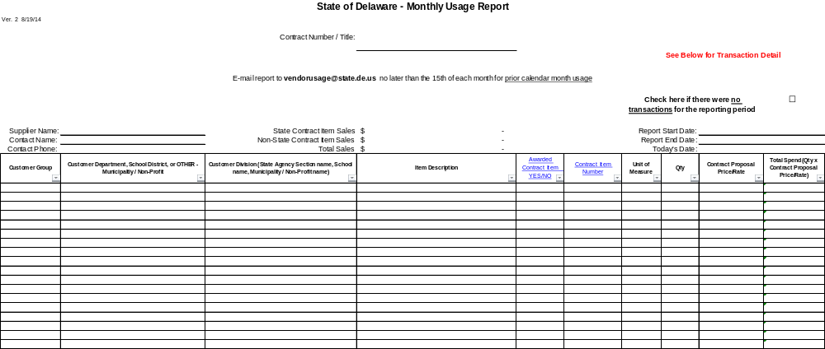

Note: A copy of the current Usage Report will be sent by electronic mail to the Awarded Vendor.

Completed reports shall be saved in an Excel format, and submitted to the following email address: Parks_OBS@state.de.us

Attachment 9
SAMPLE REPORT – FOR ILLUSTRATION PURPOSES ONLY
State of Delaware
Subcontracting (2nd tier) Quarterly Report
Prime Name: |  |  |  |  |  |  | Report Start Date:
Contract Name/Number |  |  |  |  |  |  | Report End Date:
Contact Name: |  |  |  |  |  |  | Today's Date:
Contact Phone: |  |  |  |  |  |  | *Minimum Required |  | Requested detail
Vendor Name* | Vendor TaxID* | Contract Name/ Number* | Vendor Contact Name* | Vendor Contact Phone* | Report Start Date* | Report End Date* | Amount Paid to Subcontractor* | Work Performed by Subcontractor UNSPSC | M/WBE Certifying Agency | Veteran/Service Disabled Veteran Certifying Agency | 2nd tier Supplier Name | 2nd tier Supplier Address | 2nd tier Supplier Phone Number | 2nd tier Supplier email | Description of Work Performed | 2nd tier Supplier Tax Id | Date Paid

Note: A copy of the Usage Report will be sent by electronic mail to the Awarded Vendor

Completed reports shall be saved in an Excel format, and submitted to the following email address: vendorusage@state.de.us
Attachment 10

State of Delaware

Office of Supplier Diversity
Certification Application

The most recent application can be downloaded from the following site:
http://gss.omb.delaware.gov/osd/certify.shtml

Submission of a completed Office of Supplier Diversity (OSD) application is optional and does not influence the outcome of any award decision.

The minimum criteria for certification require the entity must be at least 51% owned and actively managed by a person or persons who are eligible: minorities, women, veterans, and/or service disabled veterans. Any one or all of these categories may apply to a 51% owner.


Complete application and mail, email or fax to:

Office of Supplier Diversity (OSD)
100 Enterprise Place, Suite 4
Dover, DE 19904-8202
Telephone: (302) 857-4554 Fax: (302) 677-7086
Email: osd@state.de.us
Web site: http://gss.omb.delaware.gov/osd/index.shtml

Attachment 11

BOND IS WAIVED – INTENTIONALLY LEFT BLANK

Attachment 12

PROPOSAL REPLY REQUIREMENTS AND CHECKLIST

MINIMUM MANDATORY SUBMISSION REQUIREMENTS CHECKLIST
(MUST BE COMPLETED AND RETURNED WITH BID PACKAGE)

SUBMISSIONS MUST BE IN SEQUENCE AS LISTED BELOW:

Item Number | Description | Included?? (check yes or no)
1. | Brief Vendor Cover Letter including an Applicant's experience, if any, providing similar services. The letter shall be signed by a representative who has the legal capacity to enter. | Yes  No
2. | Table of Contents clearly identifying the structure of the proposal and showing page numbers for each of the required components. | Yes  No
3. | Two (2) paper copies of the bidder’s proposal, One (1) marked Master Copy, with all signatures being original. This includes all Appendix B Tabs printed and all Forms required in the RFP. Brochures are also required  PLEASE DO NOT PUT SUBMISSION DOCUMENTS INTO SHEET PROTECTORS.  The Appendix B – Pricing Spreadsheet is available at the following website:  www.bids.delaware.gov  Vendors MUST provide copies of all pricing spreadsheet tabs. | Yes  No
4. | Three (3) electronic copies of the complete bidder’s bid package (submitted on CD/DVD media disk or USB flash drive). This means three (3) separate CD/DVD’s or USB’s must be submitted. If the paper copy of the proposal includes a printed catalog or brochure, an electronic version of the catalog or brochure must be included on the CD’s. (If catalogs are not available in electronic version, then three (3) additional copies of the paper catalog must be provided).  All copies must have completed Appendix B in active EXCEL format, Vendor’s Proposal and Forms required in this proposal.  Include vendor catalog/brochures in pdf. Format on each CD or DVD. VERIFY ALL CD/DVD MEDIA DISC WORK CORRECTLY FROM SEVERAL SOURCES PRIOR TO SUBMISSION.  All documents in vendor’s proposal CD, excluding Appendix B and Brochures, should be scanned and saved as one PDF file. Please avoid saving individual pdf. pages of your proposal. | Yes  No
5. | One (1) complete signed and notarized copy of the Non-Collusion agreement (see Attachment 2 above). MUST HAVE ORIGINAL SIGNATURES AND NOTARY MARK. | Yes  No
6. | One (1) complete and signed copy of the Subcontractor Information Form (See Attachment E) for each subcontractor – only provide if applicable.  Click on N/A if not using subcontractor. | Yes  No  N/A
7. | One (1) completed Business Reference form (See Attachment 6) – please provide references other than State of Delaware contacts. Form must be included. | Yes  No
8. | One (1) completed Company Profile and Capabilities form (See Attachment 4) | Yes  No
9. | One (1) completed Subcontractor Information form (See Attachment 7) | Yes  No
10. | One (1) completed RFP Exception form (See Attachment 3) – please check box if no information. Form must be included. | Yes  No
11. | One (1) completed Confidential and Proprietary form (See Attachment 5) – please check box if no information provided will be considered confidential or proprietary. Form must be included. | Yes  No
12. | One (1) certificate of insurance. Please ensure you have the correct insurance levels as specified in this RFP. | Yes  No
13. | Two (2) copies of each brochure/equipment specification/product being bid on. | Yes  No
14. | One (1) copy of Financial information (balance sheets and income statements) for the past three years and/or Dun & Bradstreet report. | Yes  No
15. | One (1) complete OSD application (see link on Attachment 10) – only provide if applicable. | Yes  No
16. | One (1) completed copy of this checklist filled out by the Bidder. | Yes  No

Any “No” responses must be addressed on Attachment 3, Exceptions Form.

The items listed above provide the basis for evaluating each vendor’s proposal. Failure to provide all appropriate information may deem the submitting vendor as “non-responsive” and exclude the vendor from further consideration. If an item listed above is not applicable to your company or proposal, please make note in your submission package.

APPENDIX A
SCOPE OF WORK

- MARINA LIFT (FORKLIFT) MINIMUM REQUIREMENTS

- GENERAL

- The FORKIFT offered shall be new and unused.

- Equipment specified and/or furnished under this RFP shall be standard products of manufacturers regularly engaged in the production of such equipment and shall be the manufacturer’s latest design from 2015 to current date.

- The FORKLIFT Manufacturer's model name and/or model number shall be indicated in the bid proposal.

- The FORKLIFT shall include all genuine parts, accessories and equipment considered standard by the manufacturer for the FORKLIFT offered by the bidder.

- FORKLIFT shall be clean, lubricated and serviced ready for immediate service.

- FORKLIFT shall be protected to 20 degrees Fahrenheit below zero with permanent type antifreeze.

- FORKLIFT shall include the original Manufacturer's Statement of Origin.

- FORKLIFT shall include a copy of the manufacturer's service and standard warranty policy with all warranty verification vouchers, certificates or coupons. Bidder must provide any extended warranty program offers concerning pricing. Warranty offered is considered in the award process for this Request for Proposal.

- The successful contractor shall comply with the manufacturer's standard warranty, or authorize a qualified dealer in the locality in which the unit is assigned to do whatever is required to comply with the manufacturer's warranty.

- The successful contractor shall comply with the manufacturer's recommended pre-delivery service.

- The successful contractor shall submit at least three (3) copies of all service/technical bulletins recall notices or provide this information electronically to the Division of Parks and Recreation, 89 Kings Hwy, Dover DE 19901. These documents shall be submitted on a continual basis to keep the Division of Parks and Recreation informed regarding improvements, changes and/or problems concerning the FORKLIFT.

- The Division of Parks and Recreation will inspect the FORKLIFT prior to acceptance. It will be the responsibility of the delivering dealer to remove any FORKLIFT rejected by the ordering agency within two (2) working days after notification, and return the FORKLIFT to the Division of Parks and Recreation upon correction of deficiencies. Date in service will be the date the vehicle is accepted by the Division of Parks and Recreation, not the date of delivery.

- The State disclaims any liability for damage to any FORKLIFT not unconditionally accepted by the State.

- Unless otherwise indicated, all items requested in this specification for the FORKLIFT which are standard or optional equipment shall be factory installed and operative.

- Any FORKLIFT delivered to the State in a condition considered to be below customer acceptance levels will not be accepted. Any FORKLIFT that is delivered in an unsatisfactory condition or are missing accessories ordered will have payment withheld until the unsatisfactory condition is resolved. The Division of Parks and Recreation may negotiate with vendor to achieve a mutually beneficial resolution.

- Items which determine this acceptance level shall include, but not be limited to, the general appearance of the interior and exterior of the FORKLIFT for completeness and quality of workmanship, lubrication and fluid levels, with any leaks corrected, mechanical operation of the FORKLIFT and all electrical components operational. All equipment specified to be furnished and installed which is not available through the FORKLIFT manufacturer shall conform to the best quality standards known to that particular industry, both product and installation.

- DELIVERY:

- Towing devices may not be attached in a way that holes are drilled in the FORKLIFT. Drilling of holes in the FORKLIFT is not permitted. Any damage caused by a towing device will be replaced by the awarded vendor at no charge to the State.

- Successful contractor will be responsible for delivery of the FORKLIFT as F.O.B. destination; freight pre-paid. The State of Delaware will not pay separate delivery fees.

  - Contractor will coordinate all delivery activities with the Division of Parks and Recreation.

  - No deliveries will be accepted unless approved through the Division of Parks and Recreation.

  - The Division is not responsible for costs related to unplanned deliveries.

- MINIMUM REQUIRED SPECIFICATIONS

- Lift Capacity: 24,000 lbs. @ 96” Load Center

- Mast: Two-Stage

- Lift Height: 32’ Positive Lift and 12’ Negative Lift

- Lowered Height: 23’ Lowered

- Carriage: Corrosive package to include galvanized forks, frame and chassis

- Forks: 20 ft. rubber extruded covered galvanized forks

- Engine: Cummins Diesel Turbo; Current Tier Certification – low emissions/low noise; engine protection system built-in; automatic shutdown for high temperature/low oil pressure

- Transmission: Three speed automatic transmission; (3) forward and (3) reverse speeds

- Axle: Planetary with hydraulically actuated wet disc brakes

- Tires: 12.00x20 Non-Mark Solid Pneumatic Tires; smooth; dual drive tires and single steer tires

- Wheel Base: 130”

- Cab/Operator Console: Designed for maximum ease of use, maintenance and service; adjustable steering column; non-rusting materials; slip resistant steps; seat; seat belt; rubber floor mat; gauges; electronic push-button parking brake; fan; and mirrors

- Safety Equipment and Warning Indicators: Horn; back-up alarm; rear collision safety system; amber strobe; overhead protection; low battery indicator; low engine oil pressure warning; and high transmission oil temp warning

- Gauges: Temperature; oil; fuel; water; engine hour meter

- Working Lights: 6 forward & 2 rear working lights

- Remote Hydraulics: Wireless Lift / Lower / Engine Stop Only

- Block Heater / Cold Weather Package

- Extended Warranty

- ADDITIONAL OPTIONS

Additional Options (Optional Equipment/Configuraiton) can be proposed in Appendix B under this Request for Proposal. Minimum Specifications as are stated herein are not considered Additional Options. The Division of Parks and Recreation requests pricing be listed for Additional Options on Appendix “B” if vendor has options available in the model proposed under this Request for Proposal. All options shall be included in brochures and detailed in bid submission.

- WARRANTY

Bidders are encouraged to submit their best OEM Warranties, at no additional cost to the State. The length of the OEM warranty will be a factor in determining the lowest overall price to the State. The awarded vendor will be the sole contact and coordinator of warranty repairs and service.

- TRADE-IN FORKLIFT

The Division of Parks and Recreation is interested in trading in their current marina forklift (Wiggins Marina Bull model 22,000 @ 96” load center; wheelbase 130” the unit is powered with a Perkins diesel with 6,200 hours) with the trade in value being deducted from the overall procurement cost of a new marina lift (forklift).

- Successful contractor will be responsible for all removal logistics and costs for trade-in FORKLIFT under this contract.

  - Removal will be coordinated and approved by the Division of Parks and Recreation.

- Photos of current marina forklift and information are included in Appendix “C”, CURRENT MARINA LIFT (FORKLIFT) TRADE IN REPORT, of this Request for Proposal.

- Pricing submitted by bidders shall have pricing for new marina lift (forklift) separate from trade-in value (as shown on “Appendix B”).

- Inspection requests for the Division of Parks and Recreation current marina forklift are available by appointment only and must be completed PRIOR TO THE BID OPENING DATE.

APPENDIX B
Pricing Forms

Refer to the Pricing Spreadsheet included in this RFP posting available at http://bids.delaware.gov/.

APPENDIX “C”

CURRENT MARINA LIFT (FORKLIFT) TRADE IN REPORT

Wiggins Marina Bull model 22,000 -

Wiggins Marina Bull model 22,000 @ 96" load center. Wheelbase 130" the unit is powered with a Perkins diesel with 6,200 hours. This machine has been serviced from new by certified mechanics only. The unit is ready for inspection at the Indian River Marina and is currently working daily. A detailed service record is available during on-site inspection. Questions related to the Wiggins Marina Bull model can be sent via email to Rebecca.Lovin@state.de.us .

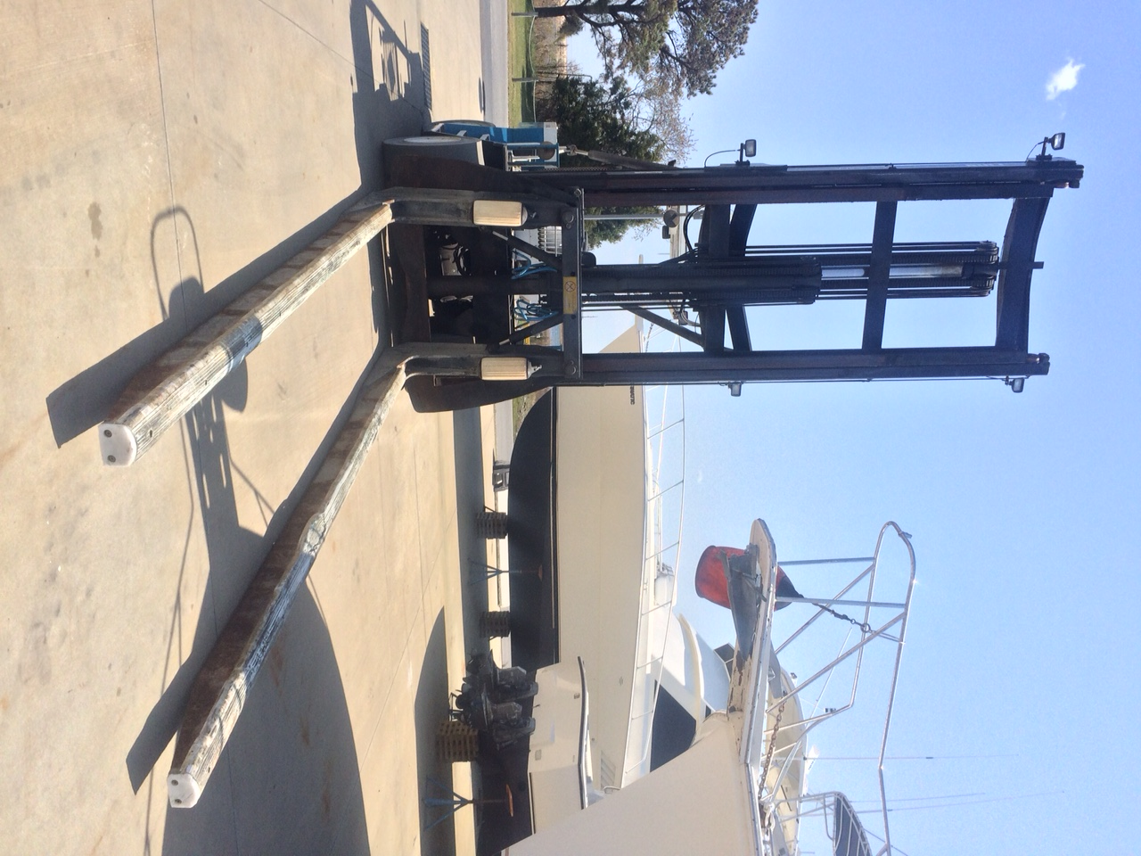
Wiggins Marina Bull model 22,000
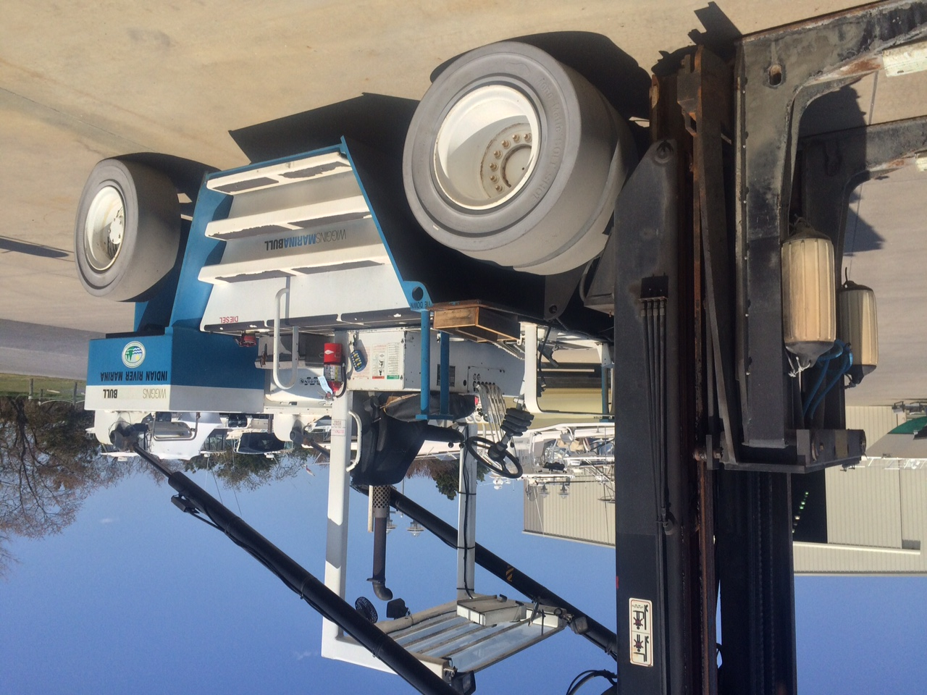
Wiggins Marina Bull model 22,000
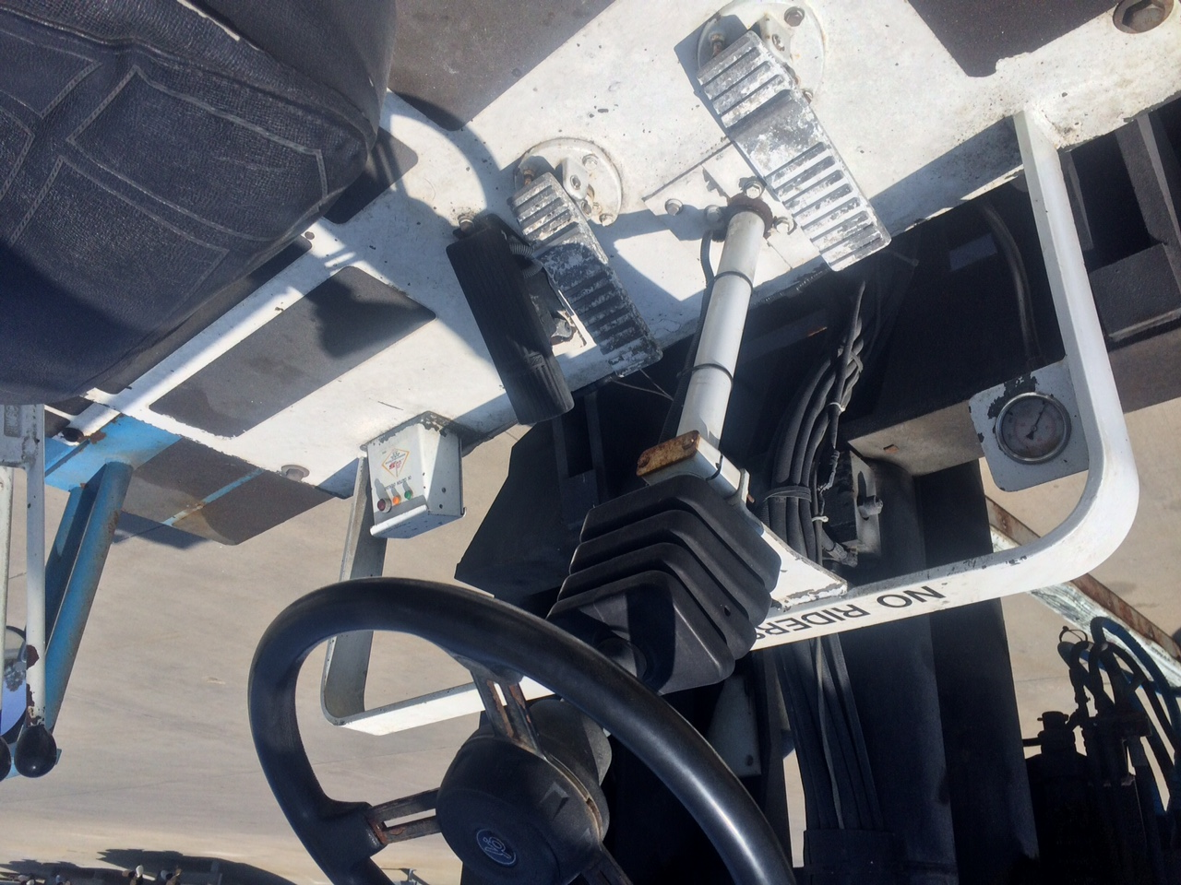
Wiggins Marina Bull model 22,000
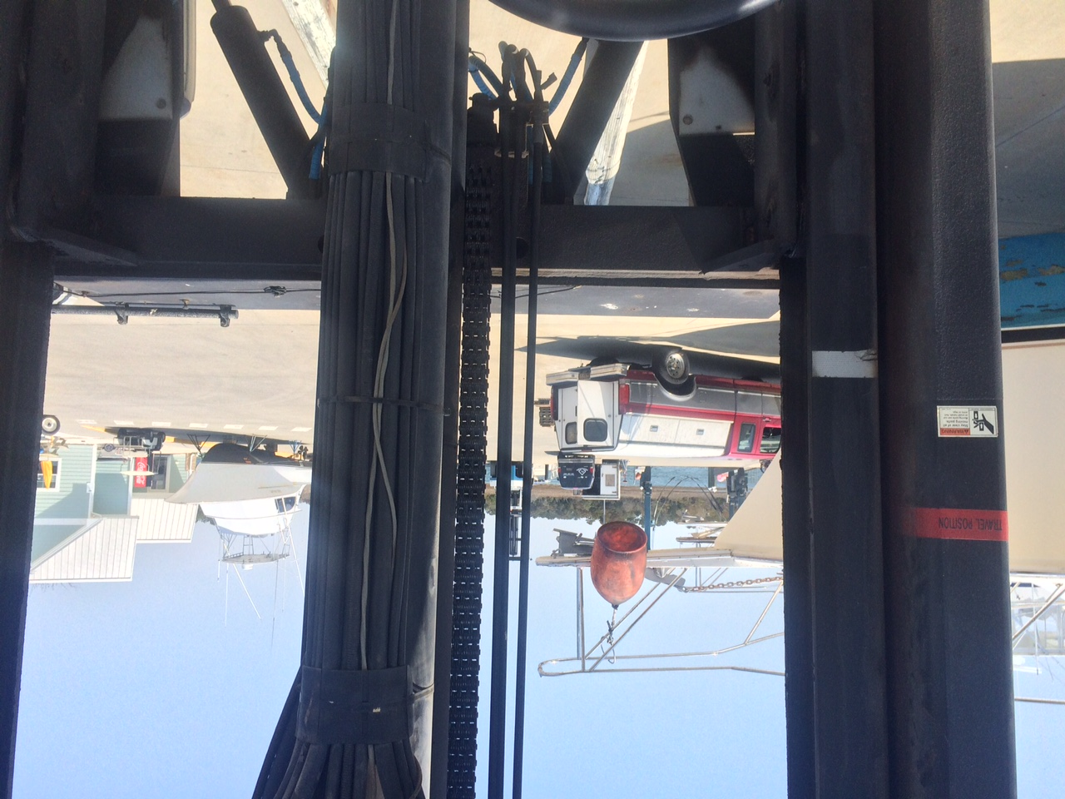
Wiggins Marina Bull model 22,000
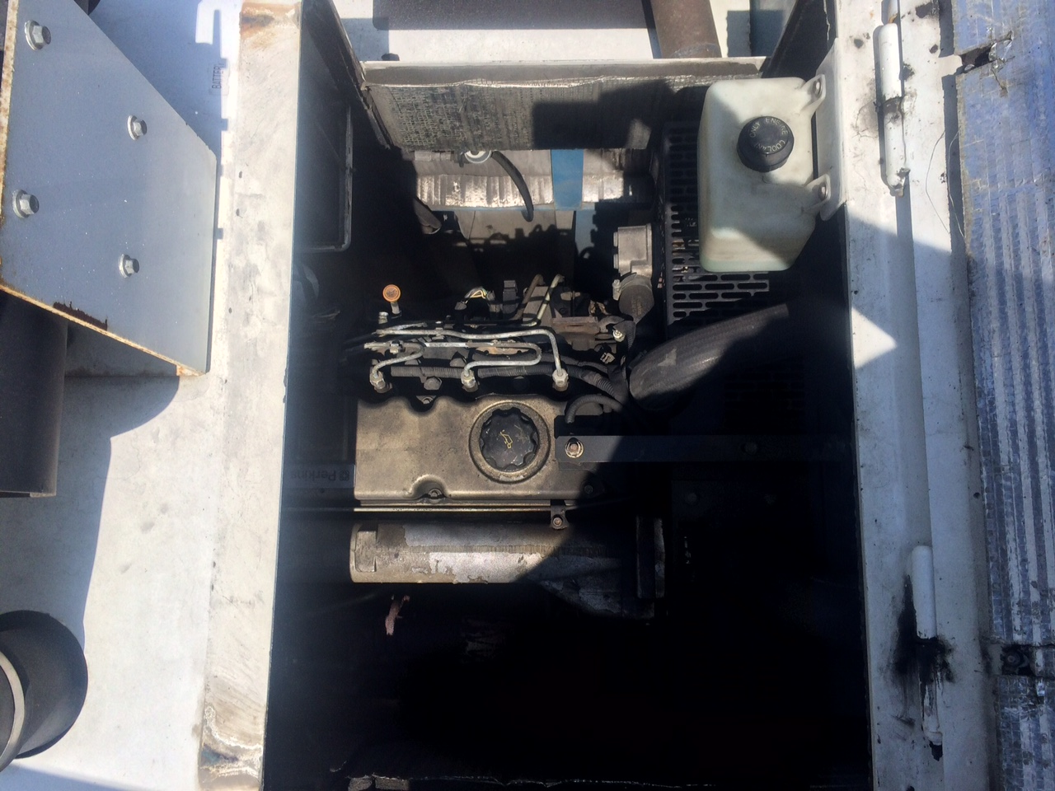
Wiggins Marina Bull model 22,000
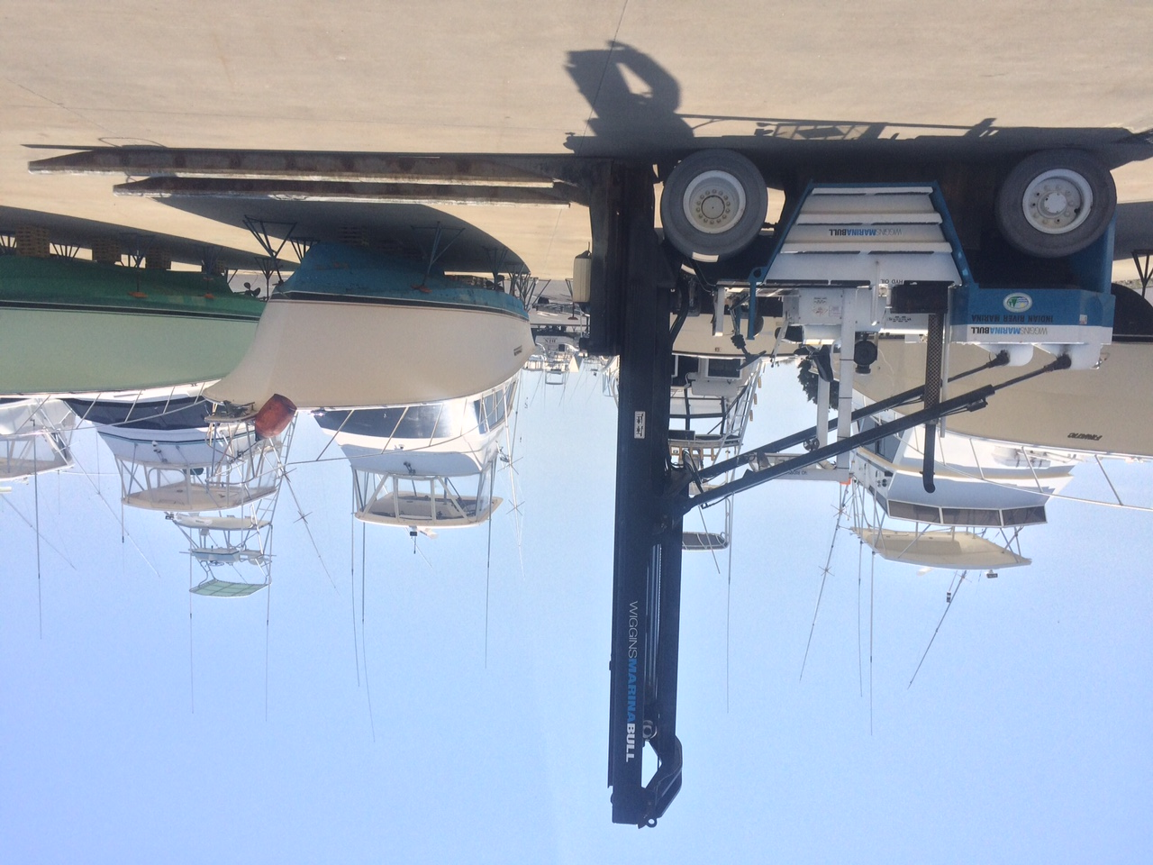
Wiggins Marina Bull model 22,000
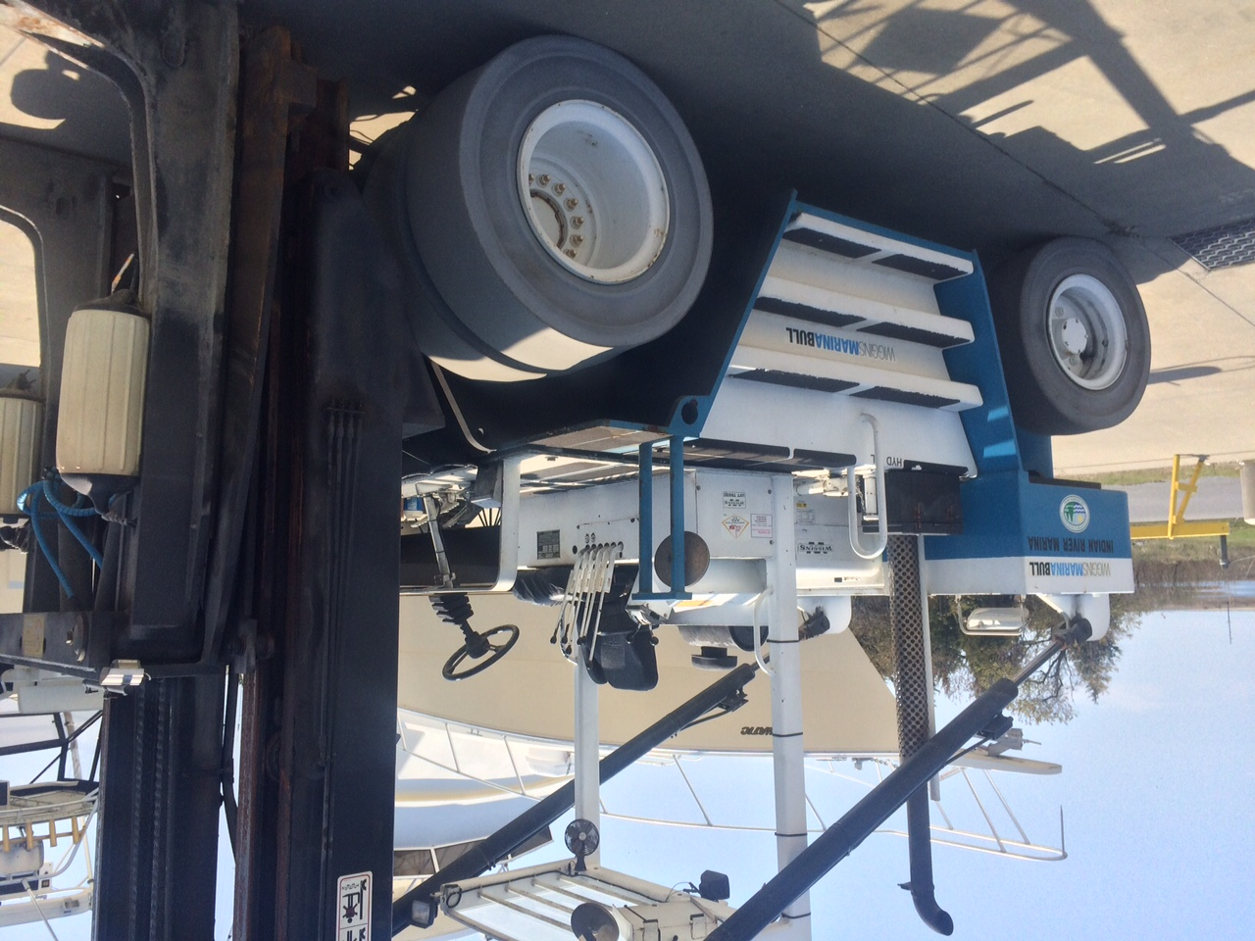
Wiggins Marina Bull model 22,000
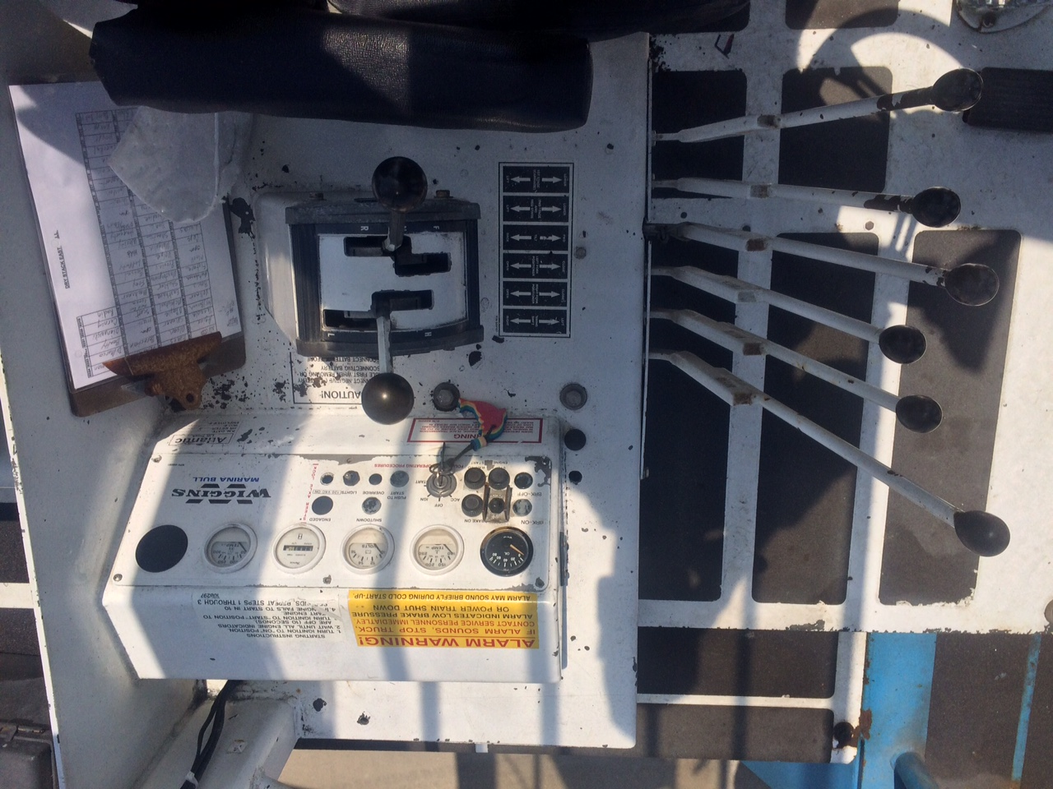
Wiggins Marina Bull model 22,000
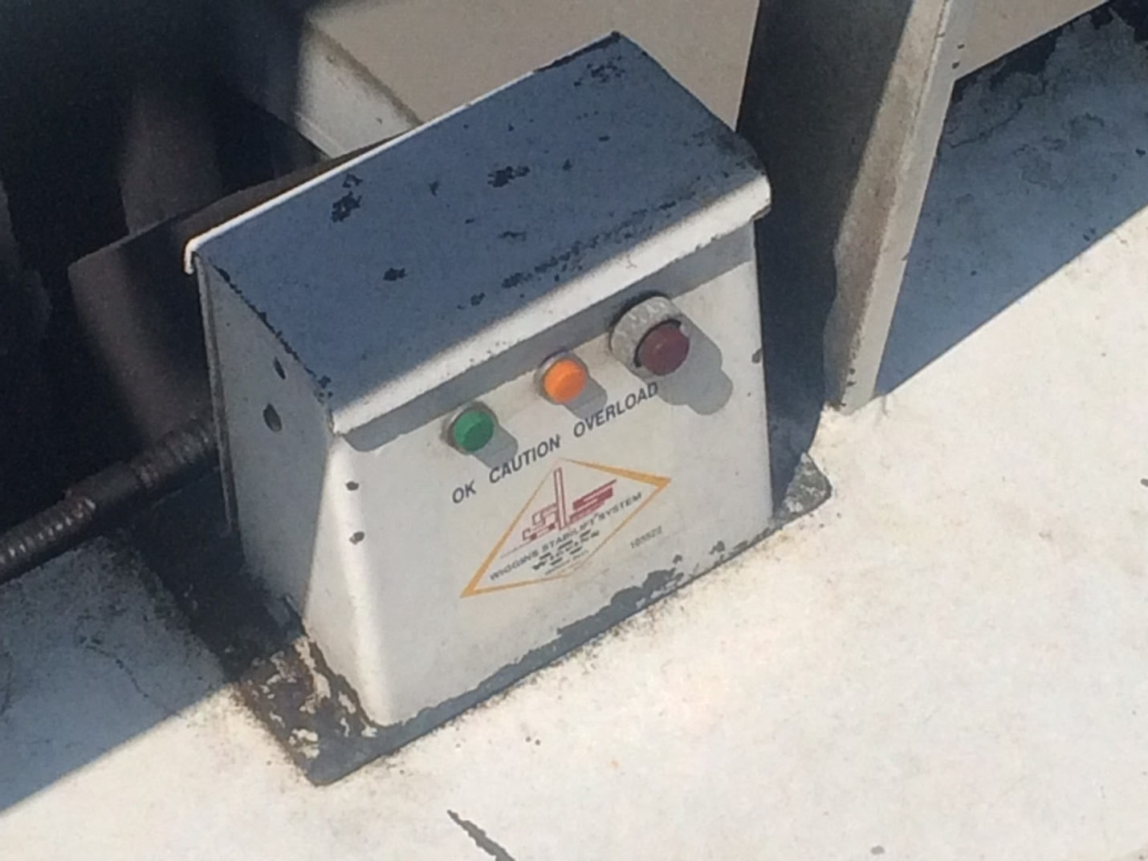
Wiggins Marina Bull model 22,000

