- Purpose
To provide the necessary guidance and policy for eligibility determination to staff who determine eligibility for enrollment into a Pre-Apprenticeship Program funded by the Department of Labor, Division of Employment and Training (DET).

- Definitions
Many terms found within this policy are defined in the Definitions provided through an RFP or as updated and disseminated by DET.

- Verification Requirements
All participants must be registered with a Jobseeker account in Delaware JobLink (DJL). Certain data elements entered during registration must be verified while others must be documented.

Verification and documentation are different.

Verification means to confirm eligibility requirements through examination of official documents: for example, social security card, birth certificates, or public assistance records.

Documentation means to maintain physical evidence, which is obtained during the verification process. Such evidence would be copies of documentation, and signed self-certification statements (with Contract Specialist’s prior approval).

A participant must be determined eligible and documentation supporting eligibility must be uploaded in (DJL). Once the enrollment for the participant is approved in DJL, they are considered enrolled and in the denominator for performance.

This policy contains a list of acceptable documents or methods for verifying and documenting each required eligibility factor. This list is attached as Attachment A. This list is extensive but not all inclusive. Before using a document or method to verify eligibility that is not included in this policy, approval must be obtained from your Contract Specialist. This policy also includes several attachments that are required forms for documenting eligibility.

All eligibility items are documented at the time of enrollment. While the Self-Certification Form may be allowed as documentation for some eligibility items, Contractors must obtain prior approval to use this form from the Contract Specialist.

4. Eligibility Requirements
- Registered in Delaware JobLink:
Registration is the process of collecting information to support a determination of eligibility. This also results in participants having a job seeker account. This is complete when the participant or staff have completed all of the following demographic sections in Delaware JobLink:
- Personal. This includes:
  - Social Security Number. Social Security Number is not required but is requested in order to obtain employment outcomes. If a participant does not want to provide their Social Security number, Attachment B will be completed.
- Veteran Status. It is important that the client answers these questions accurately so they can benefit from applicable services/priority.
- Wounded Warrior Caregiver
- Migrant Worker
- Employment Status
- Eligibility to Work in the US
- Dislocated Worker
- Work Wanted
- Low Income (this does not include the Low Income Monetary Determination Section)
- Public Assistance Information
- Needs and Barriers
- Work Wanted. For youth this should be the career goal of the youth at the time of enrollment.

Staff will review the sections with participants and edit as appropriate during their first appointment with participant.

Releases in Delaware JobLink:
- The Equal Opportunity Notification (found on the Enrollment Details screen under “EEO Printable Version” shall be reviewed with participant, signed, and placed in file.
- Delaware JobLink Authorization for the Release of Information (found on the Universal Screen under “Printable Client Releases”).
- The Provider may have additional releases unique to their program not found in DJL.

- Citizenship or Eligible to Work
A participant must be authorized to work in the United States to receive services. Participation in programs and activities or receiving funds shall be available to citizens and nationals of the United States, lawfully admitted permanent resident aliens, refugees, asylees, and parolees, and other immigrants authorized by the Attorney General to work in the United States.

- Date of Birth (Age)
A Registered Pre-Apprentice must be at least 16 years old.

- Residency
Preference shall be given to Delaware residents. Exceptions to this are when:
- Participant lives in a town split by state boundaries (e.g. Delmar); or
- Participant lives in a bordering state; or
- Participant lives in another states and is collecting/exhausted Delaware Unemployment Insurance.

- Selective Service Registrant
Men born after December 31, 1959 must register with Selective Service within 30 days of their 18th birthday or at least before they reach the age of 26. This includes males who are:
- Citizens of the U.S.;
- Non-citizens, including illegal aliens, legal permanent residents, seasonal agricultural workers, and refugees, who take up residency in the U.S. before their 26th birthday; and/or
- Dual nationals of the U.S. and another country regardless of whether they live in the U.S.

For U.S. citizens, Selective Service registration is not required if the man falls within one of the following categories:
- Men who are serving in the military on full-time active duty;
- Men attending the service academies;
- Disabled men who are continually confined to a residence, hospital or institution; and/or
- Men who are hospitalized, institutionalized, or incarcerated are not required to register during their confinement; however, they must register within 30 days after being released if they have not yet reached their 26th birthday.

For non-U.S. citizens, Selective Service registration is not required if the man falls within one of the following categories:
  - Non-U.S. male who came into this country for the first time after his 26th birthday.
  - Non-U.S. male who entered the U.S. illegally after his 26th birthday.
  - Non-U.S. male on a valid non-immigrant visa.

See Attachment C for a desk aid of who should register.

Any male who is between the ages of 18 and 26 and has not registered would be required to register prior to enrollment. Any youth who turns 18 while enrolled in a program, shall be registered for Selective Services.

- Unable to Obtain a Registered Apprenticeship
Registered Pre-Apprentices must be determined to be unable to obtain a Registered Apprenticeship position in the occupation of choice due to a lack of skill (occupational and/or professional/soft skills), experience, or resources. In conjunction with any assessments, this shall be documented with a narrative justification in the participant’s file. For example, a narrative justification may state: “Lisa is very much interested in getting into the construction trades. She currently has no work experience in this industry and has tried to apply for entry level positions without success. She does have a high school diploma but her current math scores indicate she is computing math at an 8th grade level.”

- Attachment List
- List of Acceptable Documentation
- Client Acknowledgement for no SSN
- Selective Service Desk Aid
- Citizenship or Eligible to Work Form
- Self –Certification Form

The following is a list acceptable documents for each required eligibility factor. All documents must be current. This list is extensive but not all inclusive. Before using a document or method to verify eligibility that is not included in this policy, approval must be obtained from your Contract Specialist

.
 | Eligibility Category | Eligibility Criteria |  | Acceptable Documentation
 | General Eligibility | Citizenship or Eligible to Work |  | Documents listed in accordance with the I-9 found at https://www.uscis.gov/i-9 must be verified.  Attachment E shall be completed as documentation that items were verified.
 |  | Age/Date of Birth |  | - Driver’s License  - State or Federal ID  - Birth Certificate  - Baptismal record (if date of birth shown)  - DD-214 or Report of Transfer or Discharge Paper  - Passport  - Hospital Record of birth  - Public Assistance/Social Service Records  - School Records/Identification Card  - Work Permit
 |  | Residency |  | - Driver’s License or State ID  - Utility Bill  - Lease or Landlord Statement  - Rent Receipt  - Voter Registration Card  - Public Assistance/Social Service Records  - Document from a School / School District
 |  |  | Selective Service Registrant  Documentation should support registration or that Participant was not required to register | - Internet Verification https://www.sss.gov/  - Selective Service Acknowledgement Letter  - Selective Service Registration Card  - Selective Service Verification Form (Form 3A)  - DD-214, “Report of Separation”  - Stamped Post Office Receipt of Registration  - Selective Service Telephone Verification (847) 688-6888  - Date of entry stamped on passport  - I-94 with date of entry stamp  - Letter from U.S. Citizenship and Immigration Services (USCIS) indicating the date the man entered the U.S.  - Proof he was not living in the U.S. from 18-25 (for those who entered illegally after 26th birthday).

I, _________________________ have opted to not provide my social security number. The program in which I am applying for uses social security numbers to report employment outcomes to the United States Department of Labor and the Delaware Workforce Development Board. I understand that my employment will not be reported in this manner and therefore I will provide the program staff with my employment information, including copies of paystubs when I obtain employment and as they are requested, for no less than one year after I am no longer in the program. This is required in order for my employment outcomes and success to be reported and ensures that free youth programs continue to be available.
Participant Signature Date

Parent/Guardian Signature (if youth under 18) Date

SELECTIVE SERVICE-WHO MUST REGISTER FOR?
Note: With only a few exceptions, the registration requirement applies to all male U.S. citizens and male immigrants residing in the United States who are 18 through 25 years of age.
Category | Yes | No
All male U.S. citizens born after December 31, 1959, who are 18 but not yet 26 years old, except as noted below: | X
Military Related
Members of the Armed Forces on active duty (active duty for training does not constitute “active duty” for registration purposes) |  | X*
Cadets and Midshipmen at Service Academies or Coast Guard Academy |  | X*
Cadets at the Merchant Marine Academy | X
Students in Officer Procurement Programs at the Citadel, North Georgia College and State University, Norwich University, Virginia Military Institute, Texas A&M University, Virginia Polytechnic Institute and State University |  | X*
National Guardsmen or Reservists not on active duty/Civil Air Patrol members | X
Delayed Entry Program enlistees | X
ROTC Students | X
Separatees from Active Military Service, separated for any reason before age 26 | X*
Men rejected for enlistment for any reason before age 26 | X
Immigrants**
Lawful non-immigrants on current non-immigrant visas. A complete list if acceptable documentation for exemption may be found at https://www.sss.gov/portals/0/pdfs/documentationlist.pdf |  | X
Permanent resident immigrants (USCIS Form I-551) | X
Seasonal agricultural workers (H-2A Visa) |  | X
Refugee, parolee, and asylee immigrants | X
Undocumented immigrants | X
Dual national U.S. citizens | X
Confined
Incarcerated, hospitalized, or institutionalized for medical reasons |  | X*
Handicapped physically or mentally
Able to function in public with or without assistance | X
Continually confined to a residence, hospital, or institution |  | X

Transgender People
U.S. citizens or immigrants who are born male and have changed their gender to female | X
Individuals who are born female and have changed their gender to male |  | X
*Must register within 30 days of release unless already age 26
NOTE: To be fully exempt you must have been on active duty or confined continuously from age 18 to 25
**Residents of Puerto Rico, Guam, Virgin Islands, and Northern Mariana Islands are U.S. citizens. Citizens of American Samoa are nationals and must register when they are habitual residents in the United States or reside in the U.S. for at least one year. Habitual residence is presumed and registration is required whenever a national or a citizen of the Republic of the Marshall Islands or the Federated States of Micronesia, or Palau resides in the U.S. for more than one year in any status, except when the individual resides as an employee of the government of his homeland or as a student who entered the U.S. for purpose of full-time studies, as long as such person maintain that status.

Attachment D
Citizenship or Eligible to Work Form
The following is a list of acceptable documents. All documents must be unexpired and originals (no copies). In order to document a participant’s United States citizenship or eligibility to work in the United States, staff must verify one of the documents listed in List A or a combination of one document listed in List B with one document in List C.

This completed form is the only items required to be uploaded in Delaware JobLink to document citizenship or eligibility to work.
Please circle the document(s) verified.
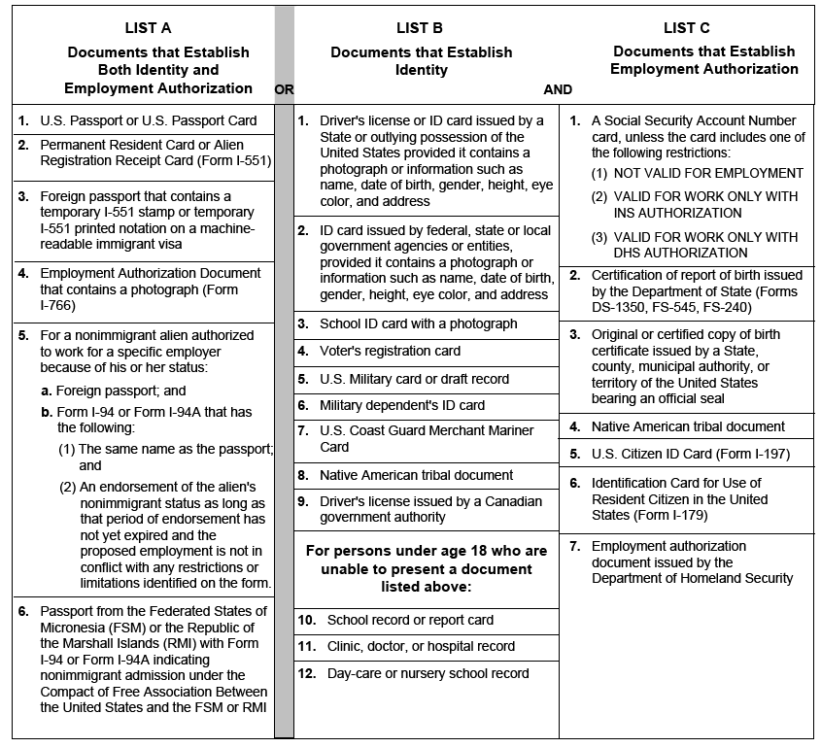
Staff Complete:
I have reviewed the official documents circled in the lists above to verify participant is a citizen or eligible to work.
Staff Signature:__________________________________________________

Participant Complete:
I have supplied these documents circled in the lists above to the Program in order to verify that I am a United States citizen or eligible to work in the United States.
Participant Signature:_______________________________________________
Attachment E
Self-Certification Form

IDENTIFYING INFORMATION
Applicant’s Name:

Item being Documented: _____________________________________________________________________

I HEREBY CERTIFY UNDER PENALTY OF LAW, THAT THE FOLLOWING INFORMATION IS TRUE:

I ATTEST THAT THE INFORMATION STATED ABOVE IS TRUE AND ACCURATE, AND UNDERSTAND THAT THE ABOVE INFORMATION, IF MISREPRESENTED, OR INCOMPLETE, MAY BE GROUNDS FOR IMMEDIATE TERMINATION AND/OR PENALTIES AS SPECIFIED BY LAW.

APPLICANT’S SIGNATURE and DATE APPLICANT’S PHONE NUMBER

APPLICANT’S ADDRESS

SIGNATURE OF PARENT OR GUARDIAN (as needed)

CERTIFICATION
I certify that the individual whose signature appears above provided the information recorded on this form.

Staff Signature/Date:

Supervisor or Reviewer Signature/Date:

