APPENDIX H2
Technical Requirements of Proposed Solution
This RFP is offered to both onsite and hosted solutions, as a result requirements pertaining to each model will be noted.

In proposals, vendors are to confirm the ability to meet the following requirements:
- Please Acknowledge
      - Standard Practices (not required for outsourced solutions)
With respect to work provided to or conducted for the State by a contractor, the contractor(s) shall be responsible for the professional quality, technical accuracy, timely completion and coordination of all services furnished to the State. The contractor(s) shall follow practices consistent with generally accepted professional and technical policies and standards. The contractor(s) shall be responsible for ensuring that all services, products and deliverables furnished to the State are coordinated with the Department of Technology and Information (DTI) and are consistent with practices utilized by, or policies and standards promulgated by DTI published at http://dti.delaware.gov/information/standards-policies.shtml. If any service, product or deliverable furnished by a contractor(s) does not conform to state policies, standards or general practices, the contractor(s) shall, at its expense and option either (1) replace it with a conforming equivalent or (2) modify it to conform to state policies, standards or practices.

Acknowledgement (initial) __________________
      - Confidentiality and Data Integrity (not required for outsourced solutions)
DTI is responsible for safeguarding the confidentiality and integrity of data in state computer files regardless of the source of those data or medium on which they are stored (e.g. electronic data, computer output microfilm - COM, tape or disk). Computer programs developed to process state agency data will not be modified without the knowledge and written authorization of DTI. All data generated from the original source data, shall be the property of the State of Delaware. The control of the disclosure of those data shall be retained by the State of Delaware and DTI.
Acknowledgement (initial) __________________

      - Security Controls (not required for outsourced solutions)
As computer, network and information security are of paramount concern, the State wants to ensure that computer/network hardware and software do not compromise the security of its IT infrastructure. Therefore, the vendor is guaranteeing that any system or software meets or exceeds the Top 20 Critical Security controls located at http://www.sans.org/critical-security-controls/.

Acknowledgement (initial) __________________

      - Cyber Security Liability (not required for outsourced solutions)
It shall be the duty of the vendor to assure that all products of its effort do not cause, directly or indirectly, any unauthorized acquisition of data that compromises the security, confidentiality or integrity of information maintained by the State of Delaware. The vendor’s agreement shall not limit or modify liability for information security breaches, and the vendor shall indemnify and hold harmless the State, its agents and employees, from any and all liability, suits, actions or claims, together with all reasonable costs and expenses (including attorneys’ fees) arising out of such breaches. In addition to all rights and remedies available to it in law or in equity, the State shall subtract from any payment made to the vendor all damages, costs and expenses caused by such information security breaches that have not been previously paid to the vendor.

Acknowledgement (initial) __________________

2. Mandatory Standards (not required for outsourced solutions)

The following State of Delaware technology standards and/or policies have been identified as potentially being related to this solution:

Acknowledgment
(initial)
a) Data Classification Policy
http://dti.delaware.gov/pdfs/pp/DataClassificationPolicy.pdf
b) Data Management Policy
http://dti.delaware.gov/pdfs/pp/DataManagementPolicy.pdf
c) State of Delaware Information Security Policy (DISP)
http://dti.delaware.gov/pdfs/pp/DelawareInformationSecurityPolicy.pdf
d) Secure File Transport
http://dti.delaware.gov/pdfs/pp/SecureFileTransport.pdf
e) Strong Password Standard
http://dti.delaware.gov/pdfs/pp/StrongPasswordStandard.pdf
f) Web Application Security
http://dti.delaware.gov/pdfs/pp/WebApplicationSecurity.pdf
g) Data Modeling Standard
http://dti.delaware.gov/pdfs/pp/DataModelingStandard.pdf
h) Disposal of Electronic Equipment and Storage Media Policy
http://dti.delaware.gov/pdfs/pp/DisposalOfElectronicEquipmentAndStorageMedia.pdf
i) Data Center Policy
http://dti.delaware.gov/pdfs/pp/DataCenterPolicy.pdf
j) Data Integration Standard
http://dti.delaware.gov/pdfs/pp/DataIntegrationStandard.pdf

3. Mandatory Architectural Documentation
a) Network Diagram
A network diagram of the proposed solution is required that clearly documents all servers, networks, communication with ports and protocols, including the user’s interaction with the solution and interfaces with any other applications. A conceptual diagram should be provided with the vendor’s proposal. A finalized diagram must be provided to DTI for review and approval after the final design is completed, and prior to implementation of the solution.

Network Diagram Template for Hosting in a State of Delaware Data Center:
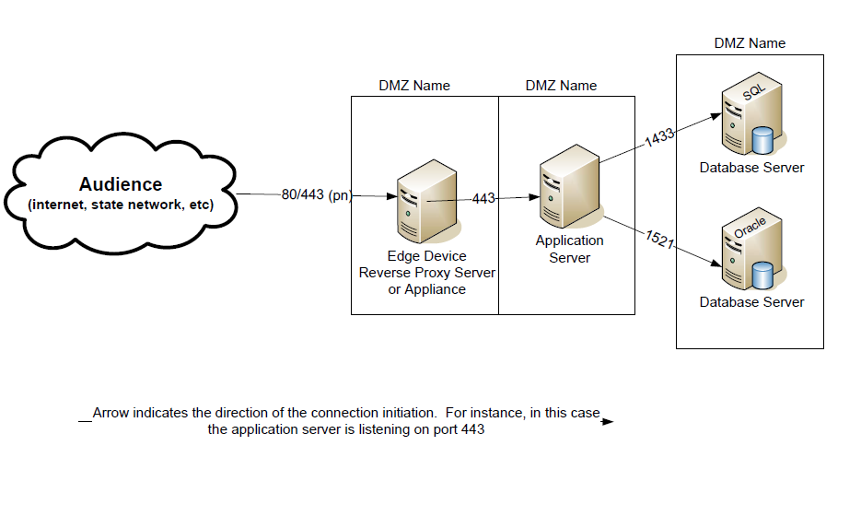

Network Diagram Template for SaaS Hosted / Outsourced Solutions

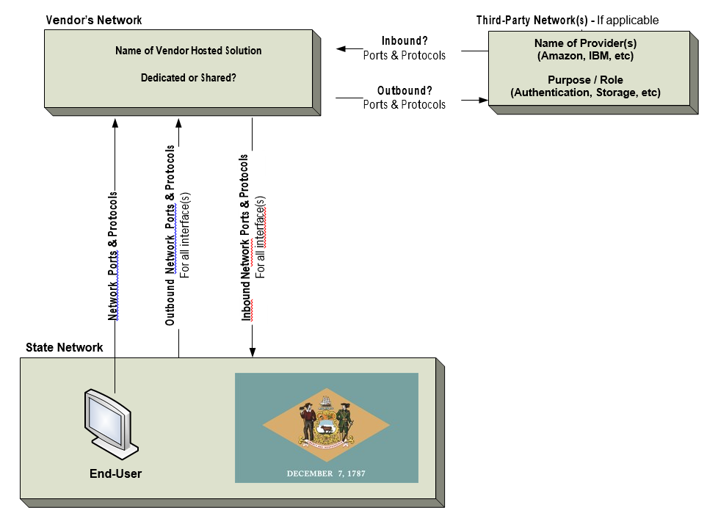

Acknowledgement (initial) __________________

- Software Inventory
A software inventory identifying any software that the State needs in relation to the proposed solution is required. For example, a certain web browser (Internet Explorer) or web service technology for an interface, and all software that will be installed on servers within the State’s infrastructure. A software list should be provided with the vendor’s proposal. A finalized software list must be provided to DTI for review and approval after the final design is completed and prior to implementation of the solution. The Software Inventory template can be found in Section 14.

Acknowledgement (initial) __________________

- Functionality Mapping Requirements
In an effort to understand how the proposed solution will meet the State’s requirements, the selected vendor will be expected to submit a conceptual document mapping the core functional requirements, as described in Appendix B, to the selected software product.

Acknowledgement (initial) __________________

- Database Dictionary or Data Model
A data dictionary, or a conceptual data model for state-owned business data, must be provided to the State. The data dictionary or conceptual data model does not have to be submitted with a vendor response to this RFP, but must be submitted once the design of the solution is complete or prior to implementation of the solution. The submitted data dictionary or conceptual data model must include at least the following items: entity names and descriptions, entity relationships and descriptions, attribute names, attribute descriptions, attribute data type, attribute lengths, and primary identifier for each entity.
Data dictionaries must be submitted in Excel or in a .csv file. The directions for how to format the Excel workbook is explained in the first section of the Data Model Samples document (http://dti.delaware.gov/pdfs/pp/DataModelSamples.pdf). If a data model is submitted, it must be in Sybase, PowerDesigner or CA Erwin format. Any submission by a vendor to comply with these requirements that necessarily includes data that the vendor wishes to claim as proprietary must be submitted and labeled “Proprietary Information” with the RFP/Contract number. The envelope must contain a letter from the vendor’s legal counsel describing the documents in the envelope, representing in good faith that the information in each document is not “public record” as defined by 29Del. C. § 10002(d), and briefly stating the reasons that each document meets the said definitions. The vendor’s counsel must also acknowledge what elements of the submission are not claimed as proprietary and are subject to release upon request.

This is to be provided by the vendor and must be submitted to DTI for review after completion of the final design and prior to implementation of the solution.

Acknowledgement (initial) __________________
- The vendor must describe required password complexity and the method used by the solution for hashing user passwords. Include items like hash algorithm, salt generation and storage and number of iterations. Preferred, not required.

Acknowledgement (initial) __________________
- The vendor must describe the solution’s ability to encrypt non-public state data at rest. Include encryption algorithm(s) and the approach to key management. Preferred, not required.

Acknowledgement (initial) __________________

4. External Hosted / SaaS Solutions

Vendors with solutions that will not be hosted in a State of Delaware data center/SaaS need to agree to the following:

a) Terms and Conditions
The State of Delaware is taking a very deliberate approach to cloud-based engagements because of concerns around the protection of our data, access control, and the lack of mature standards in the industry. It is for this reason that DTI and agencies are requesting an explicit review of our Cloud Terms and Conditions, including an item-by-item acknowledgement from the vendor and their subcontractors for those solutions involving any non-public data.
Clauses 1-13 in Appendix G – Cloud and Offsite Hosting Policy are mandatory for every engagement. Exceptions will be considered non-compliant and non-responsive.

Acknowledgement (initial) __________________

b) Operational Health
The vendor must describe their approach to conveying the ‘operational health’ of the solution to the State of Delaware. The vendor will detail procedures for planned and unplanned downtime. The vendor should include information about any system monitoring, system performance metrics, and intrusion detection systems. Also, the vendor must list any third party cloud management providers that they integrate with.

Acknowledgement (initial) __________________

c) Data Center Rating (required for outsourced solution)
The vendor must meet or exceed a Tier II rating (as defined in the Uptime Institute Guidelines for 2012 (or the latest version at the time of this RFP), Data Center Site Infrastructure Tier Standard, Topology and Data Center Site Infrastructure Tier Standard, and Operational Sustainability for the data center hosting the proposed solution. The Uptime Institute publications can be accessed online at: http://uptimeinstitute.com/publications.

Acknowledgement (initial) __________________

5. Architecture Review Board (ARB)
The ARB may require a follow-up discussion with the selected vendor upon review of the required architectural documents to clarify any additional architecture questions that may arise to ensure the solution will fit into the State’s acceptable architecture.

